Algorithms for the Longest Common Subsequence Problem
Daniel S. Hirschberg
Journal of the ACM, Vol. 24, No. 4, pp. 664-675, Oct. 1977
Abstract
Two algorithms are presented that solve the longest common subsequence problem. The first algorithm is applicable in the general case and require O(pn+ nlogn) time where p is the length of the LCS. The second algorithm requires time bounded by O(p(m+1-p)logn). In the common special case where p is close to m, this algorithm takes much less time than n².
- pn algorithm
Define: L(i, j) is the length of the LCS of prefixes of lengths i and j of strings A and B, i.e. the length of the LCS of A_{1i} and B_{1i}.

Define: <i, j> represents the positions of a_{i} and b_{i}, the ith element of string A and the jth element of string B.

Define: {<0, 0>} is the set of 0-candidates, and we define <i, j> to be a k-candidate (for k≧1) if a_{i} = b_{i} and there exist i` and j` such that i` < i, j` < j, and <i`, j`> is a (k-1)-candidate. We say that <i`, j`> generates <i, j>.

Lemma: Let the set of k-candidates be {<i_{r}, j_{r}>} (r = 1, 2, …). We can rule out candidates so that i₁ < i₂ < … and j₁ > j₂ > ….

Define: For a matrix D. D[k, i] is the j-value of the unique minimal k-candidate having i-value of i or 0 if there is no such minimal k-candidate.
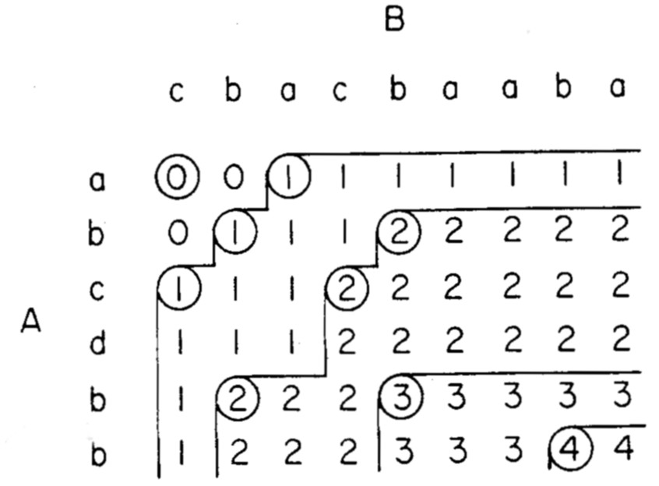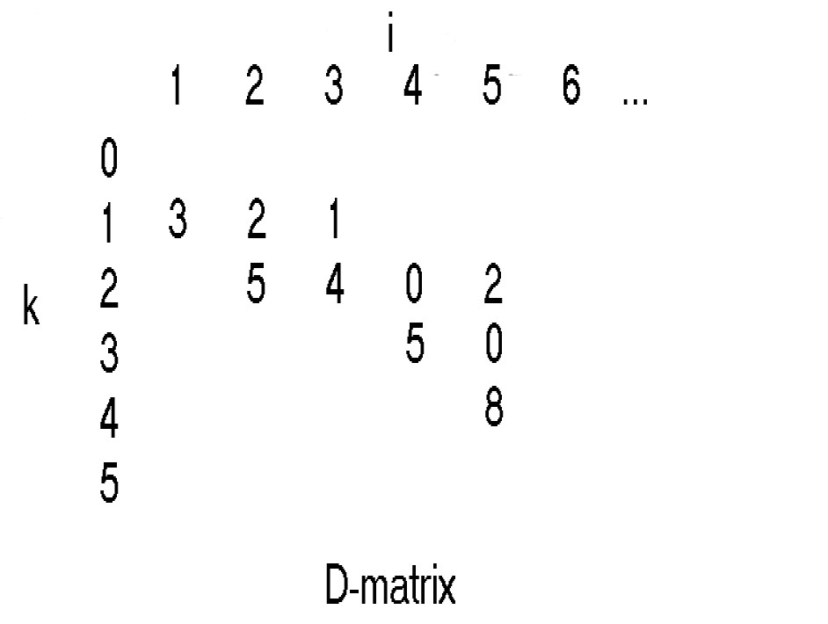

Created by : Chao-Li Peng
Date : Feb. 19, 2002

