GENOME REARRANGEMENTS

SETUBAL/MEIDANIS

Introduction to Computational Molecular Biology
7.1 BIOLOGICAL BACKGROUND
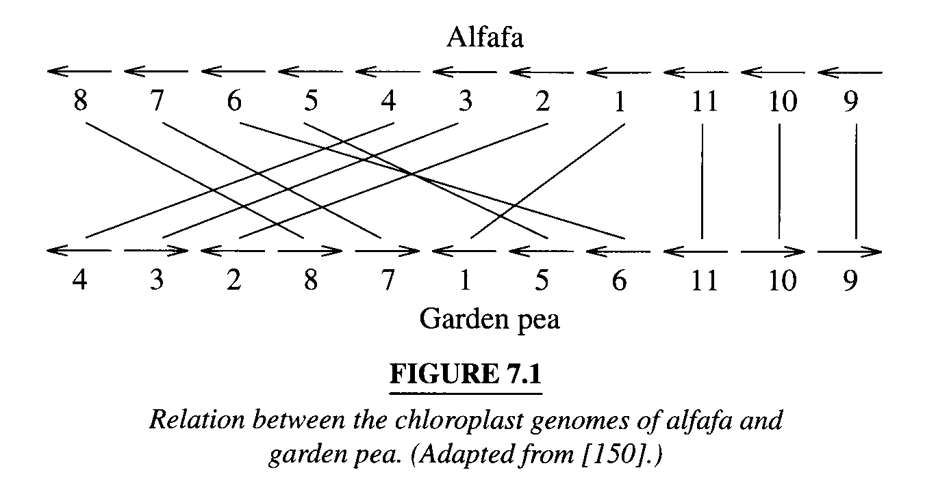
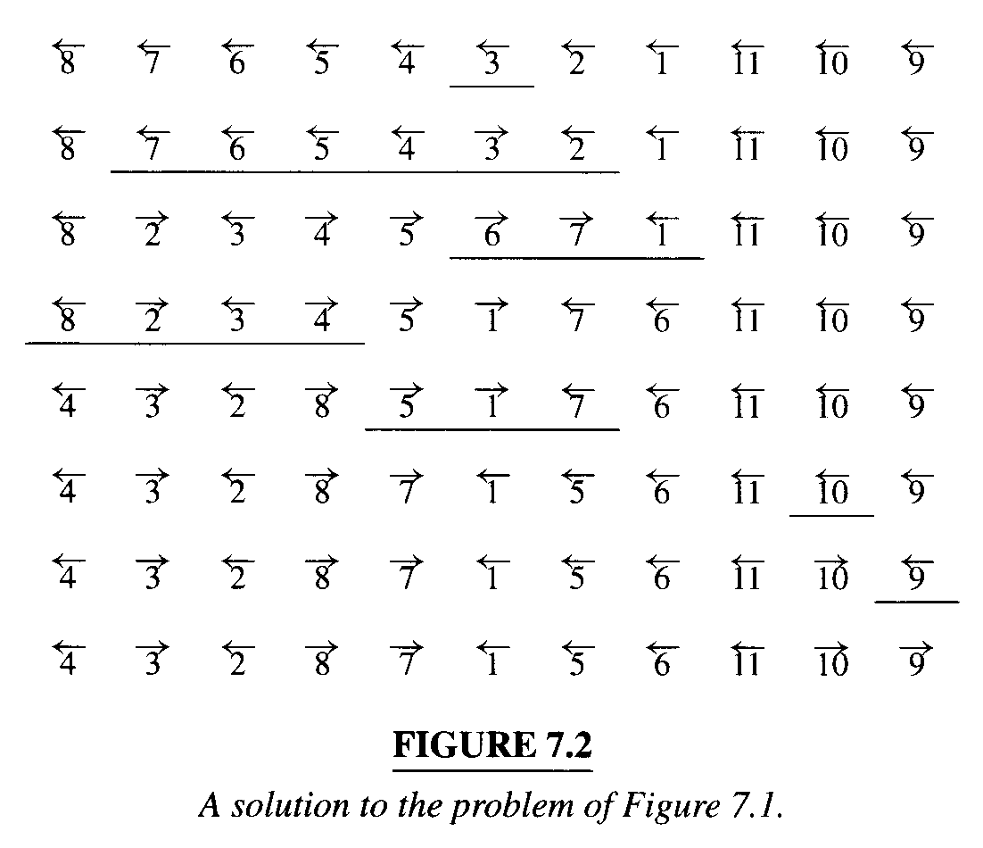
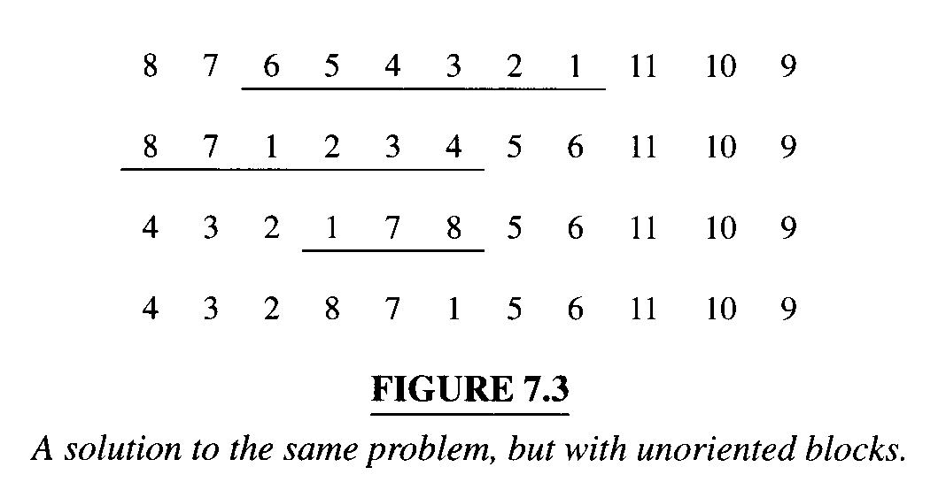
7.2 ORIENT BLOCKS
BREAKPOINTS
A Lower Bound
The Diagram of Reality and Desire
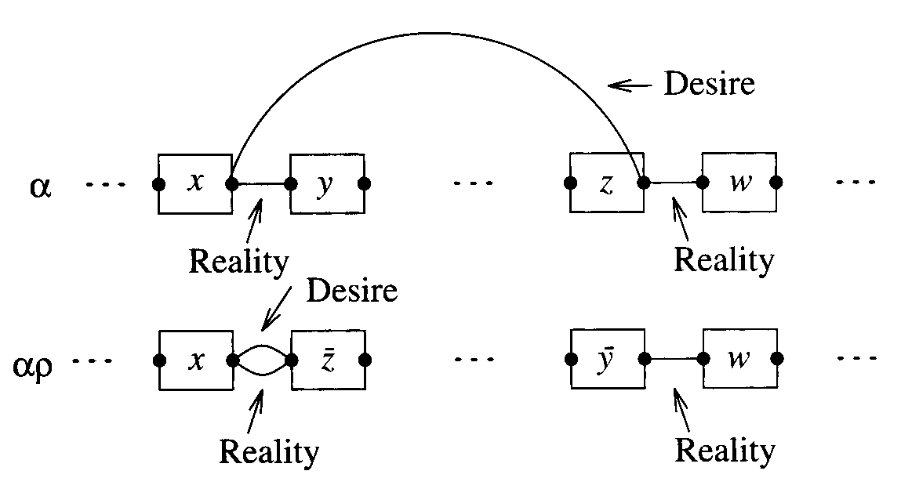

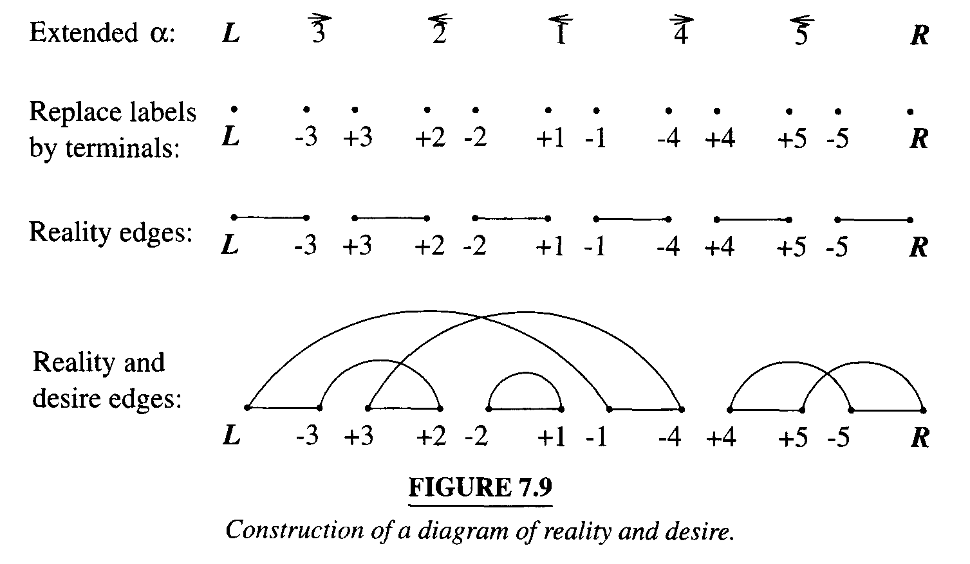
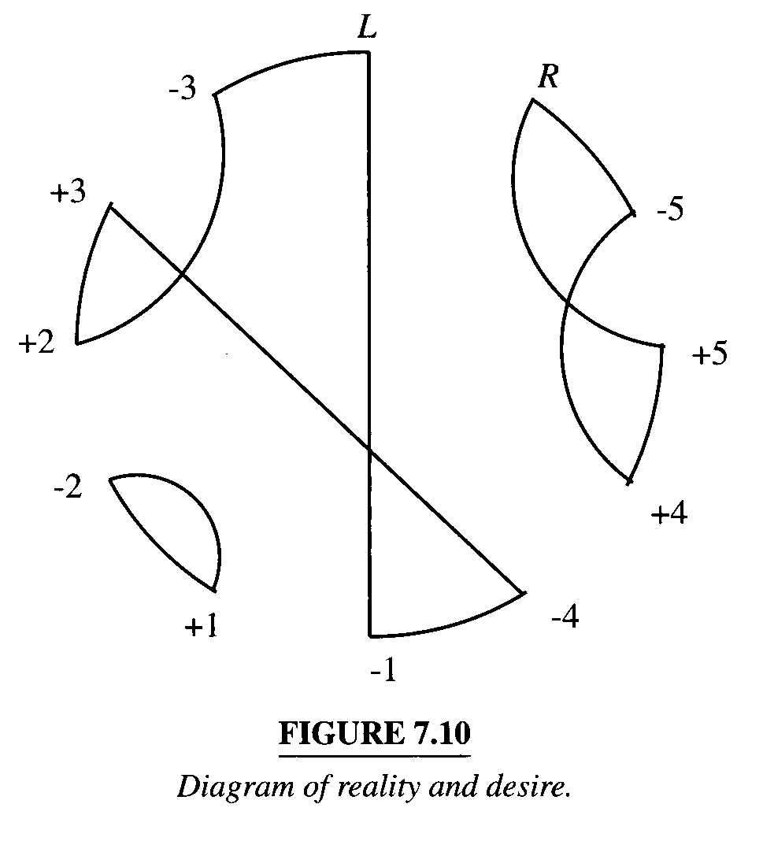
Theorem 7.1 Let (s,t) and (u,v) be two reality edges characterizing a reversal p, with (s,t) preceding (u,v) in the permutation α. Then RD(αp) differs from RD(α) as follows.
- Reality edges (s,t) and (u,v) are replaced by (s,u) and (t,v).
- Desire edges remain nchanged.
- The section of the circle going from node t to node u,including these extremities, in counterclockwise direction,is reversed.

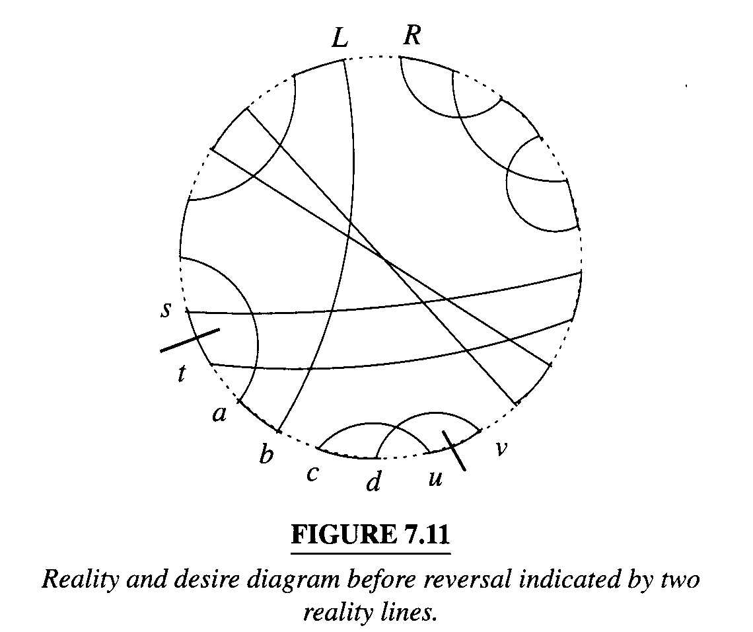

Theorem 7.2 Let p be a reversal action on two reality edges e and f of RD(αp). Then
- If e and f belong to different cycles,c(αp) = c(α) – 1.
- If e and f belong to the same cycle and converge,then c(αp) = c(α).
- If e and f belong to the same cycle and diverge,then c(αp) = c(α) + 1.

Another better low bound: The number of cycles changes by at most one with each reversal. This leads to another lower bound for the reversal distance.
Suppose that a series of reversals p₁,p₂,…,p_{t} take α to β, that is,

αp₁p₂…p_{t} = β
Computing the number of cycles, we get

c(αp₁p₂…p_{t}) = c(β) = n + 1

One the other hand, by Theorem 7.2, we have
c(αp₁) – c(α) <= 1
c(αp₁p₂…p_{t}) – c(αp₁) <= 1
…
c(αp₁p₂…p_{t}) – c(αp₁p₂…p_{t-1}) <= 1

Adding all this up and canceling terms, we get
n + 1 – c(α) <= t
If p₁,p₂,…,p_{t} is an optimal sorting, then t = d(α)
n + 1 – c(α) <= d(α)
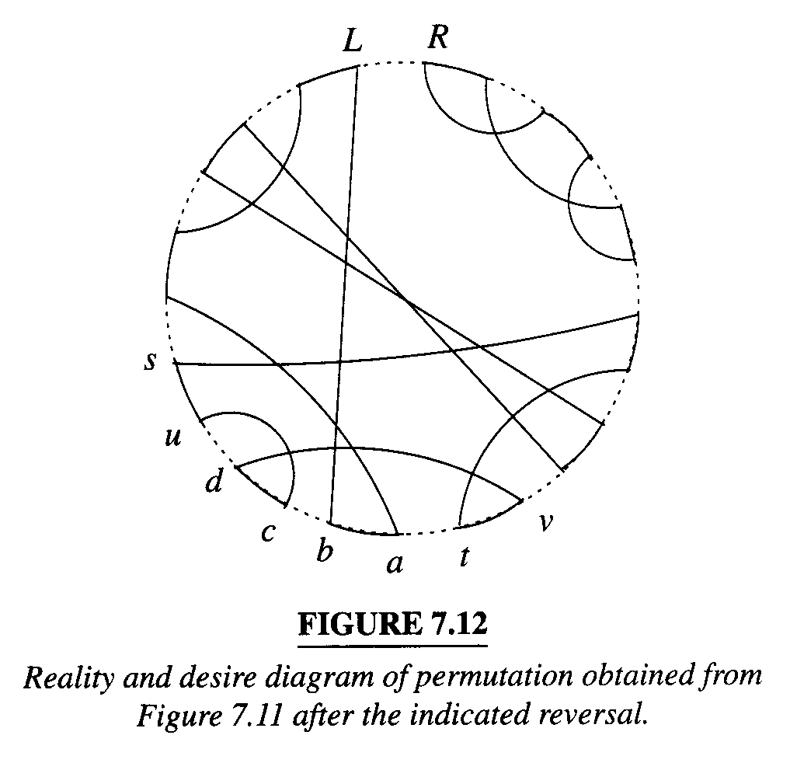
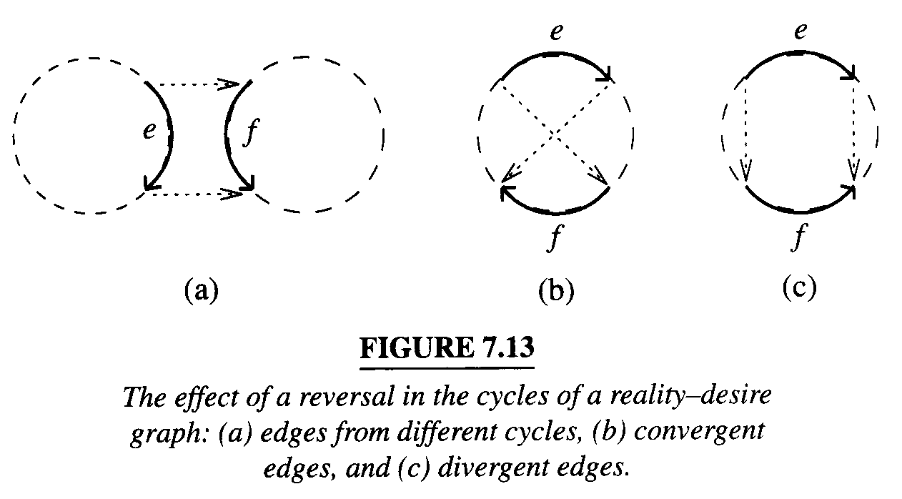

INTERLEAVING GRAPH
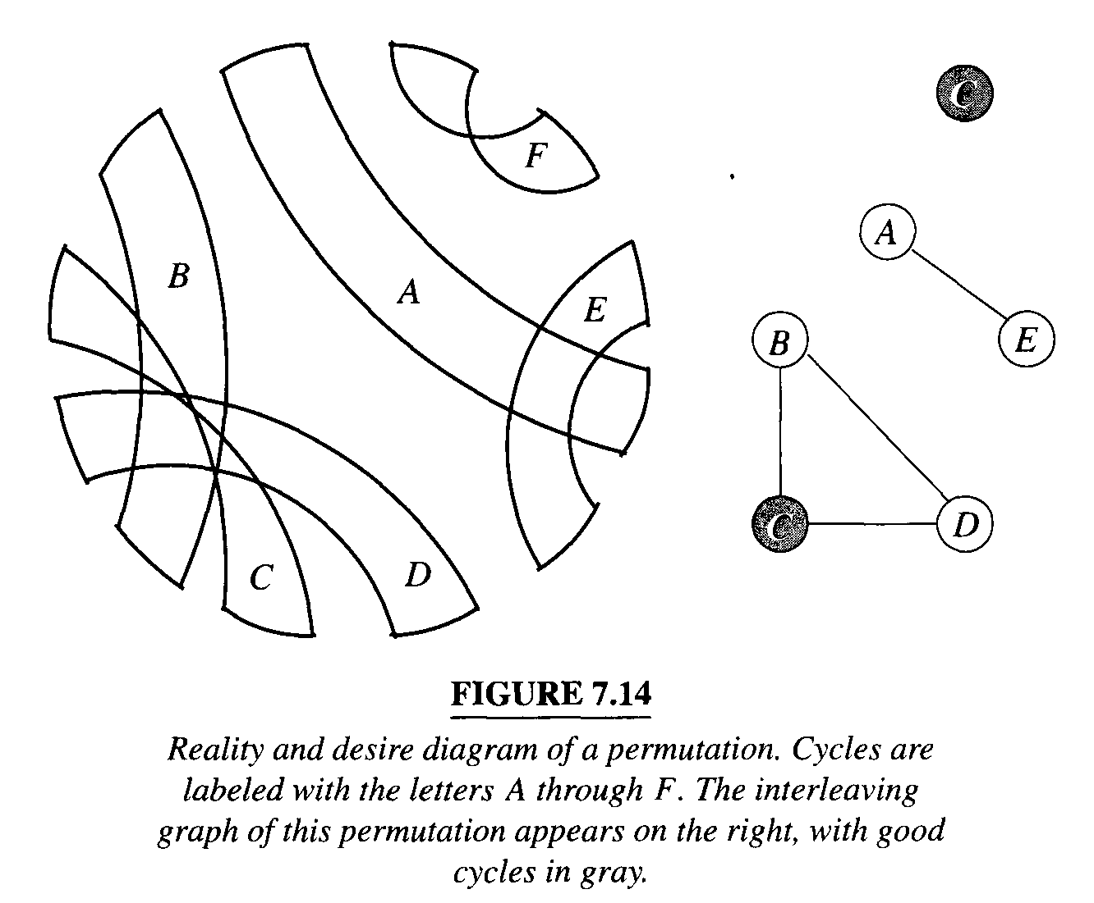
A cycle is good if it has two divergent reality edges;
Otherwise it is called bad.

B separates componets A and C if all chords in RD(α) that link a terminal in A to a terminal in C cross a desire edge of B.

A hurdle is a bad component that does not separate any other two bad components.If a bad component separates others, then it is a nonhurdle.

We say that a hurdle A protects a nonhurdle B when removal of A would cause B to become a hurdle.

A hurdle A is called a super hurdle if it protects some nonhurdle B. Otherwise it is called a simple hurdle.
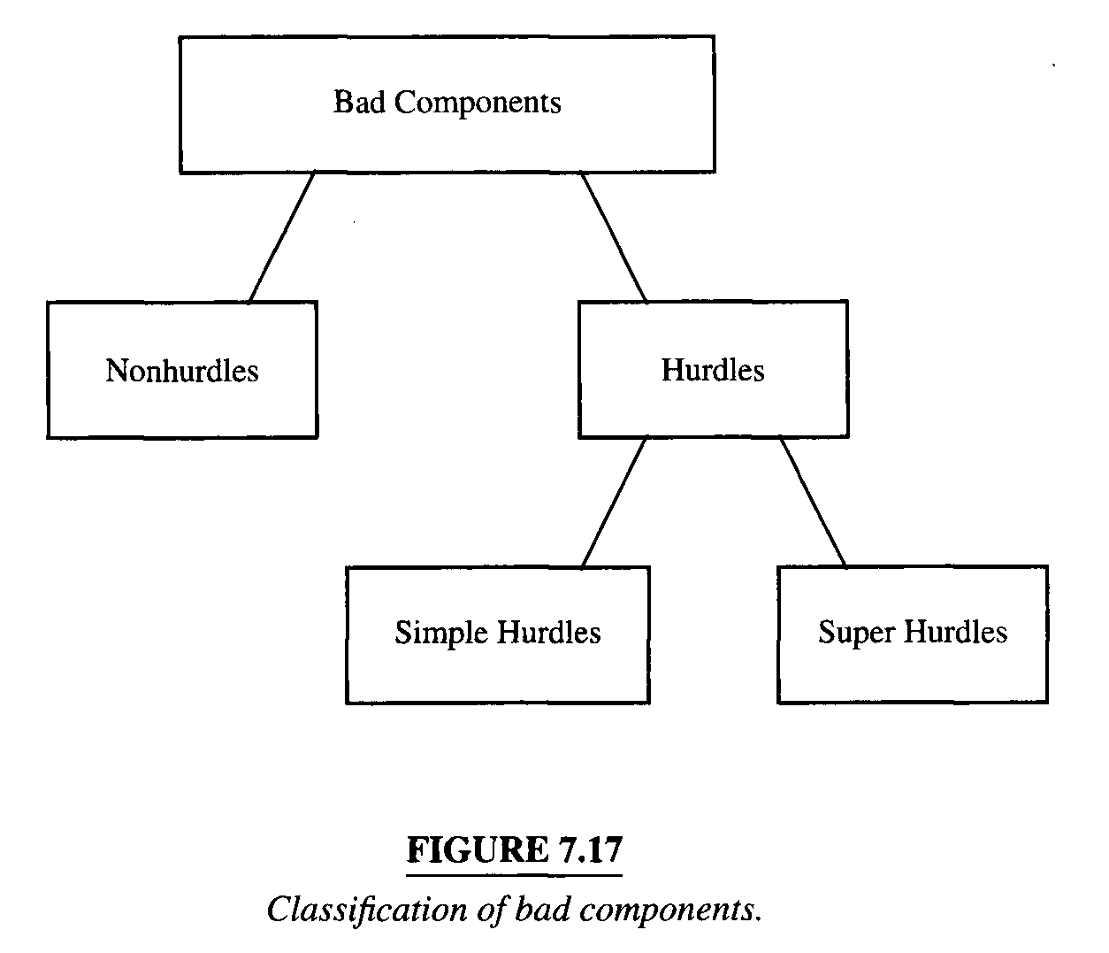
A permutation α is called a fortress when its reality and desire diagram contains an odd number of hurdles and all of them are super hurdles. 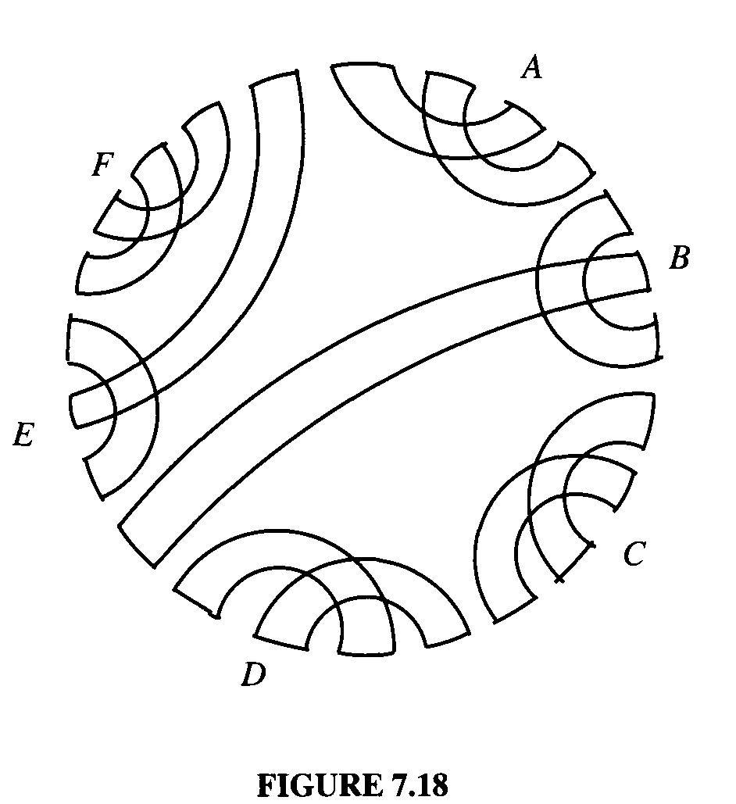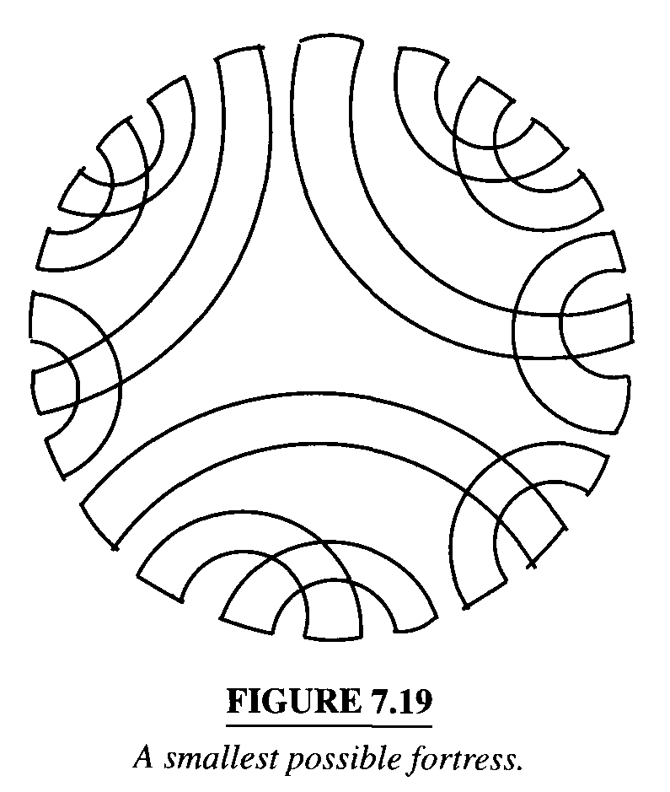
d(α) = n + 1 – c(α) + h(α) + f(α)
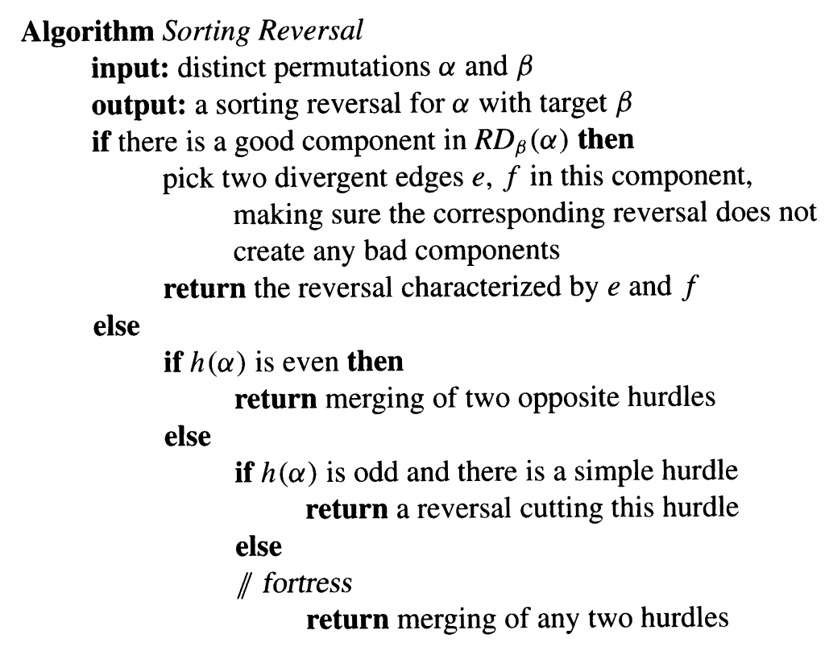
7.3 UNORIENTED BLOCKS
