GENOME REARANGEMENTS
SETUBAL/MEIDANIS
Introduction to Computational Molecular Biology
7.2 ORIENTED BLOCKS
Theorem 7.3 A reversal characterized by two divergent edges of the same cycle is a sorting reversal if and only if its application does not lead to the creation of bad components.
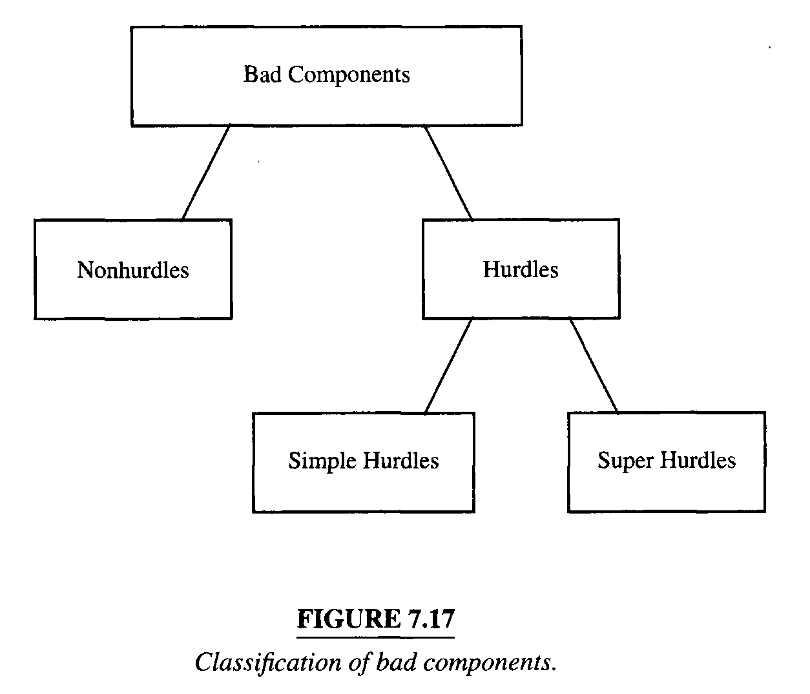
A component B separates components A and C if all chords in RD(α) that link a terminal in A to a terminal in C cross a desire edge of B.
A hurdle is a bad component that does not separate any other two bad components. If a bad component separates others,then it is a nonhurdle.

We say a hurdle A protects a nonhurdle B when removal of A would cause B to become a hurdle.
A hurdle A is called a super hurdle if it protects some nonhurdle B.Otherwise it is called a simple hurdle.Notice that a hurdle can protect at most one nonhurdle.
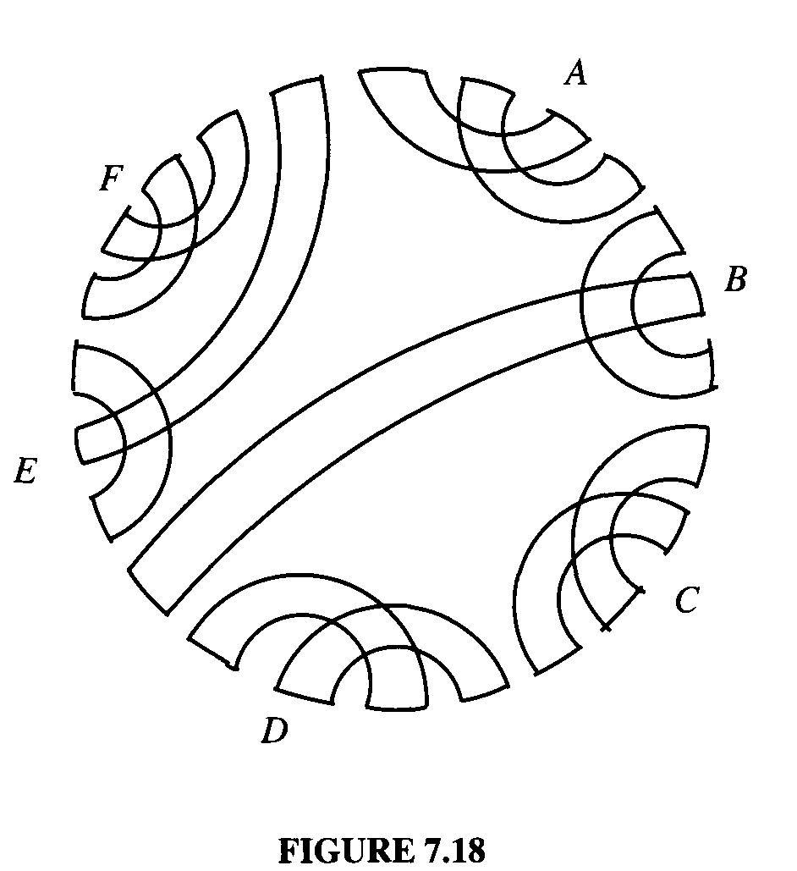
d(α) = n + 1 – c(α) + h(α) + f(α)
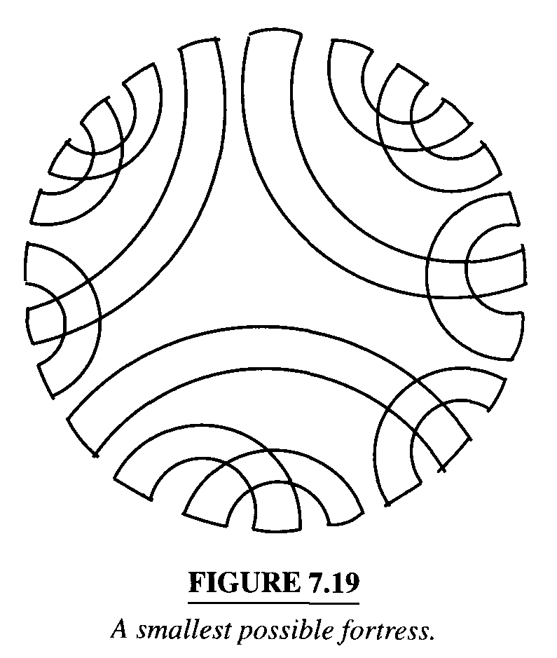
A permutation α is called a fortress when its reality and desire diagram contains an odd number of hurdles and all of them are super hurdles.

A reversal characterized by reality edges of different hurdles is called a hurdle merging.
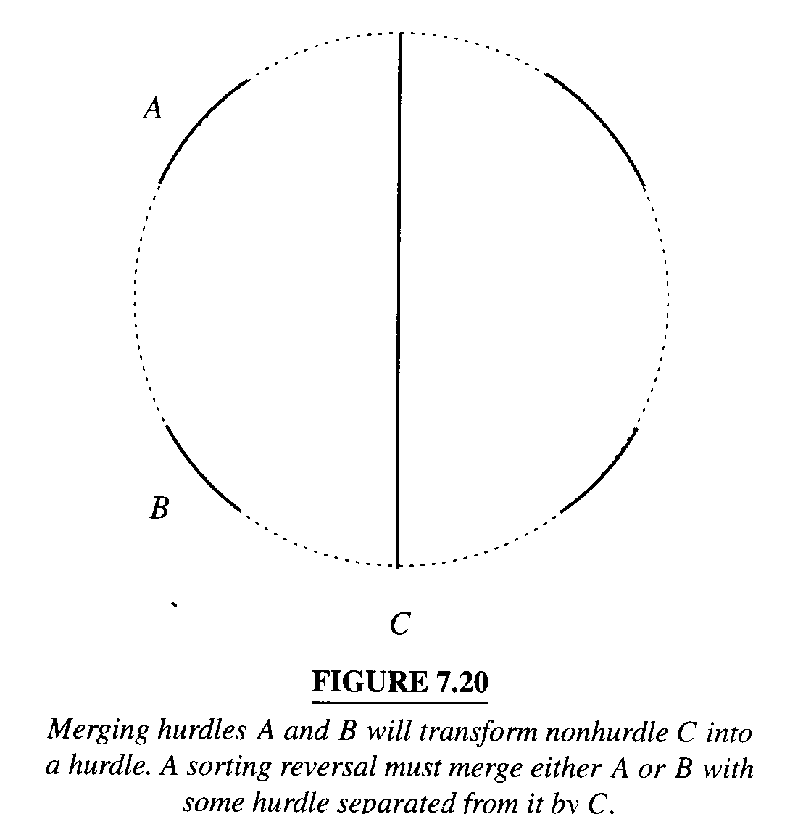
We call two hurdles A and B oppsite when we find the same number of hurdles when walking around the circle counterclockwise from A to B as we find walking from B to A counterclockwise.
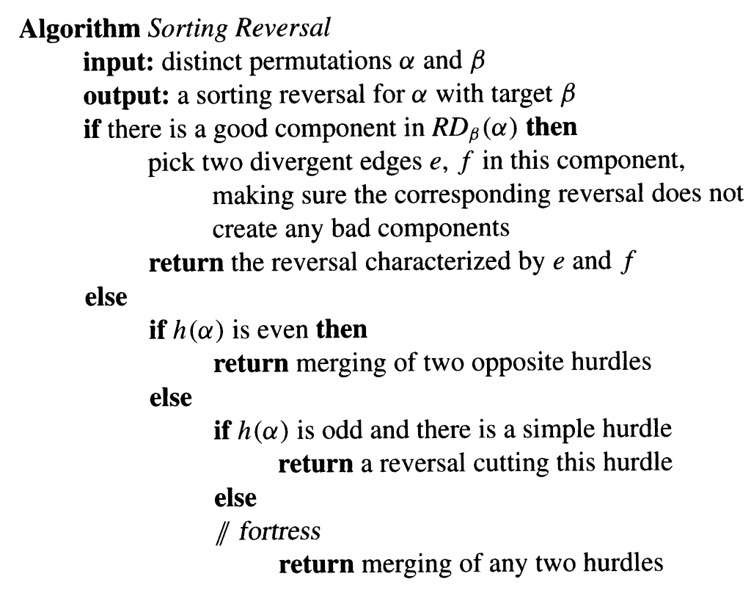

7.3 UNORIENTED BLOCKS
A sequence of consecutive labels surrounded by breakpoints buy with no internal breakpoints is called a strip.
L 1 2．8 7．3．5 6．4．R
Theorem 7.4 If label k belongs to a decreasing strip and k-1 belongs to an increasing strip, then there is a reversal that removes at least one breakpoint.

Theorem 7.5 If label k belongs to a decreasing strip and k+1 belongs to an increasing strip, then there is a reversal that removes at least one breakpoint.

Theorem 7.6 Let α be a permutation with a decreasing strip. If all reversals that remove breakpoints from α leave no decreasing strips, then there is a reversal that removes two breakpoints from α.

