★★★☆☆
題組：Problem Set Archive with Online Judge
題號：10007: Count the Trees
解題者：黃建廷
解題日期：2022年05月19日
題意：
有n個node的binary tree，請問有此tree有幾種排列組合方式？
題意範例：
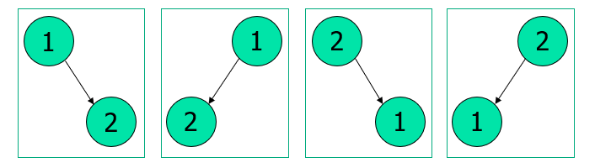
Input 2:
Output: 4

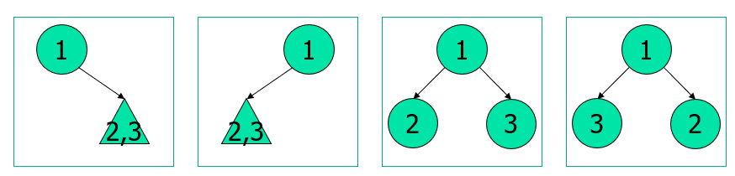
Input: 3
Output: 30
解法：
將問題分解為二：
(1) 不管node之編號，單純算n個node可有幾種tree之排列
Dynamic Programming
大數加法/乘法
(2) 將node之編號帶入各個tree的排列
排列組合：n!
大數乘法
(3) 將(1)與(2)相乘
若有範例，則列出。若沒有，則填寫「無」。
解法範例：
Input: 2 - (1)
tree有幾種排列：
1個root node
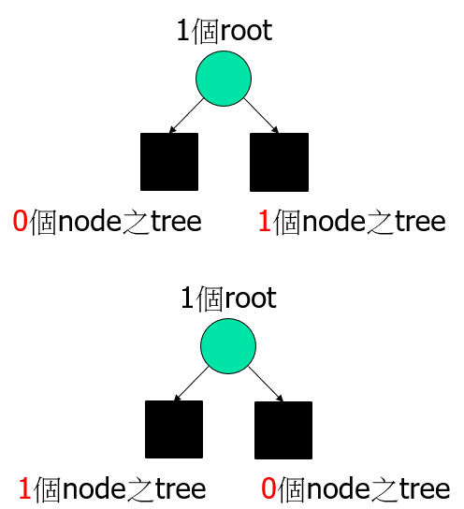
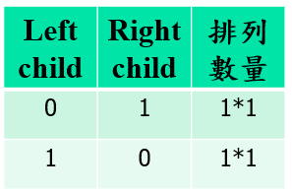
1個other node
Tree之排列：2

Input: 2 - (2)
將編號填入tree中
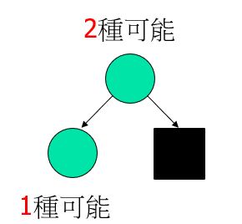
每一種tree之排列數：2!
Output: 2 * 2! = 4

Input: 3 - (1)
tree有幾種排列：
1個root node
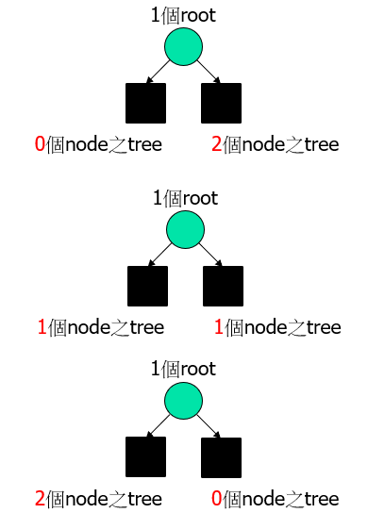
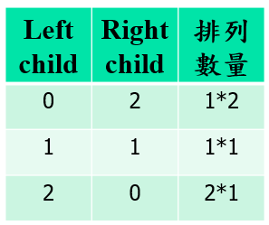
2個other node
Tree之排列：5

Input: 3 - (2)
將編號填入tree中
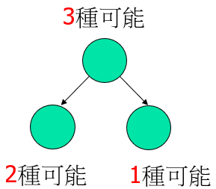
每一種tree之排列數：3!
Output: 5 * 3! = 30
討論：
(1) 將計算過之 n! 值儲存，可提升下筆輸入之運算速度
(2) 大數乘法時，需注意可能是兩個大數之相乘
程式：
#include <iostream>
#include <cstring>
#include <cstdlib>
#include <vector>
#include <fstream>
//#define TEST

using namespace std;

typedef struct NODE{
vector<char> tree;
vector<char> fact;
}NODE;

void init();
void print(vector<char> str);
void tree_count(short int n);
void fact_count(short int n);
void add(vector<char>& d, vector<char> s);
vector<char> multiply(vector<char> a, vector<char> b);

NODE record[301];

ofstream file;

int main(void)
{
short int choice = 0;
vector<char> result;

#ifdef TEST
file.open("file.txt", ios::out | ios::trunc ); //why cannot put in global
#endif

init();

do{
cin >> choice;
if(!choice) continue;

tree_count(choice);
//cout << "tree:"; print(record[choice].tree); cout << "---------\n";

fact_count(choice);
//cout << "fact:"; print(record[choice].fact); cout << "---------\n";

result = multiply(record[choice].tree, record[choice].fact);
print(result);

}while(choice);

return 0;
}

void init()
{
record[0].tree.push_back('1');
record[0].fact.push_back('1');

return;
}

void print(vector<char> str)
{
for(int i = str.size()-1; i >= 0; i--){
#ifndef TEST
cout << str[i];
#endif
#ifdef TEST
file << str[i];
#endif
}
#ifndef TEST
cout << endl;
#endif
#ifdef TEST
file << endl;
#endif

return;
}

void tree_count(short int n)
{
if(!record[n].tree.empty()) return;

vector<char> temp;
for(short int i = 0; i < n>>1; i++){ //i.e., i < (n-1)/2 +(n-1)%2
tree_count(i);
tree_count(n-1-i);

add(record[n].tree, multiply(record[i].tree, record[n-1-i].tree) ); //may have problem
//cout << __LINE__ << ":"; print(record[n].tree); //
}
vector<char> multiplicand(1, '2');
record[n].tree = multiply(record[n].tree, multiplicand);
//cout << __LINE__ << ":"; print(record[n].tree); //

if(n%2){
tree_count(n>>1);
temp = multiply(record[n>>1].tree, record[n>>1].tree);
//cout << __LINE__ << ":"; print(temp); //
add(record[n].tree, temp);
//cout << __LINE__ << ":"; print(record[n].tree); //
temp.clear();
//add(record[n].tree, multiply(record[n>>1].tree, record[n>>1].tree) ); //may have problem
}

return;
}

void fact_count(short int n)
{
if(!record[n].fact.empty()) return;

fact_count(n-1);

vector<char> multiplicand;
short int t = n;
while(t){
multiplicand.push_back('0' + (t%10));
t /= 10;
}

record[n].fact = multiply(record[n-1].fact, multiplicand);

return;
}

void add(vector<char>& d, vector<char> s) //add s to d, do not allocate
{
//cout << "d.capacity: " << d.capacity() << endl << "s.capacity: " << s.capacity() << endl;

if(d.size() < s.size()){
for(int i = d.size(); i < s.size(); i++) d.push_back('0');
}
else if(d.size() > s.size()){
for(int i = s.size(); i < d.size(); i++) s.push_back('0');
}
//cout << "d.capacity: " << d.capacity() << endl << "s.capacity: " << s.capacity() << endl;

char carry = 0, temp = 0;
for(short int i = 0; i < d.size(); i++){
temp = d[i] + s[i] - 2*'0' + carry;
carry = temp/10;
d[i] = '0' + (temp%10);
}
if(carry) d.push_back('0' + carry);
//cout << "d.capacity: " << d.capacity() << endl << "s.capacity: " << s.capacity() << endl;

return;
}

vector<char> multiply(vector<char> a, vector<char> b) //returning muliple of a and b, allocate
{
vector<short int> temp; //may need int
vector<char> result;
temp.assign(a.size() + b.size(), 0);
result.assign(a.size() + b.size() - 1, '0');

for(int i = 0; i < a.size(); i++){
for(int j = 0; j < b.size(); j++){
temp[i+j] += (a[i]-'0') * (b[j]-'0'); //add comparison with 0 to speedup?
}
}

short int carry = 0;
for(int i = 0; i < temp.size() - 1; i++){
temp[i] += carry;
result[i] = '0' + (temp[i]%10);
carry = temp[i]/10;
}
if(carry) result.push_back('0' + carry);
//cout << "result.capacity: " << result.capacity() << endl;
temp.clear();

return result;
}

