The CFS and ED Data Distribution Schemes for Sparse Arrays on Distributed Memory Multicomputers¹

Chun-Yuan Lin, Yeh-Ching Chung², and Jen-Shiuh Liu

Department of Information Engineering
Feng Chia University, Taichung, Taiwan 407, ROC
Tel: 886-4-24517250 x3765
Fax: 886-4-24516101
Email: {cylin, ychung, liuj}@iecs.fcu.edu.tw

Abstract
A data distribution scheme of sparse arrays on a distributed memory multicomputer, in general, is composed of three phases, data partition, data distribution, and data compression. In the data partition phase, a global sparse array is partitioned into some local sparse arrays. In the data distribution phase, these local sparse arrays are distributed to processors. In the data compression phase, a local sparse array is compressed by some data compression methods in order to obtain better performance for sparse array operations. To implement the data distribution scheme, methods proposed in the literature first perform the data partition phase, then the data distribution phase, followed by the data compression phase. We called this scheme as Send Followed Compress (SFC) scheme. In this paper, we propose two other data distribution schemes, Compress Followed Send (CFS) and Encoding-Decoding (ED), for sparse array distribution. In the CFS scheme, the data compression phase is performed before the data distribution phase. In the ED scheme, the data compression phase can be divided into two steps, encoding and decoding. The encoding step and the decoding step are performed before and after the data distribution phase, respectively. To evaluate the CFS and the ED schemes, we compare them with the SFC scheme. In theoretical analysis, we analyze the SFC, the CFS, and the ED schemes in terms of the data distribution time and the data compression time. In experimental test, for all test cases, we implemented these schemes on an IBM SP2 parallel machine. From the experimental results, the CFS and the ED schemes outperform the SFC scheme for all test cases. For the CFS and the ED schemes, the ED scheme outperforms the CFS scheme.

Index Terms－Data distribution schemes, Data compression methods, Partition methods, Sparse ratio, Distributed memory multicomputers

1. The work of this paper was partially supported by NSC under contract NSC90-2213-E-035-019
2. The corresponding author.
1. Introduction
Array operations are useful in a large number of important scientific codes, such as molecular dynamics [16], finite-element methods [23], climate modeling [40], etc. A data distribution scheme of sparse arrays on a distributed memory multicomputer, in general, is composed of three phases, data partition, data distribution, and data compression. In the data partition phase, a global sparse array is partitioned into some local sparse arrays. In the data distribution phase, these local sparse arrays are distributed to processors. In the data compression phase, a local sparse array is compressed by some data compression methods in order to obtain better performance for sparse array operations.
To implement the data distribution scheme, many methods have been proposed in the literature [2, 10-14, 37-42, 45]. Among them, the Multiple Recursive Decomposition (MRD) scheme [2, 42] have been popularly used to solve other important issues for sparse array problems [2-7, 10-14, 19-22, 37-42, 45]. In the data partition phase, the MRD scheme uses a 2D mesh partition with load-balancing method that is similar to (Block, Block) data distribution schemes used in Fortran 90 [1]. In the data distribution phase, both methods send local sparse arrays to processors. In the data compression phase, both methods use either the Compressed Column Storage (CCS) scheme [8] or the Compressed Row Storage (CRS) scheme [8] to compress the local sparse array in each processor.
For methods mentioned above, the three phases of the data distribution scheme are performed in the following order, the data partition phase, then the data distribution phase, followed by the data compression phase. A data distribution scheme with this order is called the Send Followed Compress (SFC) scheme. In this paper, we propose two data distribution schemes, Compress Followed Send (CFS) and Encoding-Decoding (ED), for sparse array distribution. In the CFS scheme, the data compression phase is performed before the data distribution phase. The three phases in the CFS scheme are performed in the following order, the data partition phase, then data compression phase, followed by the data distribution phase. The ED is a novel concept in which the data compression phase can be divided into two steps, encoding and decoding. The encoding step and the decoding step are performed before and after the data distribution phase, respectively. In encoding step, we encode information of nonzero array elements into a special buffer for each local sparse array. In decoding step, the special buffer is decoded into a compressed local sparse array. For the ED scheme, the data partition phase is performed first, then the encoding step, followed by the data distribution phase and the decoding step.
To evaluate the CFS and the ED schemes, we compare them with the SFC scheme. In the data partition phase, the 2D mesh partition with load-balancing method is used for these three schemes. In the data distribution phase, local sparse arrays, whether compressed or not, are sent to processors in sequence. In the compression phase, the CRS/CCS methods are used to compress sparse local arrays for the SFC and the CFS schemes while the encoding/decoding step is used for the ED scheme. Based on the methods used in the three phases, both theoretical analysis and experimental test were conducted. In theoretical analysis, we analyze the SFC, the CFS, and the ED schemes in terms of the data distribution time and the data compression time. Here, we do not consider the data partition time since the comparisons of the data distribution time and the data compression time of these three schemes are based on the same partition methods. In experimental test, we implemented the SFC, the CFS, and the ED schemes on an IBM SP2 parallel machine. From the experimental results, for all test cases, the CFS and the ED schemes outperform the SFC scheme. The reason is that we do not send entire local sparse arrays to processors in the CFS and the ED schemes. The data distribution time can be reduced. For the CFS and the ED schemes, the ED scheme outperforms the CFS scheme for all test cases. The reason is that, for the ED scheme, the data distribution time is less than that of the CFS scheme.
This paper is organized as follows. In Section 2, a brief survey of related work will be presented. Section 3 will describe the SFC, the CFS, and the ED schemes in detail. Section 4 will analyze the theoretical performance for the SFC, the CFS, and the ED schemes based on the 2D mesh partition with load-balancing method. The experimental results of these three schemes will be given in Section 5.

2. Related Work
Many methods have been proposed in the literature to implement the data distribution scheme [2, 10-14, 37-42, 45]. Zapata et al. [2, 42] have proposed a distribution scheme, MRD, for two-dimensional sparse arrays. Based on the MRD scheme, they solve other important problems based on sparse arrays [2-4, 6-7, 37-42, 44]. The MRD scheme can be considered as a generalization of the Binary Recursive Decomposition [9], a well-known data distribution scheme. For the MRD scheme, each processor has the same number of nonzero array elements, yet each processor has different size of local sparse array. The data compression time is determined by a processor, which has largest size of local sparse array. The data compression time for the MRD scheme will be large when nonzero array elements were in a part of a global sparse array. The reason is that, for the MRD scheme, there exists at least one processor whose local sparse array has the size similar to that of the global sparse array. Therefore, the data compression time for the MRD will be large in this situation.
Ziantz et al. [45] proposed a run-time optimization technique that was applied to sparse arrays compressed by the CRS/CCS methods for array distribution and off-processor data fetching to reduce both the communication and computation time. They used the block data distribution scheme with a bin-packing algorithm. The block data distribution scheme with a bin-packing algorithm belongs to the SFC scheme.
Lee et al. [10-14] presented an efficient library for parallel sparse computations with Fortran 90 array intrinsic operations. They provide a new data compression method, which is based on the CRS/CCS methods for two-dimensional sparse arrays, for multi-dimensional sparse arrays. Based on the MRD scheme, they also provide a new data distribution scheme for multi-dimensional sparse arrays. Their scheme is similar to (*, …, Block, Block) data distribution scheme used in Fortran 90. Their approach is promising in speeding up sparse array computations using array intrinsic functions on both sequential and distributed memory environments.

3. The SFC, CFS and ED Schemes
In the following, we describe the SFC, the CFS, and the ED schemes in detail. We assume that a two-dimensional global sparse array is given.

3.1 The SFC Scheme
The SFC is an intuitive data distribution scheme. In the SFC scheme, the data partition phase is performed first, then the data distribution phase, followed by the data compression phase.
In the data partition phase, a global sparse array is partitioned into local sparse arrays by some partition methods. In this paper, the 2D mesh partition with load-balancing method is used to partition a global sparse array. The 2D mesh partition with load-balancing method tries to partition a global sparse array into some local sparse arrays such that each local sparse array has the same number of nonzero array elements. The details can be found in [2, 42]. Assume that an 8×10 sparse array A with 16 nonzero array elements (Figure 1) and four processors are given. The partition result for the sparse array A by using the 2D mesh partition with load-balancing method is shown in Figure 2. For the 2D mesh partition with load-balancing method, the four processors are treated as a 2×2 processor array.
In the data distribution phase, local sparse arrays are packed and sent to processors in sequence. Figure 3 shows the corresponding local sparse arrays received by each processor for the partition result shown in Figure 2.

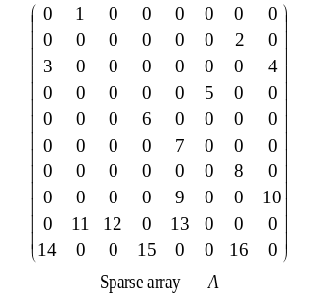
Figure 1: An 8×10 sparse array A with 16 nonzero array elements.

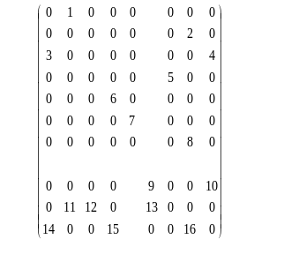
Figure 2: The partition result for the sparse array A by using the 2D mesh partition with load-balancing method.

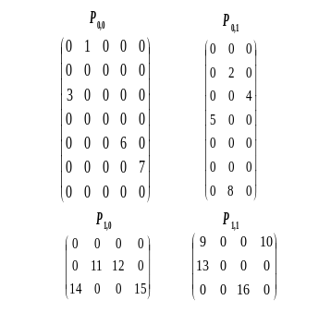
Figure 3: The corresponding local sparse arrays received by each processor for the partition result shown in Figure 2.

In the data compression phase, a local sparse array in each processor is compressed by a data compression method. In this paper, the CRS and the CCS methods are used to compress sparse local arrays for the SFC and CFS schemes. The CRS (CCS) method uses two one-dimensional integer arrays, RO and CO, and one one-dimensional floating-point array, VL, to compress all of nonzero array elements along the rows (columns for CCS) of the sparse array. Array RO stores information of nonzero array elements of each row (column for CCS). The number of nonzero array elements in the ith row (jth column for CCS) can be obtained by subtracting the value of RO[i] from RO[i+1]. Array CO stores the column (row for CCS) indices of nonzero array elements of each row (column for CCS). Array VL stores the values of nonzero array elements of the sparse array. The base of these three arrays is 0. Figure 4 show the compressed results by using the CRS method for the received local sparse arrays shown in Figure 3.

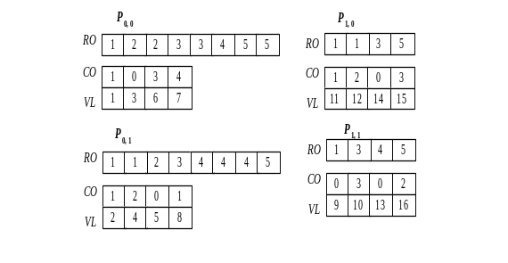
Figure 4: The compressed results by using the CRS method for the received local sparse arrays shown in Figure 3.

3.2 The CFS Scheme
The CFS scheme is similar to the SFC scheme except that the data compression phase is performed before the data distribution phase. In the data partition phase, the 2D mesh partition with load-balancing method mentioned in the SFC scheme is used to partition a global sparse array. In the data compression phase, the CRS/CCS methods are used to compress local sparse arrays. In the compression, the values stored in CO are global array indices. In the data distribution phase, RO, CO, and VL for each local sparse array are packed and sent to its corresponding processor. After received the corresponding packed buffer, each processor unpacks the buffer to the corresponding RO, CO, and VL. Since the values stored in CO are global array indices in the compression phase, when unpack the received buffer, the values stored in CO may need to be converted to local array indices. We have the following case.
Case 3.2.1: When the 2D mesh partition with load-balancing method and the CRS (CCS) method is used in the data partition phase and the data compression phase, respectively, each processor P_{i,j} converts the values stored in CO of the received buffer to the corresponding local array indices by subtracting M from each value stored in CO of the received buffer, where M is the total number of columns (rows for CCS) in P_{i,0}, P_{i,1}, …, P_{i,j-1} (P_{0,j}, P_{1,j}, …, P_{i-1,j} for CCS).

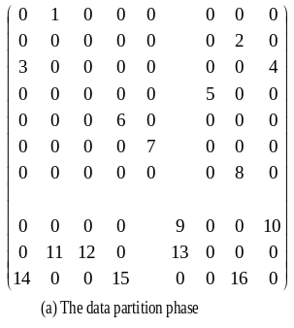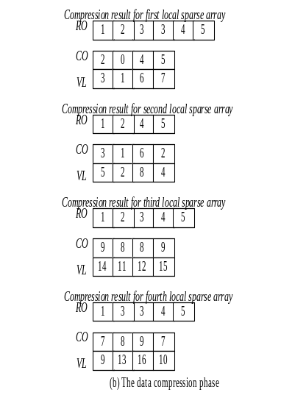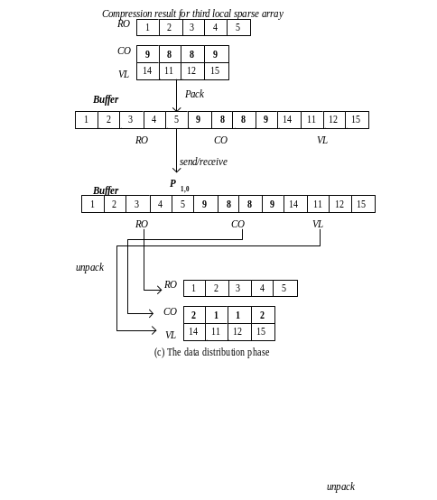
Figure 5: An example of the CFS scheme.

An example of the CFS scheme is given in Figure 5 in which the 2D mesh partition with load-balancing method is used in the data partition phase and the CCS method is used in the data compression phase.
Figure 5(a) shows the partition result for the sparse array A (Figure 1) by using the 2D mesh partition with load-balancing method. Figure 5(b) shows the compressed results by using the CCS method for local sparse arrays shown in Figure 5(a). In Figure 5(b), the values stored in CO are global indices of global sparse array A, not local indices of a local sparse array. Figure 5(c) only shows the data distribution phase for P_{1,0}. In Figure 5(c), RO, CO, and VL for the first local sparse array are packed into a buffer and sent to P_{1,0}. After receiving the buffer, P_{1,0} unpacks the received buffer to the corresponding RO, CO, and VL. According to Case 3.2.1 described above, P_{1,0} converts the values stored in CO of the received buffer to the corresponding local array indices by subtracting 7 from each value stored in CO of the received buffer. For P_{0,0}, P_{0,1}, and P_{1,1}, the packing, send/receive, and unpacking procedures are similar to that of P_{1,0}.

3.3 The ED Scheme
The ED is a novel concept in which the data compression phase can be divided into two steps, encoding and decoding. The encoding step and the decoding step are performed before and after the data distribution phase, respectively. In the ED scheme, the data partition phase is performed first, then the encoding step, followed by the data distribution phase and the decoding step.
In the data partition phase, the 2D mesh partition with load-balancing method mentioned in the SFC scheme is used to partition a global sparse array. In the encoding step, each local sparse array is encoded into a special buffer B. Figure 6 shows the formats of the special buffer B for the CRS/CCS methods. In Figure 6, for the CRS (CCS) method, the R_{i} is used to store the number of nonzero array elements in a row (column for CCS) i. The C_{i,j} and V_{i,j} are used to store the column (row for CCS) index and the value of the jth nonzero array element in a row (column for CCS) i, respectively. The C_{i,j} and V_{i,j} are alternately stored in the buffer B and each C_{i,j} is a global index of the global sparse array.

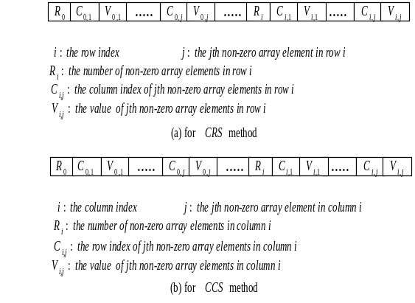
Figure 6: The formats of the special buffer B.

In the data distribution phase, these special buffers are sent to processors in sequence. In the decoding step, the special buffer B is decoded to get RO, CO, and VL in each processor. To get RO, in each processor, RO[0] is first initialized to 1. Then other values of RO are computed according to the formula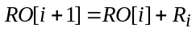, where i = 0, 1, …, n and n is the number of rows in a local sparse array. To get CO, in each processor, we move C_{0,0}, C_{0,1} , …, C_{0,j}, C_{1,0}, C_{1,1}, …, C_{1,j}, …, C_{i,0}, C_{i,1}, …, C_{i,j} stored in the special buffer to CO, where i = 0, 1, …, n, j = 0, 1, …,m, n is the number of rows of the local sparse array of a processor, and m is the number of nonzero array elements in row i. To get VL, we move all V_{i,j} to VL in a similar manner as that of getting CO. Since each C_{i,j} is a global array index in the encoding step, to decode the received special buffer in the decoding step, each C_{i,j} may need to be converted to a local array index. We have the following case.
Case 3.3.1: When the 2D mesh partition with load-balancing method and the CRS (CCS) method are used in the data partition phase and the data compression phase, respectively, each processor P_{i,j} converts each C_{i,j} of the received special buffer to the corresponding local array index by subtracting M from each C_{i,j} of the received special buffer, where M is the total number of columns (rows for CCS) in P_{i,0}, P_{i,1}, …, P_{i,j-1} (P_{0,j}, P_{1,j}, …, P_{i-1,j} for CCS).
An example of the ED scheme is given in Figure 7 in which the 2D mesh partition with load-balancing method is used in the data partition phase and the local sparse arrays are in CCS format. Figure 7(a) shows the partition result for the sparse array A (Figure 1) by using the 2D mesh partition with load-balancing method. Figure 7(b) shows the special buffers for local sparse arrays shown in Figure 7(a). In Figure 7(b), each C_{i,j} is a global index of global sparse array A. Figure 7(c) shows the special buffers received by each processor. Figure 7(d) only shows the decoding step for P_{1,0}. After receiving the special buffer, to get RO, RO[0] is first set to 1. Then other values of RO are computed according to the formula, where i = 0, 1, and 2. To get CO, we move C_{0,0}, C_{1,0}, C_{2,0}, and C_{3,0} stored in the special buffer to CO. According to Case 3.3.1 described above, P_{1,0} subtracts 7 from C_{0,0}, C_{1,0}, C_{2,0},and C_{3,0} of the received special buffer to convert them to the desired local array indices. To get VL, we move V_{0,0}, V_{1,0}, V_{2,0}, and V_{3,0} stored in the special buffer to VL. For P_{0,0}, P_{0,1}, and P_{1,1}, the decoding step is similar to that of P_{1,0}.

4. Theoretical Analysis
In this section, we analyze the SFC, the CFS, and the ED schemes for two-dimensional sparse arrays in terms of the data distribution time and the data compression time. Here, we do not consider the data partition time since the comparisons of the data distribution time and the data compression time of these three schemes are based on the same partition methods. In the data partition phase, the 2D mesh partition with load-balancing method is used for these three schemes. In the compression phase, the CRS/CCS methods are used to compress sparse local arrays for the SFC and the CFS schemes while the encoding/decoding step is used for the ED scheme. In the following, we list the notations used in the theoretical analysis.

- T_{Startup} is the startup time for a communication channel.
- T_{Data} is the transmission time for sending an array element through a communication channel.
- T_{Operation} is the operation time for an array element. In order to simplify the analysis, we use T_{Operation} to present any operation cost for an array element, such as memory access, addition or subtraction operations, etc.
- T_{Distribution} is the data distribution time for the data distribution phase. The data distribution time includes the packing/unpacking time and send/receive time.
- T_{Compression} is the data compression time for the data compression phase. For the ED scheme, the data compression time is the sum of the encoding time and the decoding time in the encoding and the decoding steps, respectively.
- A is an n×n global sparse array.
- p is the number of processors.
- s is the sparse ratio of A.

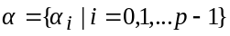 is the set of sparse ratios for each local sparse array. The space ratio for a local sparse array is the size of a local sparse array divided by the size of the global sparse array A. The largest space ratio in α is denoted as 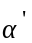. The dimension of the largest local sparse array is r'×q' = 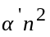.

4.1 The 2D Mesh Partition with Load-Balancing Method
Assume that A and p = r×q processors are given. The number of nonzero array elements in A is sn².

4.1.1 The CRS method
A. The SFC scheme
For the SFC scheme, the 2D mesh partition with load-balancing method partition A into r×q local sparse arrays and the number of nonzero array elements for each local sparse array is sn²/r×q. In the data distribution phase, local sparse arrays are sent to processors. For a two-dimensional spare array in the 2D mesh partition with load-balancing method, array elements in a local sparse array are not continuous. Therefore, local sparse arrays are sent to processors after packing into buffers. The data distribution time T_{Distribution} is (r×q×T_{Startup} + n²×T_{Data} + n²×T_{Operation}) that is determined by the size of a global sparse array. In the data compression phase, local sparse arrays are compressed by the CRS method. Therefore, the data compression time T_{Compression} is ((n²×(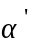+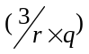s))×T_{Operation}) that is determined by the processor that has the largest size of local sparse array.

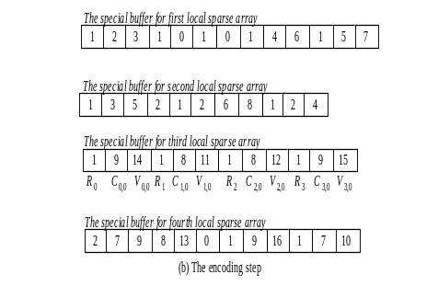
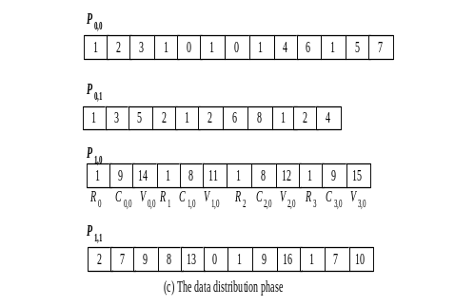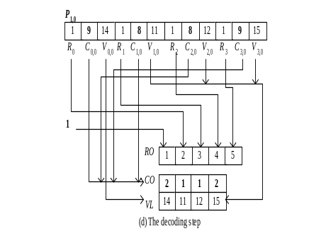
Figure 7: An example of the ED scheme.

B. The CFS scheme
In the data compression phase, local sparse arrays are compressed by the CRS method. This phase is similar to compress a global sparse array by the CRS method. Therefore, the data compression time T_{Compression} is (n²×(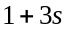))×T_{Operation} that is determined by the size of a global sparse array. In the data distribution phase, the compressed results are first packed into buffers. These buffers are then sent to the corresponding processors. After receiving the corresponding buffer, each processor unpacks the buffer to get the desired RO, CO, and VL. The values stored in CO need to be converted to local sparse indices in each processor according to Case 3.2.1. The packing time is (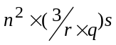+r'+1)×T_{Operation}, the send/receive time is r×q×T_{Startup} + (2n²s+qn+rq)×T_{Data}, and the unpacking time is (2n²s+qn+rq)×T_{Operation}. Therefore, the data distribution time T_{Distribution} is r×q×T_{Startup} + (2n²s+qn+rq)×T_{Data} + (2n²s+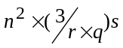+r'+qn+rq+1)×T_{Operation}. The number of nonzero array elements of a global sparse array determines the data distribution time.

C. The ED scheme
In the encoding step, local sparse arrays are encoded into special buffers. The encoding time is (n²×(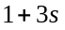))×T_{Operation} that is determined by the size of a global sparse array. In the data distribution phase, these special buffers are sent to processors. The data distribution time T_{Distribution} is (r×q×T_{Startup} + (2n²s+qn)×T_{Data}) that is determined by the number of nonzero array elements of a global sparse array. In the decoding step, the special buffer B in each processor is decoded. The C_{i,j} stored in the special buffer need to be converted to local sparse indices in each processor according Case 3.3.1. The decoding time is (+r'+1)×T_{Operation} that is determined by the number of nonzero array element of a local spare array. The data compression time T_{Compression} is (n²×(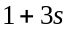) + +r'+1)×T_{Operation}.
Table 1 lists the data distribution time and the data compression time of the SFC, the CFS, and the ED schemes using the 2D mesh partition with load-balancing method and the CRS method.

D. Discussions
From Table 1, we can see that the data distribution time of the ED scheme is less than that of the CFS scheme. The data distribution time of the ED scheme is less than that of the SFC scheme if the sparse ratio of a global sparse array is less than 0.5. Since the sparse ratio of a global sparse array is less than 0.5, the data distribution time of the ED scheme is less than that of the SFC scheme. We have the following remark.
Remark 1. The data distribution time of the ED scheme is less than that of the SFC and the CFS schemes.
For the data distribution time of the CFS scheme, it is less than that of the SFC scheme if the sparse ratio of a global sparse array is less than 0.5. We have the following remark.
Remark 2. The data distribution time of the CFS scheme is less than that of the SFC scheme.

Table 1: The data distribution time and the data compression time of the SFC, the CFS, and the ED schemes using the 2D mesh partition with load-balancing method and the CRS method.
Method | Complexity | Cost
SFC | T_{Distribution} | r×q×T_{Startup} + n²×T_{Data} + n²×T_{Operation}
SFC | T_{Compression} | (n²×(+s))×T_{Operation}
CFS | T_{Distribution} | r×q×T_{Startup} + (2n²s+qn+rq)×T_{Data} + (2n²s++r'+qn+rq+1)×T_{Operation}
CFS | T_{Compression} | (n²×())×T_{Operation}
ED | T_{Distribution} | r×q×T_{Startup} + (2n²s+qn)×T_{Data}
ED | T_{Compression} | (n²×() + +r'+1)×T_{Operation}

Table 2: The data distribution time and the data compression time of the SFC, the CFS, and the ED schemes using the 2D mesh partition with load-balancing method and the CCS method.
Method | Complexity | Cost
SFC | T_{Distribution} | r×q×T_{Startup} + n²×T_{Data} + n²×T_{Operation}
SFC | T_{Compression} | (n²×(+s))×T_{Operation}
CFS | T_{Distribution} | r×q×T_{Startup} + (2n²s+rn+rq)×T_{Data} +(2n²s++q'+rn+rq+1)×T_{Operation}
CFS | T_{Compression} | (n²×())×T_{Operation}
ED | T_{Distribution} | r×q×T_{Startup} + (2n²s+rn)×T_{Data}
ED | T_{Compression} | (n²×() + +q'+1)×T_{Operation}

For the data compression time of the SFC, the CFS, and the ED schemes, we have the following remark.
Remark 3. The data compression time of the SFC scheme is less than that of the CFS scheme that is less than that of the ED scheme.
From Table 1, for the overall performance of the SFC, the CFS, and the ED schemes, we have two remarks.
Remark 4. The ED scheme outperforms the CFS scheme.
Remark 5. The ED and the CFS schemes outperform the SFC scheme if the conditions 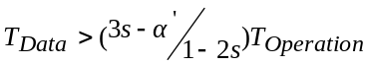 and 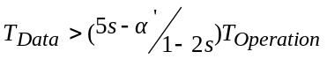 are satisfied, respectively.

4.1.2 The CCS method
Table 2 lists the data distribution time and the data compression time of the SFC, the CFS, and the ED schemes using the 2D mesh partition with load-balancing method and the CCS method. From Table 2, for the data distribution time, the data compression time, and the overall performance of these three schemes, we have similar observations as those of Remarks 1, 2, 3, 4, and 5.

5. Experimental Results
In the experimental test, we implement the SFC, the CFS, and the ED schemes on an IBM SP2 parallel machine. In the partition phase, the 2D mesh partition with load-balancing method is implemented. In the compression phase, the CRS method is implemented. All methods are written in C + MPI (Message Passing Interface) codes. The sparse ratio is set to 0.1 for all two-dimensional sparse arrays used as test samples.

5.1 The 2D Mesh Partition with Load-Balancing Method
Table 3 shows the data distribution and the data compression time for the SFC, the CFS, and the ED schemes using the 2D mesh partition with load-balancing method. From Table 3, for the data distribution time, we have the following observations.
- The data distribution time of the ED scheme is less than that of the SFC and the CFS schemes.
- The data distribution time of the CFS scheme is less than that of the SFC scheme.
These results match Remarks 1 and 2. For the data compression time, from Table 3, we have the following observation.
- The data compression of the SFC scheme is less than that of CFS scheme is less than that of the ED scheme.
This result matches Remark 3. From experimental tests, we can estimate that 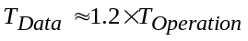. For the overall performance, from Table 3, we have the following observations.

Table 3: The data distribution and the data compression time of the SFC, the CFS, and the ED schemes using the 2D mesh partition with load-balancing method.
No. of Processors | Array Sizes  Methods-Costs |  | 120×120 | 240×240 | 480×480 | 960×960 | 1920×1920
2×2 | SFC | T_{Distribution} | 11.905 | 48.543 | 167.326 | 259.691 | 905.85
2×2 | SFC | T_{Compression} | 0.665 | 2.565 | 9.515 | 34.905 | 136.747
2×2 | CFS | T_{Distribution} | 3.538 | 9.82 | 35.644 | 55.252 | 204.104
2×2 | CFS | T_{Compression} | 4.573 | 18.295 | 73.183 | 119.348 | 507.399
2×2 | ED | T_{Distribution} | 1.659 | 4.701 | 16.718 | 25.695 | 100.251
2×2 | ED | T_{Compression} | 4.893 | 19.967 | 75.023 | 124.171 | 515.103
3×3 | SFC | T_{Distribution} | 13.219 | 50.372 | 169.201 | 263.424 | 913.466
3×3 | SFC | T_{Compression} | 0.421 | 1.492 | 4.224 | 18.452 | 71.559
3×3 | CFS | T_{Distribution} | 4.195 | 10.245 | 37.422 | 58.724 | 210.189
3×3 | CFS | T_{Compression} | 4.573 | 18.295 | 73.183 | 119.348 | 507.399
3×3 | ED | T_{Distribution} | 2.621 | 7.174 | 20.277 | 29.854 | 106.109
3×3 | ED | T_{Compression} | 5.245 | 20.542 | 76.542 | 127.254 | 521.524
4×4 | SFC | T_{Distribution} | 14.522 | 52.696 | 173.702 | 266.785 | 918.182
4×4 | SFC | T_{Compression} | 0.339 | 0.998 | 3.355 | 10.742 | 38.227
4×4 | CFS | T_{Distribution} | 5.803 | 12.298 | 42.391 | 63.154 | 220.962
4×4 | CFS | T_{Compression} | 4.573 | 18.295 | 73.183 | 119.348 | 507.399
4×4 | ED | T_{Distribution} | 3.702 | 9.143 | 23.209 | 32.293 | 110.895
4×4 | ED | T_{Compression} | 6.296 | 21.367 | 78.619 | 131.496 | 528.426
5×5 | SFC | T_{Distribution} | 16.656 | 55.321 | 177.226 | 273.247 | 925.524
5×5 | SFC | T_{Compression} | 0.267 | 0.737 | 1.938 | 6.724 | 24.254
5×5 | CFS | T_{Distribution} | 6.279 | 14.098 | 47.088 | 70.722 | 229.254
5×5 | CFS | T_{Compression} | 4.573 | 18.295 | 73.183 | 119.348 | 507.399
5×5 | ED | T_{Distribution} | 3.927 | 9.593 | 24.100 | 33.733 | 113.724
5×5 | ED | T_{Compression} | 6.667 | 22.459 | 80.426 | 140.741 | 540.141
6×6 | SFC | T_{Distribution} | 18.285 | 60.028 | 183.293 | 285.124 | 938.247
6×6 | SFC | T_{Compression} | 0.184 | 0.588 | 1.228 | 4.425 | 19.827
6×6 | CFS | T_{Distribution} | 7.155 | 15.895 | 52.006 | 79.752 | 240.841
6×6 | CFS | T_{Compression} | 4.573 | 18.295 | 73.183 | 119.348 | 507.399
6×6 | ED | T_{Distribution} | 4.177 | 10.093 | 25.090 | 34.649 | 115.602
6×6 | ED | T_{Compression} | 7.425 | 23.852 | 85.722 | 148.424 | 551.541
Time: ms

- The ED scheme outperforms the CFS scheme.
- The CFS and the ED schemes outperform the SFC scheme since the conditions 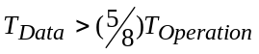 and 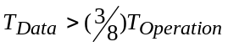 shown in Table 1 are satisfied, respectively.
These results match Remarks 4 and 5. From Table 3, we can see that the experimental results match the theoretical analysis in Table 1.
From the theoretical analysis and experimental results, for the SFC, the CFS, and the ED schemes, we have the following conclusions.
Conclusion 1: For the data distribution phase, the data distribution time of the ED scheme is less than that of the SFC and the CFS schemes. The data distribution time of the CFS scheme is less than that of the SFC scheme.
Conclusion 2: For the data compression phase, the data compression time of the SFC is less than that of the CFS scheme that is less than that of the ED scheme.
Conclusion 3: For the overall performance, the ED scheme outperforms the CFS scheme. For most of cases, the CFS and the ED schemes outperform the SFC scheme.

6. Conclusions and Future Work
In this paper, we have proposed two data distribution schemes, CFS and ED, for the distribution of sparse arrays on distributed memory multicomputers. To evaluate the CFS and the ED schemes, we compare them with the SFC scheme. In the data partition phase, the 2D mesh partition with load-balancing method is used for these three schemes. In the data distribution phase, local sparse arrays, whether compressed or not, are sent to processors in sequence. In the compression phase, the CRS/CCS methods are used to compress sparse local arrays for the SFC and the CFS schemes while the decoding/encoding step is used for the ED scheme. Based on the methods used in the three phases, both theoretical analysis and experimental test were conducted. In theoretical analysis, we analyze the SFC, the CFS, and the ED schemes in term of the data distribution time and the data compression time. In experimental test, we implemented the SFC, the CFS, and the ED schemes on an IBM SP2 parallel machine. From the experimental results, for all of test cases, the CFS and the ED schemes outperform the SFC scheme. The reason is that we do not send entire local sparse arrays to processors in the CFS and the ED schemes. The data distribution time can be reduced. For the CFS and the ED schemes, the ED scheme outperforms the CFS scheme for all test cases. The reason is that, for the ED scheme, the data distribution time is less than that for the CFS scheme.
In the future, we plan to work on the following directions. (1) Analyze the performance of the SFC, the CFS, and the ED schemes for multi-dimensional sparse arrays. (2) Develop efficient data distribution schemes for multi-dimensional sparse arrays based on the extended Karnaugh map representation (EKMR) scheme [30-33]. (3) Develop efficient data partition methods for multi-dimensional sparse arrays. We believe that these directions are of importance in parallel sparse array operations.

References
- Jeanne C. Adams, Walter S. Brainerd, Jeanne T. Martin, Brain T. Smith, and Jerrold L. Wagener. Fortran 90 Handbook. Intertext Publications/ McGraw-Hill Inc., 1992.
- R. Asenjo, L.F. Romero, Manuel Ujaldon and Emilio L. Zapata, “Sparse Block and Cyclic Data Distributions for Matrix Computations,” In Proceedings of High Performance Computing: Technology, Methods and Applications Advanced Workshop, June 1994.
- R. Asenjo, O. Plata, J. Tourino, R. Doallo, and Emilio L. Zapata, “HPF-2 Support for Dynamic Sparse Computations,” Languages and Compilers for Parallel Computing, 1998.
- Gerardo Bandera and Emilio L. Zapata, “Extending CRAFT Data-Distributions for Sparse Matrices,” 2nd. European Cray MPP Workshop, July 1996.
- Gerardo Bandera, Manuel Ujaldon, M.A. Trenas and Emilio L. Zapata, “The Sparse Cyclic Distribution against its Dense Counterparts,” 11th International Parallel Processing Symposium (IPPS'97), April 1997.
- Gerardo Bandera, Pablo P. Trabado and Emilio L. Zapata, “Local Enumeration Techniques for Sparse Algorithms,” In Proceedings of IEEE International Parallel Processing Symposium (IPPS'98), Apr. 1998.
- Gerardo Bandera and Emilio L. Zapata, “Sparse Matrix Block-Cyclic Redistribution,” In Proceedings of IEEE International Parallel Processing Symposium (IPPS'99), April 1999.
- R. Barrett, M. Berry, T. F. Chan, J. Demmel, J. Dongarra, V. Eijkhout, R. Pozo, C. Romine and H. Van der Vorst, Templates for the Solution of Linear Systems: Building Blocks for the Iterative Methods, 2nd Edition, SIAM, 1994.
- M.J. Berger and S.H. Bokhari, “A Partitioning Strategy for Nonuniform Problems on Multiprocessors,” IEEE Transactions on Computers, vol. 36, no. 5, pp. 570-580, 1987.
- Rong-Guey Chang, Tyng-Ruey Chung, and Jenq Kuen Lee, “Compiler Optimization for Parallel Sparse Programs with Array Intrinsics of Fortran 90,” In the International Conference on Parallel Processing, September, 1999.
- Rong-Guey Chang, Tyng-Ruey Chung, and Jenq Kuen Lee, “Parallel Sparse Supports for Array Intrinsic Functions of Fortran 90,” accepted by Journal of Supercomputing.
- Rong-Guey Chang, Tyng-Ruey Chung, and Jenq Kuen Lee, “Towards Automatic Support of Parallel Sparse Computation in Java with Continuous Compilation,” to appear in Concurrency: Practice and Experiences.
- Tyng-Ruey Chung, Rong-Guey Chang, and Jenq Kuen Lee, “Sampling and Analytical Techniques for Data Distribution of Parallel Sparse Computation,” In SIAM Conference on Parallel Processing for Scientific Computing, March, 1997.
- Tyng-Ruey Chung, Rong-Guey Chang, and Jenq Kuen Lee, “Efficient Support of Parallel Sparse Computation for Array Intrinsic Functions of Fortran 90,” In the 12th ACM International Conference on Supercomputing, July, 1998.
- M. Cierniak and W. Li, “Unifying Data and Control Transformations for Distributed Shared Memory Machines,” Technical Report, November 1994.
- J.K. Cullum and R.A. Willoughby, “Algorithms for Large Symmetric Eignenvalue Computations,” vol. 1 (birkhauser, Boston 1985).
- I. Duff, R.Grimes, and J. Lewis: Sparse matrix test problems. ACM Transaction on Mathematical Software, 15, 1-14, 1989.
- I. Duff, R.Grimes, and J. Lewis: User's Giude for the Harwell-Boeing Sparse Matrix Collection. CERFACS, Toulouse, France: Cedex 1992.
- B.B. Fraguela, R. Doallo, and Emilio L. Zapata, “Cache Misses Prediction for High Performance Sparse Algorithms, ” 4th International Euro-Par Conference (Euro-Par'98), September 1998.
- B.B. Fraguela, R. Doallo, and Emilio L. Zapata, “Cache Probabilistic Schemeling for Basic Sparse Algebra Kernels Involving Matrices with a Non-Uniform Distribution, ” 24th IEEE Euromicro Conference, pp.345-348, August 1998.
- B.B. Fraguela, R. Doallo, and Emilio L. Zapata, “Schemeling Set Associative Caches Behaviors for Irregular Computations, ” ACM International Conference on Measurement and Schemeling of Computer Systems (SIGMETRICS'98), pp.192-201, June 1998.
- B.B. Fraguela, R. Doallo, and Emilio L. Zapata, “Automatic Analytical Schemeling for the Estimation of Cache Misses, ” International Conference on Parallel Architectures and Compilation Techniques (PACT'99), October, 1999.
- G.H. Golub and C.F. Van Loan, Matrix Computations, 2nd ed. (Johns Hopkins Univ.Press, Baltimore, 1989)
- High Performance Fortran Forum, “High Performance Fortran Language Specification (version 2.0),” Rice Univ., Jan. 1997.
- Christoph W. Kebler, “Applicability of Automatic Program Comprehension to Sparse Matrix Computations,” In Proceedings of 3rd International Euro-Par Conference, Aug 1997.
- Christoph W. Kebler and Craig H. Smith, “The SPARAMAT Approach to Automatic Comprehension of Sparse Matrix Computations,” In Proceedings of the Seventh International Workshop on Program Comprehension, pp. 200-207, IEEE Computer Society Press, 1999.
- Vladimir Kotlyar, Keshav Pingali, and Paul Stodghill, “Compiling Parallel Sparse Code for User-Defined Data Structures,” In Proceedings of 8th SIAM Conference on Parallel Processing for Scientific Computing, March, 1997.
- Vladimir Kotlyar, Keshav Pingali, and Paul Stodghill, “A Relation Approach to the Compilation of Sparse Matrix Programs,” In Euro Par, August, 1997.
- Vladimir Kotlyar, Keshav Pingali, and Paul Stodghill, “Compiling Parallel Code for Sparse Matrix Applications,” In Proceedings of the Supercomputing Conference, August, 1997.
- Chun-Yuan Lin, Jen-Shiuh Liu, and Yeh-Ching Chung, “Efficient Representation Scheme for Multi-Dimensional Array Operations, ” IEEE Transactions on Computers, Vol. 51, No. 3, pp. 327-345, March 2002.
- Chun-Yuan Lin, Jen-Shiuh Liu, and Yeh-Ching Chung, “Efficient Data Compression Methods for Multi-Dimensional Sparse Array Operations Based on the EKMR Scheme,” Accepted by The Eighth Workshop on Compiler Techniques for High Performance Computing (CTHPC), March 2002.
- Jen-Shiuh Liu, Jiun-Yuan Lin, and Yeh-Ching Chung, “Efficient Representation for Multi-Dimensional Matrix Operations,” Proceedings of Workshop on Compiler Techniques for High Performance Computing (CTHPC), pp. 133-142, March 2000.
- Jen-Shiuh Liu, Jiun-Yuan Lin, and Yeh-Ching Chung, “Efficient Parallel Algorithms for Multi-Dimensional Matrix Operations,” Proceedings of IEEE International Symposium on Parallel Architectures, Algorithms and Networks (I-SPAN), Dec. 2000.
- Nikolay Mateev, Keshav Pingali, Paul Stodghill, and Vladimir Kotlyar, “Next-generation Generic Programming and its Application to Sparse Matrix Computations,” In Proceedings of International Conference on Supercomputing, 2000.
- W. H. Press, S. A. Teukolsky, William T. Vetterling, and Brian P. Flannery, Numerical Recipes in Fortran 90: The Art of Parallel Scientific Computing. (Cambridge University Press, 1996)
- Peter D. Sulatycke and Kanad Ghose, “Caching Efficient Multithreaded Fast Multiplication of Sparse Matrices,” In Proceedings of the 1st Merged International Parallel Processing Symposium and Symposium on Parallel and Distributed Processing, 1998.
- Manuel Ujaldon, Emilio L. Zapata, Barbara M. Chapman and Hans P. Zima, “New Data-Parallel Language Features for Sparse Matrix Computations,” 9th IEEE International Parallel Processing Symposium (IPPS'95), April 1995.
- Manuel Ujaldon, Shamik D. Sharma, Joel Saltz, and Emilio L. Zapata, “Run-time techniques for parallelizing sparse matrix problems,” Workshop on Parallel Algorithms for Irregularly Structured Problems, 1995
- Manuel Ujaldon and Emilio L. Zapata, “Efficient Resolution of Sparse Indirections in Data-Parallel Compiler,” 9th ACM International Conference on Supercomputing, July 1995.
- M. Ujaldon, Emilio L. Zapata, Shamik D. Sharma, and Joel Saltz, “Parallelization Techniques for Sparse Matrix Applications,” Journal of parallel and distribution computing, 1996.
- Manuel Ujaldon, Shamik D. Sharma, Emilio L. Zapata, and Joel Saltz, “Experimental Evaluation of Efficient Sparse Matrix Distributions,” In Proceedings of International Conference on Supercomputing, 1996.
- Manuel Ujaldon, Emilio L. Zapata, Barbara M. Chapman, and Hans P. Zima, “Vienna-Fortran/HPF Extensions for Sparse and Irregular Problems and Their Compilation,” IEEE Transactions on Parallel and Distributed Systems, vol. 8, no 10, October 1997.
- James B. White, and P. Sadayappan, “On Improving the Performance of Sparse Matrix-Vector Multiplication,” International Conference on High-Performance Computing, 1997.
- Emilio L. Zapata, O. Plata, R. Asenjo and G,P. Trabado, “Data-Parallel Support for Numerical Irregular Problems,” Journal of Supercomputing, 1999.
- Louis H. Ziantz, Can C. Ozturan, and Boleslaw K. Szymanski, “Run-Time Optimization of Sparse Matrix-Vector Multiplication on SIMD Machines,” In Proceedings International Conference of Parallel Architectures and Languages, Athens, July, 1994.

