An Efficient Algorithm for Finding Maximal Mean Subsequence

Chun-Chao Yeh¹ and Chun-Hsin Wu²

¹Department of Computer Science
National Taiwan Ocean University, Keelung 202, Taiwan
ccyeh@cs.ntou.edu.tw

²Institute of Information Science
Academia Sinica, Nankang 115, Taiwan
wuch@iis.sinica.edu.tw

Abstract

In this paper, we present an efficient method to find maximal mean subsequence (MMS) for a given sequence of non-negative number and a minimal subsequence length, L. When L is one, the MMS problem can be reduced to find a maximal number in the sequence, which can be solved easily. However, when the minimal subsequence length L is larger than one, the problem becomes non-trivial. A simple version of solution by brute-force approach will result in complexity of O(n²), given a sequence of n elements. In this paper we propose a more sophisticate algorithm to solve the problem with complexity of O(Ln), where L is a given constant number associated with the problem as the minimal subsequence length constraints. Furthermore, we employ an efficient filtering scheme, named forward /backward cancellation, to reduce search space. Consequently, the proposed algorithm can find the solution much efficiently.

1 Introduction

For a given sequence A=(a₁, a₂, …, a_{n}), and a value L as minimal subsequence length constraints, the maximal mean subsequence (MMS) problem, denoted by MMS(A, L), is to find a continuous subsequence of A with maximal mean value. Here, the mean value of a continuous subsequence from element u to v for a given sequence A, denoted as A(u,v) = (a_{u}, a_{u+1}, … ,a_{u+v-1}), is defined as (u,v) = (a_{u} + a_{u+1} + … +a_{u+v-1})/(v-u+1). That is if the MMS is from k to m, then it implies (k,m)= max{(i,j) | 1≤i≤j ≤n, L-1≤j-i≤ (n-1)}. It is worthy to note that the subsequence here we discuss in this context is for the “continuous” subsequence case only, while there is more general definition of subsequence [1]. For the case without the continuality constraint, the problem becomes trivial; under this case, it can be showed that the maximal mean subsequence can be determined by taking those first L largest elements in the sequence. For the following context, we refer the term of subsequence to the case of continuous subsequence only, except those with explicit notations. The MMS problem is intrinsically to find out a dominating subsequence (with length no less than L) with most significance in average. For example, some researchers use MMS as one of the evaluation factors to find conserved regions in sequence alignment, in bio-informatics research [2].
A simple solution of finding MMS can be done by exhausting search as shown in Algorithm 1, and results in complexity of O(n²), for a sequence consists of n elements. In this paper we develop a more sophisticate search scheme to find optimal solutions. Instead of search all of possible subsequence, we filter out those infeasible solutions first and search with a sophisticate algorithm for those possible candidates only. There could be more than one subsequence with same maximal mean value. We show in this paper that one of these maximal mean subsequences can be found among the subsequences with length between L and 2L-1. Consequently, we can reduce search space largely, especially when L is far less than sequence size n. Furthermore, we employ an efficient filtering scheme to reduce search space further. Combining these two techniques, the proposed algorithm can find the solution much efficiently. From intensive experiments, we show our algorithm greatly reduce search efforts than the one conducted by exhausted search.
In the following section, we present some important properties of MMS. And, basing on these properties, in Section 3 we develop an efficient algorithm to solve the MMS problem. Also, in Section 4, we evaluate performance of the proposed algorithm with intensive experiments. The results show that the proposed algorithm can solve the problem efficiently. Finally, a concluding summary is given in the last section.

Algorithm 1. Simple_MMS_quadratic
Procedure simple_mms_quadratic (L: integer, A: integer array)
{
/* (i,j) := (a_{i} + a_{i+1} + …+ a_{j} )/ k; k=j-i+1 */
max, i,j,k: integer;
max_i, max_j: integer;

max := 0; max_i:=0; max_j:=0;
/* search all subsequences (with length k from L to n) */
for(k:= L to n) {
for (i:= 1 to n-k+1) {
j:=i+k-1;
if (max > (i,j) )
{max := (i,j); max_i:=i; max_j:=j;}
}
}
{/*max mean subsequence is (a_{max_i}, a_{max_i+1}, …, a_{max_j} ) */}
}

2 Some Important Properties of the MMS Problem

For the following discussion, we define a MMS problem as MMS(A,L), where A is an n-element array (a₁ , a₂ , … , a_{n}), representing the input sequence, and L is the minimal subsequence length to be considered. Subsequence of A is denoted as A(i,j) =( a_{i}, a_{i+1}, …,a_{i+j-1}), 1≤i≤j ≤|A|=n. Length of subsequence A(i,j) is defined as number of elements in it, that is j-i+1. Also we define two functions, s(i,j) as sum of the subsequence A(i,j) and (i,j) as mean value of this subsequence. That is s(i,j)= a_{i} + a_{i+1} + … + a_{j,} , and (i,j)= s(i,j)/(j-i+1). For a given MMS problem MMS(A,L), we would like to find a subsequence A(u,v) resulting in maximal mean value. That is (u,v)= max{(i,j) | 1≤i≤j ≤n, L-1≤j-i≤ (n-1)}. Also, we add two extra boundary elements a₀ and a_{n+1} in A , with a₀= a_{n+1} = 0, if necessary.
For a given n-element sequence, all subsequences’ mean value can be listed and constructed as a triangle as shown in Figure 1. A simple algorithm to find the maximal mean subsequence is to search all over these mean value once and find the maximal one. This results in complexity O(n²). Further improvement can be made basing on following lemmas.

Lemma 1. For a given MMS problem MMS(A,L), if L=1, then MMS(A,L)= max{ a_{k} | for all k}.
Proof: Let t= max{ a_{k} | for all k}. That is, t is the maximal subsequent value among all subsequent with length equal to 1=L. Consider a subsequence A(i,j) with length larger than L=1. That is j-i+1>1. Mean value of A (i,j) =(i,j) = s(i,j)/(j-i+1)= (a_{i} + a_{i+1} + … + a_{j})/(j-i+1) ≤ (t +t+ ….+t)/ (j-i+1) = t(j-i+1)/ (j-i+1) = t. That is, t≥(i,j) as well, for all 1≤i<j ≤n. Consequently, MMS(A,L)= max{ a_{k} | for all k}, if L=1. Q.E.D

Lemma 2 (Backward cancellation rule) Given a sequence of number, A=( a₁, a₂, …, a_{n}), if y≥ (k-1,j-1) and y≥ (j,m) , then y≥ (k-1,m), for all k,m , 2≤k≤j≤m≤n.

Proof: Let (k-1,j-1) = y-d₁, (j,m) = y-d₂, d₁, d₂≥0.

(k-1, m) = s(k-1, m)/ (m-k+2)
= ((a_{k-1} + … + a_{j-1} ) + ( a_{j} + … + a_{m} ))/(m-k+2)
= (s(k-1,j-1) + s (j,m))/(m-k+2)
= ((j-k+1)(k-1,j-1)+(m-j+1)(j,m))/ (m-k+2)
= ((j-k+1)(y-d₁)+(m-j+1)( y-d₂) )/(m-k+2)
= (y(m-k+2) – ((j-k+1)d₁+(m-j+1)d₂) )/(m-k+2)
= y-((j-k+1)d₁+(m-j+1)d₂)/(m-k+2) ≤ y
Q.E.D

Lemma 3. (Forward cancellation rule) Given a sequence of number, A=( a₁, a₂, …, a_{n}), if y≥ (j+1,m+1) and y≥ (k,j) , then y≥ (k,m+1), for all k,m , 1≤k≤j ≤m≤n-1.

Proof: Let (j+1,m+1) = y-d₁, (k,j) = y-d₂, d₁, d₂≥0.
(k, m+1) = s(k, m+1)/ (m-k+2)
= ((a_{k} + …+ a_{j})+ (a_{j+1} + … + a_{m+1})/(m-k+2)
= ( s (k,j) + s (j+1,m+1) )/(m-k+2)
= ((j-k+1)(k,j)+(m-j+1)(j+1,m+1))/ (m-k+2)
= ((j-k+1)( y-d₂) +(m-j+1)( y-d₁))/(m-k+2)
= ((y(m-k+2) – ((j-k+1)d₂+(m-j+1)d₁) )/(m-k+2)
= y - ((j-k+1)d₂+(m-j+1)d₁)/(m-k+2) ≤ y Q.E.D

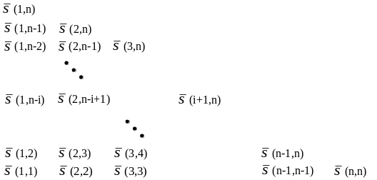
Figure 1. A triangle representation of all subsequence’s mean value for a sequence consists of n elements
Lemma 1 is a special case for L=1, we show that under such a case, the MMS problem MMS (A,1) is equivalent to find the maximal number in the sequence A, which can be solved easily with complexity O(n). Lemma 2 and Lemma 3 provide rules to skip comparisons with some subsequences, using some prior comparison results. Figure 2 shows the cases of applying Lemma 2 and Lemma 3 to the MMS problem represented in Figure 1. The line path, for example, from (k-1,k-1) to (k,m) then to (k-1,m) in Figure 2, means if y≥(k-1,k-1) and y≥(k,m) then y≥(k-1,m).

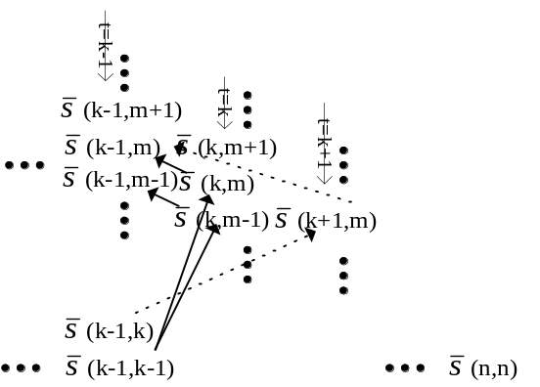
(a). Backward rule cancellation

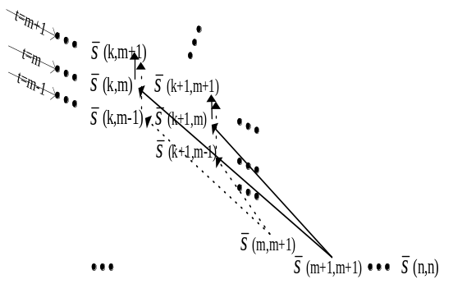
(b) Forward rule cancellation

Figure 2. (a) Backward rule cancellation, and (b) Forward rule cancellation

3 Proposed Algorithms to the MMS Problem

  - An O(Ln) algorithm for the MMS problem

The MMS problem can be solved by a simple algorithm such as Algorithm 1 mentioned in previous section. In Algorithm 1, we search all possible value of (i,j), for 1≤i≤j ≤n, L-1≤j-i≤ (n-1), and results in O(n²) time complexity. Based on explored properties stated in Section 2, we show in this section that we can reduce the O(n²) search space to O(L x n). Since the minimal sequence length L is no more than problem size n and could be far less than it, the improvement is significant.

Lemma 4. Given a sequence of number, A=( a₁, a₂, …, a_{n}), (a) if y≥ a_{k-1} and y≥ (k,m) , then y≥ (k-1,m), for all k,m , 2≤k≤m≤n. (b) if y≥ a_{m+1} and y≥ (k,m) , then y≥ (k,m+1), for all k,m , 1≤k≤m≤n-1.

Proof: (a) can be obtained from Lemma 2 by setting j=k. Similarly, (b) can be obtained from Lemma 3 by setting j=m. Q.E.D

Lemma 5. Given a sequence of number, A=( a₁, a₂, …, a_{n}), and an integer L, if y≥ (i,j) , for all i,j , 1≤i<j≤n , L-1≤j-i<2L-1≤n, then y≥ (i,j) , for all i,j , L-1≤j-i<min{3L-1, n}.

Proof:
Case 1. For all L-1≤j-i<2L-1, we have y≥ (j,i), by assumption.

Case 2. For all 2L-1≤j-i<min{3L-1,n}, since 2L-1≤j-i<min{3L-1,n}≤3L-1, we have L-1≤(j-L)-i<2L-1 and 1≤i<j-L≤n. By assumption, we get y≥ (i,j-L). Similarly, since j- (j-L+1)=L-1 and 1≤j-L+1<j≤n , we get y≥ (j-L+1,j) as wll. From Lemma 3, we know if we have y ≥ (i,j-L) and y≥ (j-L+1,j), then we have y≥ (i,j). Q.E.D

Theorem 1. Given a sequence of number, A=( a₁, a₂, …, a_{n}), and an integer L, if y≥ (i,j) , for all i,j , 1≤i<j≤n , 0≤L-1≤j-i<2L-1, then y≥ (i,j) , for all i,j , 1≤i<j≤n, L-1≤j-i<n.

Proof: We prove this by induction. First, from Lemma 5 we have if y≥ (i,j) , for all i,j , 1≤i<j≤n , 0≤L-1≤j-i<2L-1, then y≥ (i,j) , for all i,j , L-1≤j-i<3L-1. Then, Assume y≥ (i,j) , for all i,j , 1≤i<j≤n , L-1≤j-i<kL-1, k≥3. Consider for all (i,j), 1≤i<j≤n , kL-1≤j-i<min{(k+1)L-1,n} ≤(k+1)L-1. Since (k-1)L-1≤(j-L)-i<kL-1 and 1≤i<j-L≤n. By assumption, we get y≥ (i,j-L). Similarly, since j- (j-L+1)=L-1 and 1≤j-L+1<j≤n , we get y≥ (j-L+1,j) as wll. Consequently, we have both y≥ (i,j-L) and y≥ (j-L+1,j). Again, from Lemma 3, we have y≥ (i,j), for kL-1≤j-i<(k+1)L-1 as well. Consequently, by induction we have y≥ (i,j), for all i,j , 1≤i<j≤n, L-1≤j-i<n. Q.E.D

Theorem 1 shows that there exists one subsequence with maximal mean value among the subsequences with length less or equal to 2L-1(when n is greater than 2L-1). As a result, we can modify Algorithm 1 to Algorithm 2 by searching only the subsequences with length no greater than 2L-1, instead of all the subsequence. Complexity of Algorithm 2 is O(Ln).

Algorithm 2. Simple_MMS_Ln
Procedure simple_mms_Ln( L: integer, A: integer array)
{
/* (i,j) := (a_{i} + a_{i+1} + …+ a_{j} )/ k; k=j-i+1*/
max, i,j,k: integer;
max_i, max_j: integer;

max := 0; max_i :=0; max_j :=0;
/* search only those subsequences with length k from L to 2L-1 */
for(k:= L to min(2L-1,n)) {
for (i:= 1 to n-k+1) {
j:=i+k-1;
if (max > (i,j) )
{max := (i,j); max_i:=i; max_j:=j;}
}
}
{/* max mean subsequence is (a_{max_i}, a_{max_i+1}, …, a_{max_j} ) */}
}

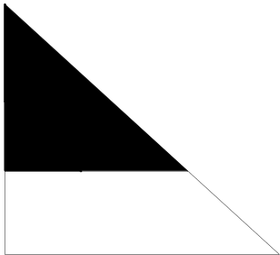
- Partition of all elements into two sets A, B, applying backward cancellation rule to elements in set A, and forward cancellation to elements in set B.
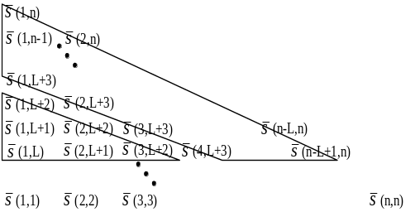
- Example of the partition, assume (3,L+2) is max. of all subsequences with length L.

Figure 3. Partition of all elements into two sets A, B for forward/backward cancellation process
  - Further improvement with forward and backward cancellation rules

Further improvement can be achieved by applying backward cancellation rule (Lemma 2) and forward cancellation rule (Lemma 3). First we consider all the possible subsequences (with length no less than L). Using the representation of Figure 1, all subsequence mean value can be partitioned into two subsets A and B as shown in Figure 3. The boarder line between A and B is (i,v), 1≤i ≤u, v-u=L-1, where (u,v) is mean value of subsequence from u to v, which is assumed to be maximum among all subsequence with length equal to L. That is A={(i,j) | i≤u, j≤v}. B is complement set of A.
In the following we give a short description about how the backward and forward cancellation rules can be applied. First apply a simple version of backward cancellation rule (as shown in Lemma 4 (a)) to elements in set A, line by line (vertical line in area A shown in Figure 3), for each line i containing elements s(i,j), i+L-1≤j≤v, i from u back to 1. Assume a value y is no less than all elements in the vertical lines from u back to k, that is y≥(i,j), i+L-1≤j≤v, k≤i≤u. If y≥ a_{k-1}, then we know, from Lemma 4, y is no less than all elements in the line k-1 except the element with length L starting from k-1 that is (k-1,k+L-2). Since we backward search from line u which containing single element(u,v), we know that y≥(u,v) ≥ (k-1,k+L-2). Consequently if y≥ a_{k-1}, we can skip all the elements in line k-1 in the area A. Similarly, apply forward cancellation rule to elements in set B, line by line (diagonal line in area B shown in Figure 3), for each line j containing elements (i,j) , 1≤i≤ j-L+1, j from v+1 to n. Again, if a value y is no less than all elements in the diagonal lines from v+1 to m, (that is y≥(i,j), 1≤i≤ j-L+1, v+1≤j≤m) and y≥ a_{m+1}, then y is no less than all elements in line m+1 except the element with length L ending at m+1 that is (m-L+2,m+1). Since y≥(u,v), we have y≥(m-L+2,m+1) as well. As a result for all elements on the lines in area B, if y≥ a_{m+1}, we can skip all the elements in line m+1.
Consequently, for the case that only elements with subsequence length between L and 2L-1 are concerned as in Algorithm 2, a more efficient algorithm can be modified from Algorithm 2 by adding above forward/backward cancellation rule to filter out unlikely elements. Algorithm 3 below describes details of the method.

Algorithm 3. FB_cancellation_MMS_Ln
Procedure FB_cancellation_mms_Ln ( L: integer, A: integer array)
{
/* (i,j) := (a_{i} + a_{i+1} + …+ a_{j} )/ k; k=j-i+1*/
max, i,j,k: integer;
max_i, max_j: integer;

find max mean subsequence A(u,v) with length equal to L (that is u-v+1=L).
max := (u,v); max_i :=u; max_j :=v;

/* search only those subsequences with length k from L to 2L-1 (the candidates)*/
/* 1. apply backward rule to search those candidates in area A */
for (i:= u-1 down to 1) {
if (max < a_{i} ) { /* compare vertical line i */
for (j= i+L to min(i+ 2L-2, v) ) {
if (max > (i,j) )
{max := (i,j); max_i:=i; max_j:=j;}
}
}
}

/* 2. apply forward rule to search those candidates in area B */
for (j:= v+1 to n) {
if (max < a_{j} ) { /* compare diagonal line j */
for (i= max(1,j-2L+2) to j-L ) {
if (max > (i,j) )
{max := (i,j); max_i:=i; max_j:=j;}
}
}
}

{/* max mean subsequence is (a_{max_i}, a_{max_i+1}, …, a_{max_j} ) */}
}

It is worthy to note that we apply a simple version of cancellation rule (Lemma 4) to the algorithm only. More elements might be able to be cancelled when a more complicate checking rults as Lemma 2 and Lemma 3 stated is applied. Nonetheless, this will generate more computing cost for the checking. From our experiments we found that in general, it works well when only a simple version of cancellation rule is applied.

4 Performance Evaluation

To evaluate efficiency of the proposed algorithm, we make some experiments with computer simulations. We would like to know how much elements could be skipped (cancelled) with the proposed algorithm, comparing with brute-force approach. Three parameters are concerned, sequence length n (n=20,50,100,200, and 500), minimal subsequence length L(L=3, 5, 10, and n/10), and the value range of each element in the sequence U(1-5,1-10, 1-n/2, 1-n). Figure 4 and Figure 5 show parts of results. Figure 4(a) and Figure 5(a) show the compound improvement over exhausted search (Algorithm 1 vs. Algorithm 3), with different observation factors. Both results show that the compound improvement is quite large(over 90 percent as n over 50-100), especially when sequence length n is relatively much larger than the minimal subsequence length L. Under such a situation, over 96% of elements can be skipped. Figure 4(a) also shows that value range of the elements seems not to make much difference to the system performance. Meanwhile, Figure 4(b) and Figure 5(b) show the performance of forward/backward cancellation. 50%-70% of elements can be skipped further, comparing the case without applying the strategy (That is, Algorithm 2 v.s. Algorithm 3).

5 Conclusion

In this paper, we present an efficient method to find maximal mean subsequence (MMS) for a given sequence of non-negative number. An simple version of solution will result in complexity of O(n²) using exhausted search, for a sequence consists of n elements. We show that the problem can be solved efficiently by skipping those impossible candidates. First, we show only subsequences with length between L and 2L-1 need to be checked. This important property reduces large of search space from O(n²) to O(Ln). Then we show that more elements can be skipped further using the proposed forward/backward cancellation rules. The later can skip up to seventy percent of elements (concerned in Algorithm 2). Also, from our simulation results, we show that compound performance improvement (algorithm 1 vs. algorithm 3) is quite large, especially when the total sequence length n is relatively much larger than the minimal subsequence length L. Under such a situation, over 96% of elements can be skipped.

References

- Kenneth H. Rosen .Discrete Mathematics and Its Applications. McGraw-Hill, 2000.
- Kun-Mao Chao .finding conserved regions in sequence alignment. lecture in Summer Institute on Bioinformatics, 2001, IIS, Sinica, Taipei,Taiwan, “http://www.iis.sinica.edu.tw/~hil/summer/chao/chao.files/frame.htm

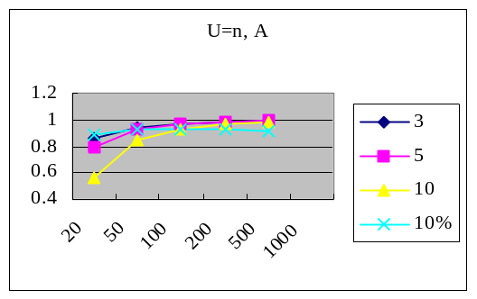
- Compound improvement comparing with exhausted search (Algorithm 1 vs. Algorithm 3)(percentage of skipped elements. Value range: 1-n; minimal subsequence length is 3, 5, 10, and n/10)

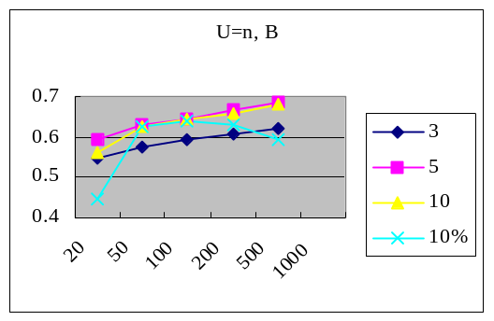
- Further improvement by forward /backward cancellation (Algorithm 2 vs. Algorithm 3) (percentage of skipped elements. Value range: 1-n; minimal subsequence length is 3, 5, 10, and n/10)

Figure 4. Performance comparison (minimal subsequence length effects)

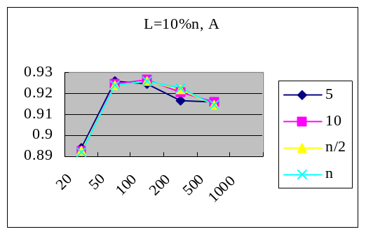
- Compound improvement comparing with exhausted search (Algorithm 1 vs. Algorithm 3)(percentage of skipped elements. Value range: 5, 10, n/2, and n; minimal subsequence length is n/10)

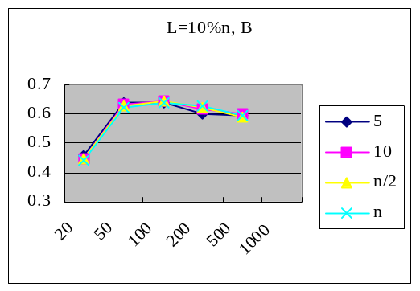
- Further improvement by forward /backward cancellation (Algorithm 2 vs. Algorithm 3) (percentage of skipped elements. Value range: 5, 10, n/2, and n; minimal subsequence length is n/10)

Figure 5. Performance comparison (Value range effects )

