Independent Spanning Trees on Two-dimension Tori

Shyue-Ming Tang and Yue-Li Wang
Department of Information Management
National Taiwan University of Science and Technology
ylwang@cs.ntust.edu.tw

Abstract
Two spanning trees of a given graph G having the same root r are said to be independent if for every vertex v of G the two paths from r to v along these two trees are vertex-disjoint. A set of spanning trees of G is said to be independent if they are pairwise independent. A two-dimension torus is a mesh with wrap-around connections in both the vertical and horizontal directions. Any two-dimension torus has four independent spanning trees rooted at the same vertex. In this paper, a linear time algorithm is proposed to construct four independent spanning trees on a two-dimension torus.

1. Introduction

A two-dimension torus, denoted by R(r, c), is a graph G = (V, E) with V = {0,1,2,..., rc−1} and E = {(u, v) | v = [u±c]rc or u−[u]c+[u±1]c }, where [u]c denotes u modulo c. If both r and c are greater than two, R(r, c) is 4-connected and 4-regular. We show R(5, 6) in Figure 1.
Two-dimension tori (or torus networks) are important due to its simple structure and suitability for developing algorithms [1,4,5]. There are commercially available parallel computers, such as the Intel Paragon, which are equipped with the torus interconnection structure. Therefore, it is valuable to investigate the communication problems on torus networks.
A set of paths connecting two vertices in a graph is said to be internally disjoint if and only if any pair of paths in the set have no common vertex except the two end vertices. Considering a graph G=(V,E), a tree T is called a spanning tree of G if T is a subgraph of G and T contains all vertices in V. Two spanning trees of G are said to be independent if they are rooted at the same vertex, say r, and for each vertex v ∈ V\{r}, the two paths from r to v, one path in each tree, are internally disjoint. A set of spanning trees of a graph is said to be independent if they are pairwise independent. For example, four independent spanning trees of R(5,6) are shown in Figure 2.
Recently, the problem of finding independent spanning trees of a given graph has received increasing attention. The study on independent spanning trees find applications in fault-tolerant protocols for distributed computing networks. For example, broadcasting in a network is sending a message from a given node to all other nodes in the network. We can design a fault-tolerant broadcasting scheme based on independent spanning trees [2, 8]. The fault-tolerance can be achieved by sending k copies of the message along k independent spanning trees rooted at the source node. If the source node is faultless, this scheme can tolerate up to k-1 faulty nodes.
Itai and Rodeh [8] gave a linear time algorithm for finding two independent spanning trees in a biconnected graph. Cheriyan and Maheshwari [3] showed that, for any 3-connected graph G and for any vertex r of G, three independent spanning trees rooted at r can be found in O(|V||E|) time. In [9] and [12], the authors conjectured that any k-connected graph has k independent spanning trees rooted at an arbitrary vertex r. In 1999, Huck [7] has proved that the conjecture is true for planar graphs. The conjecture is still open for arbitrary k-connected graphs with k > 3.

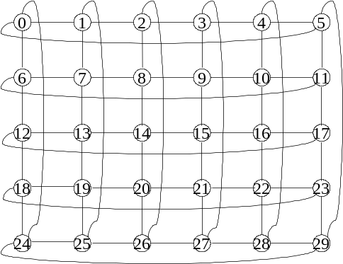

Figure 1. A torus network R(5, 6).

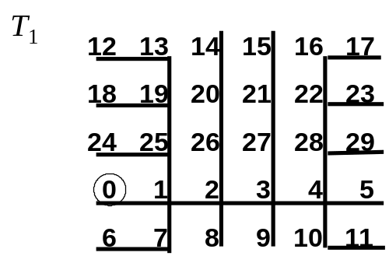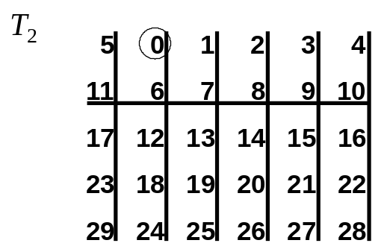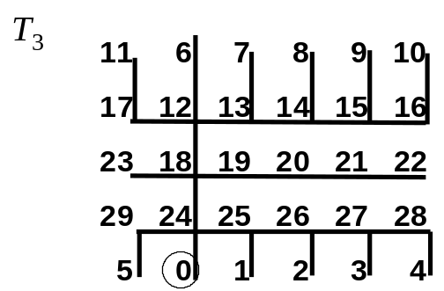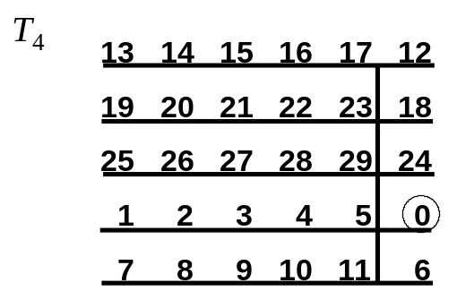

Figure 2. Four independent spanning trees of R(5, 6).

Obokata et al. [10] have mentioned that an n-dimension torus is a 2n-channel graph and has 2n independent spanning trees rooted at any vertex. They view a 2-dimension torus R(r,c) as the product graph of cycles C_{r} and C_{c} , and construct four independent spanning trees of R(r,c) from independent spanning trees (paths) of C_{r} and C_{c} . Four independent spanning trees of R(5,6) shown in Figure 2 are constructed by Obokata's algorithm. Actually, their algorithm is a “cure-all”, and hence very hard to figure out. In this paper, we shall propose a simpler algorithm to construct four independent spanning trees on a two-dimension torus.
The remaining part of this paper is organized as follows. In Section 2, we propose an algorithm for constructing four independent spanning trees on a two-dimension torus. In Section 3, we discuss the correctness of our algorithm. Section 4 contains our concluding remarks.

2. Construction of independent spanning trees

Torus networks are vertex-symmetric[6]. Without loss of generality, we simply consider independent spanning trees rooted at vertex 0 of a torus network. Let R(r,c) be a two-dimension torus with vertices labeled from 0 to rc−1. Four neighbors of vertex v are [v+c]rc, [v−c]rc, v−[v]c+[v+1]c and v−[v]c+[v−1]c. We propose an algorithm to construct four trees rooted at vertex 0 on R(r,c). Let T1, T2, T3 and T4 denote the trees. The algorithm contains six steps. Each step follows the same rule and builds up a set of edges in T1, T2, T3 and T4. The edge set created by different steps are defined as backbone edges, side edges, neck edge, pike edges, rib edges and hair edges.
At the first step, we start from vertex 0 to create backbone edges for every spanning tree. The backbone edges of T1 contain (0,1), (1,2), ..., (c−2,c−1). In T2, they are (0,c), (c,2c), ..., ((r−2)c,(r−1)c). Edges (0,c−1), (c−1,c−2), ..., (2,1) form the backbone edges of T3. The backbone edges of T4 consist of (0, (r−1)c), ((r−1)c,(r−2)c), ..., (2c,c). Obviously, the backbone edges of T1, T2, T3 and T4 are developed toward four different directions from vertex 0. Each spanning tree has c−1 (in T1, T3) or r−1 (in T2, T4) backbone edges. For implementing this step, we have Procedure Backbone_edges.

Procedure Backbone_edges(r,c)
(T1) for i := 0 to c−2 do
connect vertex i with vertex i+1 ;
(T2) for i := 0 to r−2 do
connect vertex ci with vertex c(i+1) ;
(T3) for i := 0 to c−2 do
connect vertex [c−i]c with vertex c−(i+1) ;
(T4) for i := 0 to r−2 do
connect vertex [c(r−i)]rc with vertex c(r−(i+1))
end

At the second step, we extend the backbone edges to create side edges for every spanning tree. The side edges of T1 contain (1,(r−1)c+1), (2,(r−1)c+2), ..., (c−2,(r−1)c+c−2). In T2, they are (c,c+1), (2c,2c+1), ..., ((r−2)c,(r−2)c+1). Edges (c−1,2c−1), (c−2,2c−2), ..., (2,c+2) form the side edges of T3. The side edges of T4 consist of ((r−1)c,rc−1), ((r−2)c,(r−1) c−1), ..., (2c,3c−1). Side edges are vertical to backbone edges. Each spanning tree has c−2 (in T1, T3) or r−2 (in T2, T4) side edges. For implementing this step, we have Procedure Side_edges.

Procedure Side_edges(r,c)
(T1) for i := 1 to c−2 do
connect vertex i with vertex [i−c]rc ;
(T2) for i := 1 to r−2 do
connect vertex ci with vertex ci+1 ;
(T3) for i := 2 to c−1 do
connect vertex i with vertex i+c ;
(T4) for i := 2 to r−1 do
connect vertex ci with vertex c(i+1)−1
end

At the third step, we create a neck edge for every spanning tree. It is extended from the first backbone edge. The neck edge of T1, T2, T3 and T4 is (1,c+1), (c,2c−1), (c−1,rc−1) and ((r−1)c,(r−1)c+1), respectively. Not like other types of edges, there is only one neck edge in every spanning tree. For implementing this edge, we have Procedure Neck_edge.

Procedure Neck_edge(r,c)
(T1) connect vertex 1 with vertex c+1 ;
(T2) connect vertex c with vertex 2c−1 ;
(T3) connect vertex c−1 with vertex rc−1 ;
(T4) connect vertex (r−1)c with vertex (r−1)c+1
end

At the fourth step, we extend the neck edge to create pike edges for every spanning tree. The pike edges of T1 contain (c+1,c+2), (c+2,c+3), ..., (2c−3,2c−2). In T2, they are (2c−1,3c−1), (3c−1,4c−1), ..., ((r−2)c−1,(r−1)c−1). Edges (rc−1,rc−2), (rc−2,rc−3), ..., ((r−1)c+3,(r−1)c+2) form the pick edges of T3. The pike edges of T4 consist of ((r−1)c+1,(r−2)c+1), ((r−2)c+1,(r−3)c+1), ..., (3c+1,2c+1). Pike edges are horizontal to backbone edges. Each spanning tree has c−3 (in T1, T3) or r−3 (in T2, T4) pike edges. For implementing this step, we have Procedure Pike_edges.

Procedure Pike_edges(r,c)
(T1) for i := 1 to c−3 do
connect vertex c+i with vertex c+i+1 ;
(T2) for i := 2 to r−2 do
connect vertex ci−1 with vertex c(i+1)−1 ;
(T3) for i := 1 to c−3 do
connect vertex rc−i with vertex rc−(i+1) ;
(T4) for i := 1 to r−3 do
connect vertex c(r−i)+1 with vertex c(r−(i+1))+1
end

At the fifth step, we extend the pike edge to create rib edges for every spanning tree. Rib edges are vertical to backbone edges and pike edges. Most edges of the spanning trees are rib edges if r and c are large enough. There are (r−3)(c−2) rib edges in T1 and T3, or (r−2)(c−3) rib edges in T2 and T4. For implementing this step, we have Procedure Rib_edges.

Procedure Rib_edges(r,c)
(T1) for i := 1 to c−2 do
for j := 1 to r−3 do
connect vertex cj+i with
vertex c(j+1)+i ;
(T2) for i := 2 to r−1 do
for j := 1 to c−3 do
connect vertex ci−j with vertex ci−(j+1) ;
(T3) for i := 1 to c−2 do
for j := 0 to r−4 do
connect vertex c(r−j)−i with
vertex c(r−(j+1))−i ;
(T4) for i := 2 to r−1 do
for j := 1 to c−3 do
connect vertex c(r−i)+j with
vertex c(r−i)+(j+1)
end

At the last step, we have to connect all residual vertices with suitable tree edges. Thus hair edges are created for every spanning tree. Hair edges are horizontal to backbone edges. There are 2(r−1) hair edges in T1 and T3, or 2(c−1) hair edges in T2 and T4. For implementing this step, we have Procedure Hair_edges.

Procedure Hair_edges(r,c)
(T1) for i := 1 to r−1 do begin
connect vertex ci+1 with vertex ci ;
connect vertex c(i+1)−2 with vertex c(i+1)−1
end ;
(T2) for i := 1 to c−1 do begin
connect vertex i+c with vertex i ;
connect vertex i+c(r−2) with
vertex i+c(r−1)
end ;
(T3) for i := 1 to r−1 do begin
connect vertex c(i+1)−1 with vertex ci ;
connect vertex ci+2 with vertex ci+1
end ;
(T4) for i := 1 to c−1 do begin
connect vertex [i−c]rc with vertex i ;
connect vertex i+2c with vertex i+c
end
end

Then, we describe our algorithm for constructing four trees based on a two-dimension torus R(r,c).

Algorithm IST_Torus
Input: R(r,c).
Output: T1, T2, T3 and T4.
Method:
Step 1. call backbone_edges ;
Step 2. call side_edges ;
Step 3. call neck_edge ;
Step 4. call pike_edges ;
Step 5. call rib_edges ;
Step 6. call hair_edges
End of Algorithm IST_Torus

For example, we construct T1, T2, T3 and T4 on R(5,6) as shown in Figure 3. Notice that different types of lines indicate different tree edges.
Obviously, the time complexity of Algorithm IST_Torus is O(rc) which is bound by Step 5.

3. Correctness

In this section, we shall prove that T1, T2, T3 and T4 are independent spanning trees rooted at 0 on R(r,c).

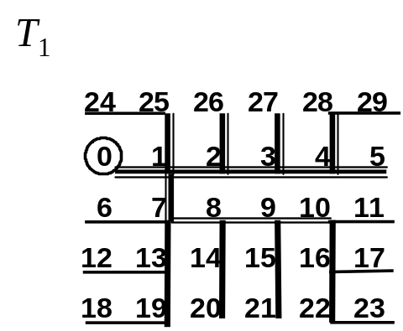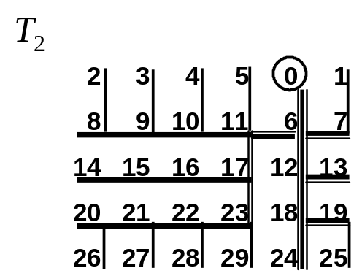

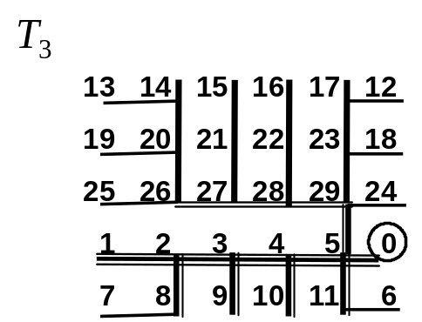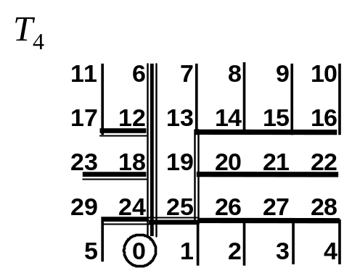
Figure 3. T1, T2, T3 and T4 of R(5,6)

Lemma 1. T1, T2, T3 and T4 are spanning trees of R(r,c).

Proof. Based on the steps of Algorithm IST_Torus, T1, T2, T3 and T4 are connected trees. Meanwhile, the number of edges in T1 and T3 is c−1 + c−2 + 1 + c−3 + (c−2)(r−3) + 2(r−1) = rc−1. The number of edges in T2 and T4 is r−1 + r−2 + 1 + r−3 + (c−3)(r−2) + 2(c−1) = rc−1. Therefore, T1, T2, T3 and T4 are four spanning trees of R(r,c).
Q.E.D.

Now, we have to prove that T1, T2, T3 and T4 are pairwise independent. For this purpose, we define the ancestor of a vertex v in Ti (i=1,2,3,4), denoted by ancestor(v,i), is the vertex set of the path from 0 to the parent vertex of v in Ti. By the definition of independent spanning trees, we have the proposition: “Ti and Tj (i≠j) are independent if and only if for every vertex v in R(r,c), v ≠ 0, ancestor(v,i) ∩ ancestor(v,j) = {0}”. This proposition is helpful in proving the following lemma.

Lemma 2. Let v be a vertex in R(r,c) and 1 ≤ v ≤ c−1, then
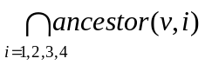 = {0}.
Proof. See Figure 4. In case that v = 1, ancestor(1,1) ∩ ancestor(1,2) ∩ ancestor(1,3) ∩ ancestor(1,4) = {0} ∩ {c+1, c, 0} ∩ {2, 3, ..., c−1, 0} ∩ {c(r−1)+1, c(r−1), 0} = {0}. In case that 1 < v < c−1, ancestor(v,1) ∩ ancestor(v,2) ∩ ancestor(v,3) ∩ ancestor(v,4) = {v−1, v−2, ..., 1, 0} ∩ {v+c, v+c+1, ..., 2c−1, c, 0} ∩ {v+1, v+2, ..., c−1, 0} ∩ {[v−c]rc, [v−c]rc−1, ..., c(r−1), 0 } = {0}. In case that v = c−1, ancestor(c−1,1) ∩ ancestor(c−1,2) ∩ ancestor(c−1,3) ∩ ancestor(c−1,4) = {c−2, c−3, ..., 0} ∩ {2c−1, c, 0} ∩ {0} ∩ {rc−1, c(r−1), 0} = {0}. Q.E.D.

Lemma 3. Let v be a vertex in R(r,c) and c ≤ v ≤ 2c−1, then
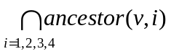 = {0}.

Proof. See Figure 5. In case that v = c, ancestor(c,1) ∩ ancestor(c,2) ∩ ancestor(c,3) ∩ ancestor(c,4) = {c+1, 1, 0} ∩ {0} ∩ {2c−1, c−1, 0} ∩ {2c, 3c, ..., c(r−1), 0} = {0}. In case that v = c+1, ancestor(c+1,1) ∩ ancestor(c+1,2) ∩ ancestor(c+1,3) ∩ ancestor(c+1,4) = {1, 0} ∩ {c, 0} ∩ {c+2, 2, ..., c−1, 0} ∩ {2c+1, 3c+1, ..., c(r−1)+1, c(r−1), 0} = {0}. In case that c+1 < v < 2c−1, ancestor(v,1) ∩ ancestor(v,2) ∩ ancestor(v,3) ∩ ancestor(v,4) = {v−1, v−2, ..., c+1, 1, 0} ∩ {v+1, v+2, ..., 2c−1, c, 0} ∩ {v−c, v−c+1, ..., c−1, 0} ∩ {v+c, v+c−1, ..., 2c+1, ..., c(r−1)+1, c(r−1), 0} = {0}. In case that v = 2c−1, ancestor(v,1) ∩ ancestor(v,2) ∩ ancestor(v,3) ∩ ancestor(v,4) = {v−1, v−2, ..., c+1, 1, 0} ∩ {c, 0} ∩ {3c−1, 2c, ..., c(r−1), 0} = {0}. Q.E.D.

Lemma 4. Let v be a vertex in R(r,c) and ci ≤ v ≤ c(i+1)−1, 2 ≤ i ≤ r−2 then
= {0}.

c(r−1) | c(r−1)−1 | ... | [v−c]rc−1 | [v−c]rc |  | ... | rc−1 | c(r−1)
0 | 1 | ... | v−1 | v | v+1 | ... | c−1 | 0
c | c+1 | ... |  | v+c | v+c+1 | ... | 2c−1 | c
Figure 4. Four paths from 0 to v in R(r,c), 1 ≤ v ≤ c−1

3c | 3c+1 | ... | ... | ... | ... | ... | 4c−1 | 3c
... | ... | ... | ... | ... | ... | ... | ... | ...
c(r−1) | c(r−1)+1 | ... | ... | .... | ... | ... | rc−1 | c(r−1)
0 | 1 | ... | ... | v−c | v−c+1 | ... | c−1 | 0
c | c+1 | ... | v−1 | v | v+1 | ... | 2c−1 | c
2c | 2c+1 | ... | v+c−1 | v+c | ... | ... | 3c−1 | 2c
Figure 5. Four paths from 0 to v in R(r,c), c ≤ v ≤ 2c−1

Proof. See Figure 6. In case that v = ci, ancestor(v,1) ∩ ancestor(v,2) ∩ ancestor(v,3) ∩ ancestor(v,4) = {v+1, v+1−c, ..., 1, 0} ∩ {v−c, v−2c, ..., c, 0} ∩ {v−1, v−1+c, ..., rc−1, c−1, 0} ∩ {v+c, v+2c, ..., c(r−1), 0} = {0}. In case that v = ci+1, 1 < i < r−1, ancestor(v,1) ∩ ancestor(v,2) ∩ ancestor(v,3) ∩ ancestor(v,4) = {v−c, v−2c, ..., 1, 0} ∩ {v−1, v−1−c, ..., c, 0} ∩ {v+1, v+1+c, ..., c(r−1)+2, ..., rc−1, c−1, 0} ∩ {v+c, v+2c, ..., c(r−1)+1, c(r−1), 0} = {0}. In case that ci+1 < v < c(i+1)−1, ancestor(v,1) ∩ ancestor(v,2) ∩ ancestor(v,3) ∩ ancestor(v,4) = {v−c, v−2c, ..., [v]c+c, ..., c+1, 1, 0} ∩ {v+1, v+2, ..., c(i+1)−1, ci−1, ..., 2c−1, c, 0} ∩ {v+c, v+2c, ..., c(r−1)+[v]c, ..., rc−1, c−1, 0} ∩ {v−1, v−2, ..., ci+1, c(i+1)+1, ..., c(r−1)+1, c(r−1), 0} = {0}. In case that v = c(i+1)−1, ancestor(v,1) ∩ ancestor(v,2) ∩ ancestor(v,3) ∩ ancestor(v,4) = {v−1, v−1−c, v−1−2c, ..., 2c−2, 2c−3, ..., c+1, 1, 0} ∩ {v−c, v−2c, ..., 2c−1, c, 0} ∩ {v+c, v+2c, ..., rc−1, c−1, 0} ∩ {ci, c(i+1), ..., c(r−1), 0} = {0}.
Q.E.D.

Lemma 5. Let v be a vertex in R(r,c) and c(r−1) ≤ v ≤ rc−1, then
= {0}.
Proof. See Figure 7. In case that v = c(r−1), ancestor(v,1) ∩ ancestor(v,2) ∩ ancestor(v,3) ∩ ancestor(v,4) = {c(r−1)+1, 1, 0} ∩ {c(r−2), ..., 2c, c, 0} ∩ {rc−1, c−1, 0} ∩ {0} = {0}. In case that v = c(r−1)+1, ancestor(v,1) ∩ ancestor(v,2) ∩ ancestor(v,3) ∩ ancestor(v,4) = {1, 0} ∩ {c(r−2)+1, c(r−2), ..., c, 0} ∩ {v+1, v+2, ..., rc−1, c−1, 0} ∩ {c(r−1), 0} = {0}. In case that c(r−1)+1 < v < rc−1, ancestor(v,1) ∩ ancestor(v,2) ∩ ancestor(v,3) ∩ ancestor(v,4) = {[v+c]rc, [v+c]rc−1, ..., 1, 0} ∩ {v−c, v−c+1, ..., c(r−1)−1,..., 2c−1, c, 0} ∩ {v+1, ..., rc−1, c−1, 0} ∩ {v−1, v−2, ..., c(r−1), 0} = {0}. In case that v = rc−1, ancestor(v,1) ∩ ancestor(v,2) ∩ ancestor(v,3) ∩ ancestor(v,4) = {rc−2, c−2, ..., 1, 0} ∩ {c(r−1)−1, ..., 2c−1, c, 0} ∩ {c−1, 0} ∩ {c(r−1), 0} = {0}. Q.E.D.

Therefore, for every vertex v in R(r,c), v ≠ 0, ancestor(v,1) ∩ ancestor(v,2) ∩ ancestor(v,3) ∩ ancestor(v,4) = {0}. That is, T1, T2, T3 and T4 are mutually independent.
We summarize Lemmas 1, 2, 3, 4 and 5 as Theorem 6.

Theorem 6. Algorithm IST_Torus correctly construct four independent spanning trees rooted at 0 on R(r,c) in O(rc) time.

 | 1 | 2 | ... | [v]c−1 | [v]c | [v]c+1 | ... | c−2 | c−1
c | c+1 | c+2 | ... | [v]c+c−1 | [v]c+c | ... | ... | 2c−2 | 2c−1
... | ... | ... | ... | ... | ... | ... | ... | ... | ...
ci−c | ci+1−c | ci+2−c | ... | ... | v−c | ... | ... | ci−2 | ci−1
ci | ci+1 | ci+2 | ... | v−1 | v | v+1 | ... | c(i+1)−2 | c(i+1)−1
c(i+1) | c(i+1)+1 | c(i+1)+2 | ... | ... | v+c | ... | ... | c(i+1) | c(i+2)−1
... | ... | ... | ... | ... | ... | ... | ... | ... | ...
c(r−1) | c(r−1)+1 | c(r−1)+2 | ... | ... | c(r−1)+[v]c | ... | ... | c(r−1) | rc−1
0 | 1 | 2 | ... | [v]c−1 | [v]c | [v]c+1 | ... | c−2 | c−1
Figure 6. Four paths from 0 to v in R(r,c), ci ≤ v ≤ c(i+1)−1, 2 ≤ i ≤ r−2

c(r−2) | c(r−2)+1 | ... | ... | v−c | v−c+1 | ... | c(r−1)−1 | c(r−2)
c(r−1) | c(r−1)+1 | ... | v−1 | v | v+1 | ... | rc−1 | c(r−1)
0 | 1 | ... | [v+c]rc−1 | [v+c]rc | ... | ... | c−1 | 0
c | c+1 | ... | ... | ... | ... | ... | 2c−1 | c
... | ... | ... | ... | ... | ... | ... | ... | ...
c(r−3) | c(r−3)+1 | ... | ... | ... | ... | ... | c(r−2)−1 | c(r−3)
Figure 7. Four paths from 0 to v in R(r,c), c(r−1) ≤ v ≤ rc−1

4. Concluding remarks

In this paper, we have presented a simpler algorithm for constructing four independent spanning trees of a two-dimension torus R(r,c). The height of every spanning tree is r+c−3. This result is optimal because the total distance from every vertex to the root vertex of one tree can not be reduced any more [11]. We are going to extend this result to tori with higher dimension. Intuitively, it seems that the property of our algorithm should hold for higher dimension too.
There are many vertex-symmetric graphs, such as star graphs, recursive circulant graphs, honeycomb tori, and so on. Linear-time algorithms to find independent spanning trees for these classes of graphs are valuable. New skills for verifying the independency of spanning trees rooted at a vertex are also eagerly needed when developing these algorithms.

Acknowledgement

This work was supported by the National Science Council, Republic of China, under Contract 90-2213-E-011-067.

References

[1] Myung M. Bae and Bella Bose, “Resource placement in torus-based networks,” IEEE Transactions on Computers 46(10), 1997, pp. 1083-1092.
[2] F. Bao, Y. Igarashi, S.R. Öhring, “Reliable broadcasting in product networks ,” IEICE Technical Report COMP 95(18), 1995, pp.57-66.
[3] J. Cheriyan, S. N. Maheshwari, “Finding nonseparating induced cycles and independent spanning trees in 3-connected graphs,” Journal of Algorithms 9, 1988, pp.507-537.
[4] Christoph von Conta, “Torus and other networks as communication networks with up to some hundred points,” IEEE Transactions on Computers 32(7), 1983, pp.657-666.
[5] Robert Cypher and Luis Gravano, “Storage-efficient and, deadlock-free packet routing algorithms for torus networks,” IEEE Transactions on Computers 43(12), 1994, pp.1376-1385.
[6] Frank Harary, “Graph Theory,” Addison-Wesley, 1968, pp.171-173.
[7] A. Huck, “Independent trees in planar graphs,” Graphs and Combinatorics 15, 1999, pp.29-77.
[8] A. Itai, M. Rodeh, “The multi-tree approach to reliability in distributed networks,” Information and Computation 79, 1988, pp.43-59.
[9] Samir Khuller, Baruch Schieber, “On independent spanning trees”, Information Processing Letters 42, 1992, pp.321-323.
[10] K. Obokata, Y. Iwasaki, F. Bao and Y. Igarashi, “Independent spanning trees of product graphs,” Lecture Notes in Computer Science 1197, 1996, pp.338-351.
[11] S. Tang, , Yue-Li Wang and Jing-Xian Lee, “On the height of independent spanning trees of a k-connected k-regular graph,” Proceedings of National Computer Symposium, Taipei, 2001, pp.A159-A164.
[12] A. Zehavi, A. Itai, “Three tree-paths,” Journal of Graph Theory 13, 1989, pp.175-188.

