八十九學年度「全國大專電腦軟體設計競賽」
大學甲組試題
Notes for Contestants
- There are 6 problems for the contest. You may work on the problems in any order.
2. You may use any algorithm/method to solve the problems. However, the execution
time of your program for each problem must not exceed 60 seconds, otherwise the
program will be considered run-time exceeded.
3. Input files for the problems are preinstalled in the system for automatic judging. The input files are named according to the problem ID, where “px.dat” is the input file for Problem X. The input and output formats of your program must be designed according to the input and output formats described in each problem.
4. Since Visual Basic does not support console mode applications, VB programs should print output to the file “output.txt” instead of the standard output.

Problem A
A Cache Simulator

Cache memories have been used widely in current microprocessor systems. In this problem, you are asked to write a program for a cache simulator. The cache has the following metrics:
- The cache size is 1 KB (K-byte).
- The cache uses the direct mapped approach.
- The cache line size is 16 bytes.
- The cacheable memory size is 256MB.

Your program will report a hit or miss when an address is given to the cache simulator. This is often called trace simulation. Initially, all of the cache lines are in the invalid state. When a memory line is first brought into the cache, the allocated cache entry transits into the valid state. Assume that a miss causes the filling of a whole cache line.

Input Format:
Up to 100 lines of address can be given in the file. Each line consists of an address given to the simulator. The address is given in hexadecimal form. We assume that each address references only one byte of data. The input file ends at the line with the word END.
Output Format:
Report either Hit or Miss for each of the given addresses. The last line reports cache hit ratio in percentage, that is, the number of hits divided by the number of total addresses given.

Sample Input:
AAAA000
00010B2
00010BA
END
Sample Output:
Miss
Miss
Hit
Hit ratio = 33.33 %
Problem B
GSM Base Station Identification

In the Personal Communication Service systems such as GSM (Global System for Mobile Communications), there are typically a number of base stations spreading around the service area. The base stations are arranged in a cellular structure, as shown in the following figure. In each cell, the base station is located at the center of the cell.
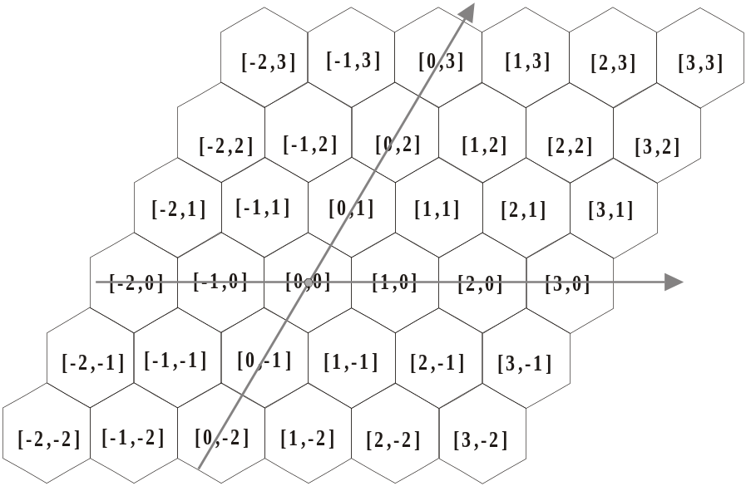

For convenience, each cell is denoted by [i, j]. The cell covers the origin is denoted by [0, 0]. The cell in the east of [0, 0] is denoted by [1, 0]. The cell in the west of [0, 0] is denoted by [-1, 0]. The cell in the northeast of [0, 0] is denoted by [0, 1]. The cell in the southwest of [0, 0] is denoted by [0, -1]. This notation can be easily generalized, as shown in the above figure.

Now the question is as follows. We have a service area represented by a Euclidean plane (i.e., x-y plane). Each unit is 1 Km. For example, point (5, 0) in the plane means the location at a distance of 5 Km to the east of the origin. We assume that there are totally 400 cells, denoted by [i, j], i = -9 .. 10, j = -9 .. 10. The base station of cell [0, 0] is located at the origin of the Euclidean plane. Each cell has a radius of R = 5 Km, as shown in the following figure.

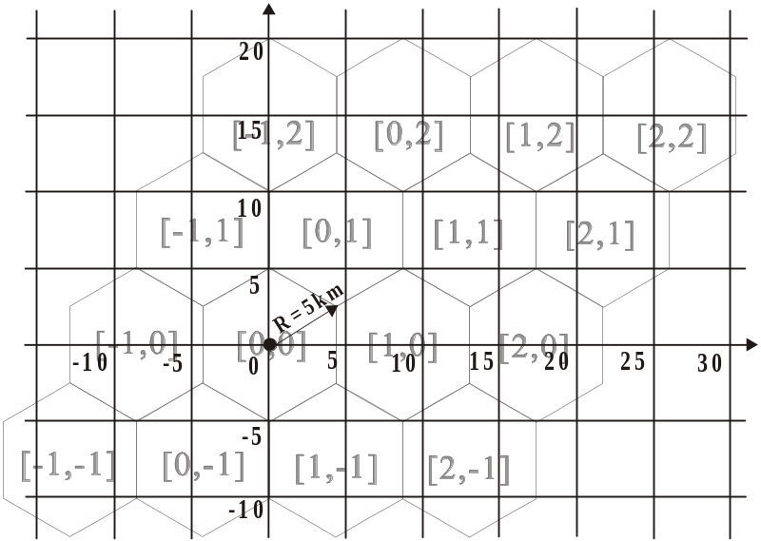

You are given an input (x, y), which indicates a mobile phone’s location. And you need to determine the cell [i, j] that covers this mobile phone and can serve this phone call. For example, given a location (10, 0), your program needs to output the cell [1, 0], which can cover this location. Specifically, the input and output are:
- input = (x, y). This is a location on the Euclidean plane. This value will not exceed the service area covered by the 400 cells. That is, you do not need to handle the exceptional case that the input is out of the boundary of the service area.
- output = [i, j]. One of the 400 cells that covers location [i, j].

Input Format:
A list of 10 locations.
Output Format:
A list of 10 cells covering the above 10 locations in the correct order.

Sample Input:
1 0
0 15
2 0
13 7
5 5
10 15
25 15
-13 -8
12 -7
-10 0
Sample Output:
[0, 0], [-1, 2], [0, 0], [1, 1], [0, 1], [0, 2], [2, 2], [-1, -1], [2, -1], [-1, 0]

Problem C
Minimum Distance in a Star Graph

In this problem, we will define a graph called star graph, and the question is to find the minimum distance between two given nodes in the star graph.

Given an integer n, an n-dimensional star graph, also referred to as S_{n}, is an undirected graph consisting of n! nodes (or vertices) and ((n-1) * n!)/2 edges. Each node is uniquely assigned a label x₁ x₂ ... x_{n} which is any permutation of the n digits {1, 2, 3, ..., n}. For instance, an S₄ has the following 24 nodes {1234, 1243, 1324, 1342, 1423, 1432, 2134, 2143, 2314, 2341, 2413, 2431, 3124, 3142, 3214, 3241, 3412, 3421, 4123, 4132, 4213, 4231, 4312, 4321}. For each node with label x₁ x₂ x₃ x₄ ... x_{n}, it has n-1 edges connecting to nodes x₂ x₁ x₃ x₄ ... x_{n}, x₃ x₂ x₁ x₄ ... x_{n}, x₄ x₂ x₃ x₁ ... x_{n}, ..., and x_{n} x₂ x₃ x₄ ... x₁. That is, the n-1 adjacent nodes are obtained by swapping the first symbol and the d-th symbol of x₁ x₂ x₃ x₄ ... x_{n}, for d = 2, ..., n. For instance, in S₄, node 1234 has 3 edges connecting to nodes 2134, 3214, and 4231. The following figure shows how S₄ looks (note that the symbols a, b, c, and d are not nodes; we only use them to show the connectivity between nodes; this is for the clarity of the figure).

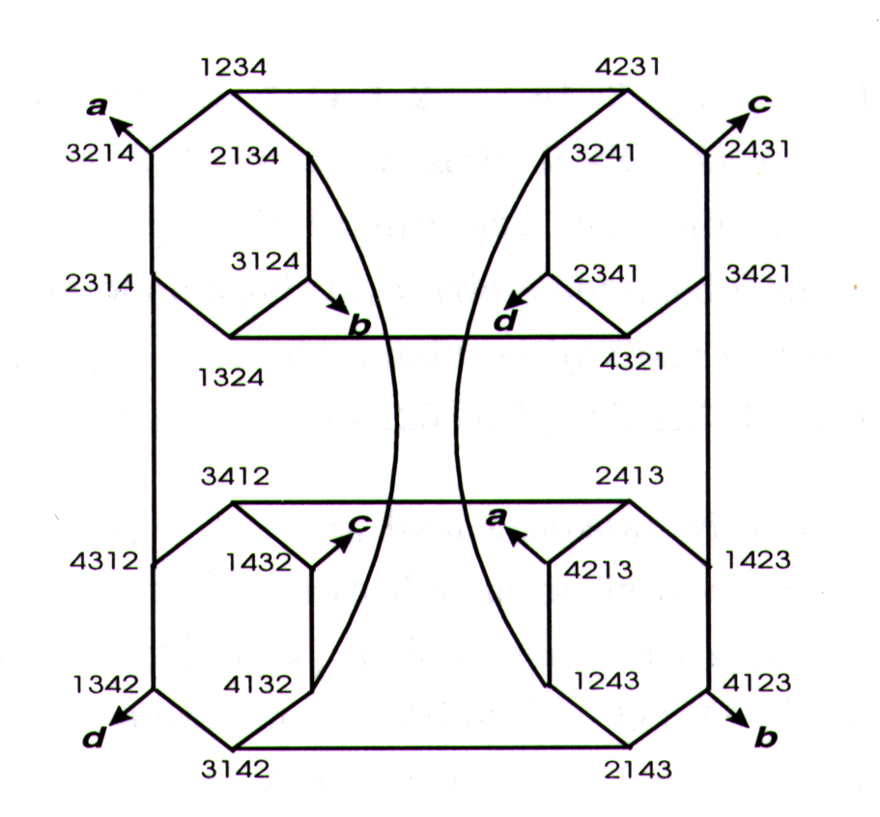

In this problem, you are given the following inputs:
- n: the dimension of the star graph. We assume that n ranges from 4 to 10.
- two nodes x₁ x₂ x₃ ... x_{n} and y₁ y₂ y₃ ... y_{n} in S_{n}.
You have to calculate the distance between these two nodes (which is an integer).

Input Format:
n (dimension of the star graph)
A list of 5 pairs of nodes.
Output Format:
A list of 5 values, each representing the distance of a pair of nodes.

Sample Input:
4
1234 4231
1234 3124
2341 1324
3214 4213
3214 2143
Sample Output:
1
2
2
1
3

Problem D
Line Segments Clipped by Windows

A rectangular area specified in world coordinates is called a window. The rectangular area on the display device to which a window is mapped is called a viewport. The picture elements that fall within this window area is visible. In the viewport there is a block which is given higher priority for displaying. That is, those line segments that falls behind the block will not be visible. Assume the boundaries of a viewport: x=x_{min}, x=x_{max}, y=y_{min}, y=y_{max}, the boundaries of block: x=x'_{min}, x=x'_{max}, y=y'_{min}, y=y'_{max}, and (x_{i1} , y_{i1} ) ( x_{i2 ,} y_{i2}) : the endpoints of the lines in device coordinates.
Please calculate the coordinate value of the endpoints of all the visible line.
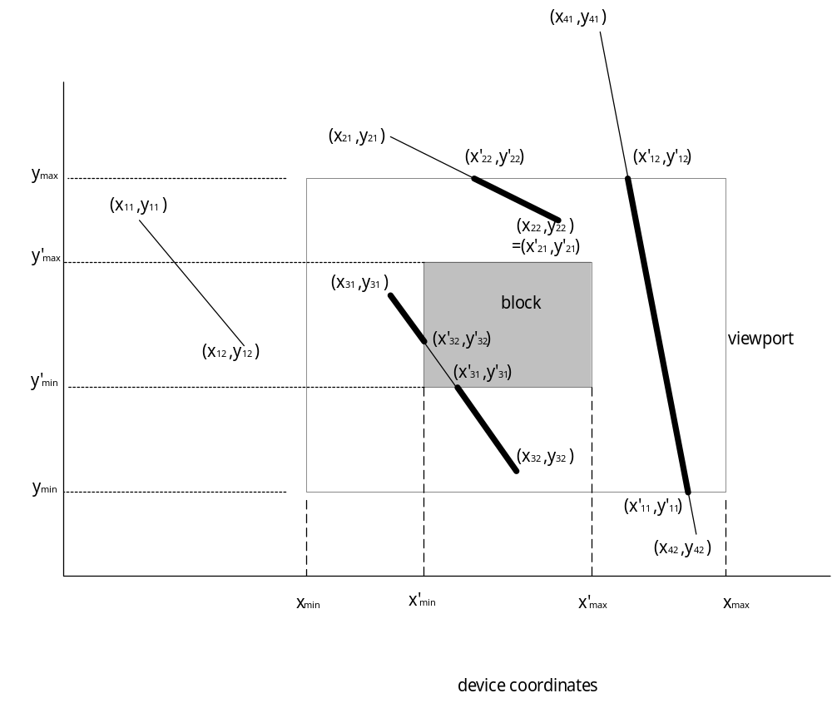

Input Format:
The boundaries of a viewport and block, endpoints of the lines in device coordinates.

x_{min} y_{min} x_{max} y_{max}
x'_{min} y'_{min} x'_{max} y'_{max}
x₁₁ y₁₁ x₁₂ y₁₂
x₂₁ y₂₁ x₂₂ y₂₂
x₃₁ y₃₁ x₃₂ y₃₂
……
x_{n1} y_{n1} x_{n2} y_{n2}

Output Format:
Endpoints of all the visible lines. Please sort the coordinate values of x'_{i1} ’s in descending order.

x'₁₁ y'₁₁ x'₁₂ y'₁₂
x'₂₁ y'₂₁ x'₂₂ y'₂₂
x'₃₁ y'₃₁ x'₃₂ y'₃₂
……
x'_{k1} y'_{k1} x'_{k2} y'_{k2}

Note:
- x'_{i1} < x'_{i2}
- In the condition of only the endpoints of the segments are falling on the boundaries of the viewport or block and the other part is invisible, please neglect it.
- Integers: x_{min ,} y_{min ,} x_{max ,} y_{max}, x'_{min} , y'_{min ,} x'_{max ,} y'_{max} ; float: y_{ij}

Sample Input:
0 0 5 5
1 2 2 3
3.0 3.0 7.0 7.0
9.0 7.0 2.0 6.0
4.0 2.0 1.1 4.0
9.0 -1.0 5.1 7.0
2.0 2.0 1.0 3.0
-2.5 3.1 5.2 -3.0
-1.0 7.3 -2.1 0.6
-2.1 5.6 6.0 7.0
-0.7 2.1 -5.2 12.6
Sample Output:
3.0000 3.0000 5.0000 5.0000
1.1000 4.0000 4.0000 2.0000
0.0000 1.1195 1.4131 0.0000

Problem E
The Heaviest Non-decreasing Subsequence Problem

Let S be a sequence of integers 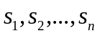. Each integer is associated with a weight by the following rules:

- If is negative, then its weight is 0.
- If is greater than or equal to 10000, then its weight is 5. Furthermore, the real integer value of is 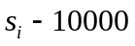. For example, if is 10101, then is reset to 101 and its weight is 5.
- Otherwise, its weight is 1.

A non-decreasing subsequence of S is a subsequence 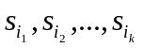, with 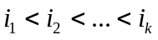, such that, for all 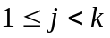, we have 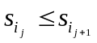. A heaviest non-decreasing subsequence of S is a non-decreasing subsequence with the maximum sum of weights.
Write a program that reads a sequence of integers, and outputs the weight of its heaviest non-decreasing subsequence. For example, given the following sequence:

80 75 73 93 73 73 10101 97 -1 -1 114 -1 10113 118

The heaviest non-decreasing subsequence of the sequence is <73, 73, 73, 101, 113, 118> with the total weight being 1+1+1+5+5+1 = 14. Therefore, your program should output 14 in this example.

Input Format:
A list of integers separated by blanks:
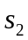 … 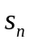
Output Format:
A positive integer that is the weight of the heaviest non-decreasing subsequence.

Sample Input:
80 75 73 93 73 73 10101 97 -1 -1 114 -1 10113 118
Sample Output:
14

Problem F
Frequent Subsets Problem

The frequent subset problem is defined as follows. Suppose U={1, 2,…,N} is the universe, and S₁, S₂,…,S_{M} are M sets over U. Given a positive constant α, 0<α≦1, a subset B (B≠0) is α-frequent if it is contained in at least αM sets of S₁, S₂,…,S_{M}, i.e. . The frequent subset problem is to find all the subsets that are α-frequent. For example, let U={1, 2,…5}, M=3, α=0.5, and S₁={1, 5}, S₂={1,2,5}, S₃={1,3,4}. Then there are 3 α-frequent subsets of U, which are {1},{5} and {1,5}.

Input Format:
The first line contains two numbers N and α, where N is a positive integers, and α is a floating-point number between 0 and 1. Each of the subsequent lines contains a set which consists of a sequence of positive integers separated by blanks, i.e., line i + 1 contains S_{i}, 1≦i≦M . Your program should be able to handle N up to 200 and M up to 50.
Output Format:
The number of α-frequent subsets.

Sample Input:
15 0.4
1 8 14 4 13 2
3 7 11 6
10 8 4 2
9 3 12 7 15 2
8 3 2 4 5
Sample Output:
11

