八 十 四 學 年 度 軟 體 設 計 競 賽 大 學 組 甲 類 初 賽 試 題
Problem A: Driving Simulation
Input File: jtd1.dat
Mr. Chen has a driving-tour from T City to K City via the super high way. Please write a program to estimate the elapsed time.
The model of driving behavior is defined by the following activities and events.
(A) The initial velocity of a car is 0. The car will be accelerated until the velocity reach the specified speed limit. Mr. Chen always keeps the speed as high as possible. Mr. Chen is a good civilian, so he never drives over speed limit. On meeting a traffic-sign, the car will be accelerated or decelerated until the velocity meets the requirement of this sign.
(B) The car should be stopped exactly at the destination when Mr. Chen arrives. The car must be also stopped completely and then be restarted when it arrives a toll station, a gasoline station, or a rest station. Assume that the time spent in a toll station, a rest station, and a gasoline station are 0, 15, and 5 minutes respectively.
(C) Mr. Chen has three cars: Y car, F car and B car. The capabilities of these cars, including accelerate rate and decelerate rate are:
Y car: 2m/s2, -4m/s2;
F car: 4m/s2, -6m/s2;
B car: 6m/s2, -8m/s2.
Your program should compute the minimum time that Mr.Chen will spend on the tour according to the input data: the car ID, the tour distance, and some traffic signs.
Input: A file consists of several tour information, each tour with a car ID, a distance from T City to K City, and a list of traffic signs.
Input format:
※car ID: an ASCII character to indicate either Y car, F car, or B car;
※distance: an integer representing the number of km;
※traffic sign: including three parts:
。location of this sign: an integer representing the distance (in km) from T city
。sign type: 'S' for speed limit; 'T' for toll station; 'G' for gasoline station; 'R' for rest station
。parameter: in 'S' sign, it is an integer representing the speed limit (in km/h); in other signs, it is an integer representing the distance (in km) from this traffic sign to a gasoline station, a toll station, or a rest station.
Output: xx Hours, yy Minutes, zz Seconds
Sample input:  B  383  0 S 100  14 T 2  45 S 70  116 G 2  180 T 6  206 S 120  288 R 7  350 T 3  Y  .  .  .  EOF | Sample output:  4 Hours, 33 Minutes, 54 Seconds  .  .  .
八 十 四 學 年 度 軟 體 設 計 競 賽 大 學 組 甲 類 初 賽 試 題
Problem B: Merge of Rectangles
Input File: jtd2.dat
Input: A list of rectangles, given in a text file as follows. Each rectangle is represented as 4 non-negative integers, (X Y W H), where X and Y are horizontal and vertical coordinates of the rectangle's upper-left point, respectively, and W and H are width and height of the rectangle in pixels, respectively. For example, if the number of rectangles is N, the input file is as follows:
N // number of rectangles
X1 Y1 W1 H1 // rectangle 1
X2 Y2 W2 H2 // rectangle 2
.... ....
XN YN WN HN // rectangle N
Problem: Split, merge, and sort all the input rectangles into another list of rectangles which obey the following rules:
(1) non-overlapping: every rectangle should not overlap each other.
(2) horizontal priority: the split and merge of the rectangle should be horizontal first as the case 1 rather than the case 2 (see figure 1).
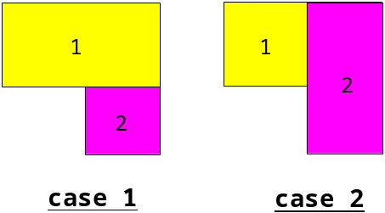figure 1
(3) least amount: neighboring rectangles must be merged to a larger rectangle if possible, so that the amount of the result rectangles is least.
(4) sorted: all rectangles in the list should be sorted from top to bottom, i.e. y1 <= y2 <= y3 <= ... yn. If two rectangles have the same y, then the one with small x will precede the other (i.e. sorted from left to right).
Output: The result list of rectangles should be output to a text file with the same format as input file.
Example: A list of rectangles before merge is shown in figure 2. The list of rectangles after merge is shown in figure 3. The contents of the correspondent input file and output file are listed as follows.
Sample Input: Output:
5 6
140 60 210 180 140 60 210 40
180 100 240 200 140 100 280 60
90 190 190 240 530 120 80 220
530 120 80 220 140 160 360 30
260 160 240 200 90 190 410 170
90 360 190 70
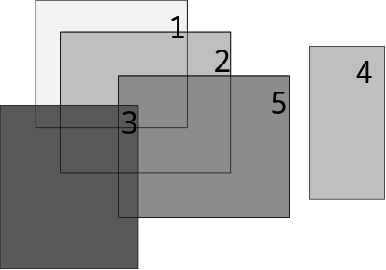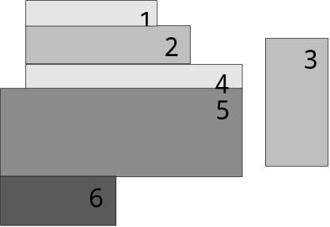
figure 2 figure 3
八 十 四 學 年 度 軟 體 設 計 競 賽 大 學 組 甲 類 初 賽 試 題
Problem C: Tree
Input File: jtd3.dat
The "tree" data structure imposes a hierarchical relation on a set of elements called nodes. There are three useful ways in which we can systematically order all nodes of a tree. They are preorder, inorder, and postorder listings. In the following we give an example showing a tree and its preorder,inroder, and postorder node orderings.
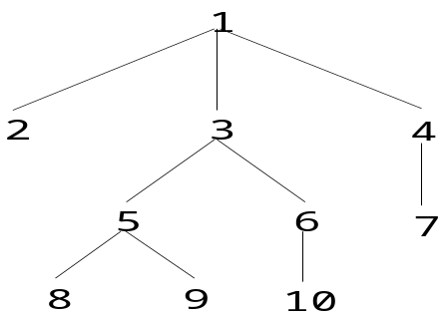
preorder: 1 2 3 5 8 9 6 10 4 7
inorder: 2 1 8 5 9 3 10 6 7 4
postorder: 2 8 9 5 10 6 3 7 4 1
Write a program which given three (preorder, inorder, and postorder) node orderings of a tree will output the tree structure. Each node given in the input is denoted as a positive integer. The output tree structure must be represented as a set of triples (a,b,c) denoting the nodes, where a is a node, b is a's parent node, and c is a number indicating that a is the c-th child from the leftmost of b's children. If a is the root of a tree then the triple will be denoted as (a,-,-), where "-" means undefined. For example, the tree structure for the above example is denoted as (1,-,-), (2,1,1), (3,1,2), (4,1,3), (5,3,1), (6,3,2), (7,4,1), (8,5,1), (9,5,2), (10,6,1).
To test your program five test data cases, each with three (preorder, inorder, postorder) node orderings of a tree, will be used. These five test data cases are stored in a file called "jtd3.dat". This implies that your program will read the file "jtd3.dat" and output five different tree structrues. Each test data case occupies three contiguous single lines of positive integers, representing preorder, inorder, and postorder node listings of a tree subsequently. The integers in each line are separated each other by one blank space and no leading blanks appear before the first interger; while the five test data cases are separated each other by one blank line. An example of the five test cases is shown below.
1 2 6 7 3 4 8 9 10 5
6 2 7 1 3 9 8 10 4 5
6 7 2 3 9 10 8 4 5 1
1 2 4 10 11 12 5 6 3 7 8 9
10 4 11 12 2 5 6 1 7 3 8 9
10 11 12 4 5 6 2 7 8 9 3 1
1 2 8 3 4 5 6 7
8 2 3 1 4 5 7 6
8 3 2 4 5 7 6 1
1 2 4 8 9 5 10 11 3 6 12 13 7 14 15
8 4 9 2 10 5 11 1 12 6 13 3 14 7 15
8 9 4 10 11 5 2 12 13 6 14 15 7 3 1
1 2 3 4 5 6 7 8 9 10
2 1 3 4 5 6 7 8 9 10
2 3 4 5 6 7 8 9 10 1

八 十 四 學 年 度 軟 體 設 計 競 賽 大 學 組 甲 類 初 賽 試 題
Problem D: Calendar

Input File: jtd4.dat
Write a program to print a nicely formatted calendar for a given year, displaying three months on one page. The inputs of the program are: 1) the given year, and 2) a reference date and its day of the week. For example, if the given year is 1995 and a reference day is May 9, 1995 which is Tuesday, then your program should print out a calendar whose first page should look similar to the following

JANUARY 1995
SUN | MON | TUE | WED | THU | FRI | SAT
1 | 2 | 3 | 4 | 5 | 6 | 7
8 | 9 | 10 | 11 | 12 | 13 | 14
15 | 16 | 17 | 18 | 19 | 20 | 21
22 | 23 | 24 | 25 | 26 | 27 | 28
29 | 30 | 31

FEBRUARY 1995
SUN | MON | TUE | WED | THU | FRI | SAT
 |  |  | 1 | 2 | 3 | 4
5 | 6 | 7 | 8 | 9 | 10 | 11
12 | 13 | 14 | 15 | 16 | 17 | 18
19 | 20 | 21 | 22 | 23 | 24 | 25
26 | 27 | 28

MARCH 1995
SUN | MON | TUE | WED | THU | FRI | SAT
 |  |  | 1 | 2 | 3 | 4
5 | 6 | 7 | 8 | 9 | 10 | 11
12 | 13 | 14 | 15 | 16 | 17 | 18
19 | 20 | 21 | 22 | 23 | 24 | 25
26 | 27 | 28 | 29 | 30 | 31
The following information may be needed to format your calendar
1. Months having 31 days are: January, March, May, July, August, October, and December.
2. Months having 30 days are: April, June, September, and November.
3. February has 28 days in a normal year, and 29 days in a leap year. All the years that are evenly divisible by 400 or are evenly divisible by 4 but not 100 are leap years.
4. The input Month and weekday are represented as:
Month: Jan, Feb, Mar, Apr, May, Jun, Jul, Aug, Sep, Oct, Nov, Dec
Weekday: Mon, Tue, Wed, Thu, Fri, Sat, Sun
Your program should design to read two set of input data. Inside the input file, the input data are arranged in the following order：
given year Reference date
□□□□,□□□,□□,□□□□,□□□
□□□□,□□□,□□,□□□□,□□□
á á á á
Month day year week day
八 十 四 學 年 度 軟 體 設 計 競 賽 大 學 組 甲 類 初 賽 試 題
Problem E: String Conversion
Input File: jtd5.dat
Background
Strings are basic elements in computer science. For example, Unix or DOS commands are strings. New users cannot remember the commands well, and they make errors constantly when typing commands. Instead of saying "command not found", listing a few commands that are "close" to the command the user typed may be very helpful to users. In this problem, we are going to design a program that can be used to compute those commands that are close to a command that was typed.
The Problem
A string can be converted into another string by insertion, deletion, and replacement of characters. For example, to convert CONVERT into COVERED one can delete N, insert E before T, and replace T by D. Assume that insertion, deletion and replacement are the only operations to convert a string into another string. Assume that the cost of each insertion or deletion operation is one unit, and the cost of replacement operation is two units. The minimum cost to convert a string into another string is called the distance of the two strings.
Given two strings x = x₁ x₂ ...x_{m} and y = y₁ y₂ ...y_{n}, The distance of x and y can be computed as follows.
1. If x or y is empty, a sequence of insertions or a sequence of deletions suffice.
2. If x and y are not empty, consider the following three cases and choose the one with minimum cost.
(a) Convert x = x₁ x₂ ...x_{m-1} into y = y₁ y₂ ...y_{n}, first, and then delete x_{m}.
(b) Convert x = x₁ x₂ ...x_{m} into y = y₁ y₂ ...y_{n-1}, first, and then insert y_{n}.
(c) Convert x = x₁ x₂ ...x_{m-1} into y = y₁ y₂ ...y_{n-1}, first, and then replace x_{m} by y_{n} if they are different.
Write a program to compute the distance of two strings. In addition to the distance of the two strings, the program must list the conversion operations to convert x into y. For insertions, the operation must be "insert A before x[i]=B." If the character A is inserted after the string x, then use "append A." For deletions, the operation must be "delete x[i]=A." For replacements, the operation must be "replace x[i]=A by B."
Input:
The input data come from a file. Each record of the input file contains two strings. The first string is x, and the second string is y. They are separated by a space. There are no spaces in each string. If x is empty, then the first character of the record is a space. If y is empty, then the newline character follows immediately the space that separate x and y. In any case, a record contains at least two characters, a space and a newline.
Output:
For each pair of strings in the input file, the output is as follows. The first line of the output is a listing of the string x and y. It is followed by a sequence of operations to convert x into y. The distance of the two strings is then listed after the conversion operations.
八 十 四 學 年 度 軟 體 設 計 競 賽 大 學 組 甲 類 初 賽 試 題
Problem F: The Tortoise and The Hare
Input File: jtd6.dat
The tortoise and the hare begin a race at “square 0” of 100 squares. Each square represents a possible position along the race course. The course weaves its way up the side of a slippery mountain, so occasionally the contenders lose ground. The position of the animals will be changed according to the following rule:
Animal | Move type | Percentage of the time | Actual move
Tortoise | Plod | 75 % | x squares to the right
 | Slip | 25 % | 2x squares to the left
Hare | Sleep | w % | No move at all
 | Hop | 3z % | y squares to the right
 | Slip | z % | 2y squares to the left
The hare would like to know the possible maximum percentage of time it can sleep but not losing the race.
Input: The input will contain one or more data set, one per line. Each data set consists of an integer value for x (between 2 and 8), an integer value for y (between 6 and 20), and y should greater than x. The end of data for the entire input is the number 0 for x.
Output: For each data set, display integer z and integer w.
Sample Input
3 6
6 6
2 8
8 20
0
Output for the Sample Input
13 48
Invalid Input
7 72
10 60

八 十 四 學 年 度 軟 體 設 計 競 賽 大 學 組 甲 類 初 賽 試 題
Problem B: Graph Serach
Input File: graph.in
Assume a fugitive is hiding in an area represented as a graph. With as few guards as possible, search and clear every path of the graph from node 0 to ensure the capture. Let the fugitive be smart enough to escape if there are any loopholes. A path (i, j) is verified to be cleared if there are guards standing at node i plus another guard walking from node i to node j. Assume you can use any new (or available) guards at any nodes and let the nodes and guards be numbered from 0, 1, 2, ... etc.
Hint: To ensure no loopholes, remember to keep at least a guard at node i if there exists at least one cleared path (i, j) and one uncleared path (i, k).
Input:
N: An integer representing the number of nodes in the graph.
C[N][N]: Adjacent matrix. If there is a path between node i and j, then C[i][j] = C[j][i] =1, else C[i][j] = C[j][i] = 0.
Output:
A series of searching actions represented in three integers id, i and j, where
id: the id of guard
i, j: walk from node i to node j
Example 1: Input
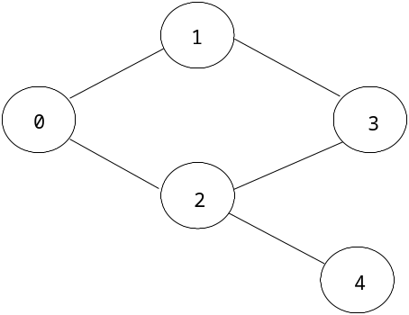
5
0 1 1 0 0
1 0 0 1 0
1 0 0 1 1
0 1 1 0 0
0 0 1 0 0

For the above graph, the following two sets are correct output except that they use different number of guards.
(1) (2)
1 0 1 1 0 1
0 0 2 0 0 2
1 1 3 2 2 4
1 3 2 2 2 3
0 2 4 1 1 3

Example 2: Input
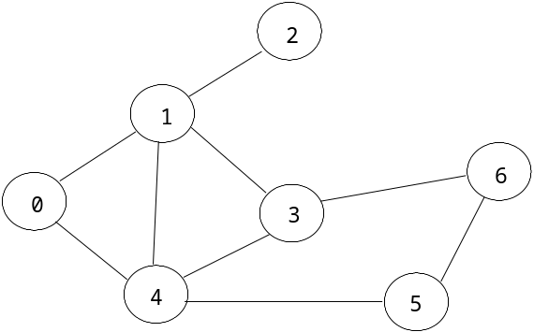
7
0 1 0 0 1 0 0
1 0 1 1 1 0 0
0 1 0 0 0 0 0
0 1 0 0 1 0 1
1 1 0 1 0 1 0
0 0 0 0 1 0 1
0 0 0 1 0 1 0

Output
1 0 1
2 1 2
0 0 4
2 4 1
1 1 3
2 4 3
1 3 6
0 4 5
1 6 5

