A Polynomial Time Approximation Scheme for Minimum Routing Cost Spanning Trees

Bang Ye Wu, Giuseppe Lancia, Vineet Bafna, Kun-Mao Chao, R. Ravi, Chuan Yi Tang

Proceedings of Ninth Annual ACM-SIAM Symposium on Discrete Algorithms (SODA’98), pp. 21-32, 1998

1. Introduction
Problem: Given a undirected graph with nonnegative delays on the edges, the goal is to find a spanning tree such that the average delay of communicating between any pair using the tree is minimized.
It is a NP-hard Problem.

2. An application to computational biology
Multiple Sequence Alignment

3. Definitions

4. A reduction from the general to the metric case
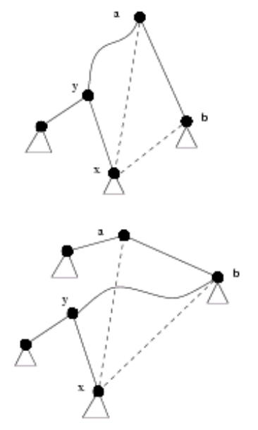

5. A PTAS for the △MRCT problem
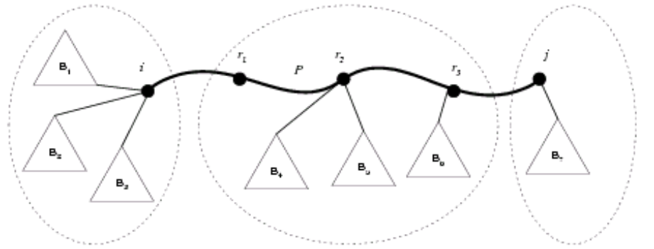

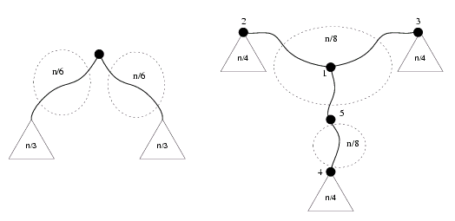

6. Finding the best k-star
L = (L₁, …, L_{k})
Total number of configurations is O(n^{2k-1})
1. Choice for S : 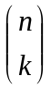
2. Possible tree topologies on k vertices: k^{k-2}
3. Possible suck k-vectors: 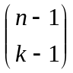
Compute per configuration: O(nk)
In general, A minimum routing cost k-star in G can be found is O(n^{2k})

7. Approximating optimal communication spanning trees

Created by: Kuo-Shi Huang
Date: Aug. 24, 2000

