Physical Mapping of DNA

1. Biological background

A physical map of a piece of DNA tells us the location of certain markers along the molecule.
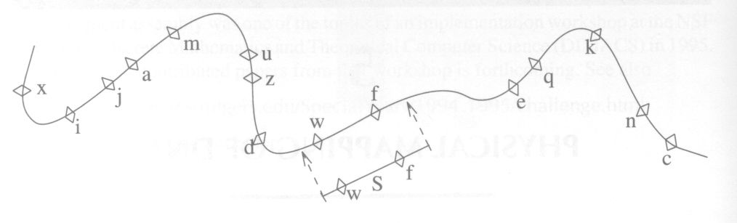

How do we create such maps?
- target DNA (several copies)
- restriction enzymes (several fragments)
- Mapping (by comparing the overlap in the fragments)

Note: Fragment Assembly vs. Physical Mapping
Fragment length:
Fragment Assembly: short fragments, find the prefix-suffix overlap to assembly.
Physical Mapping: long fragments, obtain overlap information by generating fingerprints.

Fragment generation:
Fragment Assembly: shotgun method – vibration.
Physical Mapping: restriction enzyme, gel electrophoresis, cloning.

Two way of getting fingerprints:
Restriction site analysis: A fragment’s length
Hybridization: check whether certain small sequences bind to fragments.

1.1 Restriction Site Mapping

Double Digest Problem (DDP):
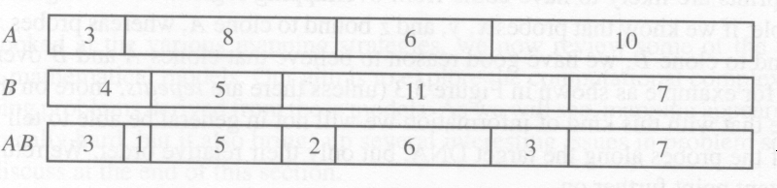

Partial Digest:
Using enzyme A:
Fragment sizes: 3, 11, 17, 27
8, 14, 24
6, 16
10

Experimental Errors:
- There is uncertainty in length measurement. (5%)
- If fragments are too small, it may not be possible to measure their lengths at all.
- Some fragments may be lost in the digestion process, leading to gaps in the DNA coverage.

1.2 Hybridization Mapping

Overlap information between fragments is based on partial information about each fragments content.

Each clone being typically several thousands of base pairs long.
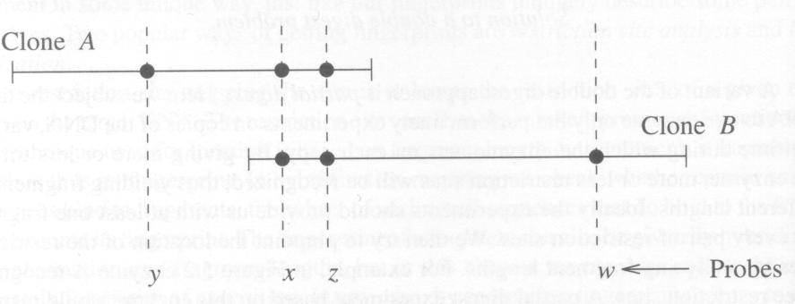
Note: We will not in general be able to tell the location of the probes along the target DNA, but only their relative order.

Experimental Errors:
- False negative.
- False positive.
- Human misreading.
- Errors may have appeared even before the hybridization itself. (Chimeric clone, Deletion)

Chimeric Clone:
During the cloning process, two separate pieces of the target DNA may join and be replicated as if they were one single clone. And from it false inference about relative probe order can be made.

In many clone libraries between 40% and 60% of all clones are in fact chimeric.

2. Models

2.1 Restriction Site Models

2.2 Interval Graph Model

Hybridization mapping (fingerprint mapping)

First Model:
Does there exist a graph G_{s} = (V, E_{s}) such that E_{r} ⊆ E_{s} ⊆ E_{t} and such that G_{s} is an interval graph?

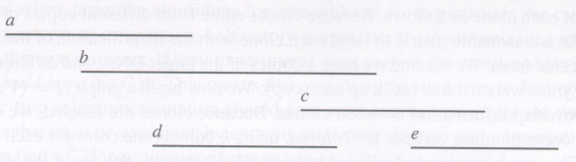
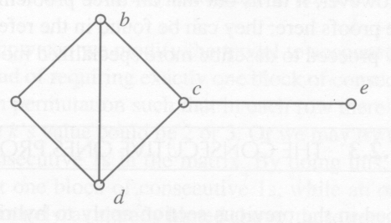
G_{r} and G_{t}:
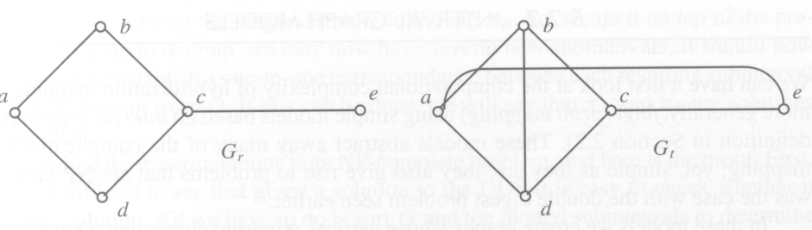
Second Model:
We do not assume that the known overlap information is reliable.

Does there exist graph G′ = (V, E′) such that E′ ⊆ E, G′ is an interval graph and |E′| is maximum?

Third Model:
We use overlap information together with information about the source of each clone.

The graph constructed will not have an edge between vertices of the same color, because they correspond to clones that came from the same molecule copy and hence cannot overlap.

Does there exist graph G′ = (V, E′) such that E ⊆ E′, G′ is an interval graph, and the coloring of G is valid for G′?

In other words, can we add edges to G transforming it into an interval graph without violating the coloring?
2.3 The Consecutive Ones Property
It can be used in any situation where we can obtain some kind of fingerprint for each fragment.

Assumption:
- The reverse complement of each probe’s sequence occurs only once along the target DNA (“probes are unique”).
- There are no errors.
- All “clones × probes” hybridization experiments have been done.

Problem:
Find a permutation of the columns (probes) such that all 1s in each row (clone) are consecutive.

Verifying whether a matrix has this property and then finding a valid permutation is a well-known problem for which polynomial algorithms exist.

If their experiments were perfect, the resulting hybridization matrix would have the C1P.

Note that even if a C1P permutation exists, we cannot claim that it is the true permutation.

NP-hardness comes up again if we relax the assumption that probes must be unique, even if no errors are present.

2.4 Algorithmic Implications

Desirable Features:
- It should work better with more data, assuming that the error rate stays the same.
- It should present a solution embedded in a rich framework of details, in particular showing how the solution was obtained, distinguishing “good” parts of the solution (groups of clones for which there was strong evidence for the ordering reported) from “not so good” parts. This greatly facilitates further experiments.
- If several candidate solutions meet the optimization criteria, all of them should be reported. If too many solutions are reported, the optimization criteria may be too weak (or the input data may contain too many errors). Conversely, if no solutions are reported, the optimization criteria may be too strong.

We may try to design an algorithm that can optimize multi-objective functions.

3. An Algorithm for the C1P Problem

- Determine whether an n×m binary matrix M has the C1P for rows.
- The goal is to find a permutation of the columns such that in each row all 1s are consecutive.

Assumption (for simplicity):
- all rows are different (no two clones have the same fingerprint)
- no row is all zeros ( every clone is hybridized by at least one probe)

Separating the rows into several components

There is an undirected edge from vertices i to j if S_{i} ∩ S_{j} ≠ φ and none of them is a subset of the other.
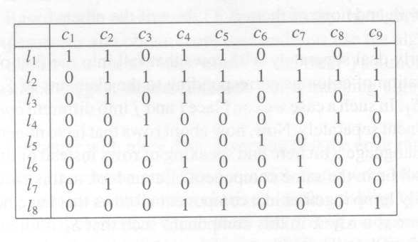
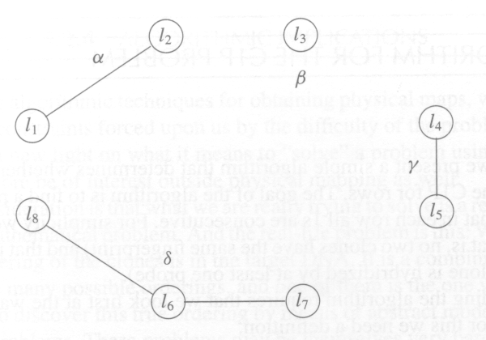
Taking Care of a Component
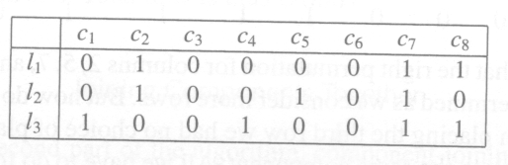
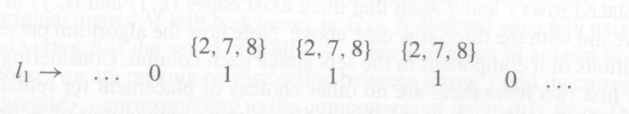

The direction we choose to place the second row does not matter.
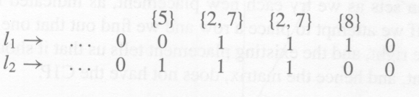

If l₁⋅l₃ < min(l₁⋅l₂, l₂⋅l₃), row l₃ must go in the same direction that l₂ was placed respect to l₁. If l₁⋅l₃ > min(l₁⋅l₂, l₂⋅l₃), then we must place l₃ in the opposite direction used to place l₂ with respect to l₁.

S₃ = {1, 4, 7, 8}, 1⋅3 = 2, 1⋅2 = 2, 3⋅2 = 1. ⇒ 2 > 1
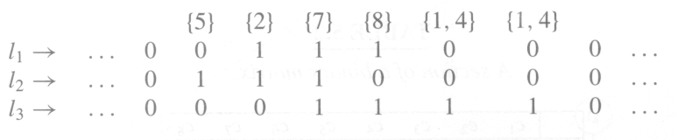

Joining Components Together

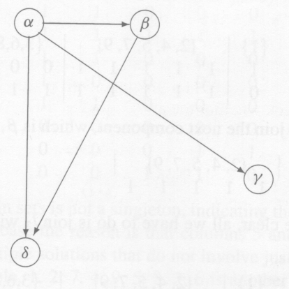

Created by: Kuo-Shi Huang
Date: Oct. 3, 2000
