Three-dimensional subband coding of an image sequence based on temporally adaptive decomposition

Yong Kwan Kim, Rin Chul Kim, Sang Uk Lee

Opt. Eng. 35(11) 3250-3259 (November 1996)

1. Introduction
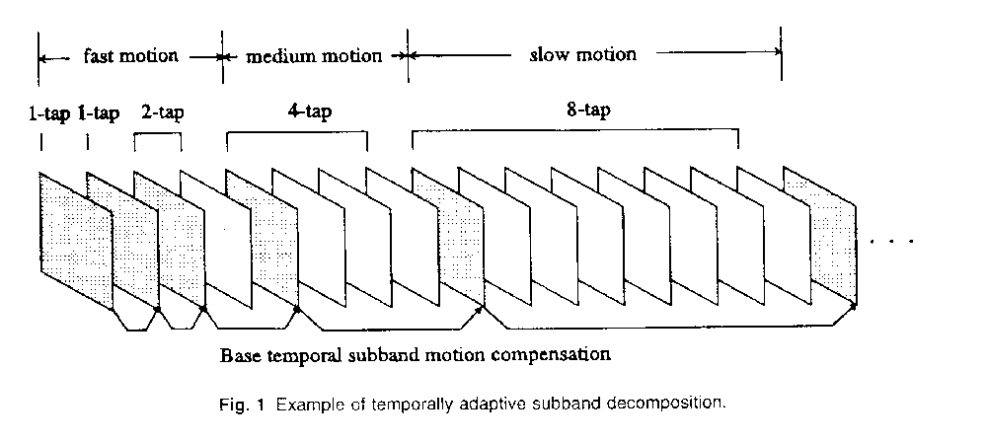

2. Adaptive 3-D SBC Techniques
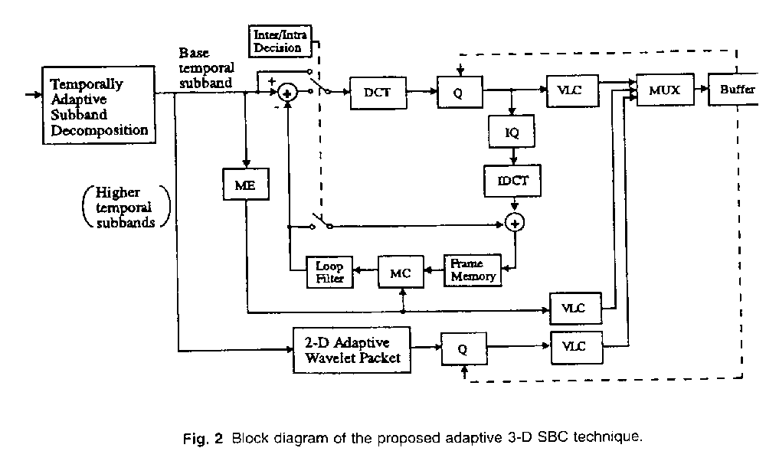
base temporal subband: H.261-like coder
higher temporal subband: adaptive wavelet packet bases algorithm
2.1 Temporally Adaptive Subband Decomposition
The higher temporal subbands exhibit relatively low correlations. Thus, the subbands can by modeled as a memoryless Laplacian.
Distortion 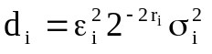 (1)
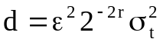 (2)
geometric mean: 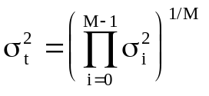 (3)
Algorithm:
Step 1: Initialize k ß 1
Step 2: Set the number of temporal subbands M(k) at k-th iteration to 2^{k-1}
Step 3: M(k) temporal subband decomposition is carried out using M(k) frames [f_{c}, f_{c+M(k)-1}]; then, the motion compensated error of the base temporal subband is obtained
Step 4: Calculate the 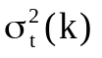 using (3);
If k = 1, then {kßk + 1; go to Step 2}
Step 5: If < 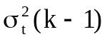, then {
If k = 4, then {kß k + 1 ; go to step 6};
Compute 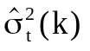 on the subsequent M(k) frames [f_{c+M(k)}, f_{c+2M(k)-1}]
using the same methods as in Step 3 and Step 4;
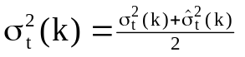;
kß k + 1; go to Step 2.}
Step 6: Choose the M(k-1) temporal subband decomposition as an optimal one.
The variance 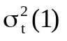 for M = 1 is multiplied by the factor 1.25.

2.2 Adaptive Wavelet Packet Bases Algorithm
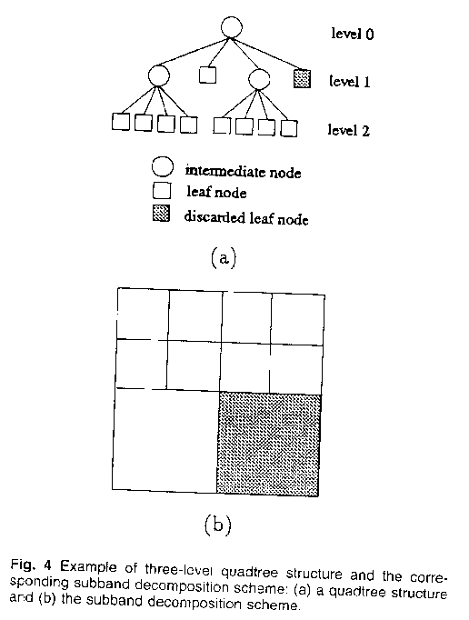

3. Coding Technique
3.1 Coding of Higher Temporal Subbands
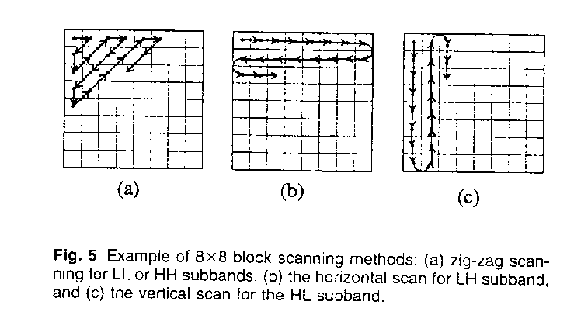
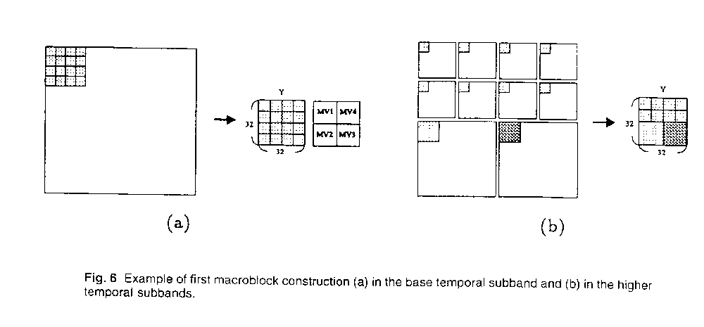
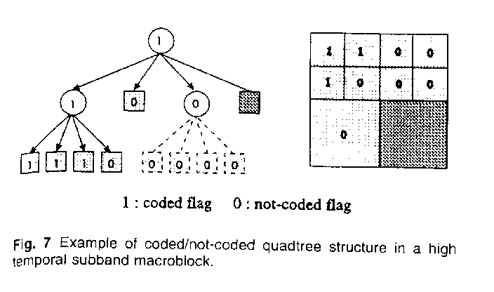
3.2 Coding of Base Temporal Subband
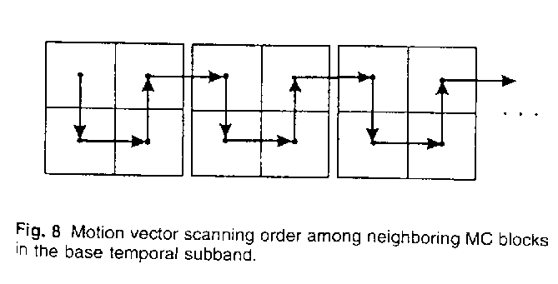
3.3 Buffer Control

4. Simulation Results

5. Conclusions
3-D SBC with MC(motion compensation)

optimal number M of the input sequence

base temporal subband: H.261-like coder
higher temporal subband: adaptive wavelet packet bases algorithm

Each subband in the higher temporal subbands was quantized by the uniform threshold quantizer and rearranged according to the characteristics of each subband. The rearranged data were coded using 2-D Huffman coding.

Created by: Kuo-Shii Huang
Date: Feb 25, 1998

