Path Costs in Evolutionary Tree Reconstruction

Dorit S. Hochbaum and Anu Pathria

Journal of Computational Biology, Vol. 4, pp. 163-175, Feb. 1997

0. Introduction

The problem of reconstruction of evolutionary, or phylogenetic, trees from protein sequence data addressed in two different set-ups. In one, the topology of the tree is to be determined based on given sequences to be assigned to the leaves. In the other set-up, the tree topology and the sequences are given, and the goal is to infer the sequences for the (internal) nodes of the tree.
If two endpoints of an edge have different labelings, then there is a positive cost assigned to that edge, where the cost is a measure of dissimilarity between the two sequences.
Overall cost can be calculated by considering the cost associated with each character position independently.
Therefore, it suffices to study the reconstruction problem in which each node is assigned a single character (which we refer to as a color).
A tree coloring that minimizes the number of bicolored edges is called a minimal coloring.

We consider several problems related to minimal evolutionary colorings.
- The Minimal Tree Reconstruction optimization problem:
Given a binary tree whose leaves are assigned a particular color from a given set of colors, the problem is to color the remaining (internal) nodes such that the resulting tree has minimum cost. The cost of a tree is equal to the number of edges that have their endpoints assigned different colors; an edge that has its endpoints assigned different colors is referred to as a bicolored edge, and has a cost of one unit.
- Finding the average edge cost of a given edge e in the set of all minimal colorings, where the average edge cost in a phylogenetic tree is defined as the fraction of minimal colorings in which the given edge is bicolored.
- The more general question of determining the average path cost (as well as minimum and maximum cost) for any given path, P, in the set of minimal colorings was raised as an open question.

1. Evolutionary Tree Reconstruction from Sequence Data

Problem Name: Minimal Tree Reconstruction
Instance: Given a tree T = (V, E), a set of colors C, and a subset V’⊆V of the nodes of T . For each v∈V’, the color of v, denoted color(v), is specified from amongst the colors in C.
Optimization Problem: Assign colors from C to the nodes V\V’ so as to minimize the number of bicolored edges; that is, color the remaining nodes so as to minimize the number of edges whose endpoints are assigned different colors.

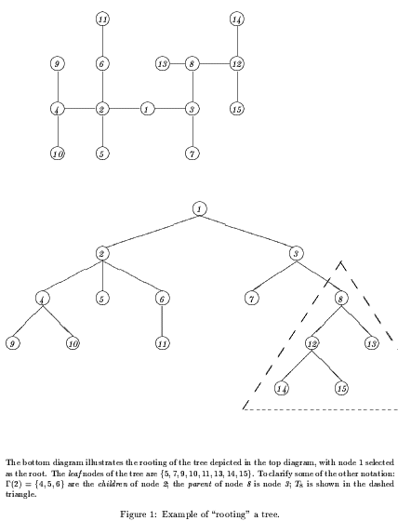
- Calculating the cost of a minimal coloring:
Boundary Condition: For x a leaf node (x ≠ r),
M_{c}(x) =∞; if color(x) preassigned, and color(x) ≠ c
0; otherwise.
Recurrence: For x an internal node,
M_{c}(x) = ∞; if color(x) preassigned, and color(x) ≠ c
Σ_{y∈Γ(x)}min{M_{c}(y),M(y)+1}; otherwise.
where M(y) = min_{k∈C}{M_{k}(y)}
Answer: M* = M(r) = min_{c∈C}M_{c}(r), where r is the root of the tree T .

- Calculating the number of a minimal coloring:
Boundary Condition: For x a leaf node (x ≠ r),
N_{c}(x) = 0; if color(x) preassigned, and color(x) ≠ c
1; otherwise.
Recurrence: For x an internal node,
N_{c}(x) = 0; if color(x) preassigned, and color(x) ≠ c
Π_{y∈Γ(x)}Ñ_{c}(y); otherwise.
where Ñ_{c}(y) is the number of different colorings of T_{y} that lead to an optimal coloring of T_{x}, given that x is assigned the color c, where x is the parent of y.
Then, by noting which colorings of y lead to minimal colorings for T_{x}, given that x is assigned the color c, we find that
Ñ_{c}(y) = N_{c}(y); If M_{c}(y) = M(y)

N(y); M_{c}(y) > M(y) + 1
N(y)+N_{c}(y); otherwise (i.e. if M_{c}(y) = M(y) + 1)
where N(y) is the sum of those N_{k}(y) for which M_{k}(y) = M(y).
Answer:
N* = N(r) = Σ_{c∈C|Mc(r)=M*}N_{c}(r), where r is the root of the tree T.

- M* and N* can be found in O(n|C|) time.

2. Calculating the Average Path Cost Amongst all Minimal Trees

2.1 Paths of Length 1(Calculating Average Edge Costs)
The average cost of e immediately follows by dividing the number of minimal colorings for which e is bicolored by the overall number of minimal colorings.

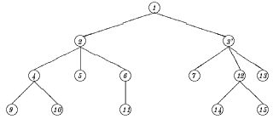

2.2 Paths of Arbitrary Length
Let N_{p} = N_{p}(r) = Σ_{k∈C|Mk}^{p}_{(r)=M*}N_{k}^{p}(r), p∈{0, 1, …, |P|}
N_{p} is the number of minimal colorings in which the path P has exactly p bicolored edges.
Thus, we can easily calculate the expected, minimum, and maximum cost of the path P in a minimal coloring as,
P_{ave} = Σ_{p}pN_{p} / N*,
P_{min} = min{ p | N_{p} > 0}, and
P_{max} = max{ p | N_{p} > 0}
Notice that, using the values N_{p}, we can also calculate other statistical measures describing the cost of P in a minimal coloring such as the range, variance, or higher order moments.

- M* and N* can be found in O((n + |P|²)|C|) time.

3. Generalizations of the Tree Reconstruction Problem

3.1 The Reconstruction Problem on General Graphs
K-cut optimization problem with specified nodes (K = |C|)
3.2 Generalizing the Reconstruction Problem on Trees
- As far as the problem of determining the edge costs of phylogenetic trees is concerned, it may be interesting to vary the costs associated with different bicolorations.
- We can also consider the generalization where costs (not necessarily equal) are associated with using particular colors.

4. Summary

Application:
- Count the number of optimal paths in a network;
- Calculate the trophic level of the species in a food web;
- Measure the network reliability.

Created by: Kuo-Shii Huang
Date: May 6, 1999

