General Technique for Comparing Unrooted Evolutionary Trees

Ming-Yang Kao, Tak-Wah Lam, Teresa M. Przytycka, Wing-Kin Sung and Hing-Fung Ting

In Proceedings of the Twenty-Ninth Annual ACM Symposium on Theory of Computing (STOC'97), USA, May 1997, pp. 54-65.

1. Introduction

An agreement subtree of two evolutionary trees is an evolutionary tree which is also a topological subtree of the two given trees.
A maximum agreement subtree is one with the largest possible number of leaves.

How much two theories have in common?

This paper presents two sets of techniques for comparing unrooted evolutionary trees:
- Four-way dynamic programming. ( O(n log n) )
- Label compression. ( O(n^{1.5}log n) )

2. Basics

Consider two rooted evolutionary trees R₀ and R₁ labeled over L. Let R₀ be a subtree of R₀ induced by some subset of L. We similarly define R₁’ for R₁. If there exists an isomorphism between R₀’ and R₁’ mapping each leaf in R₀’ to one in R₁’ with the same label, then R₀’ and R₁’ are each called agreement subtrees of R₀ and R₁.

UMAST(T₀, T₁) = max_{u∈T0,v∈T1}MAST(T₀^{u}, T₁^{v}) (1)

3. An O(n log n)-time algorithm for bounded degree trees

MAST(T₀^{x0}, T₁^{x1}) = max_{π∈Π}{ MAST(S(x₀), π(S)(x₁)) +
MAST(B(x₀), π(B)(x₁)) +
MAST(T(x₀), π(T)(x₁)) } (2)

Given a partition of a tree T into paths we define two partial orders: up and down on the set of paths in the partition. Namely, let P; P 0 be two paths of a partition of T. Then P up P’ if level(topmost(P)) > level(topmost(P’)) where level(v) is the distance of the vertex v to the root. Similarly P down P’ if level(topmost(P))) < level(topmost(P’)).

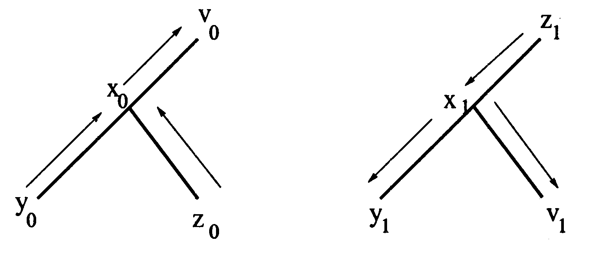
Figure: The up-down partial order.

For the up-up direction, we assume that the roots are node R₀, R₁ respectively, i.e. we compute MAST(TR₀x₀, TR₁x₁). In the up-down direction, we compute MAST(TR₀x₀, Ts(x₁)x₁) and MAST(TR₀x₀, Tb(x₁)x₁). Symmetrically for the down-up direction. Finally, in the down-down computation we compute MAST(Tb(x₀)x₀, Tb(x₁)x₁), MAST(Tb(x₀)x₀, Ts(x₁)x₁), MAST(Ts(x₀)x₀, Tb(x₁)x₁), and MAST(Ts(x₀)x₀, Ts(x₁)x₁).

UMAST(T₀, T₁) = maxr_{i}∈T_{i}, (r₀, r₁) is interestingMAST(T₀r₀, T₁r₁)

4. An O(n^{1.5}log n)-time algorithm for unbounded degree trees

5. Label compressions

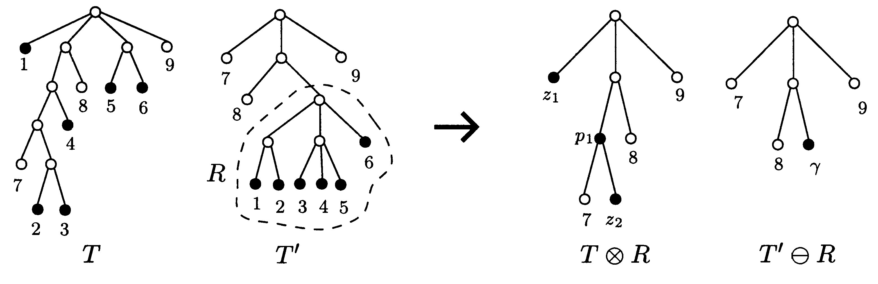
W W’

MAST(T, T’) = MAST(W, W’)

Created by: Kuo-Shii Huang

Date: May 25, 1999

