An Algorithm for Finding the Largest Approximately Common Substructures of Two Trees

Jason T. L. Wang, Bruce A. Shapiro, Dennis Shasha, Kaizhong Zhang, and Kathleen M. Currey

IEEE Transactions on Pattern Analysis and Machine Intelligence, Vol. 20, No. 8, August 1998, pp. 889-895

1. Introduction

Ordered, labeled trees are trees in which each node has a label and the left-to-right order of its children is fixed.

Application: vision, pattern recognition, molecular biology, and natural language processing, including the representation of images, patterns, and secondary structures of RNA.

Finding common patterns (motifs) in these secondary structures helps both in predicting RNA folding and in functional studies of RNA processing mechanisms.

- Previous methods for detecting motifs in RNA:
- Transforming the trees to sequences and then using sequence algorithms.
- Representing the molecules using a highly simplified tree structure and then searching for common nodes in the trees.

2. Preliminaries

- Edit Distance and Mappings
Edit Distance: relabeling, delete, insert a node.
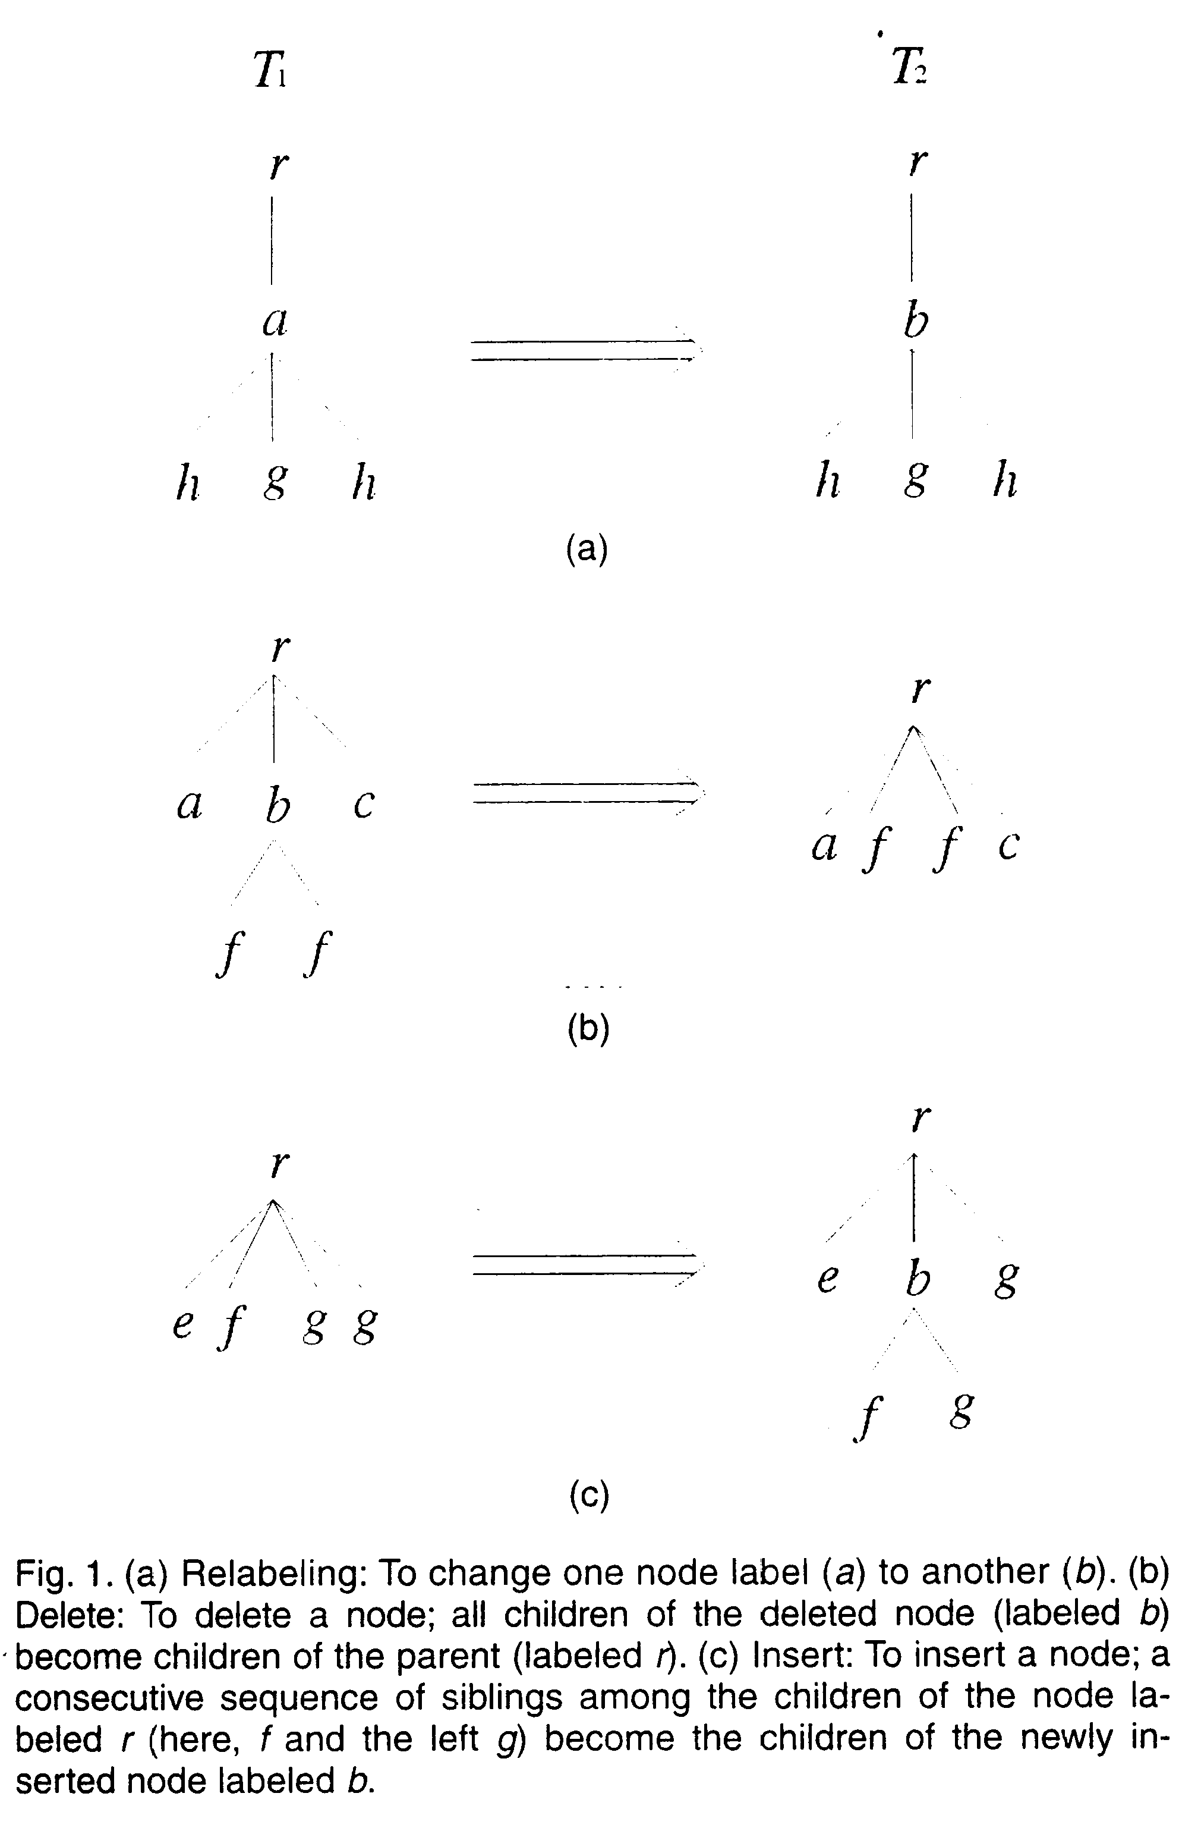

Mapping:
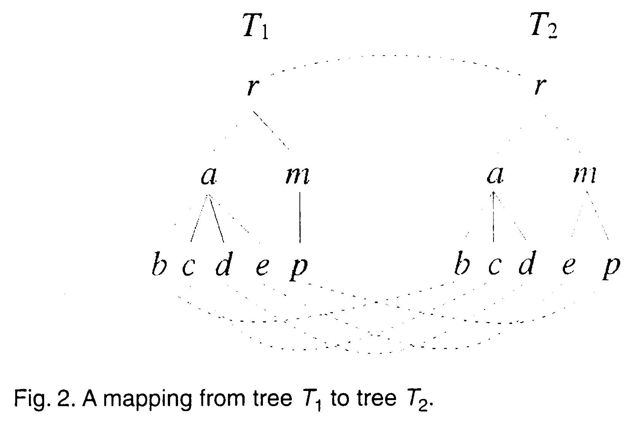
3. Our Algorithm
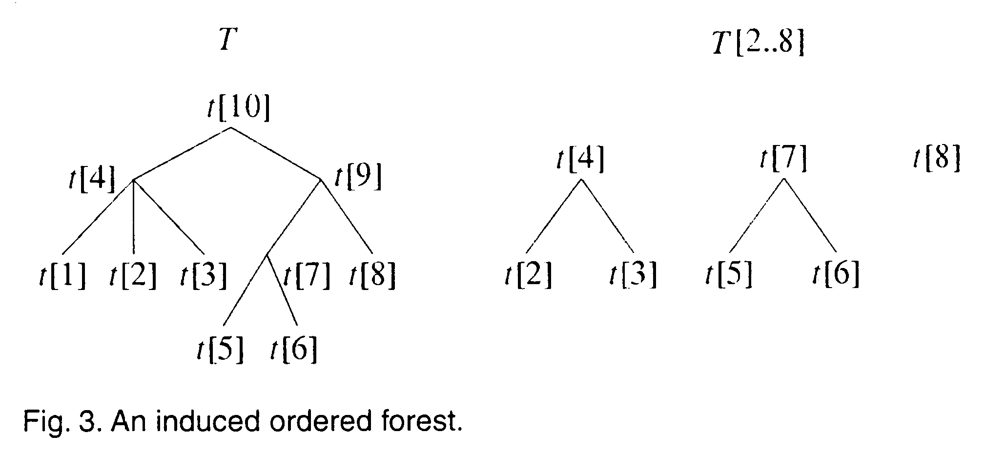
Lemma 3.1. Suppose s ∈desc(i) and t∈desc(j). Then
- Ψ(φ, φ, 0) = 0
- Ψ(T₁[l(i)..s], φ, 0) = 0
- Ψ(φ, T₂[l(j)..t], 0) = 0

Lemma 3.2. Suppose s ∈desc(i) and t∈desc(j). Then for all k, 1≤k≤d,
- Ψ(φ, φ, k) = 0
- Ψ(T₁[l(i)..s], φ, k) =
max{Ψ(T₁[l(i)..s], φ, k–1)+1, Ψ(T₁[l(i)..l(s)–1], φ, k)}
- Ψ(φ, T₂[l(j)..t], k) =
max{Ψ(φ, T₂[l(j)..t], k–1)+1, Ψ(φ, T₂[l(j)..l(t)–1], k)}

Lemma 3.3. Suppose s ∈desc(i) and t∈desc(j). If ( l(s)≠l(i) or l(t)≠l(j) ), then
Ψ( l(i)..s, l(j)..t, 0) = max {
Ψ( l(i)..l(s)–1, l(j)..t, 0),
Ψ( l(i)..s, l(j)..l(t)–1, 0),
Ψ( l(i)..l(s)–1, l(j)..l(t)–1, 0)+β(s, t, 0) }

Lemma 3.4. Suppose s ∈desc(i) and t∈desc(j). Suppose both T₁[l(i)..s] and T₂[l(j)..t] are trees (i.e., l(s) = l(i) and l(t) = l(j)). Then
Ψ( l(i)..s, l(j)..t, 0) = Ψ( l(i)..s–1, l(j)..t–1, 0)+2 if t₁[s] = t₂[t]
= 0 otherwise

Lemma 3.5. Suppose s ∈desc(i) and t∈desc(j). If ( l(s)≠l(i) or l(t)≠l(j) ), then for all k, 1≤k≤d,
Ψ( l(i)..s, l(j)..t, k) =
max {
Ψ( l(i)..l(s)–1, l(j)..t, k),
Ψ( l(i)..s, l(j)..l(t)–1, k),
Ψ( l(i)..s–1, l(j)..t, k–1)+1,
Ψ( l(i)..s, l(j)..t–1, k–1)+1,
max_{0≤h≤k}{Ψ( l(i)..l(s)–1, l(j)..l(t)–1, k–h)+β(s, t, h)} }

Lemma 3.6. Suppose s ∈desc(i) and t∈desc(j). Suppose both T₁[l(i)..s] and T2[l(j)..t] are trees (i.i., l(s) = l(i) and l(t) = l(j)). Then for all k, 1≤k≤d,
Ψ( l(i)..s, l(j)..t, k) =
max {
Ψ( l(i)..s–1, l(j)..t, k–1)+1,
Ψ( l(i)..s, l(j)..t–1, k–1)+1,
Ψ( l(i)..s–1, l(j)..t–1, k–c)+2 }
where c = 0 if t₁[s] = t₂[t]
= 1 otherwise

4. Implementation and Discussion

Created by: Kuo-Shii Huang
Date: July 27, 1999

