A One-Phase Parallel Algorithm for the Sequence Alignment Problem

Thierry Lecroq, Jean-Frederic Myoupo, and David Seme

Parallel Processing Letters, Vol. 8, No. 4, 1998, pp. 515-526

1. Introduction

Edit Distance: deletion, insertion, and substitution (of a nucleotide).

Listing: Alignment:
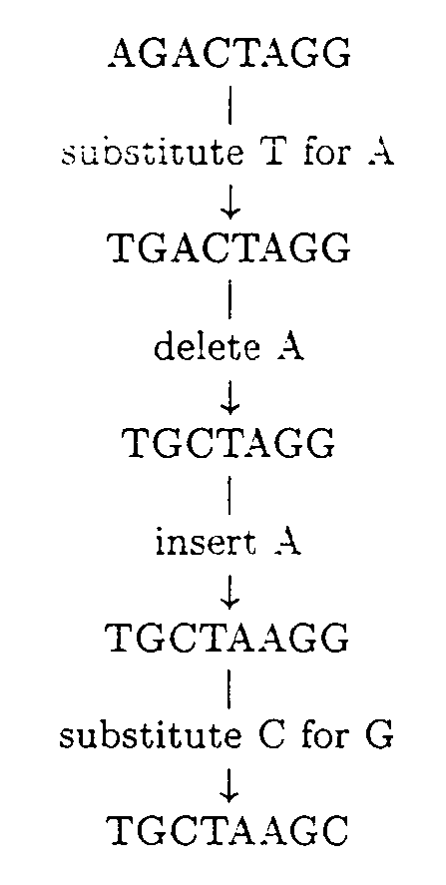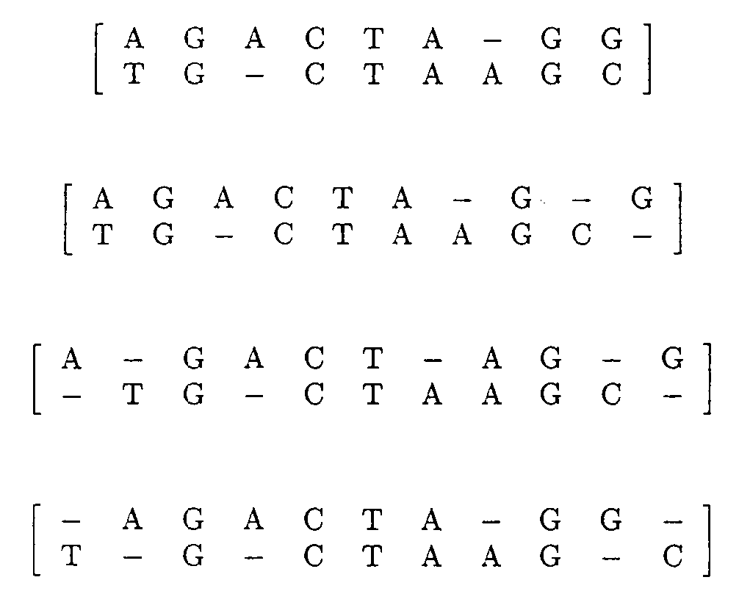

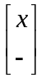: Deletion of the character x
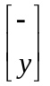: Insertion of the character y
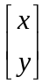: Substitution of y for x

2. Statement of the Problem

Source = Source₁Source₂Source₃ … Source_{m}
Target = Target₁Target₂Target₃ …Target_{n}
d_{i,j} is the edit distance between subsequences Source₁Source₂ … Source_{i} and Target₁Targe₂ … Target_{j}.

(1) d_{0,0} = 0
d_{i,0} = d_{i–1,0} + c_{del(Sourcei)}, 1 ≤ i ≤ m
d_{0,j} = d_{0,j–1} + c_{ins(Targetj)}, 1 ≤ j ≤ n
(2)
d_{I,j} = min | { | d_{i–1,j} + c_{del(Sourcei)},  d_{i,j–1} + c_{ins(Targetj)},  d_{i–1,j–1} + c_{sub(Sourcei, Targetj)}, | 1 ≤ i ≤ m, 1 ≤ j ≤ n

(3) c_{del(a)} = 1
c_{ins(a)} = 1
c_{sub(a,b)} = 0, if a = b
c_{sub(a,b)} = 2, if a ≠ b

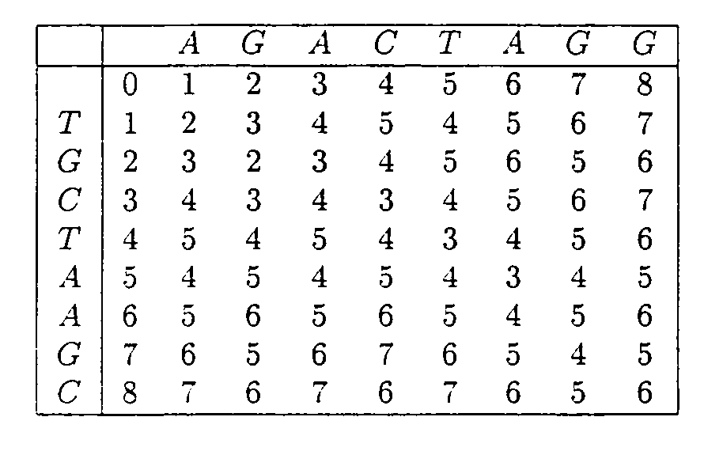
3. New Implementation
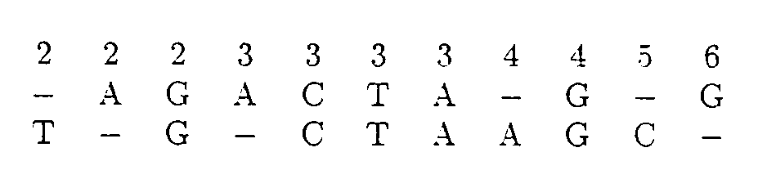
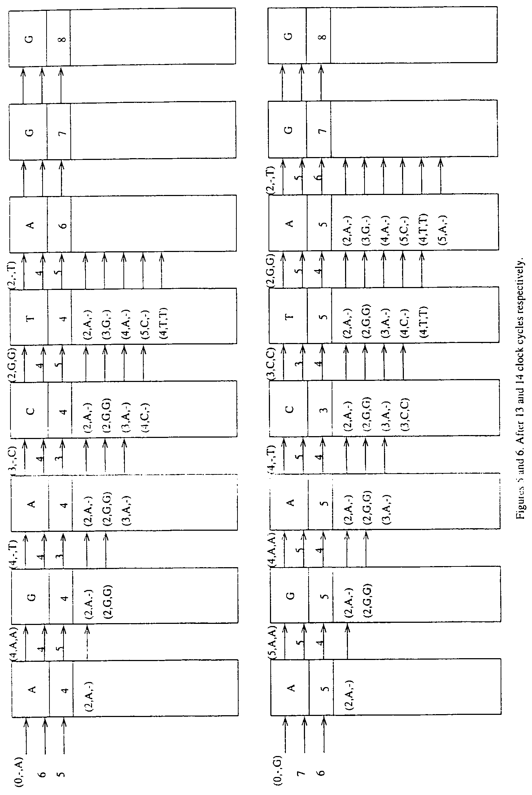

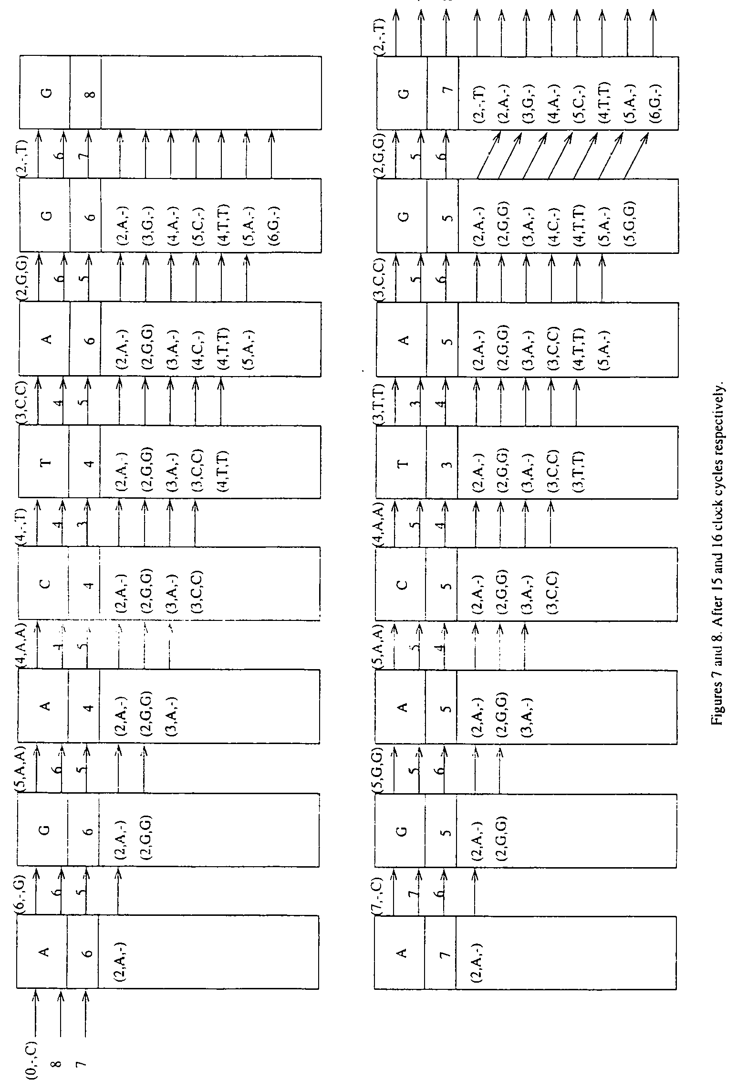
4. Conclusion

Created by: Kuo-Shii Huang
Date: Dec. 3, 1999

