The Multiple Sequence Alignment Problem in Biology

Humberto Carrillo and David Lipman

SIAM Journal of Applied Mathematics, Vol. 48, No. 5, October 1988,
pp. 1073-1082

1. Introduction

- The comparison of two or more sequences of numbers or letters is common in several fields, such as molecular biology, speech .recognition, and computer science.
- Dynamic programming with O(n^{k}) comparisons.
- Reducing computation in the dynamic programming method.

2. Sequence

3. Alignments

An alignment of the sequences S₁, …, S_{n} is another set of sequences, 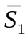, …, 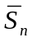, such that each sequence 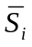 is obtained from S_{i} by inserting blanks in positions where some of the other sequences have a nonblank character.

4. Paths
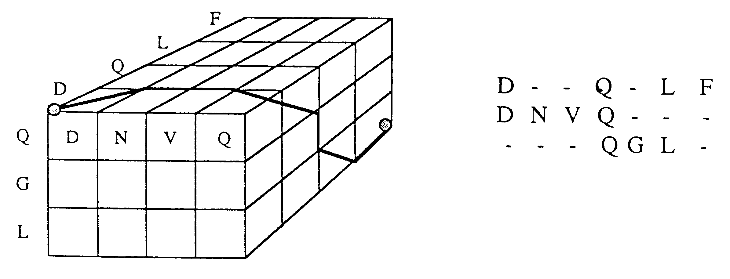

5. Optimal Paths

Each path is associated with a unique alignment, in this way the scoring rules allow us to assign to any given path γ a measure M(γ). M(γ) is a measure of the similarity among the sequences S₁, …, S_{N} when they are compared according to the alignment associated to the path γ.
Corresponding to each measure M(γ) there is at least one path such that M attains a minimum value at γ*. Such a path is called an optimal path. The optimal paths in the lattice L(S₁, …, S_{N}) can be found by dynamic programming methods. This computation of γ* takes O(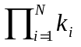) steps.
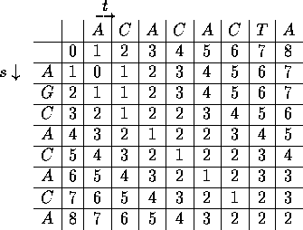

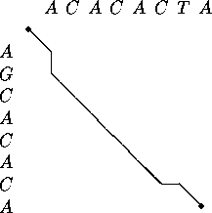

6. Constraints on multiple alignments

It will result in significantly fewer computations.
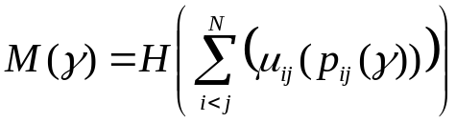,
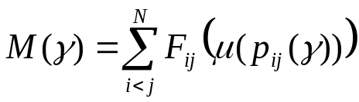,

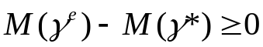,
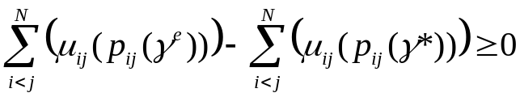,

Since, 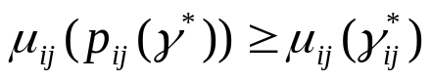
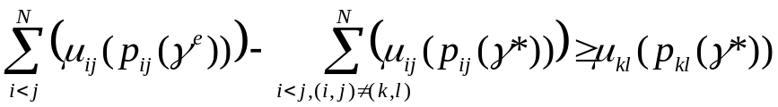,
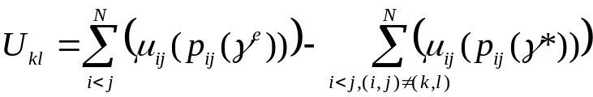.

Then, when looking for γ* we need only consider those paths γ in L(S₁, …, S_{N}) that satisfy that 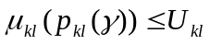. We will call this set of paths X_{kl}.
Thus the paths γ in the set X = 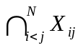 are the only possible candidates to be an optimal path. To consider only paths in X means having to apply the dynamic programming procedure to find γ* only in some subregion Y of L(S₁, …, S_{N}). All regions Y_{ij} may be computed in O(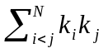).

7. Estimated paths

Approach 1:
If there is a path γ such that p_{ij}(γ) = γ_{ij}* for all i, j, where γ_{ij}* denotes an optimal path on the lattice L(S_{i}, S_{j}), then γ is an optimal path for the N-dimensional problem. Therefore, since M(γ) is a nondecreasing function of 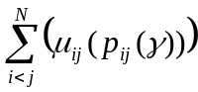, the idea is to construct γ^{e} in such a way that its projections p_{ij}(γ^{e}) are as close as possible to the optimal paths.

Approach 2:
Start with a guess of an estimated measure Me which, unlike M(γ^{e}), may not necessarily correspond to the measure of an actual γ. We may then determine all upper bounds using Me and proceed to compute an “optimal” path 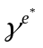 derived from this initial estimate. It is then trivial to show that if M() ≤ Me, then is a true optimal path. If M() > Me, then M() can be used to determine the upper bounds required in the computation of γ*.

8. Discussion

f_{ij} = |Y_{ij}|/k_{i}k_{j}
To determine the regions Y_{ij} requires O() computations, a figure which does not grow exponentially with N. Given the regions Y_{ij}, the region Y_{i} can be generated and the optimization can be carried out within in O(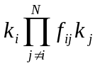) steps; the memory requirements are of the same order.

A priori M(γ*) ≥ 0, and if M(γ*) = 0, the sequences are identical and the location of γ* is on the main diagonal of the plane.

Created by: Kuo-Shii Huang
Date: Dec. 23, 1999

