A Fault-Tolerant Communication Scheme for Hypercube Computers

Tze Chiang Lee and John P. Hayes, Fellow, IEEE

IEEE Transaction on Compuers, VOL 41, NO. 10, October 1992,
- 1242-1256

1. Introduction

2. Preliminaries

Hamming distance: the number of bits in which labels x_{i} and x_{j} differ is denoted by d(x_{i}, x_{j}).

Link Representation, denoted as x | (j₁, j₂, …, j_{l})

A path containing no faulty nodes is called a feasible path.
A feasible path is minimum if it is the shortest feasible path in Q_{n} between the end nodes.
A fault hypercube is optimal if it finds a minimum feasible path for every message, whenever such a path exists.

f_{i}(x_{k}, x_{j}) to be the position the ith bit from the left, that is, the dimension i, in which the labels x_{k} and x_{j} differ.
g_{i}(x_{k}, x_{j}) gives the position of the ith common bit between x_{k} and x_{j}.
- g.
f₁(001101,001010) = 4
f₂(001101,001010) = 5
g₁(001101,001010) = 1
g₂(001101,001010) = 2
f₁(001101,001101) = 0
g₁(001101,110010) = 0
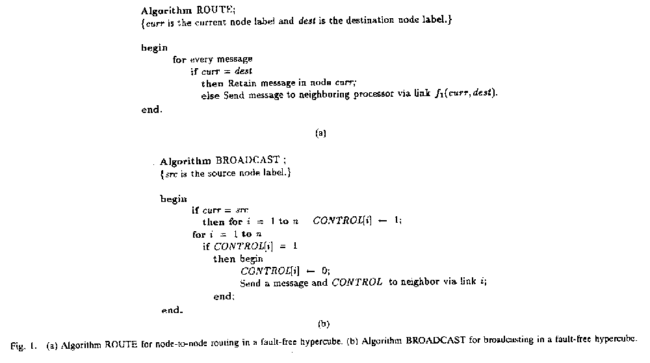
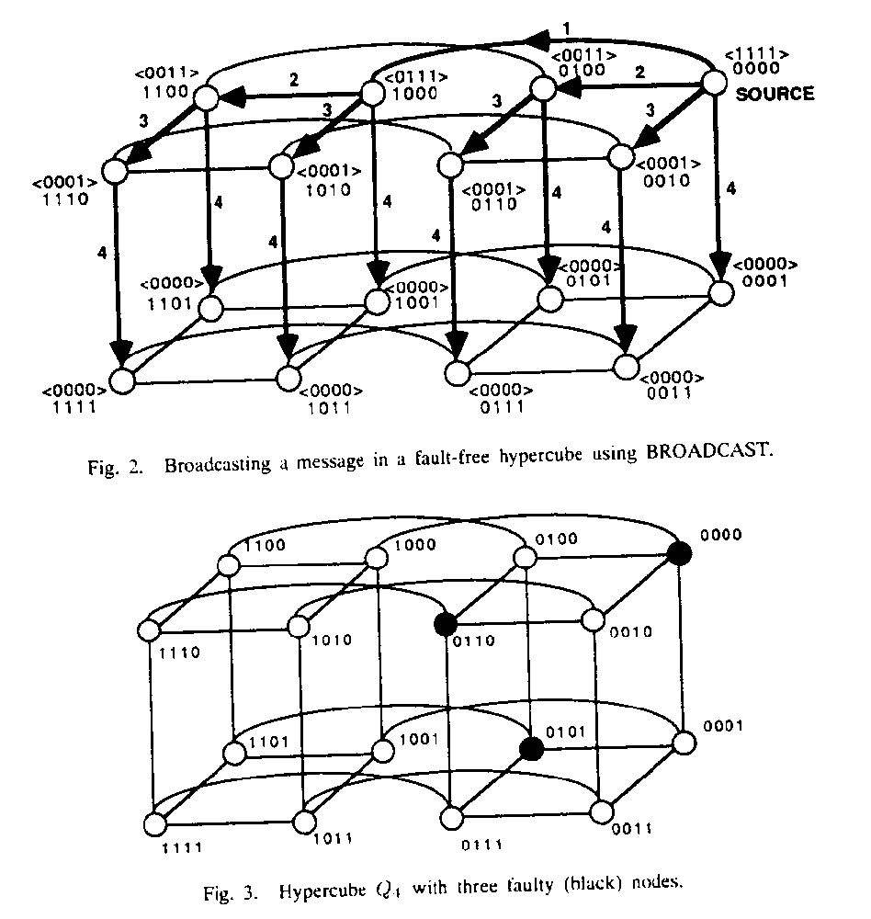

3. Routing in Faulty Hypercubes

Fig. 3:
faulty(black) nodes 0110, 0101, and 0000
- from 0111 to 0100
path 1: 0111, 1111, 1110, 1100, 0100
path 2: 0111, 1111, 1101, 1100, 0100
path 1 and path 2 are minimum feasible paths.
- from 1111 to 0100
path 1: 1111, 1110, 1100, 0100 (o.k.)
path 2: 1111, 0111….(?)

k-neighborhood information: if its fault list identifies all fault nodes at distance k or less from a node.( k = n v.s k = 1)

A. Two-State Nodes: faulty or nonfaulty
For a node x, if k = n , i.e., x has a complete fault list:
an exhaustive search always leads to an optimal routing decision by x,
but storage size and computation time?
- s. k < n)
Algorithm Route1(k): Fig 4.
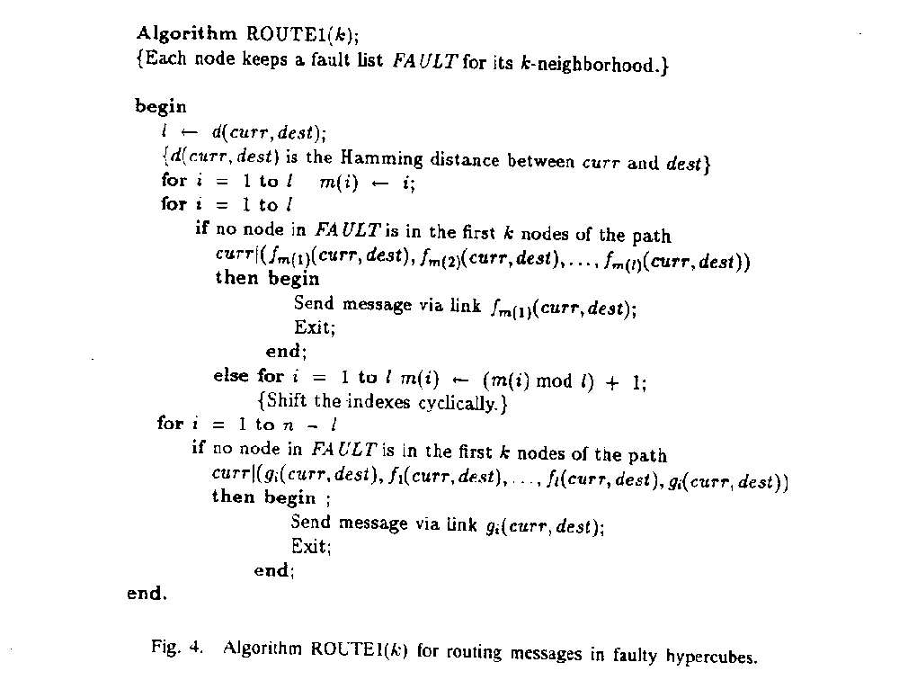
Theorem 1: Algorithm ROUTE1(k) finds a minimum feasible path for a message if each nonfaulty node in the system has no more than k faulty nodes in its k-neighborhood and k < r, where r is the Hamming distance between the source and destination nodes.
Corollary 1: ROUTE1(k) is optimal if no nonfaulty node has more than k faulty nodes in its k-neighborhood, for k ≤ 2.

Algorithm ROUTE2(k) that searches the set of all minimum paths(nondisjoint as well as disjoint) for a feasible one according to the current fault list.

Theorem 2: Route2(k) is optimal for k ≤ n - 1, provided that there no more than k faulty nodes in the k-neighborhood of each nonfaulty node.

- Three-State Nodes: active, unsafe, or faulty
A nonfaulty node is in the unsafe state if it has at least two faulty or unsafe nearest neighbors.

A subcube of dimension 1 or more is an unsafe subcube if it contains only unsafe or faulty nodes.
An unsafe subcube is maximum if it is contained in no other unsafe subcube.
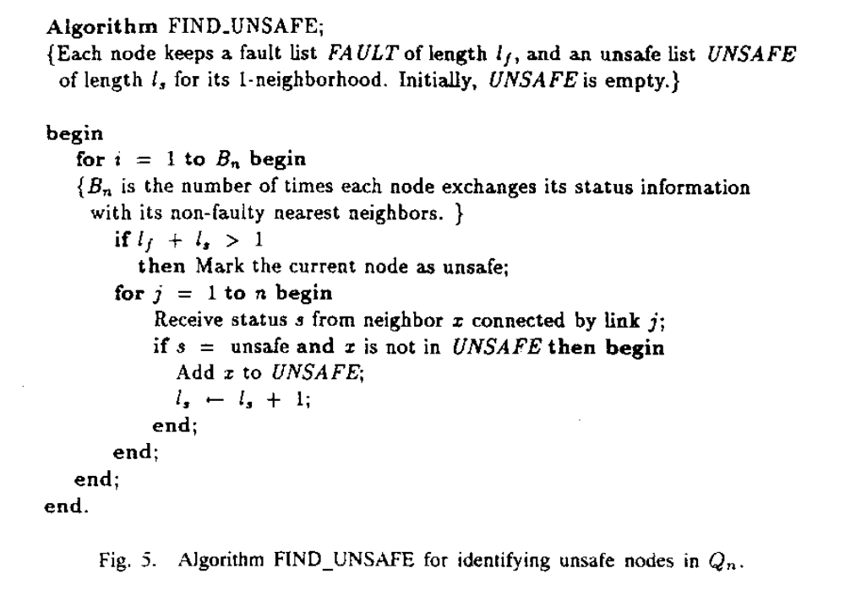
Theorem 3: The unsafe and faulty nodes of a hypercube form a set of maximum unsafe subcubes such that the distance between any two of them is at least three.
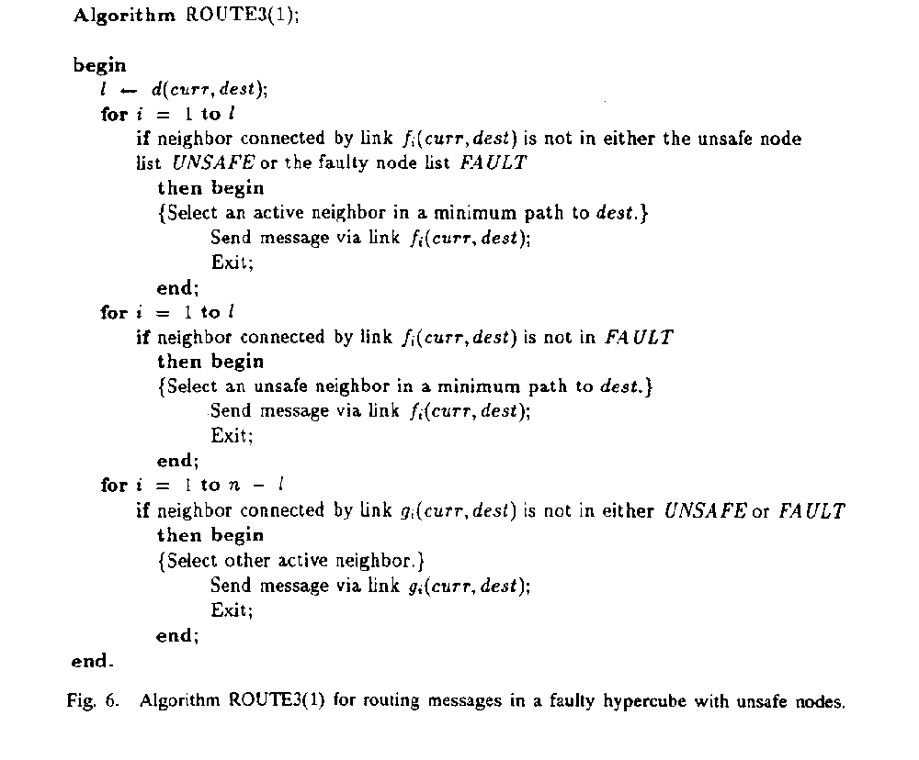

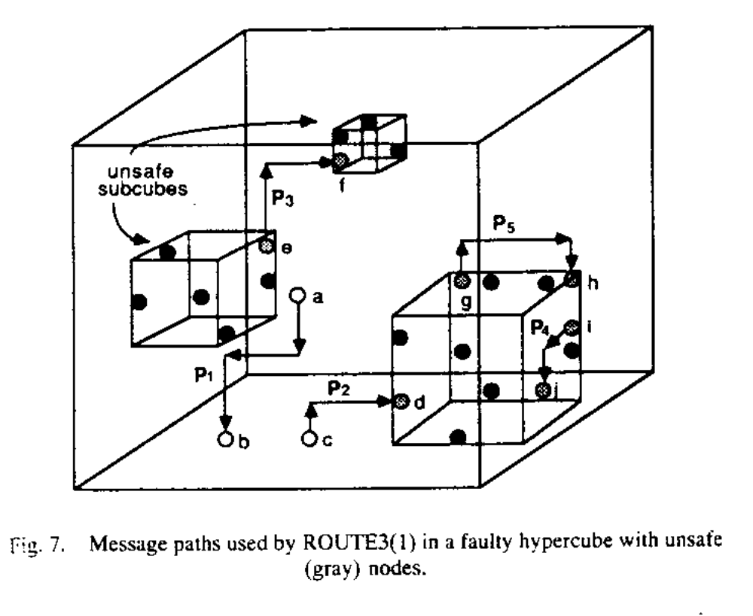Theorem 4: If Q_{n} is not unsafe, then ROUTE3(1) routes a message from source to destination via a path of length no more than the minimum path length plus two.

4. Broadcasting in Faulty Hypercubes
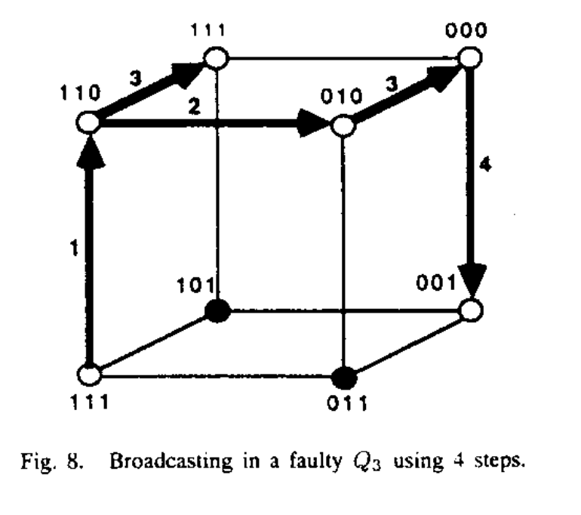
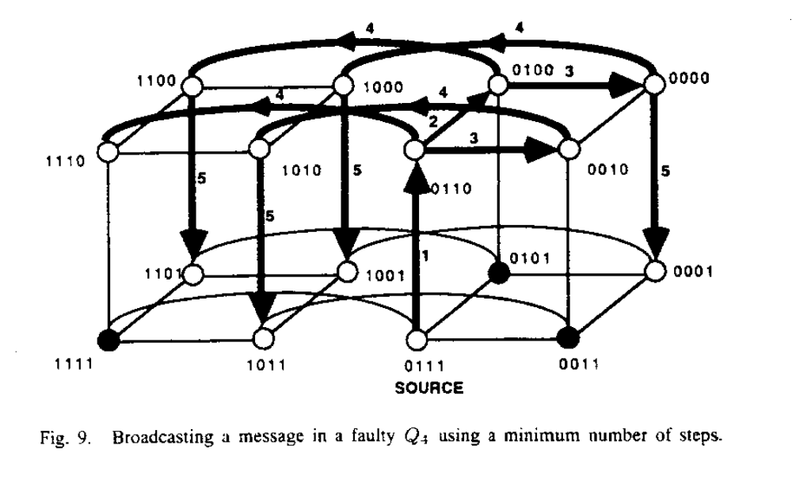
Theorem 5: Given two faulty nodes x₁ and x₂ separated by Hamming distance two in Q_{n}, the minimum number of steps required to broadcast a message from s, a common neighbor of x₁ and x₂, to all nonfaulty nodes is at least n + 1.
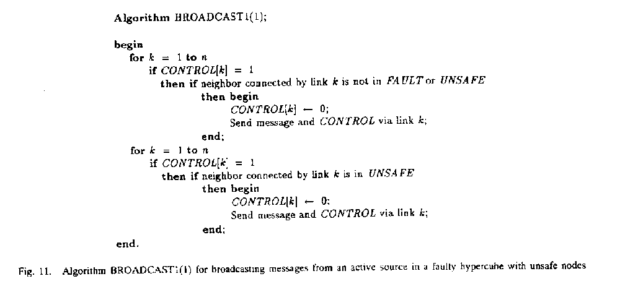
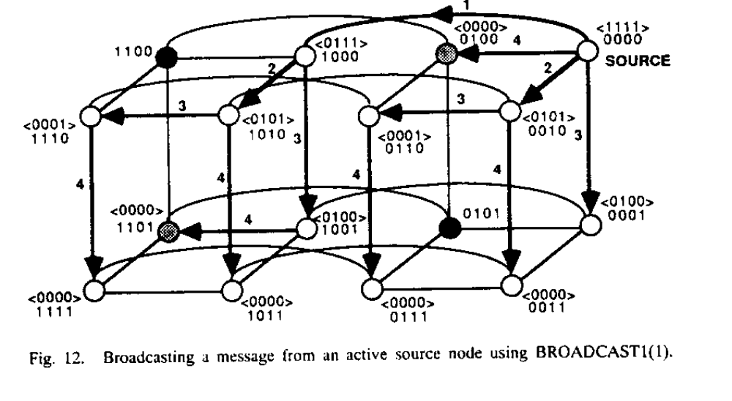
Theorem 6: BROADCAST1(1) broadcasts a message from an active node to all nonfaulty nodes in n time units, provided that Q_{n} is not unsafe.

When the source is unsafe, BROADCAST2(1) first sends a message to an active neighbor connected by the link with the smallest index.
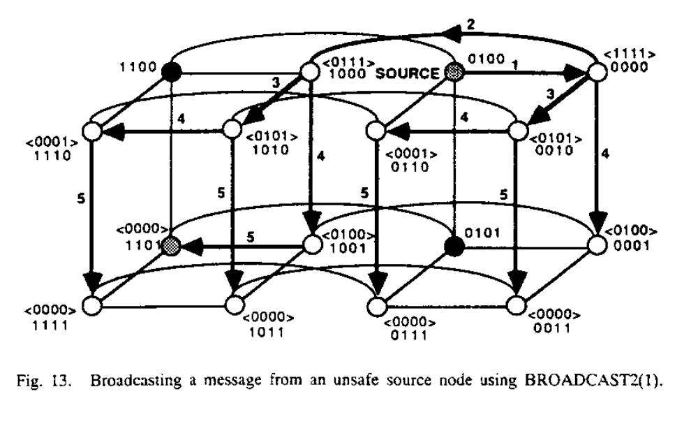
Theorem 7: BROADCAST2(1) broadcasts a message from any nonfaulty node to all nonfaulty nodes within n+1 time units, provided that Q_{n} is not unsafe.

5. Deadlock-Free Implementation
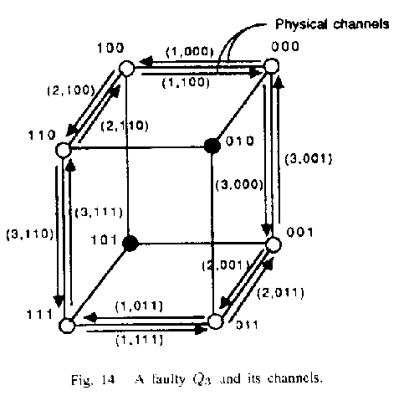
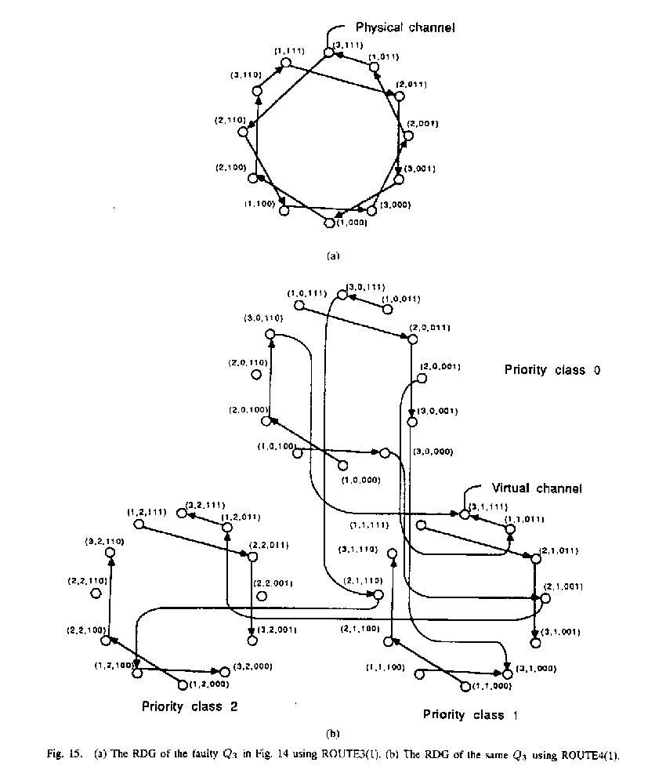
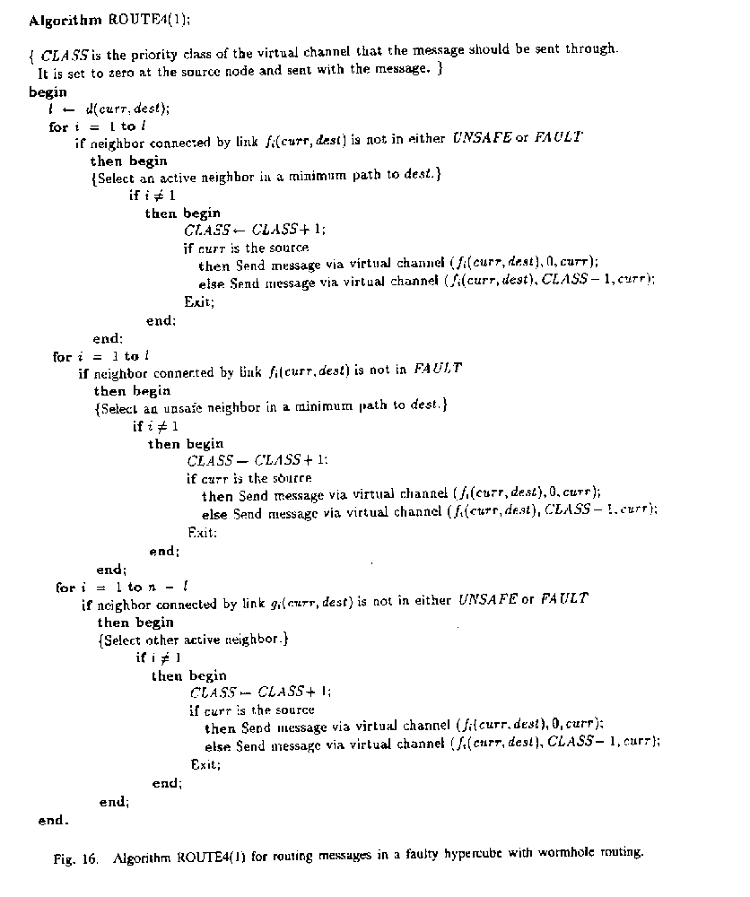Theorem 8: If Qn is not unsafe, ROUTE4(1) is deadlock-free.

