Memory Efficient and High-Speed Search Huffman Coding

Reza Hashemian, Senior Member, IEEE

IEEE Transactions on Communications, Vol. 43, No. 10, Oct. 1995,
pp. 2576 ~ 2581

1. Introduction
Huffman tree gets progressively sparse as it grows form the root. This sparsity in the Huffman tree may cause tremendous waste of memory space, unless a properly structured technique is adopted to allocate the symbols in the memory.

SGH-Tree: Single-Side Growing Huffman Tree
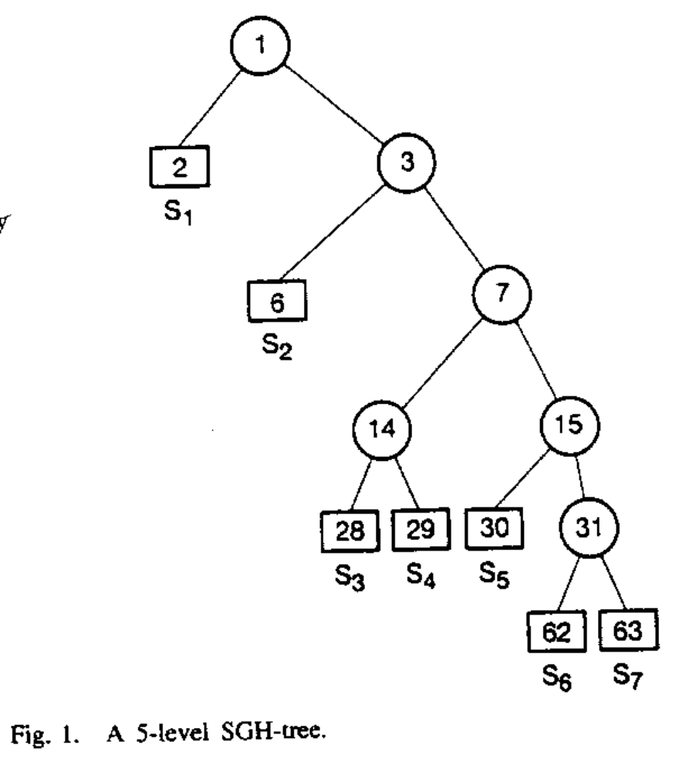

2. Variable-Length Code Structuring
Ordered pair H = (S, P), where S represents a set of source symbols S = {s₁, s₂, …, s_{n}} with probability distribution P(s_{i}) = p_{i}; for, p₁ ≥ p₂ ≥ … ≥ p_{n-1} ≥ p_{n}.
It is important to not that such a table Is uniquely obtained within permutation of the symbols in each row.

CL: codeword length
TOCL: table of codeword lengths

- Algorithm 1: Table of Codeword Lengths
CLR: codeword length recording
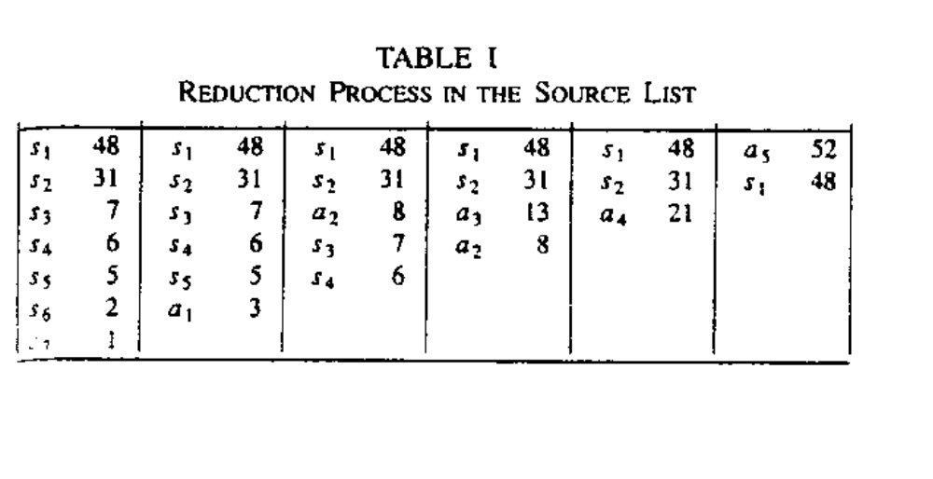
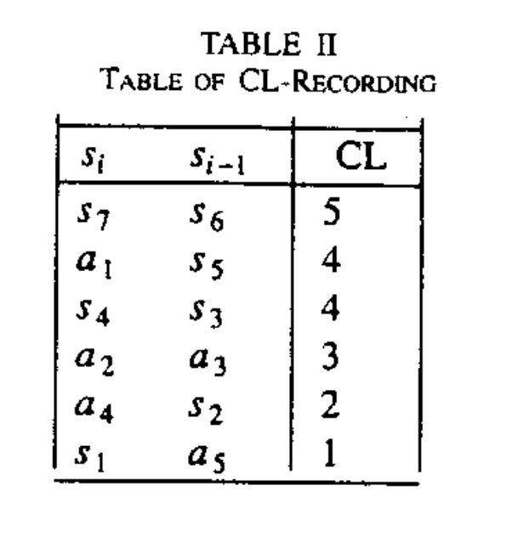
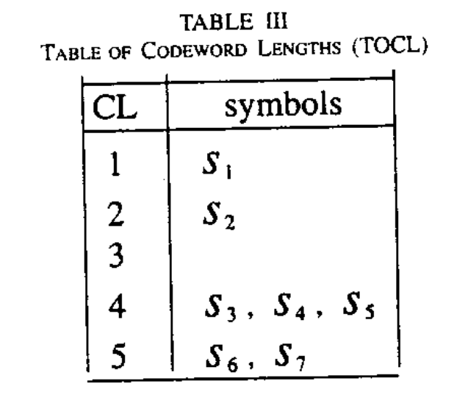
B. Single-Side Growing Huffman Table
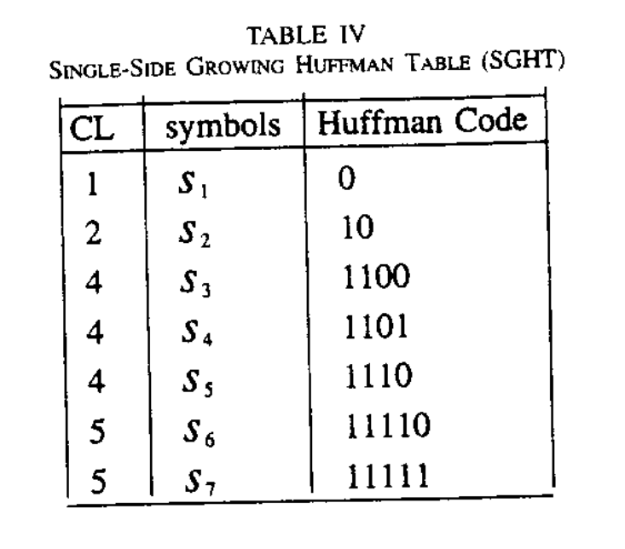
C. Algorithm 2: Development of a SGHT
c₁ = 00…0
c_{i+1} = (c_{i} + 1) * 2^{q-p}
and
c_{n} = 11…1
where p and q are the codeword lengths for s_{i} and s_{i+1}, respectively, and s_{n} (associated with c_{n}) denotes the terminal symbol.

3. Storage Allocation
In a uniformly distributed (flat) source; where p_{i} = p_{j}, for all i and j, the SGH-Tree becomes full, this is defined as a zero sparse tree.

Memory Efficiency β for a k level binary Huffman tree (or sub tree) as:
β_{k} = Number of symbols * 100% / 2^{k}.

For example: Table V.
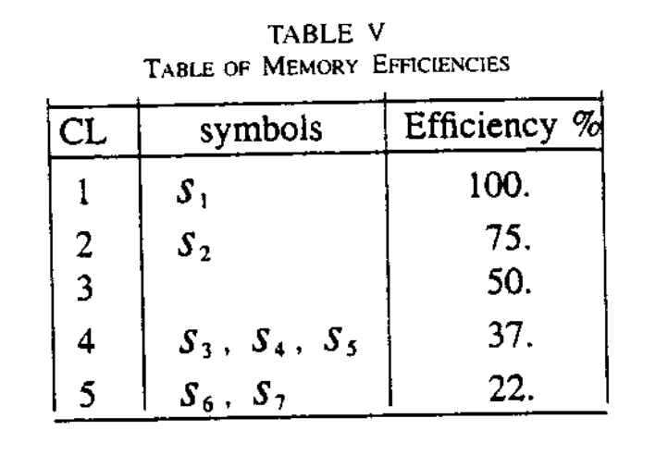
For example: 13th level for a source of 32 independent symbols. The memory efficiency has been reduced to as low as (32/8192) * 100%, or 0.39%, in this case.

We defined a cluster (subtree) T_{i} with minimum memory efficiency (MME) β_{i} , if there is no level in T_{i} with memory efficiency less than β_{i}.

A. SGH-Tree Clustering
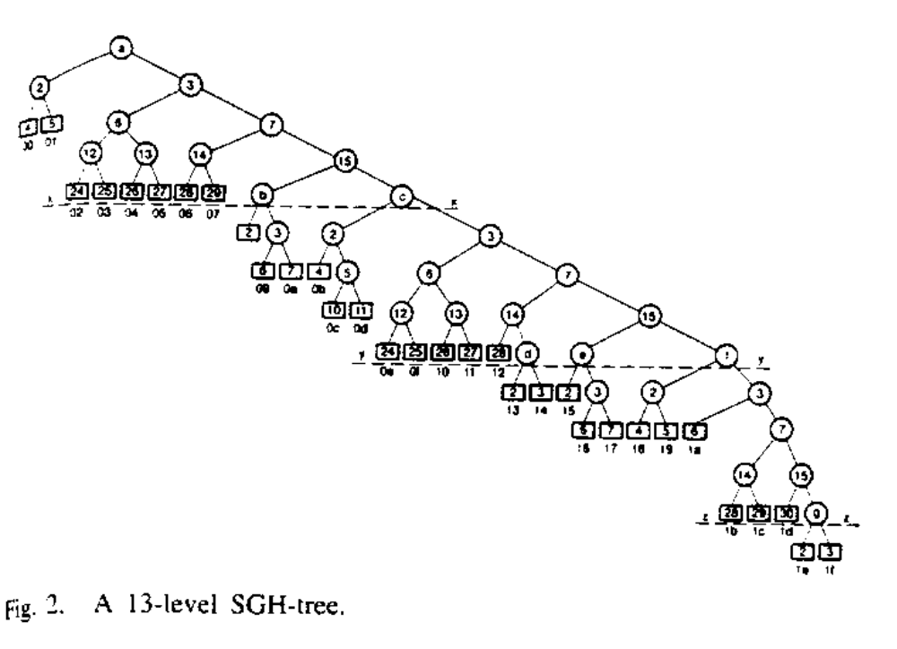
Cluster length to be equal to the maximum path length form the root to a node within the cluster.

LUT: Look Up Table.
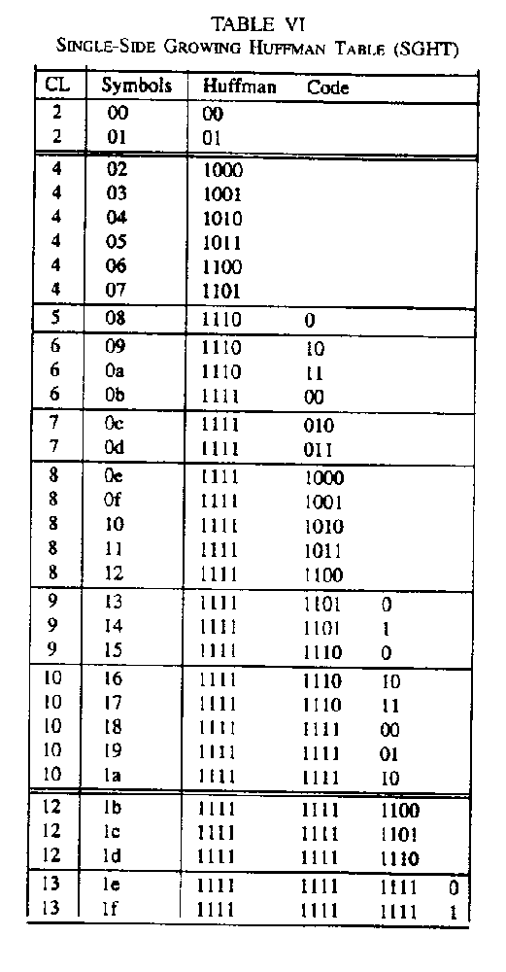
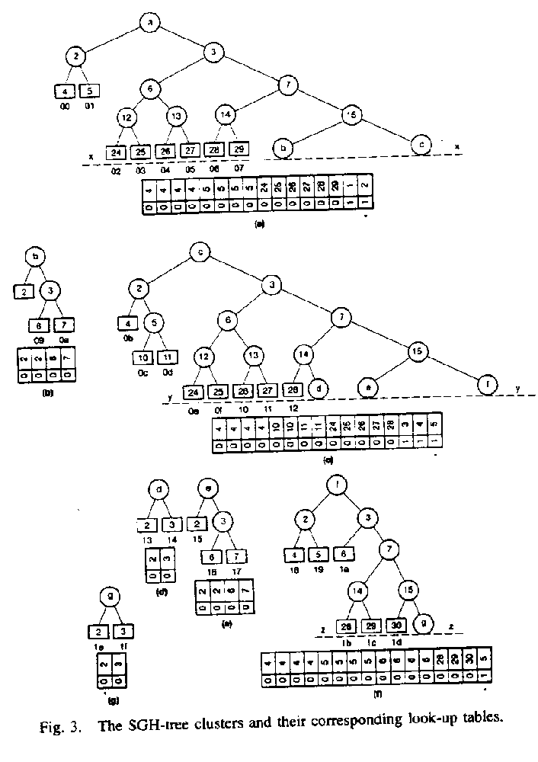
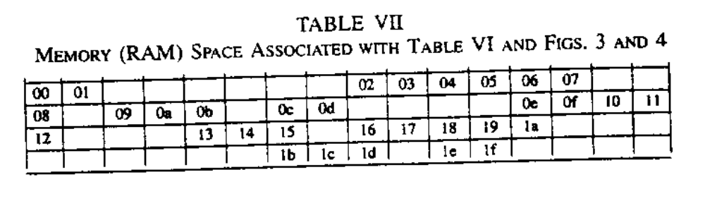
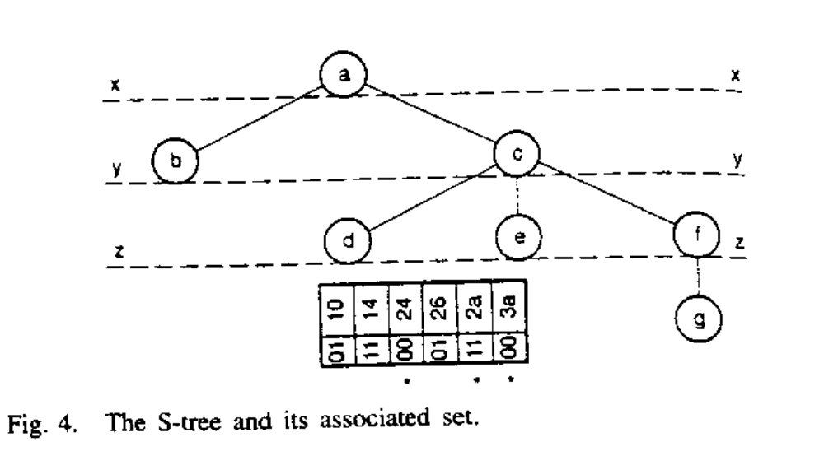

4. Huffman Decoding
- 011001011…
- 110110011…
- 1111111111110010…

