Architecture of a Multi-Cell Centralized Packet Access System

Ulrich Dropmann, Xavier Lagrange, Philippe Godlewski

The 1995 Sixth IEEE International Symposium on Personal, Indoor and Mobile Radio Communications (PIMRC ‘95), pp.279-283

1. Introduction
In this paper we present an architecture where packet access and the resource allocation is performed on a bunch of cells destined for pico-cellular and micro-cellular environments. We discuss a specific problem of that architecture, which is to determine the position of the mobile.
A. Technical Advances in Fiber Optical Technology
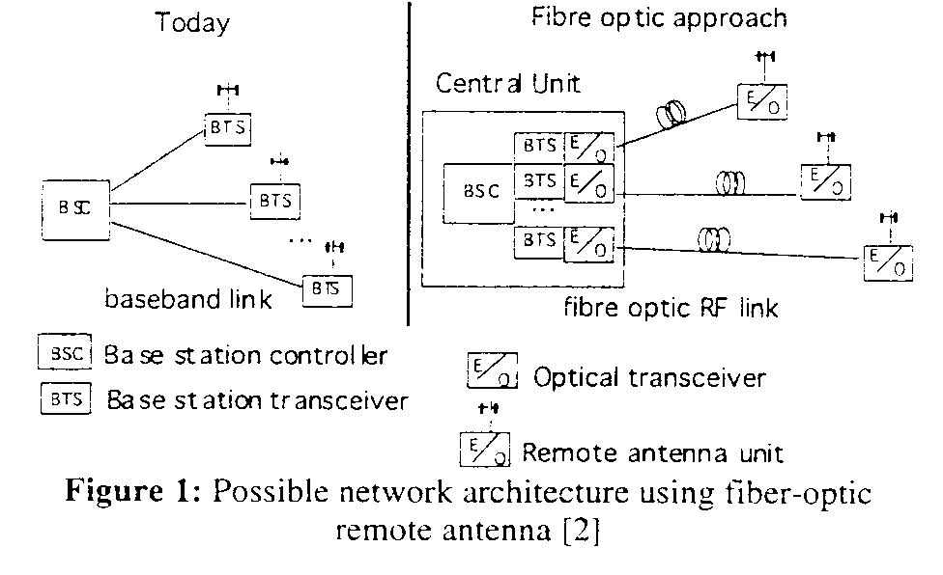
B. The Principle of Packet Access protocols
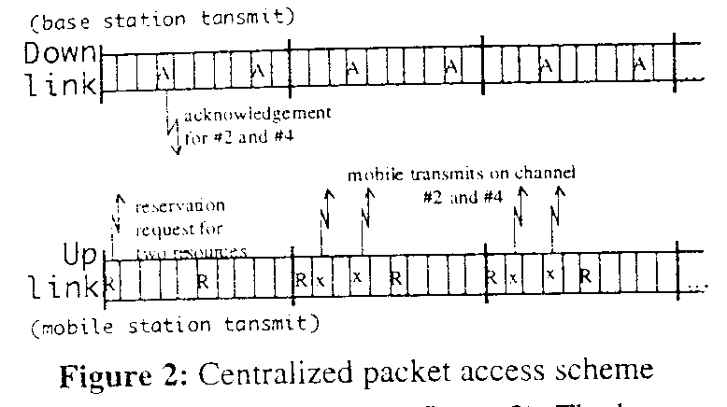

2. Multi-Cell Centralized Packet Access System
All channels are available at all antennas.
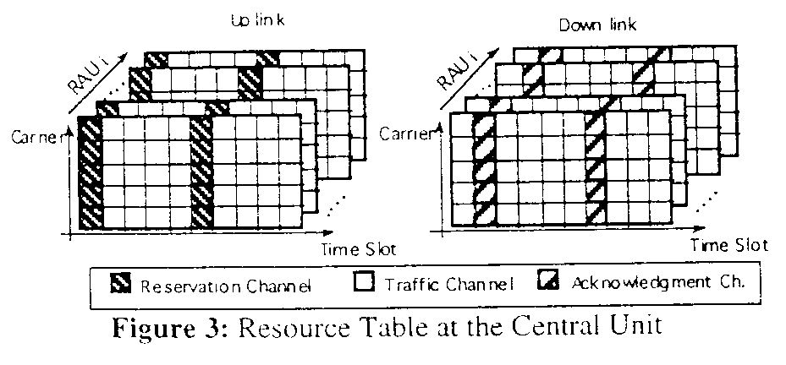
A. The Concept of Zones
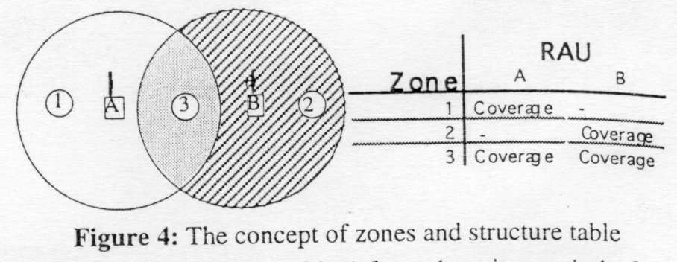

B. Two-Level Power Control and Interference
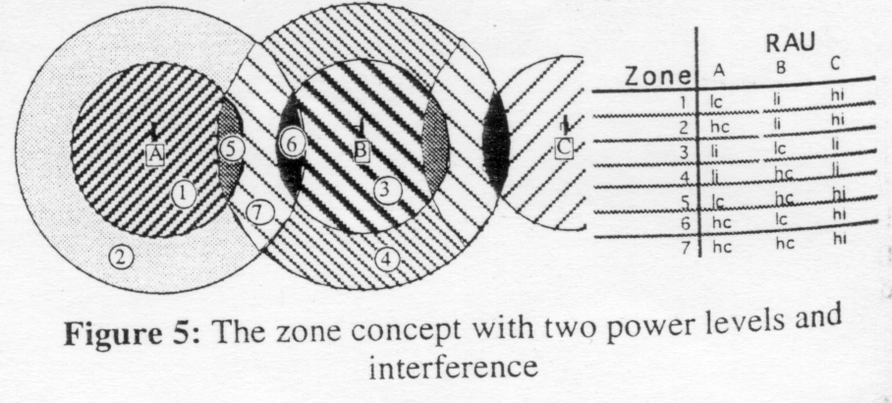

3. The Fine-Localization of the Mobile
A. The Fast Fading
B. The Shadowing Effect
C. The Up Link Reception
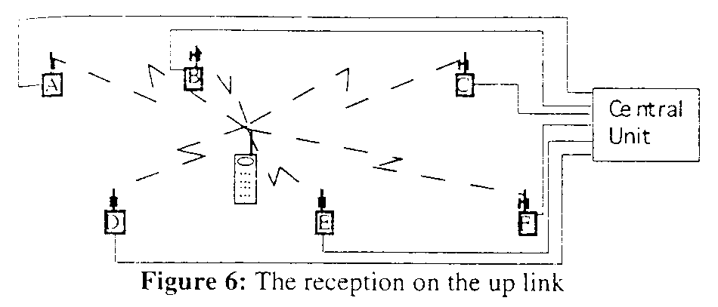
D. The Scoring Algorithm

4. Simulation
The cell radius r is normalized to 1.
The system parameter Reuse-Figure=R_{hi}/R_{hc}=R_{li}/R_{lc} is set to 3(17dB), the Power-Control-Figure=R_{hc}/R_{lc}=R_{hi}/R_{li} to 2(10dB).

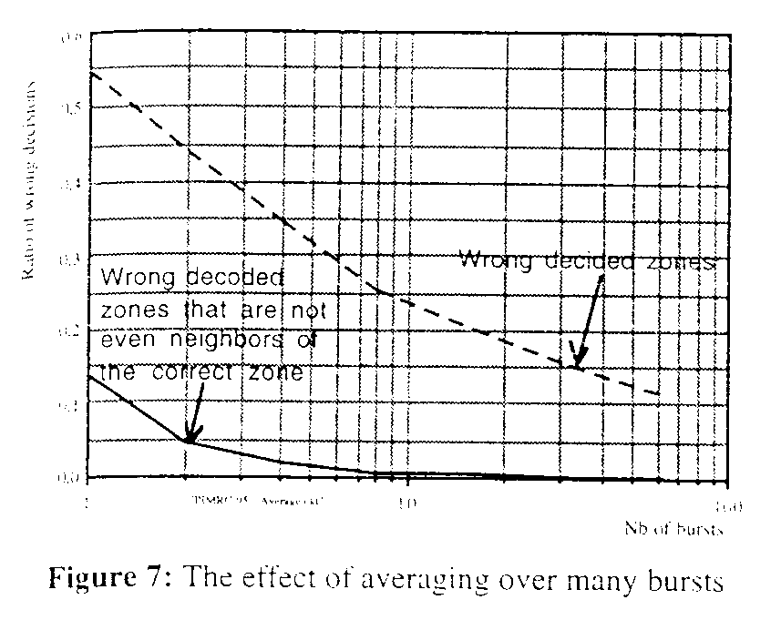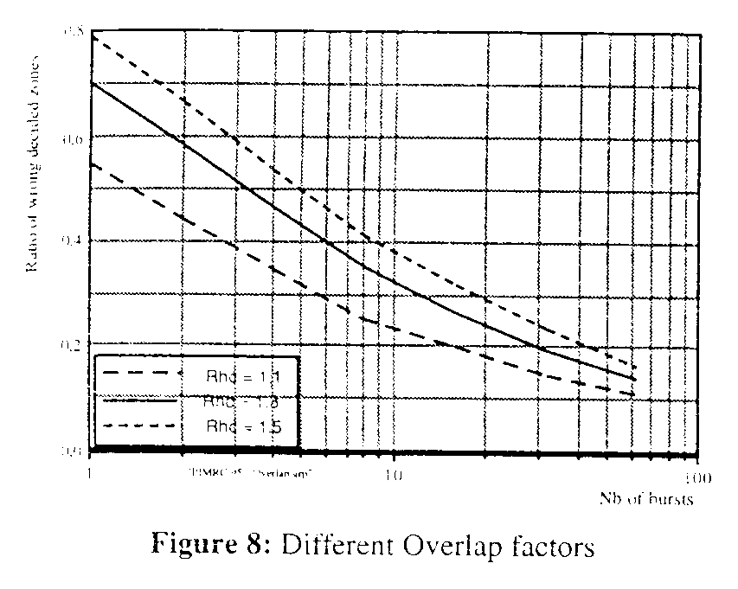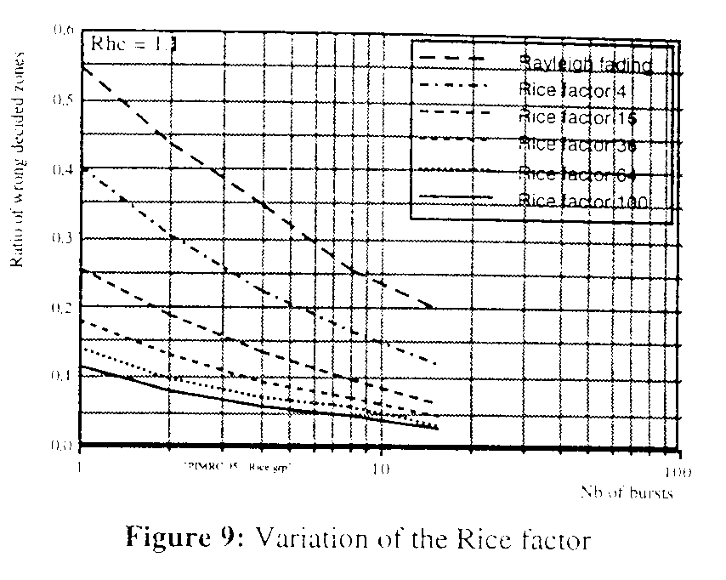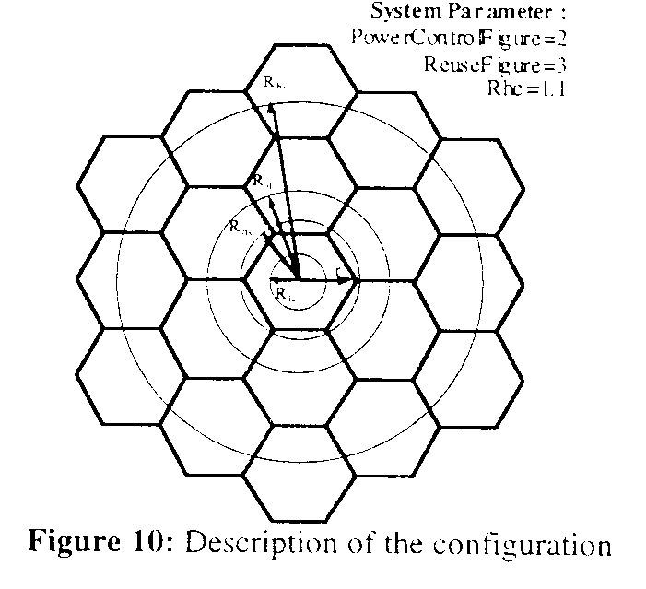
5. Concluding Remarks

Created by: Kuo-Shii Huang
Date: Sept 18, 1998

