Scalable and Robust Internetwork Routing for Mobile Hosts

David B. Johnson

Proceedings of the 14th International Conference on Distribute Computing Systems, IEEE Computer Society, June 1994, pp. 1-10

1. Introduction
This paper describes the Mobile Host Routing Protocol (MHRP), a protocol for transparently supporting the routing of packets to mobile hosts operating in a large internetwork.

2. Infrastructure
The foreign agent maintains a list recording the IP address of each visiting mobile host currently connected to that network (for which it has agreed to serve as the foreign agent), and forwards arriving IP packets addressed to one of those mobile hosts directly to the mobile host.

The home agent maintains a database recording the IP address of the foreign agent currently serving each mobile host for which this is the home network.

Any host or router may also function as a cache agent by caching the location of one or more mobile hosts.
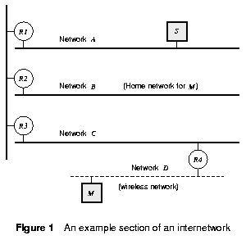

3. Moving a Mobile Host

4. Forwarding Packets to a Mobile Host
4.1. The MHRP Encapsulation Protocol
➔Tunneling
4.2. Adding the MHRP Header to a Packet
4.3. The “Location Update” Message
4.4. Foreign Agent Processing of Tunneled Packets
4.5. Handling of Returned ICMP Error Messages

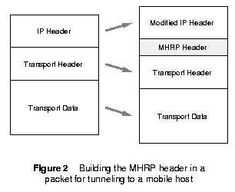
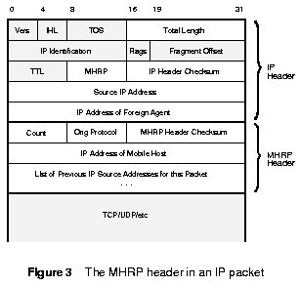

5. Protocol Robustness
5.1. Cache Agent Consistency Maintenance
5.2. Foreign Agent State Recovery
5.3. Robustness Against Routing Loops

6. Examples
6.1. The Initial Packet to a Mobile Host
6.2. Subsequent Packets to a Mobile Host
6.3. When a Mobile Host Has Moved

7. Comparison to Previous Protocols

8. Conclusion
An implementation of MHRP within the Berkeley networking code is currently in progress.

Created by: Kuo-Shii Huang
Date: Sept 4, 1998

