Deterministic Routing on the Array with Reconfigurable Optical Buses

Sanguthevar Rajasekaran and Sartaj Sahni

Parallel Processing Letters, Vol. 7, No. 3, 1997, pp. 219-224

1. Introduction

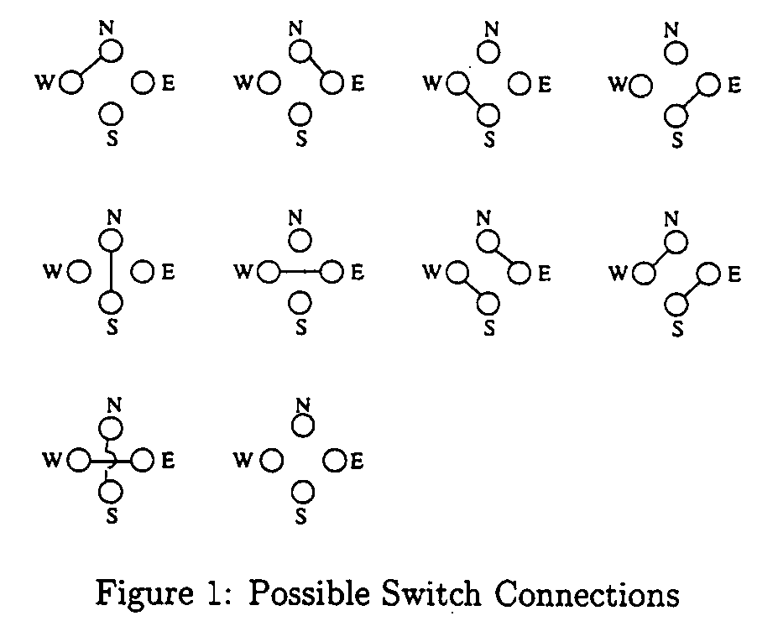

Lemma Let L be a LAROB of size n. Consider a routing problem where O(1) packets originate from any node and O(1) packets are destined for any node. This problem can also be solved in O(1) cycles.

2. Matrix Transpose Routing

Switch connection for any processor (i, j) :
SE if i + j is odd
NW if i + j is even
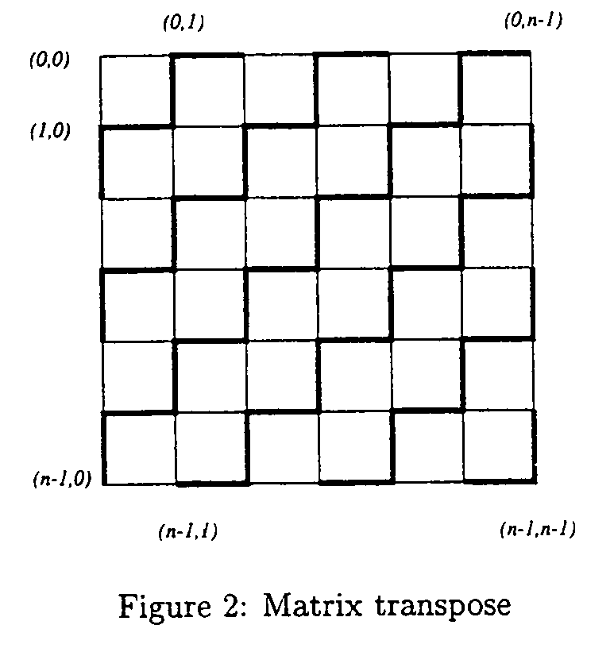
The matrix transpose permutation is a BPC permutation characterized by the vector (p/2–1, p/2–2, …, 1, 0, p, p–1, …, p/2).

Lemma Matrix transpose can be performed on an n × n AROB in O(1) cycles.

3. BPC Permutation Routing

BPC: Bit Permute and Complement
Example:
N = 8, permutation π = (-2, 0, 1)
(a₂, a₁, a₀) ⇒ (a′₂, a₀, a₁)
(1, 1, 0) ⇒ (0, 0, 1)

The basic idea is to decompose any BPC permutation into a sequence of five permutations.

Algorithm: (q is the packet.)

Phase I: A = A1, A0
A′₁ = a_{i1}, a_{i2}, …, a_{ik} and A′₀ = a_{j1}, a_{j2}, …, a_{jk}
Route the packet from A to A′ = A₁ – A′₁, A′₁, A₀
(If a_{i} ∈A₁ and π_{i} is negative, then a_{i} will appear in A′ as a′_{i}.)

Phase II: Route the packet form current location to
A₁ – A′₁, A′₁, A₀ – A′₀, A′₀
Phase III: Partition the mesh into submeshes of size 2^{k} × 2^{k} and employ matrix transpose within the submeshes. q will reach
A₁ – A′₁, A′₀, A₀ – A′₀, A′₁
Phase IV: Routing is done along the columns, q will be in its destination row.
Phase V: Finally, a routing step along the rows takes q to its desired destination.

Example:
N = 2⁸, BPC permutation π = (6, -3, -4, 1, 0, -2, 5, 7)
Packet q originates from (a₇, a₆, a₅, a₄, a₃, a₂, a₁, a₀)
A₁ = a₇, a₆, a₅, a₄ A₀ = a₃, a₂, a₁, a₀
A′₁ = a₆, a₄ A′₀ = a₁, a₀

Origin: a₇, a₆, a₅, a₄, a₃, a₂, a₁, a₀
Phase I: a₇, a′₅, a′₆, a₄, a₃, a₂, a₁, a₀
A₁–A′₁, A′₁, A₀
Phase II: a₇, a′₅, a′₆, a₄, a₃, a′₂, a₁, a₀
A₁–A′₁, A′₁, A₀–A′₀, A′₀
Phase III: a₇, a′₅, a₁, a₀, a₃, a′₂, a′₆, a₄
A₁–A′₁, A′₀, A₀–A′₀, A′₁
Phase IV: a₀, a₇, a₁, a′₅, a₃, a′₂, a′₆, a₄
Phase V: a₀, a₇, a₁, a′₅, a′₆, a′₂, a₄, a₃

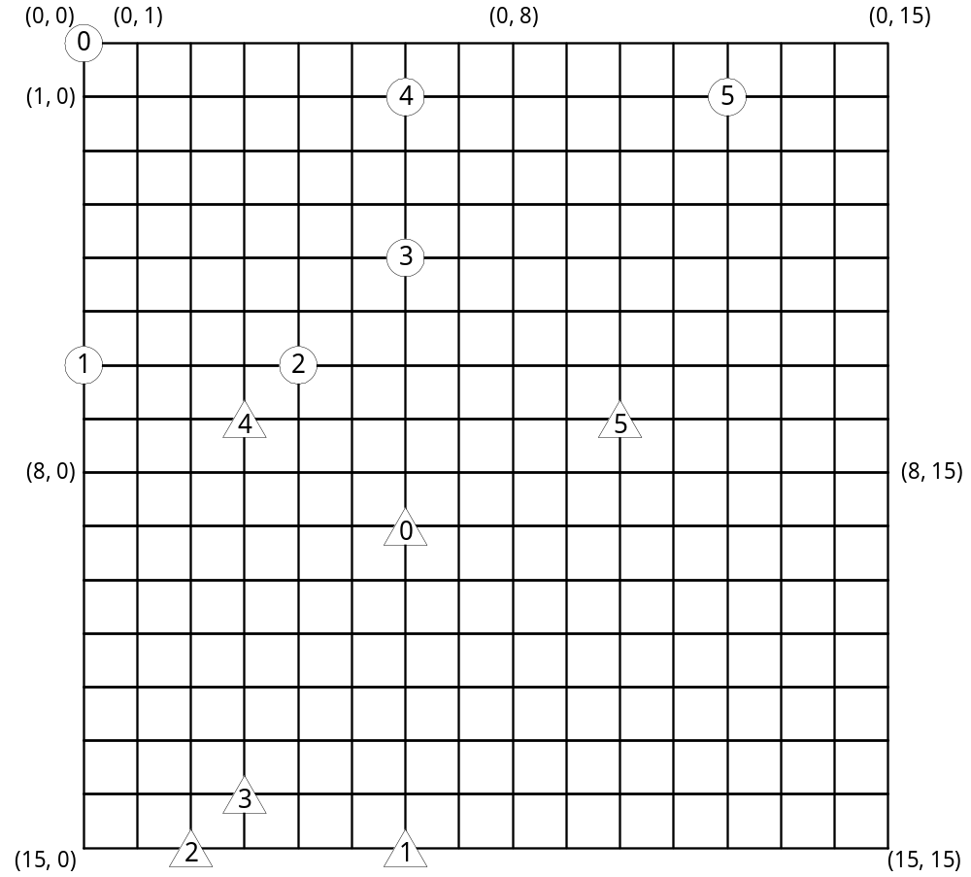

Case I Case II
Origin (0, 0) (00000000) (9, 6) (10010110)
Phase I (6, 0) (15, 6)
Phase II (6, 4) (15, 2)
Phase III (4, 6) (14, 3)
Phase IV (1, 6) (7, 3)
Phase V (1, 12) (00011100) (7, 10) (01111010)

Created by: Kuo-Shii Huang
Date: Nov. 6, 1999

