An O(n) Algorithm for Finding an Optimal Position with Relative Distances in an Evolutionary Tree

B.Y. Wu, C.Y. Tang

Information Processing Letters, Vol. 63, No. 5, Sep. 1997,
pp. 263-269

1. Introduction

The distance between two species is the total weight of the path between the two leaves. If the distance data are additive, there are efficient algorithm for reconstructing the tree. However, observed distances are hardly additive.
The relative distances of a species x is a vector D_{x} = <a₁, a₂, …, a_{n}> in which each nonnegative a_{i} stands for the observing distance between x and species i. We want to find the most suitable position in the tree for another species x with D_{x}.
Problem: given an evolutionary tree and a distance vector, find a position in the tree such that the distance (on the tree) from the position to any leaf is no less than the given one and the difference between the resulting and given distances is minimized.

2. Definitions and notations

Phylogenetic (or evolutionary) tree T = (V, E, w), there is no vertex with degree 2 in a tree. d(T, i, j) denotes the distance between i and j.

A position for x in T is a triple <e, h, k>, in which e ∈ E, h and k are values, h and k are values, h ≥ 0, and w(e) ≥ k ≥ 0.

f = <(r, s), h, k> be a position in which r is the parent of s. Define
d(T, f, i) = d(T, i, f) = min{d(T, i, r)+k, d(T, i, s)+w(r, s)-k}+h

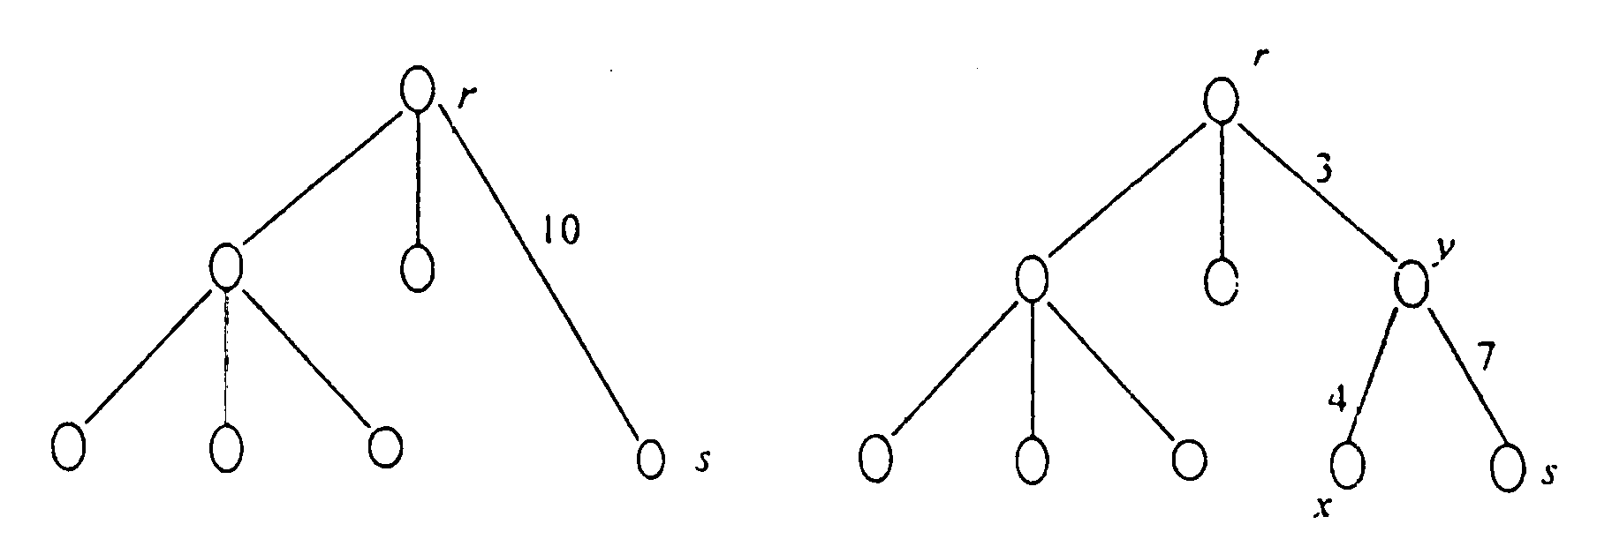
<e, h, k> = <e(r, s), h = w(y, x), k = w(r, y)>

Problem: MIP∞(T, D_{x}) (Minimum, Increment for Position under L∞-norm)
C(T, D_{x}) = min_{f}{max_{1≤i≤n}{d(T, f, i) – a_{i}}}, where f is a position for x in T

3. An O(n) algorithm

Problem: MIPE∞(T, D_{x}, e)
C_{e}(T, D_{x}) = min_{f}{max_{1≤i≤n}{d(T, f, i) – a_{i}}}, where f = <e, h, k> is a position for x in e

C(T, D_{x}) = min_{∀e∈T}{C_{e}(T, D_{x})}

Def. For any edge e = (s, r) of T, deleting e will result in two subtrees. We denote the subtree containing s by T_{s}, and the other by T_{r}. The leaf sets of T_{s} and T_{r} are V_{s} and V_{r} respectively. Let β_{i} = d(T, s, i) if leaf i ∈ V_{s} and β_{i} = d(T, r, i) if leaf i ∈ V_{r}. We also define
p_{max}(e, s) = max{a_{i} – β_{i}: ∀i∈V_{s}}, p_{max}(e, s) = min{a_{i} – β_{i}: ∀i∈V_{s}}
p_{max}(e, r) = max{a_{i} – β_{i}: ∀i∈V_{r}}, p_{max}(e, r) = min{a_{i} – β_{i}: ∀i∈V_{r}}

Let e = (s, r), C_{e}(T, D_{x}) can be computed in constant time if p_{max}(e, s), p_{max}(e, r), p_{min}(e, s) and p_{min}(e, r) are given.

Let e = (s, r), in which s is either parent or son.
p_{max}(e, s) = a_{s}, if s is s leaf
= max_{∀y≠r}{p_{max}((y, s), y) – w(y, s)}, otherwise

p_{max}((v₁, v₂), v₂) = a_{v2}, if v₂ is a leaf
= max_{∀(v2, v3)}{p_{max}((v₂, v₃), v₃) – w(v₂, v₃)}, otherwise

p_{max}((v₁, v₂), v₁) = max∀(v₁, v₃){p_{max}((v₁, v₃), v₃) – w(v₁, v₃),
p_{max}((v₀, v₁), v₀) – w(v₀, v₁)}

Algorithm: Two phase, bottom-up and top-down.
Phase I: postorder
Phase II: preorder

Richest Siblings Problem: If e₁, e₂, …, e_{n} are brothers, each with money x₁, x₂, …, x_{n} respectively, how to let every brother know who is the richest one of his brothers (excluding himself)?

4. Conclusion

Created by: Kuo-Shii Huang
Date: Mar. 25, 1999

a₃ = 11, a₄ = 11, a₅ = 15, a₆ = 15, a₇ = 16

Phase I:

(v₁,v₂)
(2, 5) 14 14 14 14 14 14 14
(2, 6) 9 15 15 15 15 15 15
(2, 7) 9 9 16 16 16 16 16
(1, 2) 9 9 9 9 9 9 9
(1, 3) 7 11 11 11
(1, 4) 7 7 11 11

Phase II:

(1, 2)
(2, 5)
(2, 6)
(2, 7)
(1, 3)
(1, 4)

