Estimation of Evolutionary Distances under Stationary and Nonstationary Models of Nucleotide Substitution

Xun Gu and Wen-Hsiung Li

Proc. Natl. Acad. Sci. USA, Vol. 95, pp. 5899-5905, May 1998

1. Introduction
Estimation of evolutionary distances has always been a major issue:
- the rate of evolution in a gene,
- the divergence dates between genes or organisms,
- the relationships among genes or organisms.

Other closely related issues are:
- the estimation of the pattern of nucleotide substitution,
- the estimation of the degree of rate variation among sites in a DNA sequence,
- statistical testing of the molecular clock hypothesis.

Evolutionary distances (usually designated by d) such as the number of nucleotide substitutions between two DNA sequences.

2. Stationary Models and Nonstationary Models
2.1 Stationary Models
SR (stationary time reversible) model.
SRV (SR rate-variable) model.
Bias-Corrected.
Measure of Rate Variation Among Sites ρ.
To estimate ρ from sequence data, we need to know the number of substitutions at each site.
- Parsimony Method – tends to underestimate the true number of substitution.
- Maximum likelihood estimation.
2.2 Nonstationary Models
LogDet and Paralinear Distances.
Bias-Corrected.
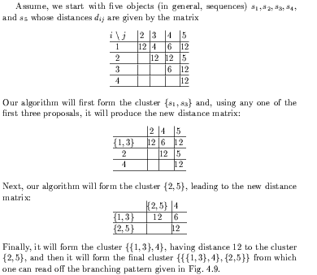
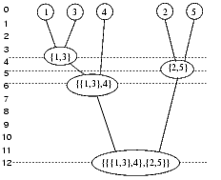
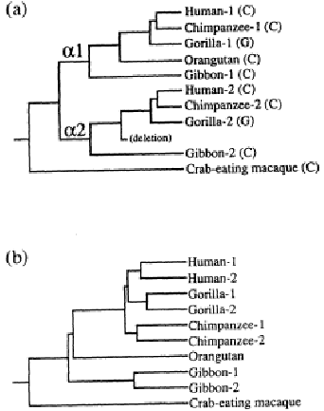
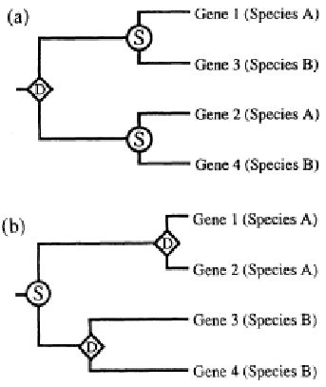
The Maximum Parsimony Method:
- Search for the most parsimonious tree, the number of nucleotide or amino acid substitution is minimum, in all possible tree.
- The number of tree is exponential growth with the number of genes or organisms.

The Maximum Likelihood Method:
- Use the statistic method to find the maximum likelihood tree.
- The amount of computation is more than the parsimony method.

Created by: Kuo-Shii Huang
Date: Jan. 29, 1999

