Wireless LANs and Mobile Networking: Standards and Future Directions

Richard O. LaMaire, Arvind Krishna, and Pravin Bhagwat, and James Panian

IEEE Communications Magazine, August 1996, pp. 86-94

IEEE 802.11 Wireless LAN Standard

Architecture
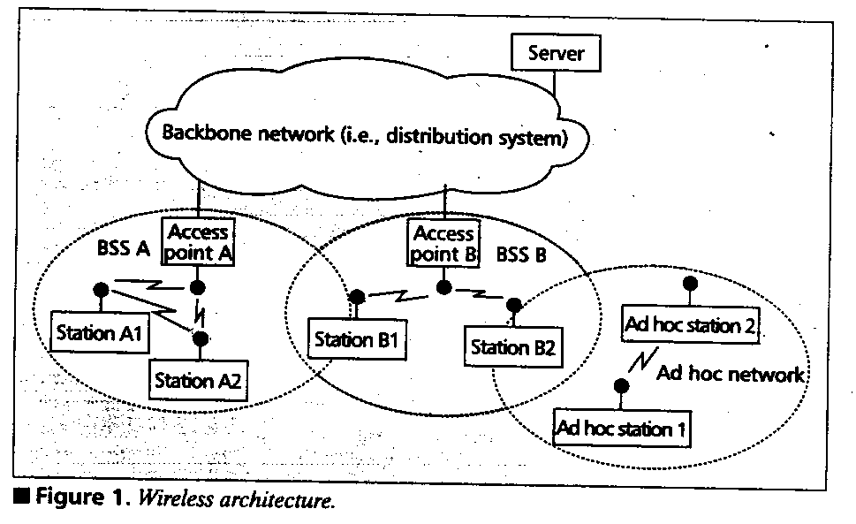

Physical Layers
The 802.11 provides for three different types of physical layers to be used:
- 2.4 GHz ISM band frequency hopping (FH) spread-spectrum radio
- 2.4 GHz ISM band direct sequence (DS) spread-spectrum radio
- Infrared (IR) light

Future activities of IrDA will focus on multipoint protocols as are used in LAN systems.

Medium Access Control
The important characteristics of the 802.11 MAC protocol are its ability to support:
- The access-point-oriented and ad hoc networking topologies
- Both asynchronous and time-critical traffic (called time-bounded services in 802.11)
- Power management

HIPERLAN

Unlike for the IEEE 802.11 standard, this committee was not driven by existing products or regulations.
In brief, the standard allows for a radio LAN system operating at 23.529 Mb/s with support for multihop routing, time-bounded services, and power saving.

Mobile Networking

The major difference is that mobile devices can move while in operation, which means that their point of attachment to the network can change from time to time.

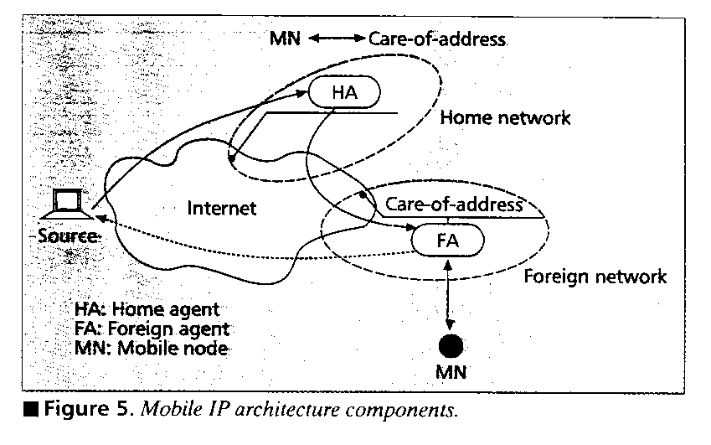

Currently, there is disagreement within the Mobile IP working group on whether it is possible to support such an authentication mechanism within the existing Internet. Therefor, the current Mobile IP proposal does not permit route optimization.

IPv6: Improve on Mobile IP design in several ways.
The new design does not require FAs; MNs dynamically acquire a care-of-address using the IPv6 neighbor discovery protocol.
By making all IPv6 nodes mobile-aware, the new protocol provides for direct tunneling of traffic to an MN’s care-of-address. The advantage of this design is that the load on Has is significantly reduced, and the triangle routing problem is resolved.

Created by: Kuo-Shii Huang
Date: August 14, 1998

