The Multiple Sequence Alignment Problem in Biology

Humberto Carrillo and David Lipman

SIAM Journal of Applied Mathematics, Vol. 48, No. 5, October 1998,
pp. 1073-1082

1. Introduction

- The comparison of two or more sequences of numbers or letters is common in several fields, such as molecular biology, speech recognition, and computer science.
- Dynamic programming.
- Reducing computation in the dynamic programming method.

2. Sequence

3. Alignments

4. Paths
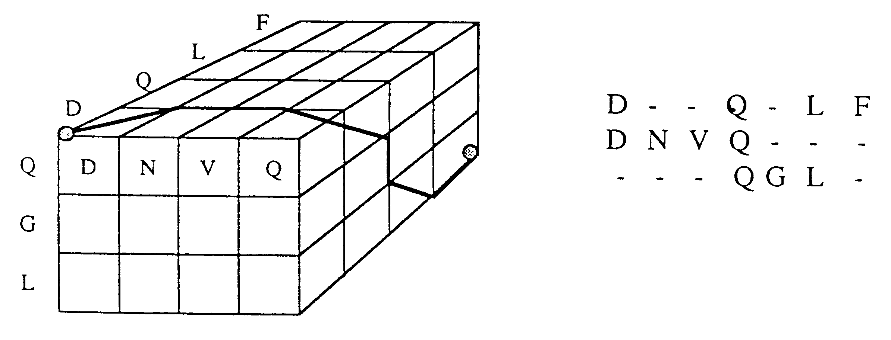

5. Optimal Paths

Each path is associated with a unique alignment, in this way the scoring rules allow us to assign to any given path γ a measure M(γ). M(γ) is a measure of the similarity among the sequences S₁, …, S_{N} when they are compared according to the alignment associated to the path γ.
Corresponding to each measure M(γ) there is at least one path such that M attains a minimum value at γ*. Such a path is called an optimal path. The optimal paths in the lattice L(S1, …, SN) can be found by dynamic programming methods.
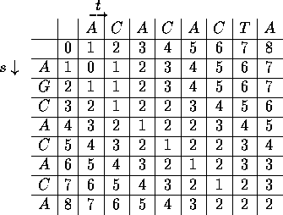

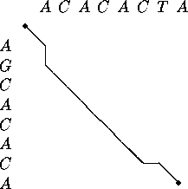

6. Constraints on multiple alignments
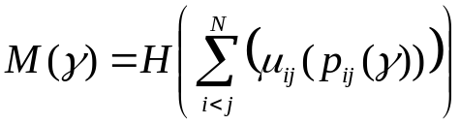,
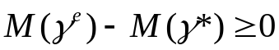,
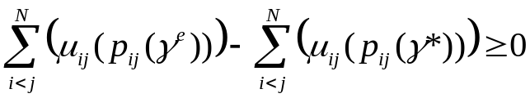,
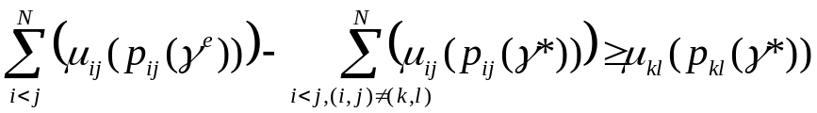,
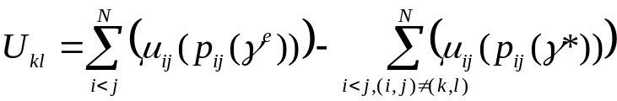.

7. Estimated paths
If there is a path γ such that p_{ij}(γ) = γ_{ij}* for all i, j, where γ_{ij}* denotes an optimal path on the lattice L(S_{i}, S_{j}), then γ is an optimal path for the N-dimensional problem.
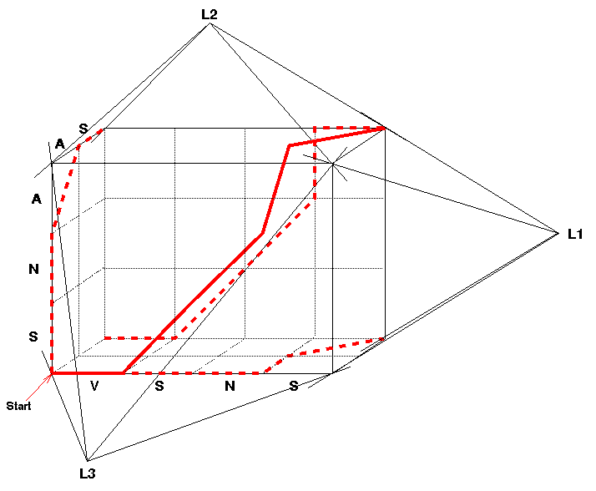

8. Discussion

A priori M(γ*) ≥ 0, and if M(γ*) = 0, the sequences are identical and the location of γ* is on the main diagonal of the plane.

Created by: Kuo-Shii Huang
Date: Dec. 10, 1998

