A New Algorithm for DNA Sequence Assembly

Ramana M. Idury, Michael S. Waterman

Journal of Computational Biology, Vol. 2, pp. 291-306

Abstract

Since the advent of rapid DNA sequencing methods in 1976, scientists have had the problem of inferring DNA sequences from sequenced fragments. Shotgun sequencing is a well-established biological and computational method used in practice. Many conventional algorithms for shotgun sequencing are based on the notion of pairwise fragment overlap. While shotgun sequencing infers a DNA sequence given the sequences of overlapping fragments, a recent and complementary method, called sequencing by hybridization (SBH), infer a DNA sequence given the set of oligomers that represents all subwords of some fixed length, k. In this paper, we propose a new computer algorithm for DNA sequence assembly that combines in a novel way the techniques of both shotgun and SBH methods. Based on our preliminary investigations, the algorithm promises to be very fast and practical for DNA sequence assembly.

1. Introduction
a = a₁a₂…a_{L},
f₁, f₂, …, f_{N} : each of approximate length l <<L
f_{i}, f_{i}^{r}
The idea of shotgun sequencing is to look for overlapping fragments and solve the puzzle of a’s sequence by assembling the sequence from these overlaps.
The general outline is much the same in these algorithm:
- Examine all pairs (f_{i}, f_{j}) and (f_{i}, f_{j}^{r}) for significant overlap.
- Form an approximate layout of the fragments using the data in (1).
- Make a multiple alignment of the layout from (2) and read a as a consensus sequence from the multiple alignment.

It is well-known that sequence assembly problem is NP-hard.

2. Sequencing by Hybridization
a = ATGTGCCGCA
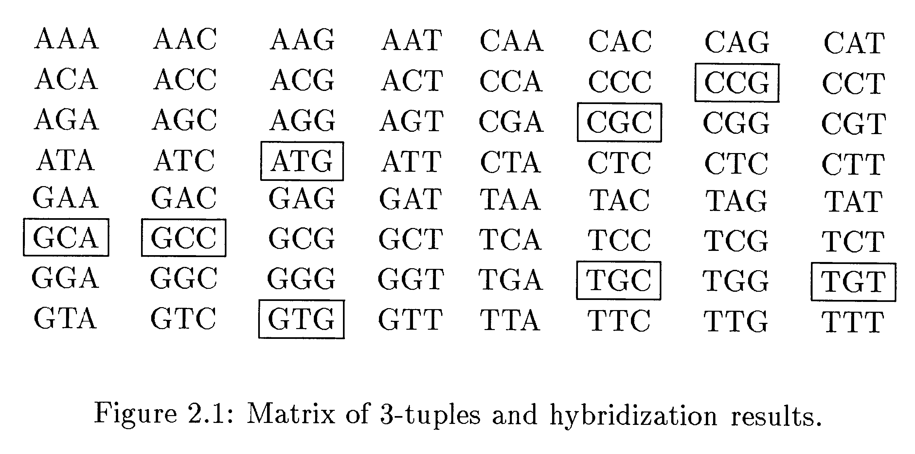
When a k-tuple occurs more than once, we can only learn that it occurred at least once but cannot tell how many times it occurred.
If k is too small then the SBH data becomes too dense to find the sequence.
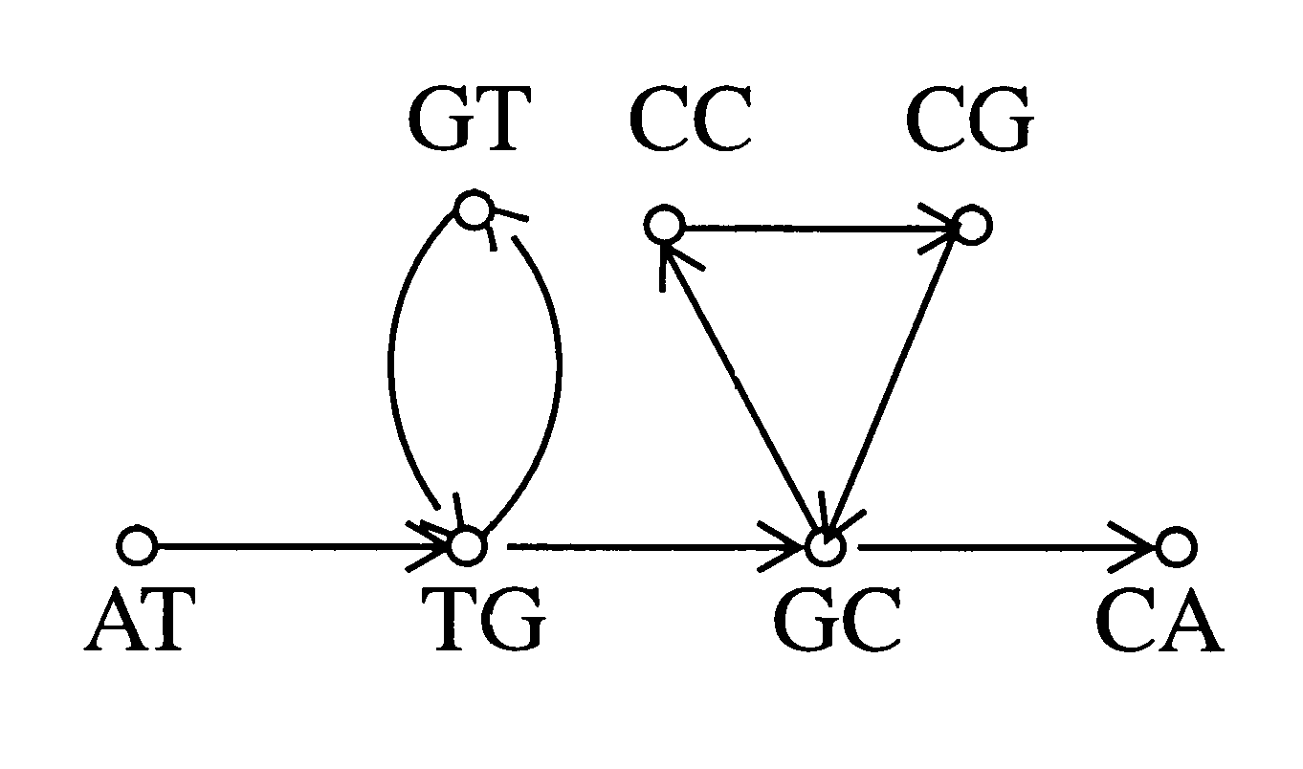
Graph G for ATGTGCCGCA
We can reduce the problem of determining the number of Eulerian paths from s to t in G to the problem of determining the number of Eulerian cycles in the graph G ∪ [t, s].
Intersection Graph:
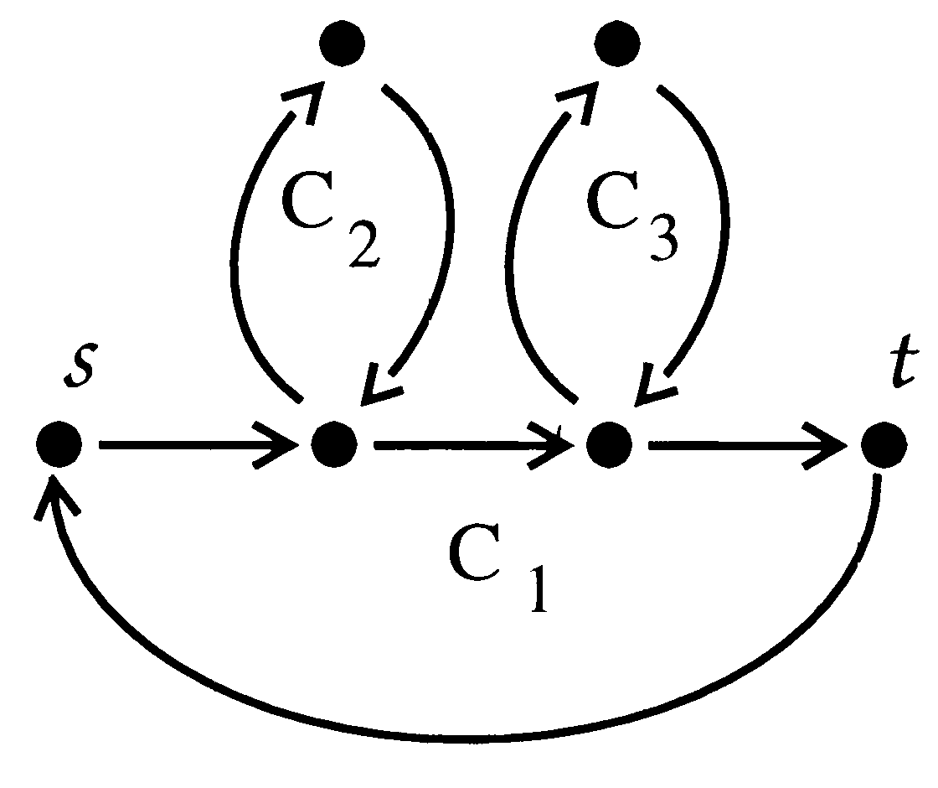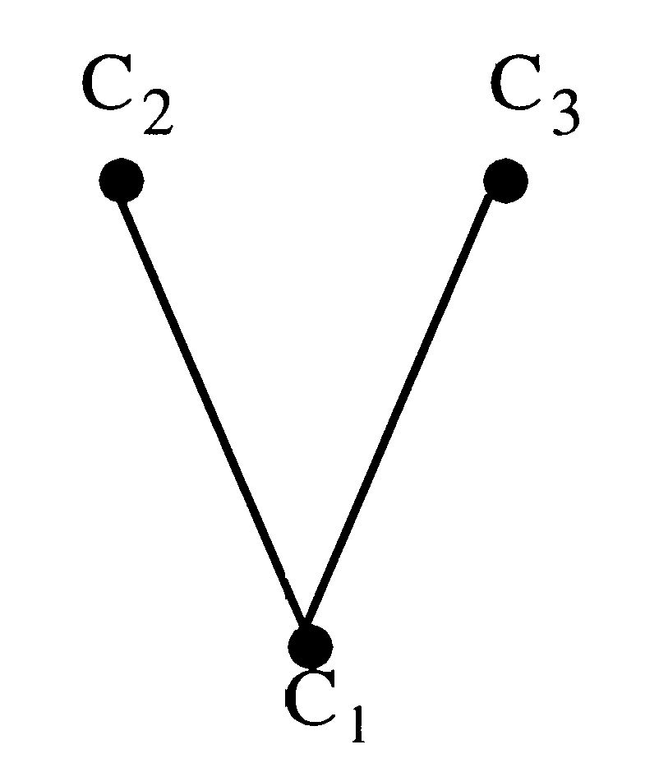
Theorem 2.1 (Pevzner 1989) There is a unique Eulerian cycle in G if and only if the intersection graph G_{I} of simple cycles from G is a tree.

3. A New Algorithm for Shotgun Sequencing
Algorithm 1(Assembly) Set N, k: input f₁, f₂, …, f_{N}.
- Obtain the union of spectrums of all fragments and there reverse complements.
- Construct the spectrum graph on (k-1)-tuples for the k-tuples from 1. Each edge is labeled with the fragment and position information.
- Perform a variant of Eulerian tour(s) and infer the sequence(s).
- Align the fragments to sequence(s) produced by (3).

4. The Sequence Graph

5. Structure of a Sequence Graph
Singleton: a vertex whose indegree and outdegree are at most one each.
Fork: a vertex for which one of indegree or outdegree is at most one, and the other is more than one.
Cross: a vertex for which both indegree and outdegree are more than one.

6. Sequence Graph Reductions
All reductions replace a path or a series of edges with a new edge. The goal of performing these reductions is to eliminate extraneous edges generated by sequencing errors, and collapse singleton vertices to obtain a simple and compact graph that can then be toured to infer the underlying sequence.
Reduction 1: Elimination of Singletons
Reduction 2: Elimination of Forks
Reduction 3: Elimination of Crosses

7. Irreducible Sequence Graphs
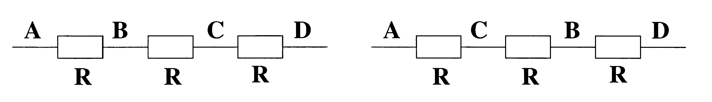
In above sequence, the regions A, B, C, D are nonrepetitive regions and R is a repetitive regions. It is not immediately clear whether ARBRCRD or ARCRBRD is the right sequence.
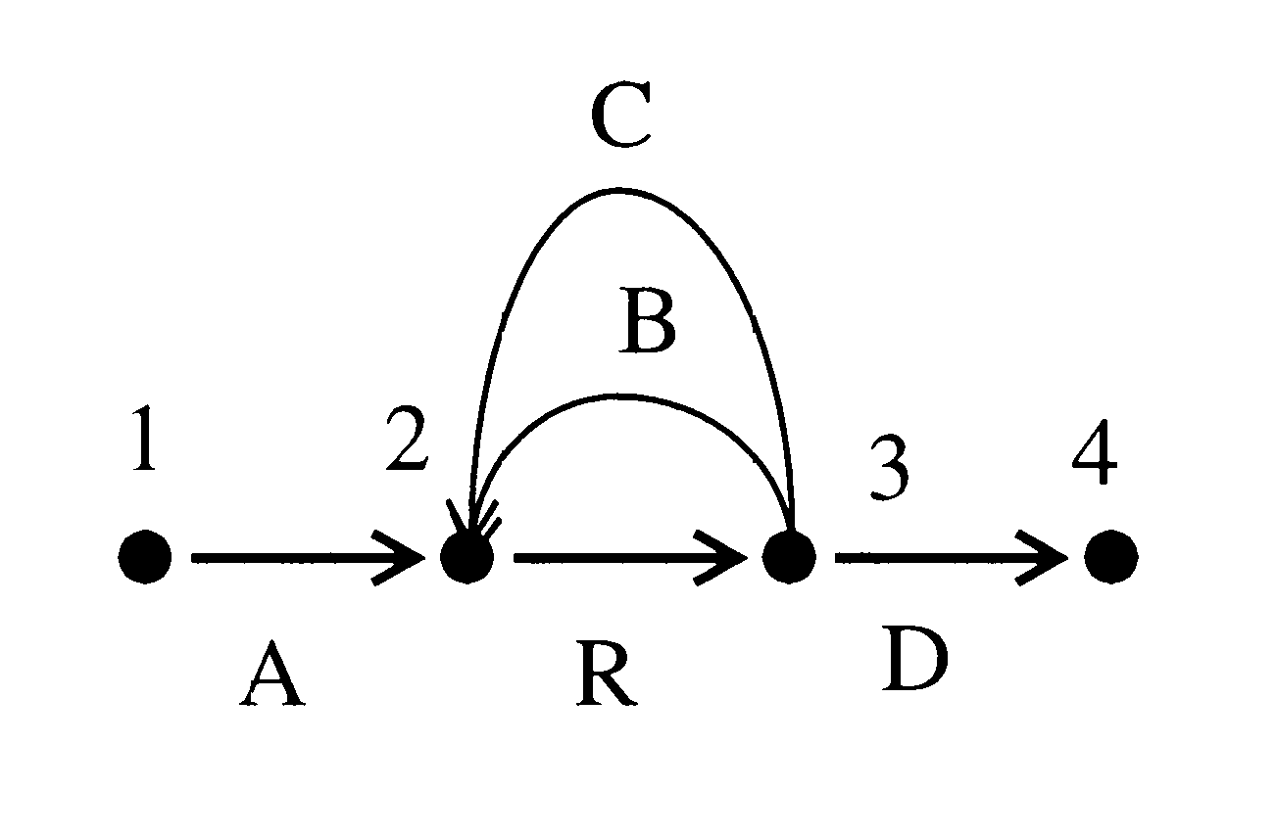
8. Conclusions
We have proposed a new algorithm for DNA sequence assembly that combines the features of shotgun sequencing and sequencing by hybridization. The algorithm takes advantage of high coverage and low sequencing error rates made possible with the advent of advanced DNA sequencing machines.

Created by: Kuo-Shii Huang
Date: Nov. 16, 1998

