An Optimal Algorithm for Mutual Exclusion in Computer Networks

Glenn Ricart, Ashok K. Agrawala

Communications of the ACM, Vol. 24, No. 1, Jan 1981, pp. 9-17

1. Introduction

The computer network whose nodes communicate only by message and do not share memory. It is assumed that there is an error-free underlying communications network in which transit times may vary and messages may not be delivered in the order sent. Nodes are assumed to operate correctly.
The algorithm uses only 2*(N-1) messages between nodes, where N is the number of nodes.

2. Algorithm

- X can defer its reply to Y if Y’s request has a lower priority than X’s until X exits the CS.(timestamp)
- A Reply message implies a Release message.

- If S requests the CS à sends a Request message to every site.
- S can enter the CS if S has received a Reply message from every site.
- If S exits the CS à send a Reply message to every deferred request.
- If Y receives the Request messageà
d1) If Y is not requesting: sends a Reply message to S.
d2) If Y is requesting: compare request timestamps and either sends a Reply message to S or defer it.

- Each node has three processes to implement the mutual exclusion:
- One is awakened when mutual exclusion is invoked on behalf of this node.
- Another receives and processes REQUEST messages.
- The last receives and processes REPLY message.
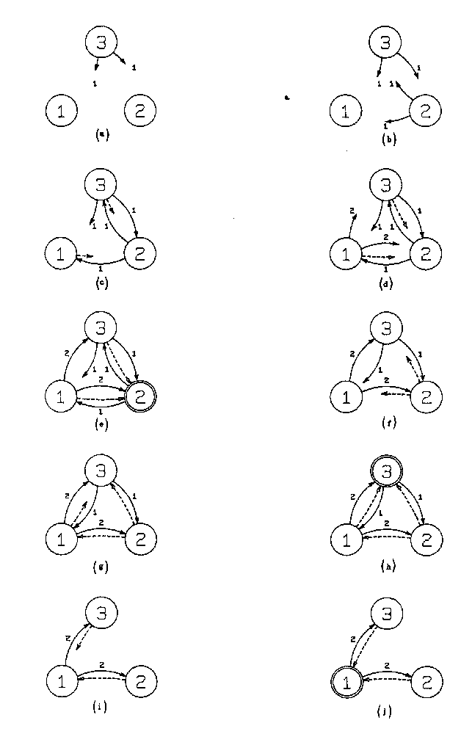

3. Assertions

- Mutual Exclusion is achieved.
- Deadlock is impossible.
- Starvation is impossible.

6. Modifications

6.6 Readers and Writers
The modification is simply that “readers” never defer a REQUEST for another “reader”; instead they always REPLY immediately. “Writers follow the original algorithm.

Created by: Kuo-Shii Huang
Date: Mar 25, 1998

