Routing in Ad Hoc Networks of Mobile Hosts

David B. Johnson

Proceedings of the IEEE Workshop on Mobile Computing Systems and Applications, December 1994, pp. 1-6

1. Introduction

An ad hoc network is a collection of wireless mobile hosts forming a temporary network without the aid of any centralized administration or standard support services regularly available on the wide-area network to which the hosts may normally be connected.
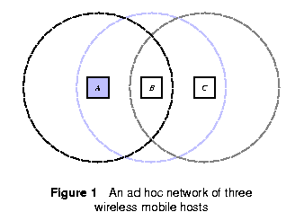

2. Conventional Routing Solutions

2.1 Description
Conventional routing protocols are based on either distance vector or link state algorithms.

In Distance Vector routing, each router maintains a table giving the distance from itself to all possible destinations.
Ex. The original routing protocol for the ARPANET, RIP (used in parts of the Internet, in Novell's IPX, and in Xerox's XNS), and RTMP (used in AppleTalk).

In Link State routing, each router maintains a complete picture of the topology of the entire network.
Ex. the “new” routing protocol that replaced the original protocol for the ARPANET, IS-IS (adopted by ISO as a standard routing protocol), and OSPF (used in parts of the Internet).

2.2. Problems
- Transmission between two hosts over a wireless network does not necessarily work equally well in both directions.
- Many “links” between routers seen by the routing algorithm may be redundant.
- Periodically sending routing updates waste network bandwidth.
- Periodically sending routing updates waste battery power.
- Finally, conventional routing protocols are not designed for the type of dynamic topology changes that may be present in ad hoc networks.

3. Route Discovery and Maintenance

The problem of routing can be divided into the two areas of route discovery and route maintenance.

3.1 Route Discovery
Address Resolution Protocol (ARP)

If the source and target mobile hosts are both within transmission range of each other, a simple ARP query is all that is needed to find a “route” to the target host.

General solution:
One possible solution is to send a request packet (similar to ARP) but to propagate the request using some form of flooding, in order to reach other mobile hosts beyond the sender's transmission range.

Since many mobile hosts may be within transmission range of each other, though, there may be many duplicate copies of each request propagated.
→ request id
=> shortest path (since it arrived first)
Maximum #(hop).

When the query packet ultimately reaches the target host, the target host may attempt to reverse the recorded route to reach the original sender, or may use the same route discovery procedure to find a route back to the original sender.

Piggybacked route discovery exchange.

3.2 Route Maintenance
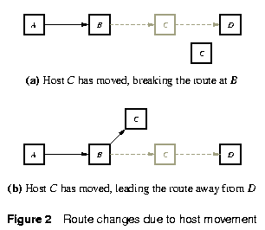
If data link level reports a transmission problem for which it cannot recover (timeout),
- report this error back to the original sender to reinvoke the route discovery procedure,
- intermediate host uses the route discovery procedure.

If the wireless network does not support such lower-level acknowledgements, an equivalent acknowledgement signal may be available in many environments.

4. Conclusions

Created by: Kuo-Shii Huang
Date: July 24, 1998

