Topological Properties of Star Graphs

Sumit Sur and Pradip K. Srimani

Computers Math. Applic. Vol. 25, No. 12, pp. 87-98, 1993

1. Introduction

The minimum distance d(π) from a given node (permutation) π to the identity permutation is given by:
d(π) = | 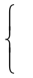 | c+m, when A is the first symbol,  c+m-2, when A is not the first symbol.
Star graphs are vertex symmetric.

2. Identification of Vertex Disjoint Paths

A star graph S_{n} of order n has vertex connectivity n-1.
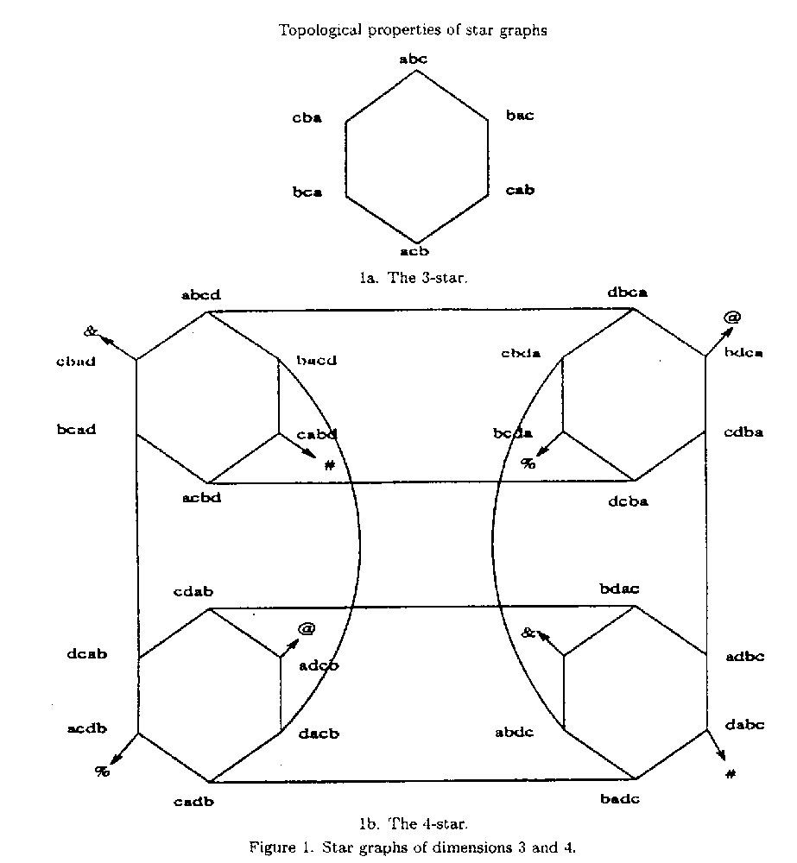
Definition 1: Consider any two mutually disjoint subgraphs V_{X} and V_{Y} of a star graph S_{n}. The set of nodes of V_{X} that are directly connected to some node of V_{Y} are called the gateway nodes of V_{X} with respect to V_{Y}. We denote this set by G_{X,Y}. In general, either or both of X and Y may be sequence of symbols instead of single symbol.

Lemma 1: In S_{n}, for any node s ∈ V_{X}, where X and Y are single symbols, (V_{X} is a star graph of dimension n-1), there exists vertex disjoint paths from s to n-2 gateway nodes in G_{X,Y} with the following properties.
- These n-2 gateway points have different symbols in their second positions.
- The symbols in all these gateway nodes other than the first, second and last are alphabetically ordered.

Algo 1: ….
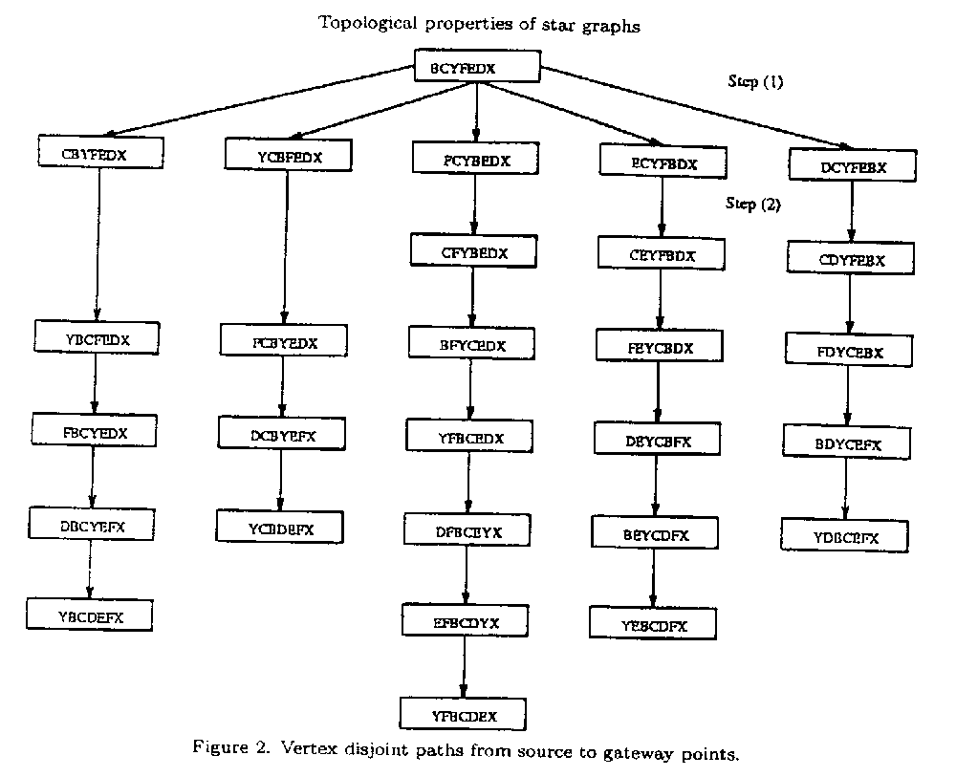
Lemma 2:
(d ∈ V_{Y} do the same work as Lemma 1, and bind corresponding gateways)
à Obtaining n-2 vertex disjoint paths.
Remark: Where is the (n-1)^{st} vertex disjoint path?
if s and d are not the gateway nodes, go from s to s’ and from d to d’ by interchanging the first symbol with the last symbol in the node.
Ex. s = BCTFEDX and d = DCBEXFY
s’ = XCTFEDB in V_{B} and d’ = YCBEXFYD in V_{D}
s – s’ – G_{B,D} – G_{D,B} – d’ – d is the (n-1)^{st} vertex disjoint path.

Lemma 3:
(if s and d are the gateway nodes, then interchanging the first symbol with the second symbol in the nodes.)

3. Number of Optimal Paths

Any node can be mapped to the identity node I by renaming the symbols.
Ex. s = BDECA and d = ECDAB
E à A, C à B, D à C, A à D, B à E
è s = ECABD and d = I = ABCDE
All the paths between the two original nodes are isomorphic to those between ECABD and the identity node in the renamed graph.
We can assume that the destination node is always the identity node.

Lemma 4: For odd n, a node (permutation) π in S_{n} is at the maximum distance ⎣3(n-1)/2⎦ from I, iff its cycle structure satisfies the following:
- A is the first symbol in π(i.e. A forms a 1-cycle)
- All other cycles are 2-cycles
Ex. AFEGCBD in S₇ has maximum distance of 9(D₇ = ⎣3(7-1)/2⎦). Note that AFEGCBD = (A)(BF)(CE)(DG) where, c = 3 and m = 6.

Lemma 5: For even n, any permutation π in S_{n} has the maximum distance D_{n} iff its cycle structure satisfies one of the following two:
- A is the first symbol in π (i.e., A forms a 1-cycle), three other symbols form a 3-cycle and the rest form 2-cycle.
- A is not in the first position in π, and all cycles are of length 2 (n/2 of them).
Ex. If π = ACDBFE = (A)(BCD)(EF), then c = 2, m = 5, and hence d(π) = 7 = D₆. For π = CDABFE, whose cycle structure is (AC)(BD)(EF), c = 3, m = 6, and hence d(π) = c + m - 2 =7.
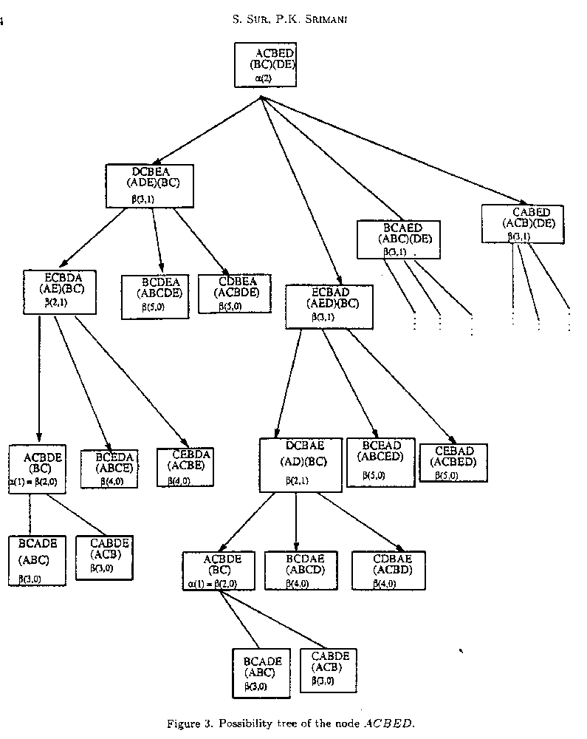
i = | 1 | 2 | 3 | 4
α(i)  γ(i)  η(i) | 2  4  3 | 24  56  42 | 576  1440  1080 | 21120  54912  41184
Table 1.

Created by: Kuo-Shii Huang
Date: Apr. 29, 1998

