Multiple Sequence Alignment Using Partial Order Graphs
Christopher Lee, Catherine Grasso and Mark F. Sharlow
BIOINFORMATICS, Vol. 18 no. 3 2002, Pages 452~464
Abstract
We present a graph representation if an MSA that can itself be aligned directly by pairwise dynamic programming, eliminating the need to reduce the MSA to a profile. This enables our algorithm (Partial Order Alignment (POA)) to guarantee that the optimal alignment of each new sequence versus each sequence in the MSA will be considered.
- Introduction
-Progressive alignment approach – CLUSTAL (Higgins and Sharp, 1988)
- RC-MSA and Profile representation
-Two questions: what sequence positions are aligned to each other; and the ordering of these positions within the sequences themselves.
- Algorithm
2.1 Partial Order Multiple Sequence Alignment (PO-MSA) data structure
-A single sequence is simply a linear series of nodes each connected by a single incoming edge and a single outgoing edge.
-Reconstructing the RC-MSA as a PO-MSA

2.2 Dynamic programming Partial Order Alignment (POA)
-Extension of standard dynamic programming sequence alignment.
-1D branches of the partial order become bifurcated surfaces in the partial order matrix.
-The score 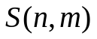of a given cell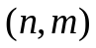 in the matrix:
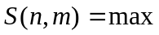{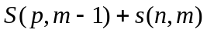 , 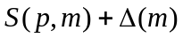 , 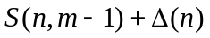},
considering all predecessor nodes that have a directed edge 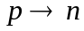.
  - Construction of the partial order graph
-Fusion
2.4 Iterative partial order alignment
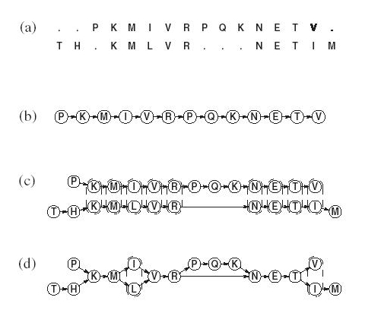
Figure 1. MSA in the POA representation.

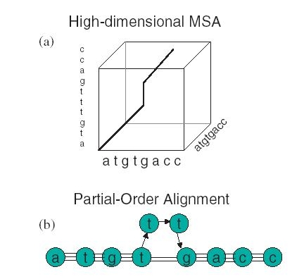
Figure 2. POA maps the high-dimensional MSA path to a reduced graph representation.
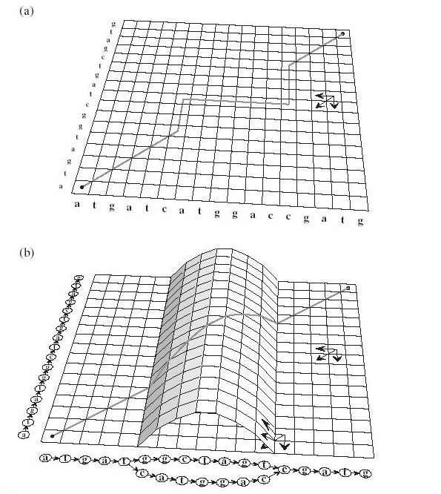
Figure 3. Dynamic programming matrix for POA algorithm.

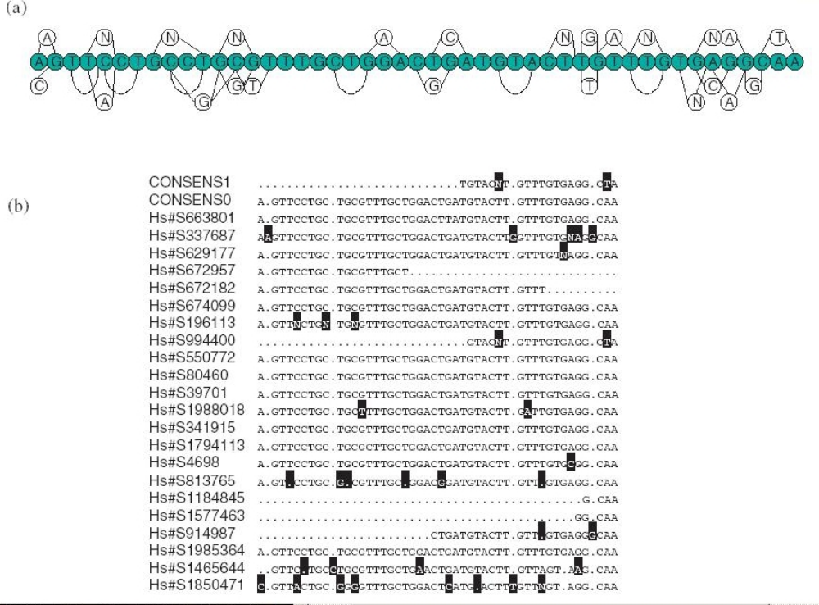
Figure 4. Partial order alignment representation of UniGene EST sequences.
- Implementation
-Multidomain proteins
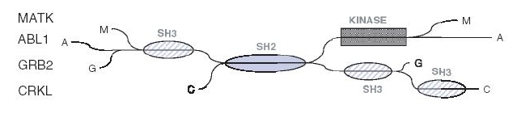
Figure 5. Partial order alignment of 4 human SH2 domain containing proteins.

Created by: Yi-Yao Huang
Date: Jan. 27, 2003

