Finding Motifs in Amino Acid Sequences

- Introduction
- Global multiple sequences alignment.
- Local multiple sequences alignment. (Motif)
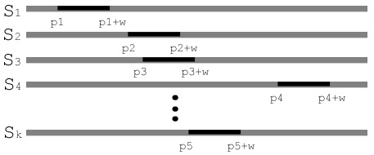
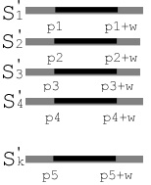
- The Gibbs Sampler of Lawrence et al.
Input：give a set T of N sequences S₁,…, S_{N} and the length of motif w.
Output：s₁,…, s_{N} are the substrings in T of length w.
Algorithm：
    - Choose a beginning position a_{i} of each sequence S_{i} in T at random. Let s_{i} is the substring of S_{i} of length w starting at position a_{i}, where i = 1..N.
    - Random pick one protein P of the N proteins.
    - Create a 20×w probability matrix Q to compute the frequency of amino acid remaining N-1 substrings of length w. In the matrix, Q_{r,j} is the frequency with which amino acid r occurs in the j position over all N-1 substrings of length w, 0≦ j ≦w。
    - For each position i in P, let P_{i} is the substring of P of length w starting at position i. There are frequency matrix Q and the background distribution B. Let p_{i} is the score of these two models, 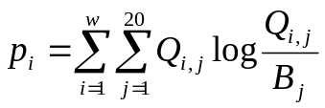.
    - Choose the starting position i of the new substring p_{i} in P at random, with probability ratio to p_{i}.
- ACO (Ant Colony Optimization) Algorithm
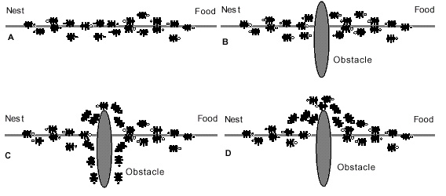
- Our Method.
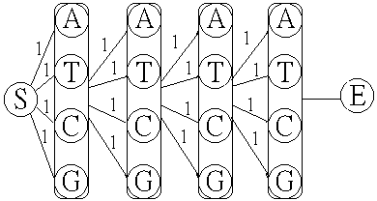
ant_1’s path=AAAA,
ant_2’s path=TTTT,
ant_3’s path=CCCC,
ant_4’s path=GGGG,
ant_5’s path=CGAT.
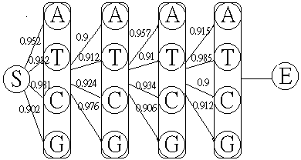
- Result
Created by: Ying-Jer Liao
Date: March 14, 2003

Paper's method |  | Our method |  |  | Performance
Time | Score | Time (our) | Time | Score | Time (%) | Score (%)
19.2 | 15.90 | 1.0 | 8.3 | 18.82 | 48 | 118.34

sigma-37 225 LTYIQNKSQK ETGDILGISQMHVSRLQR KAVKKLREAL
spoIIIC 253 LDLKKEKTQR EIAKELGISRSYVSRIEK RALMKMFHEF
NAHR 25 NQLLVDRRVS ITAENLGLTQPAVSNALK RLRTSLQDPL
ANTP 329 NRYLTRRRRI EIAHALCLTERQIKIWFQ NRRMKWKKEN
NTRC 452 ALAATRGNQI RAADLLGLNRNTLRKKIR DLDIQVYRSG
DICA 25 RRKNLKHTQR SLAKALKISHVSVSQWER GDSEPTGKNL
MERD 54 DAALQRLCFV RAAFEAGIGLGALARLCR ALDAANCDET
FIS 76 VMQYTRGNQT RAALMMGINRGTLRKKLK KYGMN
MATA1 102 KQSLNSKEKE EVAKKCGITPLQVRVWFI NKRMRSK
CII 28 LNKIAMLGTE KTAEAVGVDKSQISRWKR DWIPKFSMLL
CRP 172 DGMQIKITRQ EIGQIVGCSRETVGRILK MLEDQNLISA
LambdaCRO 18 KDYAMRFGQT KTAKDLGVYQSAINKAIH AGRKIFLTIN
P22CRO 15 DVIDHFGTQR AVAKALGISDAAVSQWKE VIPEKDAYRL
ARAC 199 HLADSNFDIA SVAQHVCLSPSRLSHLFR QQLGISVLSW
FNR 199 REFRLTMTRG DIGNYLGLTVETISRLLG RFQKSGMLAV
HTPR 255 LDEDNKSTLQ ELADRYGVSAERVRQLEK NAMKKLRAAI
NTRC 447 ALRHTQGHKQ EAARLLGWGRNTLTRKLK ELGME
CYTR 14 KKQETAATMK DVALKAKVSTATVSRALM NPDKVSQATR
DEOR 26 LKRSDKLHLK DAAALLGVSEMTIRRDLN NHSAPVVLLG
GALR 6 MATIK DVARLAGVSVATVSRVIN NSPKASEASR
LACI 8 MKPVTLY DVAEYAGVSYQTVSRVVN QASHVSAKTR
TETR 29 EVGIEGLTTR KLAQKLGVEQPTLYWHVK NKRALLDALA
TRPR 69 ELLRGEMSQR ELKNELGAGIATITRGSN SLKAAPVELR
NIFA 498 ALEKAGWVQA KAARLLGMTPRQVAYRIQ IMDITMPRL
SPOIIGB 208 LVGEEEKTQK DVADMMGISQSYISRLEK RIIKRLRKEF
PIN 163 RLIAAGTPRQ KVAIIYDVGVSTLYKRFP AGDK
PURR 5 ATIK DVAKRANVSTTTVSHVIN KTRFVAEETR
EBGR 6 MATLK DIAIEAGVSLATVSRVLN DDPTLNVKEE
LEXA 93 LIGKVAAGES ILAQEHIESHYQVDPALF HPRADFLLRV
P22C1 28 LNRIAIRGQR KVADALGINESQISRWKG DFIPKMGMLL

