DNA Sequence and Structure: Direct and Indirect Recognition in Protein-DNA Binding
N. R. Steffen, S. D. Murphy, L. Tolleri, G. W. Hatfield and R. H. Lathrop
BIOINFORMATICS, Vol. 18 Suppl. 1 2002, Pages S22~S30
Abstract
Direct recognition, or direct readout, of DNA bases by a DNA-binding protein involves amino acids that interact directly with features specific to each base. Experimental evidence also shows that in many cases the protein achieves partial sequence specificity by indirect recognition, i.e., by recognizing structural properties of the DNA.
- Introduction
- Sequence motif representations
- Direct and indirect recognition
- Integration host factor(IHF) protein
- Could threading a DNA sequence onto a crystal structure of bound DNA help explain the indirect recognition component of sequence specificity? And might the resulting pure-structure computational motif manifest itself in familiar sequence-based computational motifs?
- Methods and algorithms
This paper used a crystal structure and an objective function to estimate deformation energy.
- The structure motif was extracted from a crystal structure of a protein-DNA complex.
- The objective function modeled the energy difference between DNA in bound and unbound conformations.
DNA sequences were threaded onto the structure motif and scored using the objective function.

- Pure-structure motif: a domino model for DNA bending represents the molecule as a series of rigid rectangular solids, or dominos, each taking the place of a base pair.
- Published objective function: the function sums dimer energy over the dimer steps in the motif.
- The total deformation energy 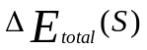 corresponds to the energy difference between sequence S in bound and unbound conformations.
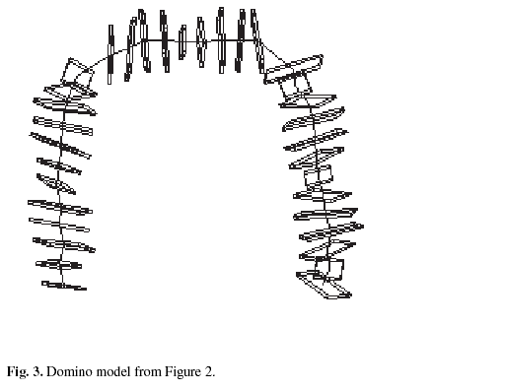
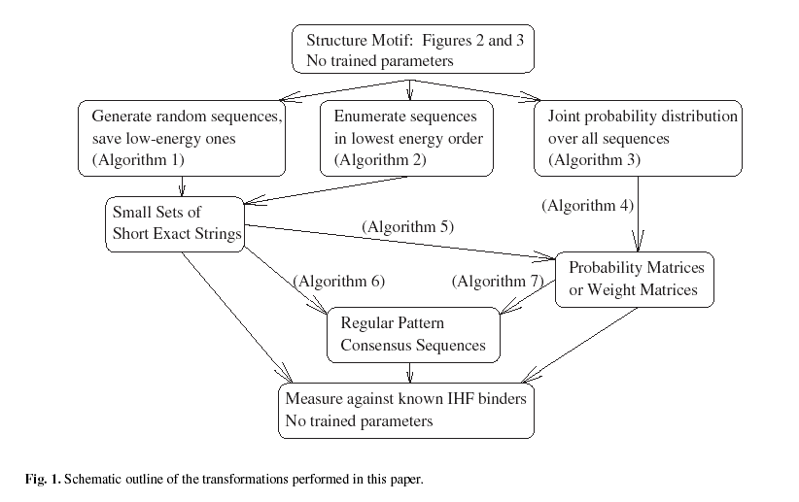
- Results
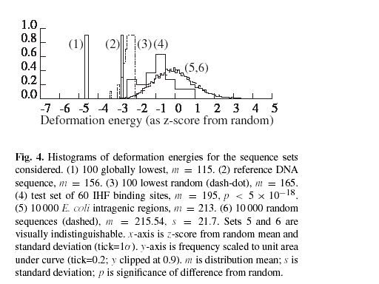
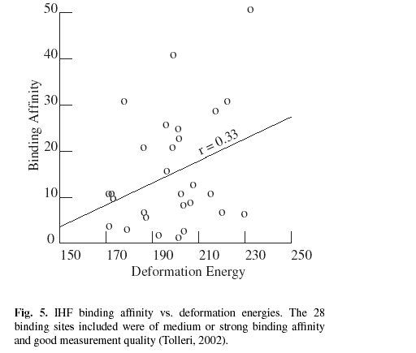
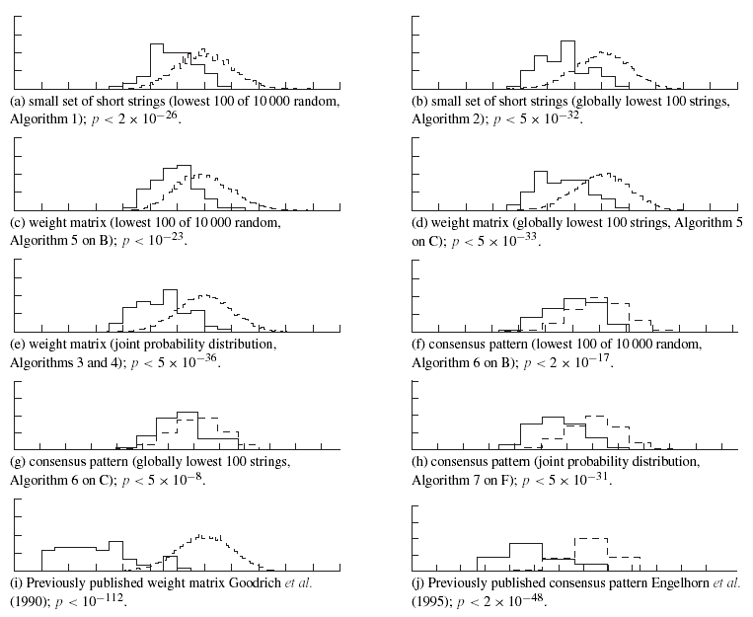
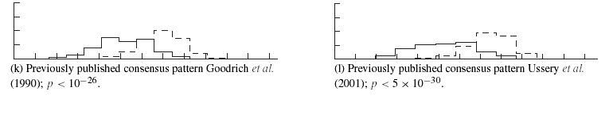

Created by: Yi-Yao Huang
Date: Mar. 19, 2003

