RNA Structure Alignment

Abstract
This algorithm is proposed for aligning two RNA sequences according to their primary and secondary structures.
- Introduction
SCOP: Structural Classification of Proteins.
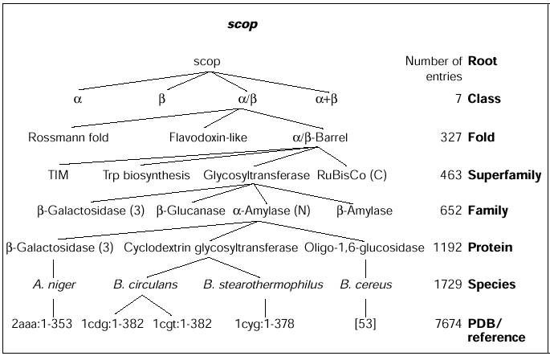Population Statistics of Protein Structures: Lessons from Structural Classifications, Steven E Brenner, Cyrus Chothia and Tim JP Hubbard, Current Opinion in Structural Biology, pp. 369-376, 1997

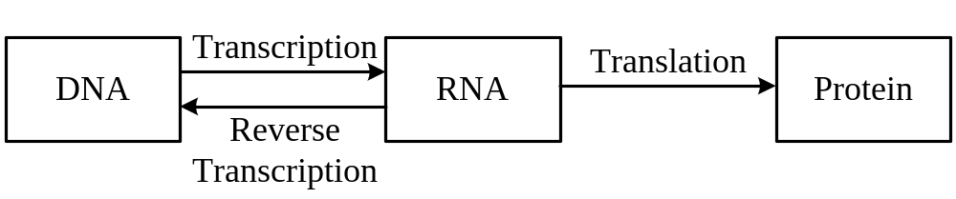

- Our Methods
Input: Two RNA sequences.

2.1 The Secondary Structure Prediction of RNA
In summary, we have the following recursive formula to compute M_{i,j}.
- If j-i≦3, then M_{i,j}= 0.
- If j-i＞3, then
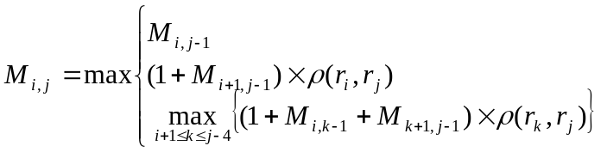

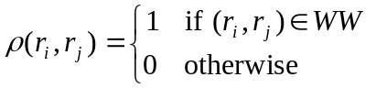
Let WW={(A,U), (U,A), (G,C), (C,G), (G,U), (U,G)}

Case 1.
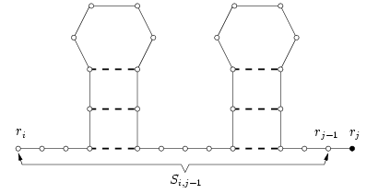
Case 2.
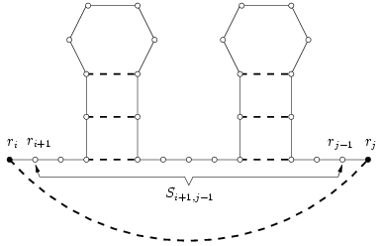
Case 3.
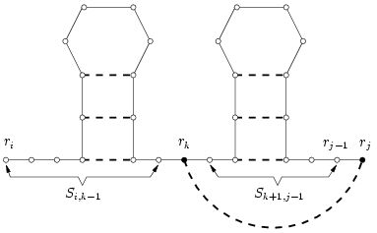

2.2 Stem Alignment

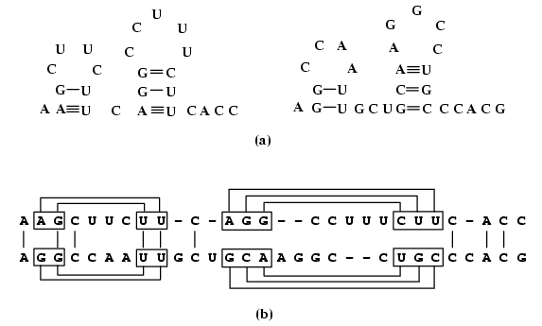

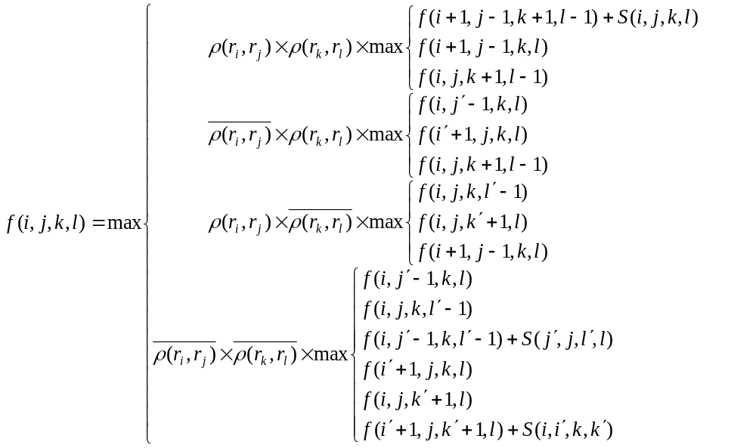
Case 1.
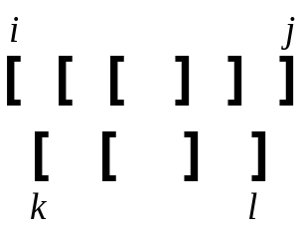

Case 2. Case 4.
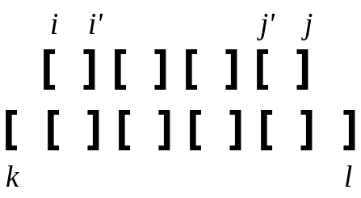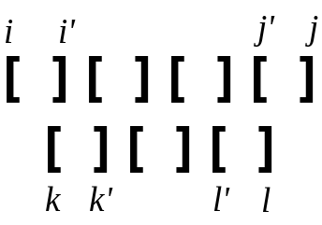

Case 3.
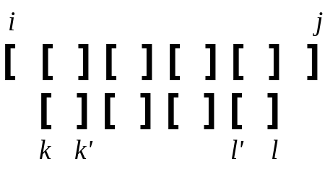

Created by : Meng-Yi Wu
Date : Mar. 19, 2003

