DNA Computing Implementation of Data Flow Logical Operations
Piort Wasiewics, Artur Malinowaski, Robert Nowak, Jan J. Mulawka,
Piotr Borsuk, Piotr Weglenski, Andrzej Plucienniczak
Future Generation Computer Systems, Vol. 17, 2001, pp. 361-378
- Introduction
In our systems the upper strand usually presents data and lower (underlined) means logic devices, rules and so on.
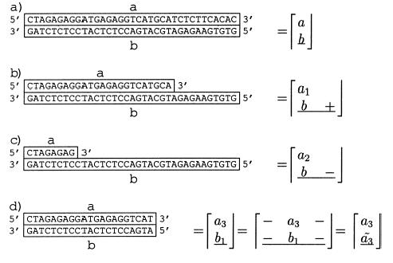
- A New Concept of Data Logic Gate

●Implement AND gate
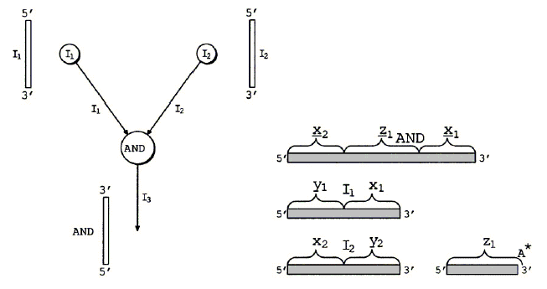

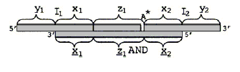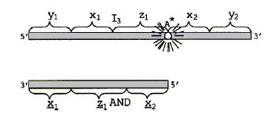

●Implement combination network
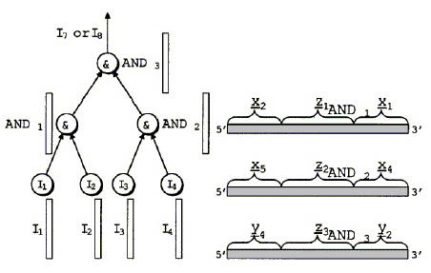

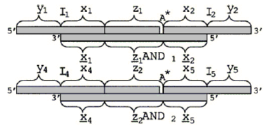 ←First level execution

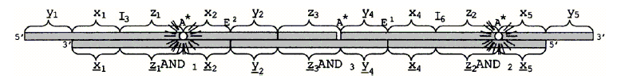
Second level execution

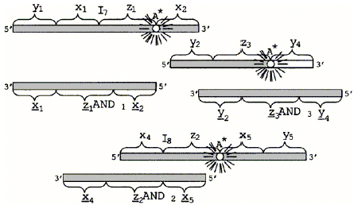←Output

- Implement NAND gate
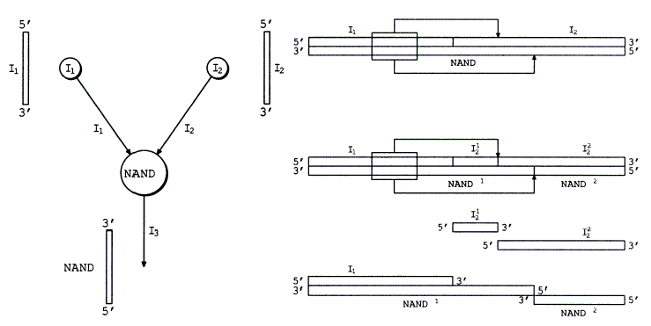

3.Conclusion
1. This major virtue of this method is to use one-time PCR in only one vessel and
electrophoresis.
2. This method does not include the negation operation.
3. Implementing logic circuits on DNA chips allows building more sophisticated data
flow device. This would permit for easy separation of output and input strands and
would provide an improvement step towards massively parallel molecular computer.
Created by : Jian-Bien Chen
Date : Mar. 26, 2003

