Detection of Unrelated Proteins in Sequences Multiple Alignments by Using Predicted Secondary Structures
Mounir Errami, Christophe Geourjon and Gilbert Deleage
BIOINFORMATICS, Vol. 19 no. 4 2003, Pages 506-512
Abstract
Multiple sequence alignments are essential tools for establishing the homology relations between proteins. However for distant proteins, it is more difficult to establish, in a reliable way, the homology relations that may exist between them. In this article, we show that secondary structure prediction is a valuable way to validate protein families at low identity rate.
- Introduction
- Homology is easy to establish when sequences are similar (sharing an identity > 30%). This does not imply that nonsimilar proteins are not related.
- The difficulty is to validate protein families when the similarity is low.
- We present a novel way to validate protein families within multiple alignments at low identity rate (10~30%).
- Our method consists in analyzing the agreement between predicted secondary structures of the aligned sequences.
- We show that it is then possible to validate structural families within multiple alignments at low identity rate, by discarding the nonrelated sequences.
- Materials and methods
- SOV parameter(segment overlap measure)
  - Structural overlap
  - SOV is calculated using reference alignments
- Reference alignments
  - SSSD─contains 126 pairs of aligned structures sharing on average 12% of sequence identity (8~13%), with variable gap rates(0 to 60%).
  - BAliBASE(multiple structural alignments)─contains five groups of alignments also called references.

- Secondary structure compatibility
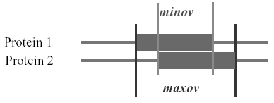
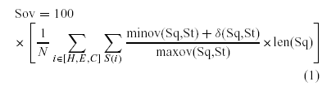
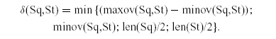

- Secondary structure prediction

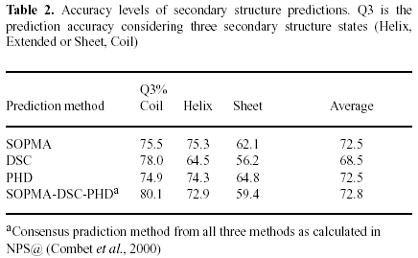

  - Control alignments
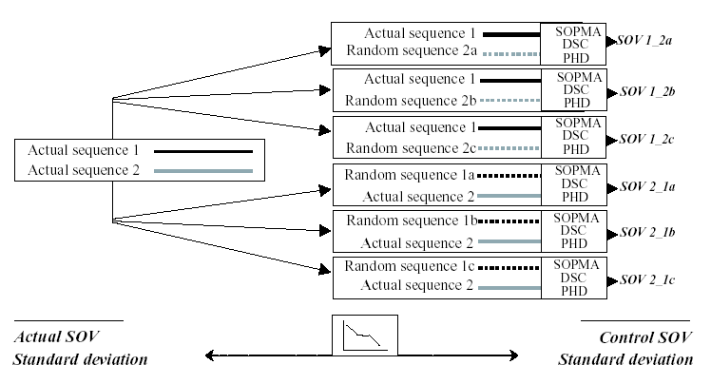
  - SOV parameters
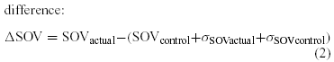
- Results
- SOV comparison
  - This distinction can be observed up to about 30% gap rate.
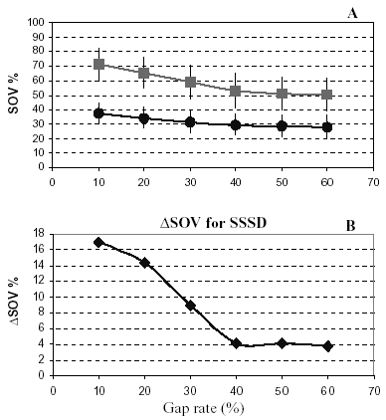
- BAliBASE
  - Reference 4 and 5 have some sequences removed
(gap rate> 30%).
  - This shows that when identity is above 40%, it becomes difficult to distinguish between a related protein sequence and a randomized sequence in a multiple alignment.
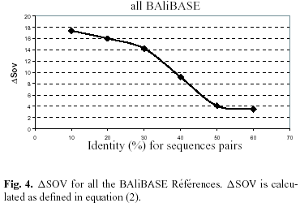

- Biological example: comparison with PSI-BLAST

Created by: Yi-Yao Huang
Date: April 17, 2003

