DIALIGN: Finding Local Similarities by Multiple Sequence Alignment
Burkhard Mogenstern, Kornelie Frech, Adreas Dress and Thmas Werner
BIOINFORMATICS, Vol. 14, 1998, pp. 290-294
- Introduction
We have proposed a novel alignment algorithm which is especially suited to detect
local similarities even if there similarities are separated by long or short unrelated parts of
these sequence (e.g. by intro for genomic DNA or loops for proteins. ).
- DIALIGN algorithm
Multiple alignments are constructed as follows. In first step, all optimal pairwise
alignments are sorted ( i ) according to their weight scores and ( ii ) according to the
degree of overlap with other diagonals in order to emphasize motifs occurring in more
than two sequence (so-call overlap weights ). The resulting list of diagonals is then used to
assemble a multiple alignment in a greedy manner.

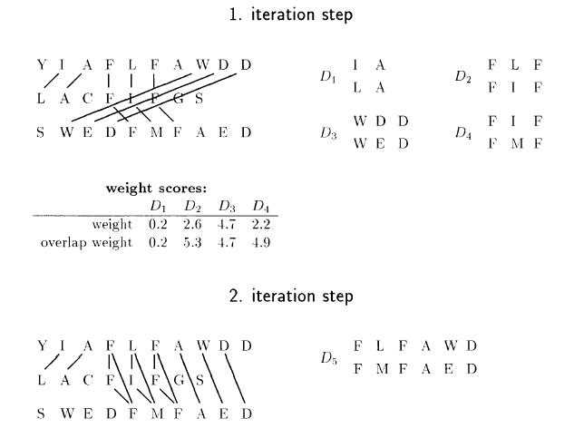
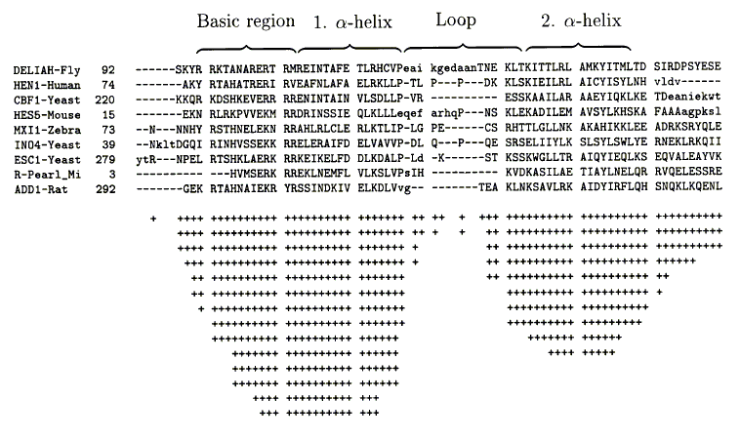

3.Conclusion
Unlike alignment method relying on the sum of dividual similarity values and on gap penalties as optimization criteria, we focus on comparing complete segments of sequence. DIALIGN is able to locate small conserved regions that can not be detected by stardand alignment programs.
Created by : Jian-Bien Chen
Date : Apr. 16, 2003

