Sequence Alignment Using FastLSA
Kevin Charter, Jonathan Schaeffer, Duane Szafron
International Conference on Mathematics and Engineering Techniques in Medicine and Biological Sciences (METMBS'2000), pp. 239-245, 2000
Abstract
For two strings of length m and n (m <= n), optimal sequence alignment takes time and space proportional to m×n to compute. Hirschberg’s algorithm reduces the space needs to roughly 2×m, but doubles the cost of computing. This paper introduces the FastLSA algorithm which is more adaptive to the amount of space available. At one extreme, it uses linear space, while at the other it uses quadratic space.
- Introduction
The LCS algorithms that are based on storing the complete matrix are called full matrix algorithms. Unfortunately, O(m×n) space can be prohibitive, especially given that a DNA sequence can be millions of characters long. Hirschberg was first to report a way of doing the computation using linear space. Less storage means that some values must be recomputed. It is a space-time tradeoff. However, Hirschberg’s algorithm does not take advantage of additional memory that might be available while FastLSA reach the goal.

- Difference between Hirchberg’s algorithm and FastLSA
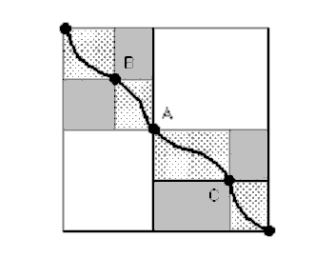
Hirschberg’s Algorithm
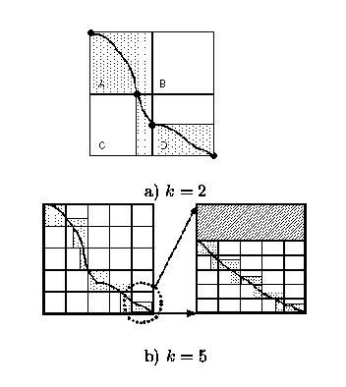
FastLSA algorithm
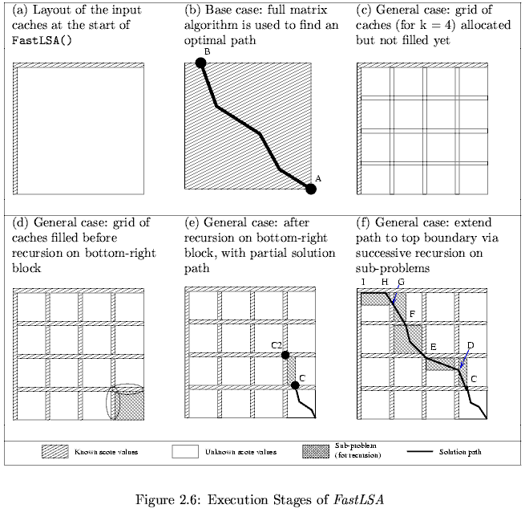

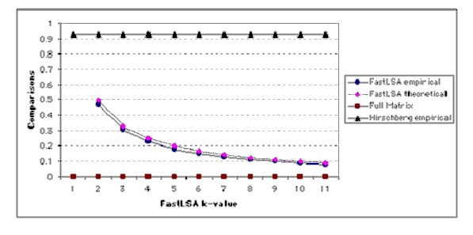
Number of Recomputation
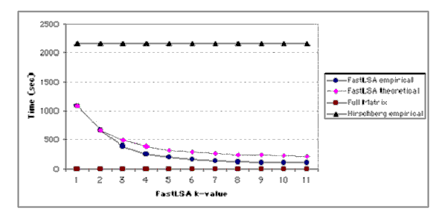
Execution Time
Created by : Yung-Hsing Peng
Date : Apr. 16, 2003

