The Degenerate Primer Design Problem
Chaim Linhart and Ron Shamir
Bioinformatics, Vol. 18, No.3, pp.172-180, April. 2002
Abstract
We study the problem of designing a pair of primers with prescribed degeneracy that match a maximum number of given input sequences.
1.Introduction

DNA sequences of homologous genes, and the goal is to design primers that will match as many of them as possible.
2. The HYDEN PROGRAM

In the first phase, HYDEN locates conserved regions in the DNA sequences by finding ungapped local alignments with a low entropy score. In the second phase, it designs primers using variants of the CONTRACTION and EXPANSION algorithms. Finally, it uses a greedy hill-climbing procedure to improve the primers, and selects the best one as the output.

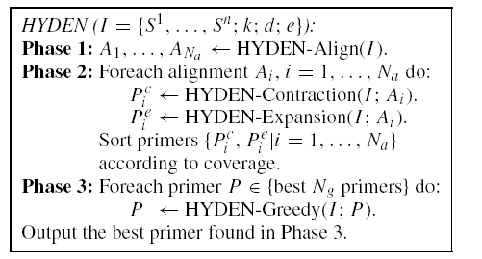

3.HYDEN-Contraction

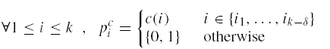

4.HYDEN-Expansion
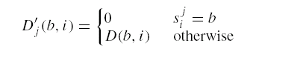
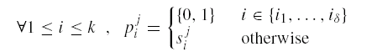
5.Entropy Score, HA:

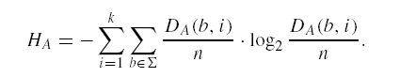

Created by : Wei-Tin Liu
Date : April. 25, 2003

