Prediction of Protein Secondary Structure at Better than 70% Accuracy
Burkhard Rost and Chris Sander
Journal of Molecular Biology (1993) 232, 584-599
Abstract
This paper used several approaches to make the prediction accuracy of protein second structure rise from 66.5% to over 70%. More than one-fifth of all residues are predicted with expected accuracy above 90%, more than half are more than 82%.
- Introduction
- The basic hypothesis that the three-dimensional structure of a protein is uniquely determined by its sequence of amino acid remains valid.
- The different algorithms used to predict the protein secondary structure can be grouped into (1) statistical information (2) physico-chemical properties (3) sequence patterns (4) multi-layered (or neural) networks (5) evolutionary conservation.
- The chance value of prediction is 33% due to the structure can be helix, strand, or loop.
- It was claimed that predictions cannot be better than 65(±2)% in 1992.
- Materials and Methods
- Cross-validation technique and data set used.
  - For homologous proteins, alignment procedures predict secondary structure more accurately than ant method using the sequence information only.
  - The restriction of “For chains with more than 80 residues the mutual pairwise similarity should be <25%” reduced the number of protein chains that can be used from 700 (PDB) to about 150. The paper use 130 of them as the input.
  - Jack-knife testing means using 129 of the 130 chains for training and one for testing, and repeat it for 130 times using different chain as testing. The average of all 130 testing is the final estimation. Its quite resource consuming.
  - Single test set method means using only one set of test chain, but its estimation quality varies with the test set.
  - We worked with 7-fold cross validation: 111 chains are taken for training, 19 for testing. This is repeated 7 times with different sets.
- Measures of protein secondary structure prediction accuracy.
  - The result can be represented in a 3×3 accuracy table A, with
A_{i,j} = number of residues predicted to be in structure type j and observed to be in type i.
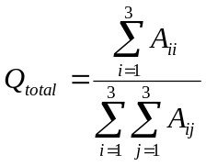
  - The Dictionary of Secondary Structures of Proteins distinguishes 8 secondary structure classes, which can be grouped into 3 classes according to the following conventions: H (α-helix), G (3₁₀-helix), I (π-helix) -> helix(α), E (extended strand) -> strand(β), and B (residue in isolated β-bridge), T (turn), S (bend), _ (rest, coil) -> Loop(L), with the corrections B_ -> ββ, but B_B -> LLL
  - Observed: ααααααααααLLL
Prediction 1: LαααLαααLαLLL
Prediction 2: LLααααααααααL
The first has higher accuracy, but the second better predicts the occurrence of the long helix.
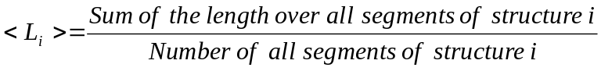
- Classification by a layered network
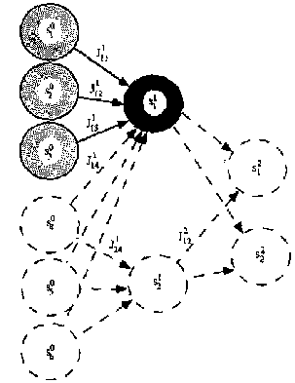
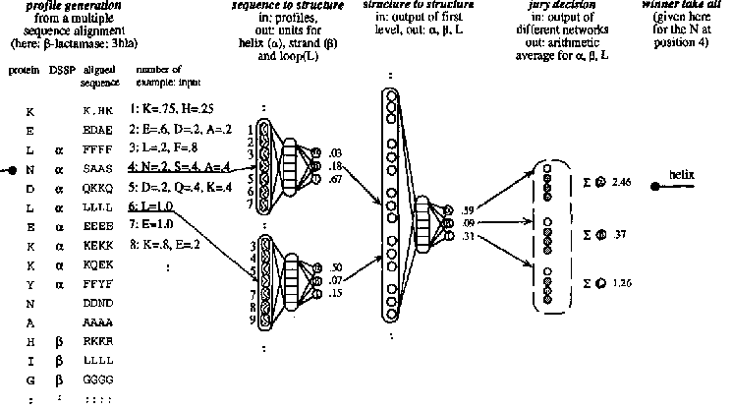
- First level: sequence-to-structure net
- Input: The occurrence probability of every protein.
- 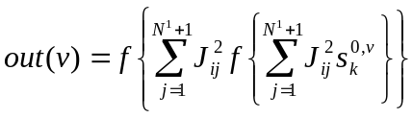
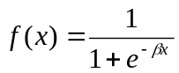
- Second level: structure-to-structure net
- Represent the explicit of the fact that consecutive patterns are correlated.
- Third level: jury decision
  - It uses arithmetic average to do the decision.
  - The training was done in a balanced and in unbalanced fashion on the first and second level of the network system. One such quartet was trained with a real coding of sequence profiles, another by adding conservation weights.
- Adding conservation weights to the sequence profiles
- The addition information about alignment can be exploited by placing a higher weight on positions that are particularly well conserved.
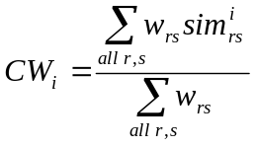
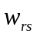= (1- percentage of sequence identity of sequence r and s)
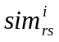 is a value from the similarity matrix between sequence r and s at position i.
- Reliability index for the prediction
  - RI=Int(10*(out_{max}-out_{next}))
RI=9 correspond to a rather reliable prediction.
- Filtering prediction
  - Helices have a minimum length of 3.
  - If length of helix <3,
If RI for all residues in that helix <4,
helix->loop
Otherwise
Extend helix up to a final length of 3
- Results
- More than six percentage points gained by use of sequence profiles
- Further two percentage points by the jury decisions
Created by : Chu-Tin Tseng
Date : Apr. 25, 2003

