An Efficient Algorithm For Minimal Primer Set Selection

Ming-Hua Hsieh, Wei-Che Hsu, Sung-Kay Chiu and Chi-Meng Tzeng
Bioinformatics, Vol. 19, No.2, pp.285-286, Jan. 2003
Abstract

The U-PRIMER algorithm, which uses automatic variable fixing and automatic redundant constraint elimination to tackle the binary integer programming problem associated with the MPS selection problem.
1.Introduction

Let a complete primer set (CPS) be a primer set that contains primers that can amplify all the DNA sequences in a given set S of n DNA sequences and a minimal primer set (MPS) of S is a CPS of S that has a minimal number of primers.Thus, the goal of this paper is to design an efficient algorithm for finding an MPS for any given set of DNA sequences.

2. U-PRIMER

The program contains two parts. The first part takes any given number of DNA sequences as input, and screens primer candidates for both ends of each sequence of any primer length, allowed number of base-pair mismatches , GC%, and Tm. It applies standard criteria for filtering out inappropriate primer candidates that contain poly N, poly AG, and potential hairpin patterns. The remaining candidates become the input of the second part which is the implementation of U-PRIMER algorithm.

3.Algorithm
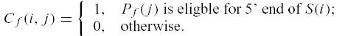
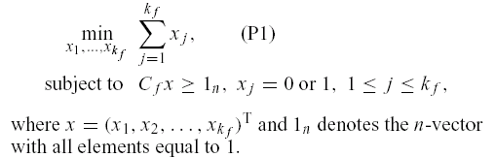

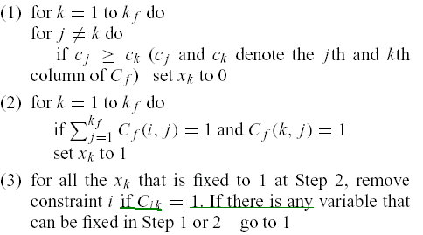

Created by : Wei-Tin Liu
Date : May. 16, 2003

