MaxSub: an Automated Measure for the Assessment of Protein Structure Prediction Quality
Naomi Siew, Arne Elofsson, Leszek Rychlewski and Daniel Fischer
BIOINFORMATICS Vol. 16 no. 9 2000 Pages 776-785
Abstract
Motivation: Evaluating the accuracy of predicted models is critical for assessing structure prediction methods. Such a method should (a) produce one single number that measures the quality of a predicted model and (b) perform similarly to human-expert evaluations.

Result: MaxSub is a new and independently developed method that further builds and extends some of the evaluation methods introduced at CASP3. Overall, the top six predicting groups ranked using the fully automated MaxSub are also the top six groups ranked at CASP3. We conclude that MaxSub is a suitable method for the automatic evaluation of models.
- Introduction
Predicting the three-dimensional (3D) structure of a protein of unknown structure from its amino acid sequence is one of the most important current problems of modern biology. However, it has become clear that evaluating predicted models is a very difficult task, and this has become an active subfield of research. Ideally, one would like to use an evaluation method that (a) is fully automated, (b) produces one single numerical measure representing the quality of the model, (c) is simple, intuitive and easy to understand, (d) most researchers in the field agree upon, (e) is applicable across the different prediction categories (Ex: folding and ab initio) (f) can be added over all targets to produce a total score for each group. (g) is independent of a pre-computed list of “correct hits”. Unfortunately, as of today, no such method exists.

RMSD computed over all atoms, is a very poor indicator of the quality of a model when only parts of the model are well predicted. The wrongly predicted regions produce such a large RMSD that it is impossible to know if the model contains “well-predicted” parts at all. Thus, what is needed is a way to identify the “well-predicted” regions only. However, defining and finding these regions are difficult problems, conceptually and computationally. MaxSub is a approximations algorithm to find the largest “well predict” set.
- Methods
Given two ordered sets of points in 3D, A={a₁, a₂, ….. a_{n}} and B={b₁,b₂, …. b_{n}}. For each i , a_{i} and b_{i} refer to the same residue. A match is an ordered set M = {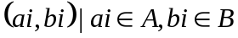}, |M|≦n. A match M defines an optimal transformation T that best superimposes the points of B over A, that is, T minimizes
RMS(M) = 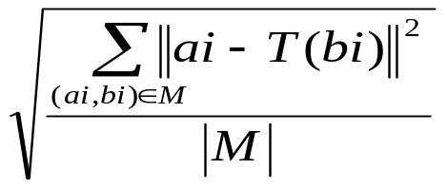

Input: The model B and the experimental structure A, and the constants L (the length of the “seed” segment) and d (the maximum distance between residue pairs that is allowed after superposition).
Output: The largest subset Mmax found.
- S_{max} = 0;
- for i=1 to n – L +1
Let M={(a_{i},b_{i}),(a_{i+1},b_{i+1})……(a_{i+L-1},b_{i+L-1})}
M = Extend(M,A,B,d)
If |M| > S_{max} then {S_{max} = |M|; M_{max} = M}
- return M_{max}

Extend(M, A, B, d)
- for j=1 to k
  - Compute the transformation T that optimally superimposes the residues in M
  - N = 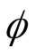
  - For i=1 to n do
i. If the distance between a_{i} and T(b_{i}) is below the threshold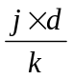, then N = N ∪ {(a_{i},b_{i})}
  - M = N
- Using the last M, re-computing the transformation T that optimally superimposes B onto A. If for some (a_{i},b_{i}) in M, the distance of ai to T(b_{i}) is above d, then remove (a_{i}, b_{i}) from M.
- return M

The normalized score S = 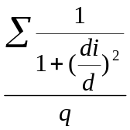

- Results
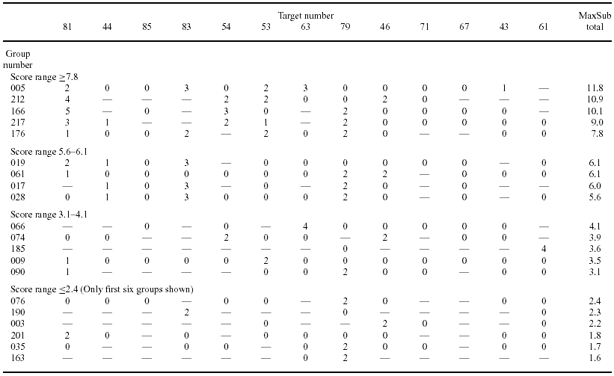

Created by : Yung-Hsing Peng
Date : May. 16, 2003

