Structure-dependent Sequence Alignment for Remotely Related Proteins
An-Suei Yang
BIOINFORMATICS, Vol. 18, No. 12, Pages 1658-1665, 2002
Abstract
- Introduction
For large-scale structural annotation at the level of whole genome analysis, it is essential to automate the comparative modeling procedures. Already, automated procedures are used routinely in predicting high quality models for protein pairs with high sequence similarity (pair-wise sequence identity > 30%) using standard sequence alignment methods, such as PSI-BLAST.
However, in cases where sequence–template pairs are distantly related, structure prediction is essentially a problem without a general solution.
In this paper, a computational procedure (structure-dependent sequence alignment (SDSA)) that improves the accuracy in sequence–template alignments for distantly related protein pairs are described.
- Methods
- SDSA procedure for distantly related protein pairs
  - based on the Needleman-Wunsch global alignment algorithm.
  - 2-D array H:
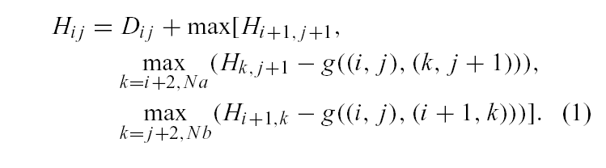
  - Structure-specific substitution matrix D:
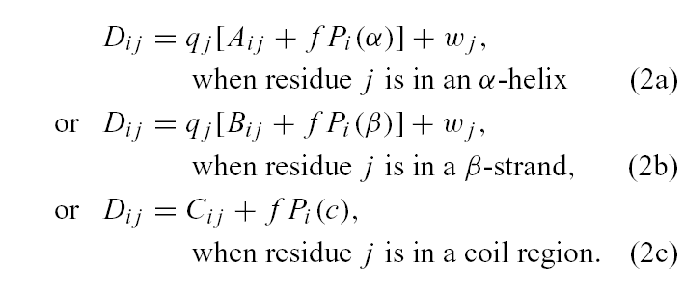
  - Log-odds probability ratio:
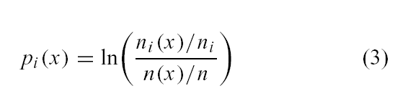
  - Gap penalty function:
    - Insertion
- Deletion

- Standard PSI-BLAST alignments
  - Uses default parameter setting(substitution matrix: BLOSUM62, gap penalties: 11-1, threshold: E-value=0.001).
- Extending a PSI-BLAST local alignment to a global sequence-template alignment (PSI-BLAST+SDSA procedure)
  - Uses the results of PSI-BLAST as the inputs
  - 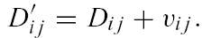
- flowchart
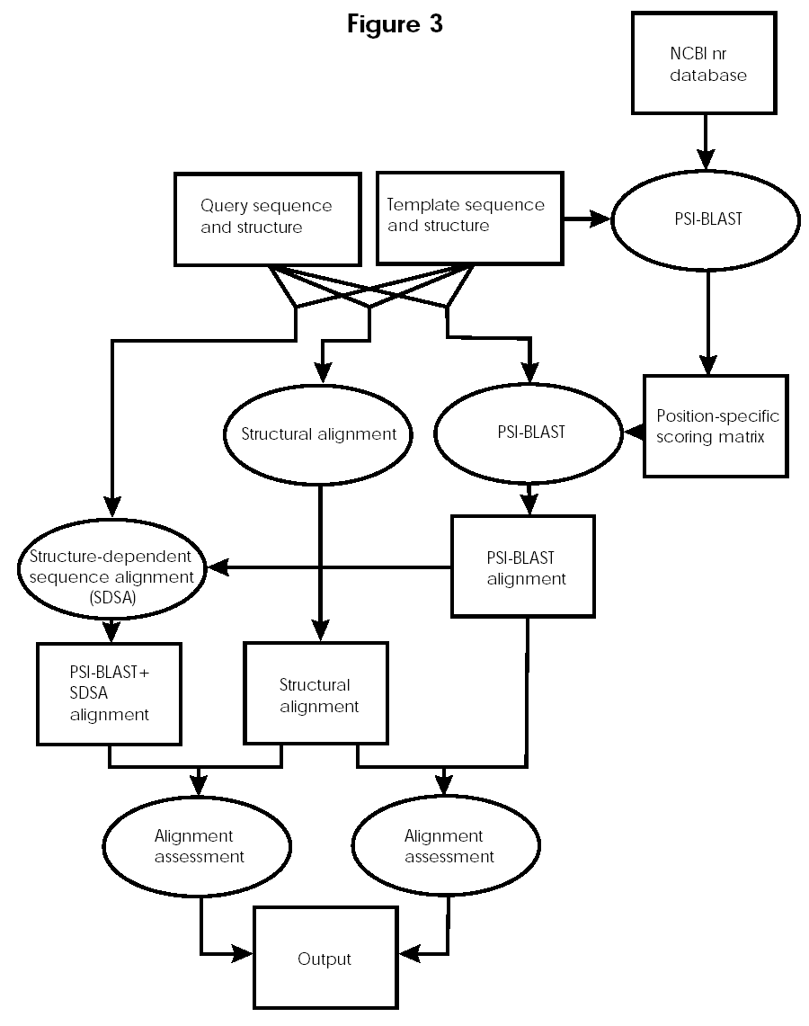
- Results
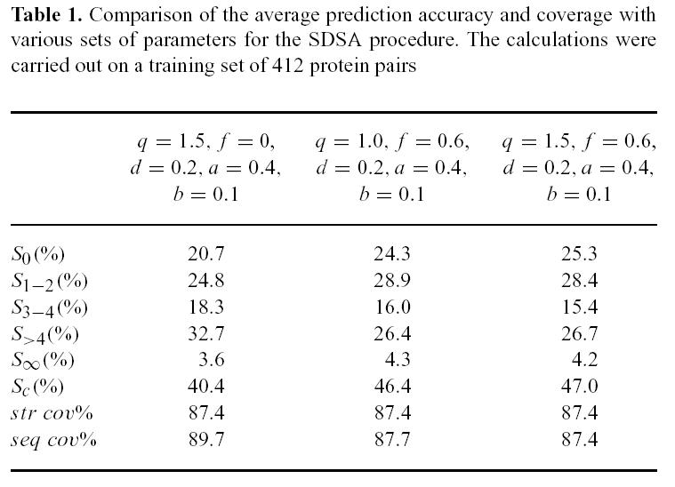

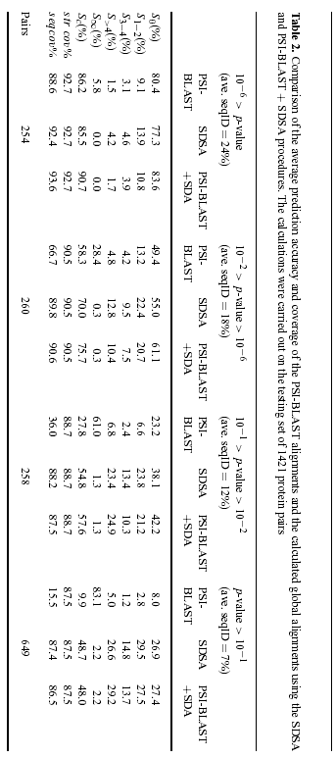

Created by: Yi-Yao Huang
Date: May 30, 2003

