Correlating Gene Promoters and Expression in Gene Disruption Experiments

Kimmo Palin , Esko Ukkonen, Alvis Brazma and Jaak Vilo

Bioinformatics, Vol. 18, No.2, pp.s172-s180, Oct. 2002
Abstract
1.Introduction

In this paper we study the correlation between the presence of binding sites and gene expression by comparing the changes of gene expression in gene disruption experiments and the presence of putative binding sites in the upstream regions of various genes.

For each disrupted gene we find the set of genes that change their expression levels significantly. On the other hand we take previously known and verified binding sites and find the corresponding sets of genes having these binding sites in their upstream regions. Then for each pair of a disrupted gene and a binding site we look how much the respective sets intersect.
2. Disruption networks and gene expression cascades
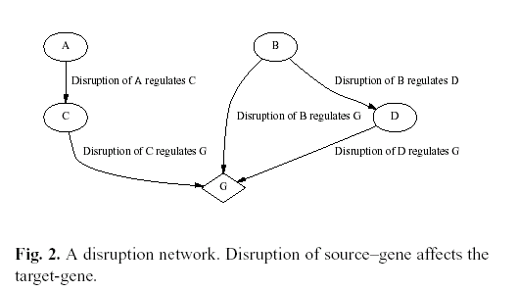

Figure 2 gives a hypothetical example, in which the cascade of G is C_{G} = {B, D,C}.
3.Results
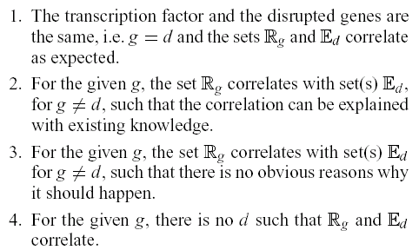
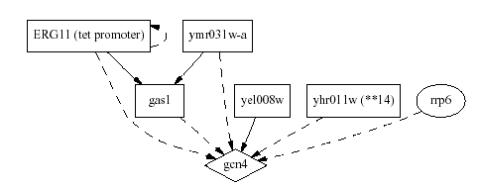
An entry in Figure 3 is marked with a triangle if the effectual set of the gene on the left and the regulation set of the motif above have significant correlation.

The entry contains a circle if the gene on the left is in the expression cascade of the transcription factor on top.

If both of these conditions are true the entry contains a rectangle.
(1).gcn4=>categories1 (2) cup5,mac1,vma8=>2 (3) Leu3,MET31-32,GCN4=>3
(4)gcn4,gas1,yel008w,yhr011w,rrp6,ERG11,ymr031w-a=>2,3
Created by : Wei-Tin Liu
Date : Jun. 27, 2003

