RAGA: RNA sequence alignment by genetic algorithm
Cédric Notredame, Emmet A. O’Brien and Desmond G. Higgins
Nucleic Acids Research, 1997, Vol. 25, No. 22
- Introduction
- Most methods of alignment are based on the primary structure of the sequences to be analyzed.
- Several algorithms have been developed for aligning RNA sequences taking into account primary and secondary information.
- Some methods attempt to simultaneously align and fold sequences.
- This paper uses GA to get the heuristic solution.
- Methods
The aim is to align two related sequences of RNA, knowing the secondary structure (master structure) of one of them (master sequence), in order to predict the position of these structural elements in the second sequence (slave sequence).
2.1 Objective function
- It combines three different scores: Pr, Se, and gap penalty.
Alignment score = Pr + (λ* Se ) – gap penalty
- Pr is a function of the aligned pairs of residues in the alignment.
- Se evaluates the stability of the folding induced by the master onto the slave sequence. Given two sequences A (master) and B (slave) with (A_{i}, A_{j}) being two nucleotides of A and (B_{k}, B_{n}) the equivalent aligned nucleotides of B, if A_{i} and A_{j} are known to be paired, Se is equal to the pairing score of B_{k} with B_{n}.
- Gap penalty = (a * GOS) + (b * GO) + (c* GEP)
a: the number of gaps between stacked pairs in stems,
b: the number of other nom-terminal gaps.
c: the total length of all the non-terminal gaps.
GOS: a penalty for opening a gap between two stacked pairs.
GO: a penalty for opening a gap in non-structured regions.
GEP: penalize gap length.
- Gaps may happen more frequently in loops or in non-structured domains.
2.2 Test cases
Two sequences are extracted from the multiple alignment. This initial alignment was kept as a reference. From the same sequence the structure of the master sequence was then extracted.
2.3 Optimization of the objective function
2.3.1 initialization
- The two desirable properties of an initial population are to have as much diversity as possible to and to contain as many good scoring blocks as possible.
- Seeding in random and in greedy are both not good.
- In RAGA, they use a variation of dynamic programming, which allows addition of a random amount of noise to the regular dynamic programming method.
2.3.2 crossovers
The principle is to map the areas of alignment that are consistent between the two parents, and take the non-identical blocks from either of the parents.
2.3.3 gap shifting
A gap is randomly chosen in an alignment and moved to another position.
2.3.4 gap insertion
2.3.5 Island parallelism
Several identically configured GAs were used, running independently in parallel and exchanging individuals every N generations. In the following model we can get ~80% of the maximum speed up.
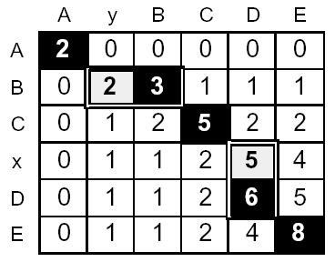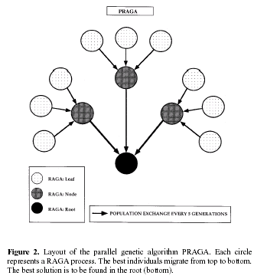

2.4 Evaluation
We use three different measures: m1, m2, and m3. m1 is the percentage of the aligned columns of nucleotides in the reference alignment that are reproduced in the test alignment. m2 is the average offset of stems between the reference and the test alignment. m3 is very similar to m1, but it only consider residues that form a pair in the secondary structure.
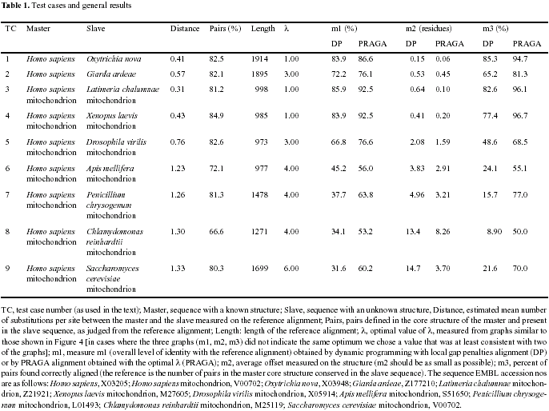
Created by : Chu-Ting Tseng
Date : Jun. 26, 2003

