Sequence Variations within Protein Families are Linearly Related to Structural Variations
Patrice Koehl and Michael Levitt
J. Mol. Biol., No. 323, pp. 551-562, 2002
Abstract

- Introduction
- A protein sequence folds into a unique 3-D structure. Interestingly, this 1-to-1 correspondence is no longer valid when all proteins are considered.
- Although there are many individual exceptions, it is believed that when two proteins share 50% or higher sequence identity, their backbones differ by less than 1 A RMS deviation. However, structure alignments have identified homologous protein pairs with less than 10% sequence identity.
- Here, we propose to study the inverse fundamental question: can we correlate the structural differences between two protein folds to differences between the subsets of sequence space that are compatible with these folds?
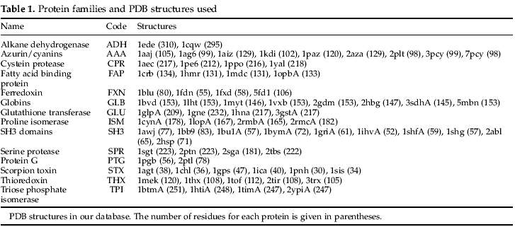
- Results
- Protein G and protein L share a significant subset of sequence space
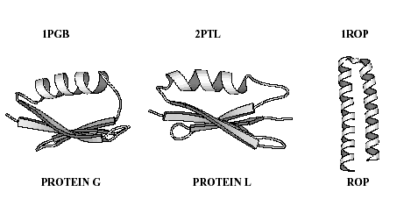

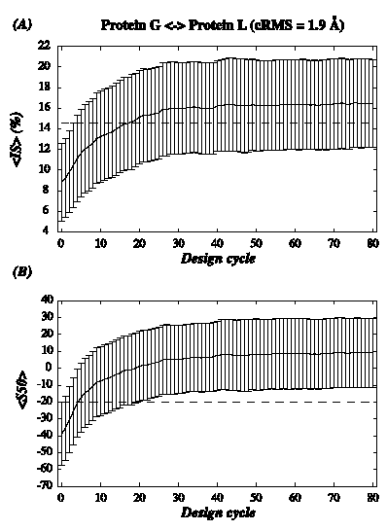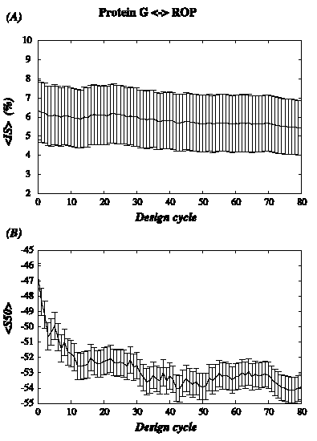
- Protein G and ROP cover different regions of protein sequence space

- Structure similarity implies sequence similarity: comparing SH3 domains
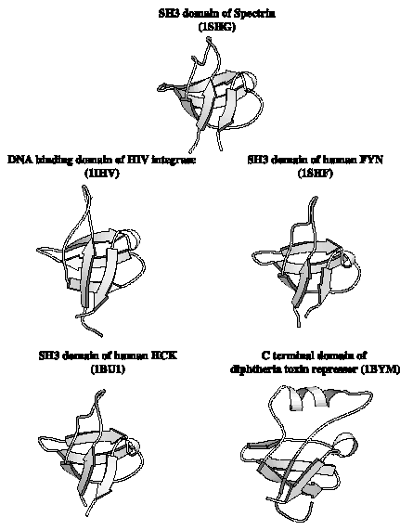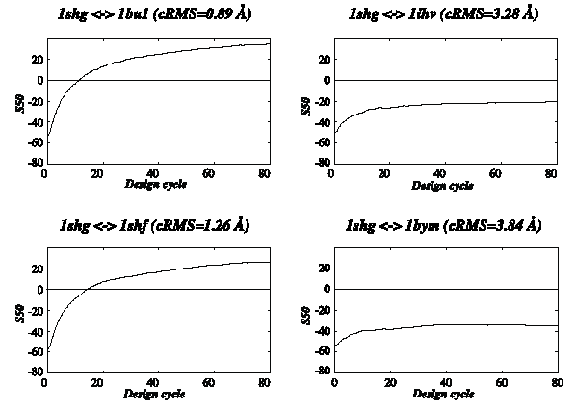
- A linear correlation between protein structure similarity and percentage sequence identity
- Methods
The similarity between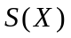 and 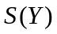 provides an estimate of the sequence similarity between the two proteins.
- Defining the sequence space
- Building full-atom model proteins and reaching specificity
- Comparing two subsets of protein sequence space
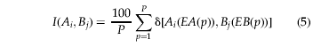
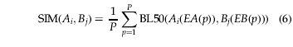

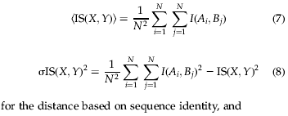

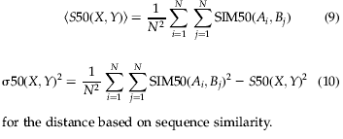

Created by: Yi-Yao Huang
Date: July 22, 2003

