Detecting Motifs from Sequences

Yuh-Jyh Hu, Dennis Kibler, and Suzanne Sandmeyer

Proceedings of the 16th International Conference on Meachine Learning 1999,pp. 181-190
Abstract
- Introduction

DMS adopts the probability matrix representation for motifs. The user provides a family of sequence and how many motifs he would like returned. The system returns a ranked order of motifs.
- The DMS Algorithm

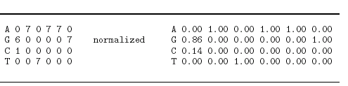

For example, given a six-base sequence, GATAAG,

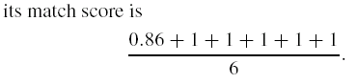

- Translating subsequences into matrices.

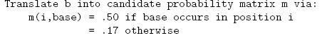

(b) Filtering possible motif occurrences.

(c) Finding and ranking motif candidates.

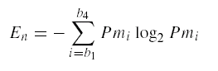
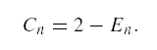
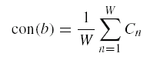

Created by : Wei-Tin Liu
Date : July. 31, 2003

