DNA Binding Sites: Representation and Discovery
Gary D. Storme
BIOINFORMATICS, Vol. 16, no. 1, 2000, pp. 16-23
- Introduction
Predict binding site can be divided into two subproblems. The first is, given a collection of known binding site, develop a representation of those sites. The second is, given a set of sequence known contain binding sites, but not knowing where the sites are, then discovery them.

- Representation Sites
- Regulator system can take advantage of the variability in the sites to better control transcription.
- There is a trade-off between the number of mismatches allowed, the ambiguity in the consensus sequence, and the sensitivity and precision of the representation.
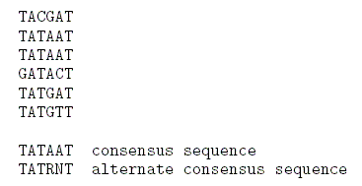
- An alternative to consensus sequences is a weight matrix representation of the sites. This is a convenient way to account for the fact that some positions are more important for the activity of the sites.
a. Use ‘Perceptron’ algorithm: This is a simple neural network that learns from examples.
b. Use HMM: Matrix correspond to di-nucleotides at the position in the sites, rather than mono-nucleotide.
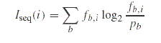

- Discovering Sites
- Looking for common words and their ‘neighbors’, which are approximate matches to those words, over a window of possible alignment. On control sets, where the correct patterns are known, the methods usually perform quiet well. So it can be expected that patterns they identify that are not already known may also correspond to new transcription factor binding sits.
- The weight matrix approach use greedy algorithm that builds up an entire alignment of the sites by adding in new ones at each iteration. Recent advances allows us to calculate a p-value for the alignment and use that as the criterion to rank different alignment.

- Conclusion
- The largest problem is that there tend to be many false positives in such searches.
- The pattern recognition methods also work fairly well, and can usually be relied upon to uncover at lease the sites involved in the coregulation of the collection of identified genes.
- However, we are still not able to reliable determine the complete set of regulatory interactions for complicated promoters typical of metazoans.
Created by : Jian-Bien Chen
Date : July 31, 2003

