Protein Fold Similarity Estimated by a Probabilistic

Approach Based on C^{α}-C^{α} Distance Comparison
Oliviero Carugo and Sandor Pongor
J. Mol. Biol., No. 315, pp. 887-898, 2002
- Introduction
- In order to understand the protein structures, the structures need to be categorized according to their recurrent local motifs or folds, which is not an easy task.
- For fold databases, such as FSSP, SCOP and CATH, the quantitative assessment of structural similarity is problematic in many respects:
  - The comparison of 3-D structures is very computer-intensive.
  - RMSD value works well only if the structures are closely related.
- This paper defines a simple numerical measure of fold similarity that is sufficiently fast to compute for large database.
- The underlying assumption is that if a fold of a protein can be reconstructed from the distances measured between all pairs of its C^{α} atoms, then folds can also be compared in terms of their C^{α}-C^{α} distances.
  - We used histograms of the C^{α}-C^{α} distance distributions as a simplified representation of the structure.
  - The comparison of distance histograms can be carried out using the standard statistical method of contingency table analysis that yields a probability of identity value for the two structures.
- Results
- The PRIDE score: probability of identity between two protein structures
  - We describe a protein fold by a set of its C^{α} ()-C^{α}(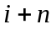) distances, where is an integer ranging from 3 to 30, and prepare a histogram of the length distribution.
e.g. C^{α} ()-C^{α}(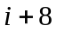) distance, i.e. separating the C^{α} atoms eight residues apart.
  - Figure. 1
- The PRIDE score as a measure of close and distant similarities
  - Relationship between the PRIDE and rmsd value
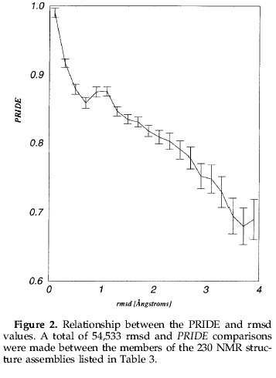
  - The classification of 28 NAD-binding domains
  - Testing on a wider range of similarities: CATH database
- Conclusions
- For closely related protein 3D structures PRIDE is highly correlated with the rmsd values. On the other hand, for more distant similarities PRIDE scores produced classifications that were in very good agreement with the known categories.
- The most important advantages of the PRIDE score:
  - It requires no structural alignment.
  - It provides probability value appreciated by non-specialist users.
  - PRIDE scores provide a useful alternative to rmsd value.
  - The only information needed to compute the PRIDE values is given by the positional parameters of the C^{α} atoms.
- Methods
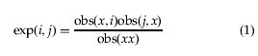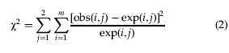
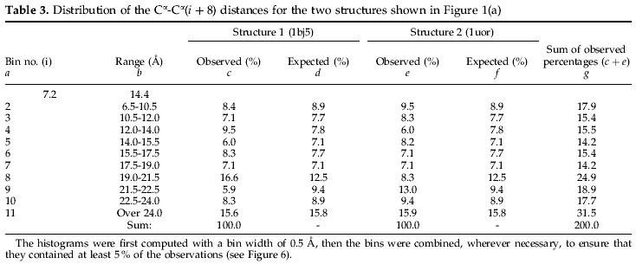
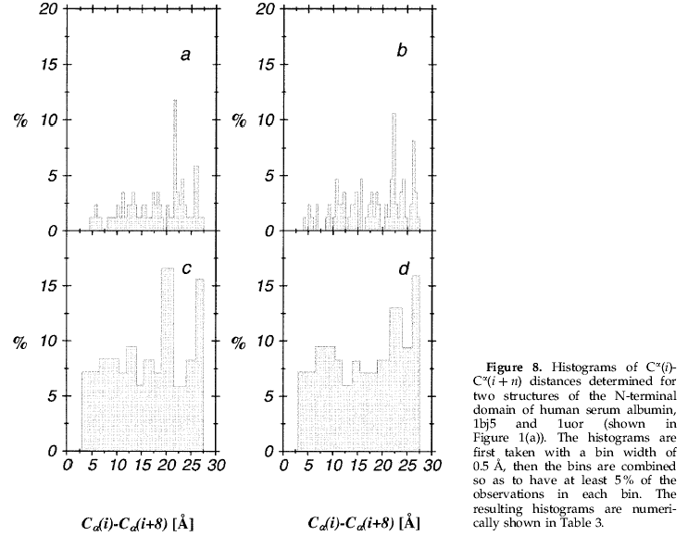
Created by: Yi-Yao Huang
Date: Aug. 19, 2003

