Molecular Computation: RNA Soultions to Chess Problem
Dirk Faulhammer, Anthony R.Cukras, Richard J. Lipton and Laura F. Landweber
Proceedings of the National Academy of Sciences (PNAS), Vol. 97, No. 4, pp. 1385-1389, 2000
Abstract
The use of RNase H can go beyond the set of available restriction enzymes. It acts as a “universal restriction enzyme” because it allows selective marking of virtually any RNA strands for digestion in parallel.
- Materials and Methods
T7-transcription
Design each bit and spacer for the library
RNA library

Design DNA oligonucleotide sequences
hybridazation
Use ethanol precipitation those unmarked RNA
RNA．DNA hybridds, marked by
DNA oligonucleotides
RNase H digestion

Polyacrylamide gel

Read out by autoradiography

- Design and Synthesis of a 10-Bit RNA library
Rules for design each bit:
1. Choose sequence by maximize the Hamming Distances between individual strands. (no more than 5 matched over a 20-window)
2. To avoid secondary structure, using three-letter alphabet for the bits and spacers.
3. Strands were controlled to avoid hybridization to themselves.
5’ 3’
Prefix (24)
Bit a (15)
Spacer (15)
Bit j (15)
Suffix (32)
－ ….
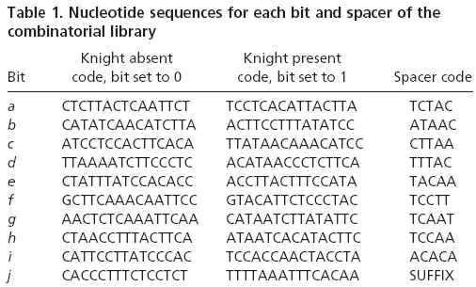
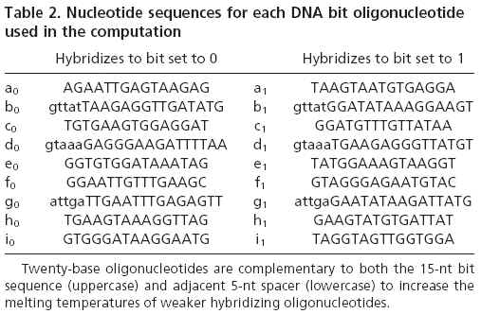
- Algorithm for Solving Knight Problem
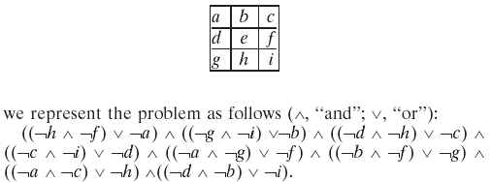
- RNA Solution
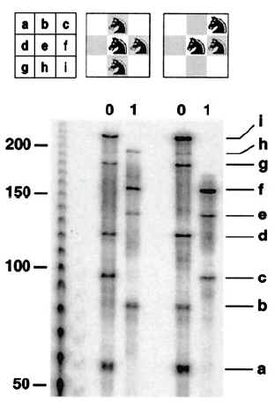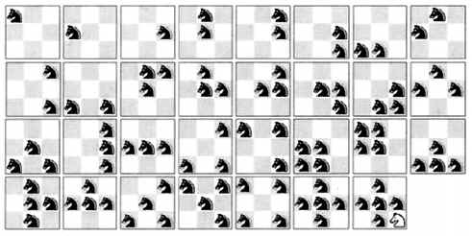
- Conclusion

Created by: Chia-Ling Sun
Date: Aug. 19, 2003

